**Supplemental Figure:** Lower Manhattan Hospitals Affected by Hurricane Sandy

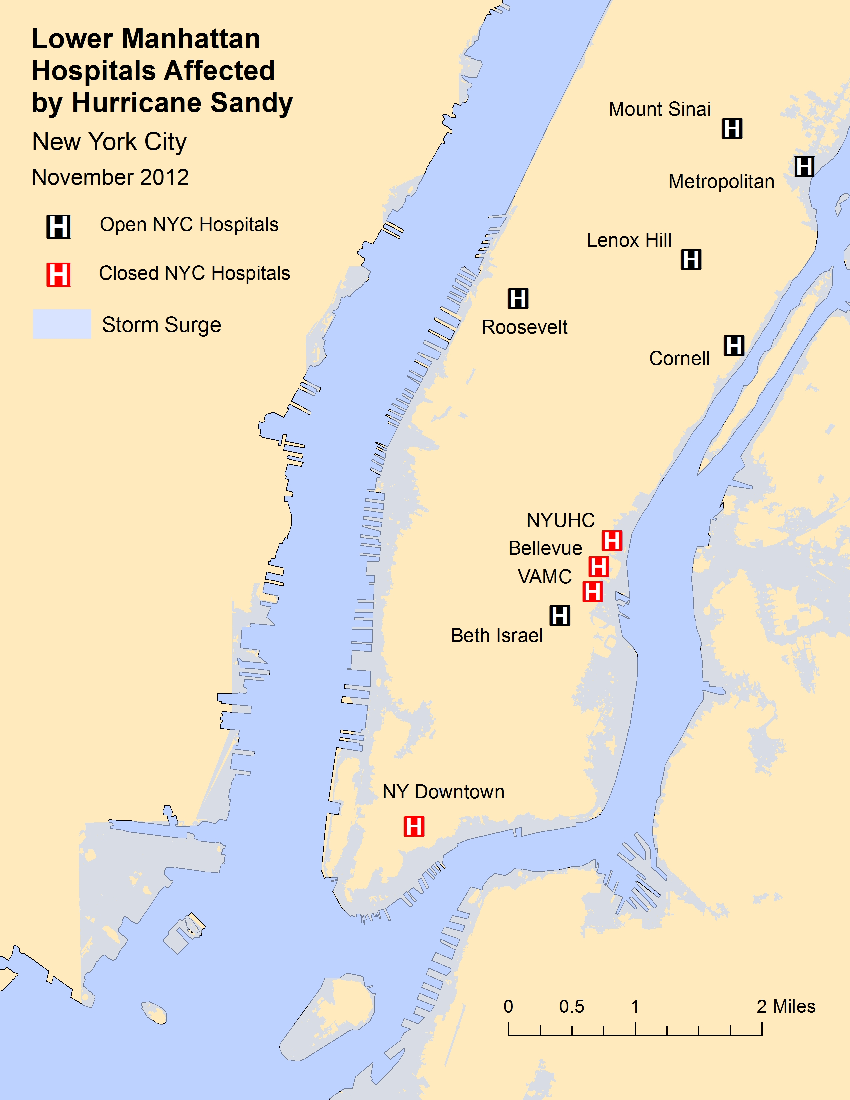

**Source:** FEMA Storm Surge Impact Analysis;1 Map produced using ArcGIS.2

**Note:** Excludes specialty hospitals (i.e. cancer, orthopedic, eye and ear, and long-term). **Abbreviations:** *Lenox Hill*, Lenox Hill Hospital; *Mount Sinai*, Mount Sinai Medical Center.

**References:**

1) FEMA Modeling Task Force. Hurricane Sandy Impact Analysis. February 14, 2013. *http://www.arcgis.com/home/item.html?id=307dd522499d4a44a33d7296a5da5ea0.* Accessed August 18, 2013.

2) *ArcGIS Desktop.* Version 10.1. Redlands, CA: Environmental Systems Research Institute, 2012.