**APPENDIX**

**Appendix Table 1:** Search strategies in various databases.

|  |  |
| --- | --- |
| **Database** | **Search Terms** |
| PubMed | “public mask AND infection”, “mask AND infections”, “facemask AND MERS”, “facemask AND community”, “face mask AND community”, “community AND facemask AND infection”, “community AND face mask AND infection”, “((community settings) AND (infection prevention)) AND ((face masks OR face mask OR facemask OR mask))” |
| Google Scholar | “((community settings) AND (infection prevention)) AND ((face masks OR face mask OR facemask OR mask))” |
| Scopus | “((community settings) AND (infection prevention)) AND ((face masks OR face mask OR facemask OR mask))”, “community AND mask AND infection(s)” |
| Health Evidence | “face mask AND community”, “facemask AND community”, “mask AND community” |
| medRxiv | “face mask AND infection”, “facemask AND infection”, “((community settings) AND (infection prevention)) AND ((face masks OR face mask OR facemask OR mask))” |

**Appendix Table 2:** Summary of criteria for article inclusion.

|  |  |  |  |
| --- | --- | --- | --- |
| **Inclusion Criteria** |  | **Exclusion Criteria** |  |
| Type of Study | Cluster randomized trial | Type of Study | Cohort, cross sectional, case study, experimental, meta-analysis, systematic review, rapid review |
| Participants | Humans | Participants | Animals/non-humans |
| Setting | Community or public | Setting | Healthcare or laboratory |
| Language | English | Language | Non-English |
| Abstract | Available | Abstract | Not available |
| Outcome | ILI symptoms or laboratory-confirmed respiratory virus | Outcome | No measure of ILI symptoms or laboratory-confirmed respiratory virus |

**Appendix Table 3:** Description of biases addressed by the Cochrane Risk of Bias tool.

|  |  |
| --- | --- |
| **Bias Domain** | **Issues Addressed** |
| Sequence generation | Was the allocation random? Would it result in comparable groups? |
| Allocation concealment | Was the allocation sequence properly concealed? Could allocations have been foreseen? |
| Blinding of participants and personnel | Were study participants blinded from the study intervention that they received? |
| Blinding of outcome assessors | Were outcome assessors blinded from the study intervention participants received? |
| Incomplete outcome data | Was the outcome data complete? Were there any exclusions? Were they properly reported? |
| Selective outcome reporting | Was the possibility of selective outcome reporting addressed? |
| Other sources of bias | Were limitations addressed? Was there a large enough sample size for generalizations? Were there confounding variables contributing to the results? Were intervention groups demographically comparable? |
| Overall risk of bias | High means > 2 high ratings; Medium means 1 high rating and < 2 unclear ratings; Low means no high ratings and < 2 unclear ratings |

**Appendix Table 4:** Individual category and overall risk of bias scores for each study.

|  |  |  |  |  |  |  |  |  |
| --- | --- | --- | --- | --- | --- | --- | --- | --- |
| **Author** | **Sequence Generation** | **Allocation Concealment** | **Blinding of Participants and Personnel** | **Blinding of Outcome Assessors** | **Incomplete Outcome Data** | **Selective Outcome Reporting** | **Other Sources of Bias** | **Overall Risk of Bias** |
| Aiello A et al., 2010 (36) | Low | Low | Low | Unclear | Low | Unclear | Low | Low |
| Aiello A et al., 2012 (37) | Low | Unclear | Low | Low | Low | Low | Low | Low |
| Alfelali M et al., 2019 (38) | Low | Low | Low | Low | Low | Unclear | High | Medium |
| Barasheed O et al., 2014 (39) | Unclear | Unclear | Low | High | Low | Low | High | High |
| Canini L et al., 2010 (40) | Low | Low | Low | Low | Low | Low | High | Low |
| Cowling B et al., 2009 (41) | Low | Low | Low | Unclear | Low | Low | Low | Low |
| Larson E et al., 2010 (42) | High | Unclear | Low | Unclear | Low | Low | Low | Medium |
| MacIntyre C et al., 2009 (43) | Unclear | Unclear | Low | Low | Low | Low | Low | Low |
| MacIntyre C et al., 2016  (44) | Low | Low | Low | Low | Unclear | Low | Low | Low |
| Simmerman J et al., 2011 (45) | Low | Low | Unclear | Unclear | Low | Low | Low | Low |
| Suess T et al., 2012  (46) | Low | Low | Low | Unclear | Low | Low | Low | Low |

High = study showed clear red flags when addressing the bias issues in Appendix Table 3; Unclear = study did not address the bias issues in Appendix Table 3; Low = study properly addressed bias issues in Appendix Table 3

**Appendix Figure 1:** Contour enhance funnel plot measuring study effect size (log risk) against variance (standard error).



**Appendix Figure 2:**Forest plot of estimations of the association between face mask use combined with elevated hand hygiene and influenza-like illness symptoms.



ILI+ = showed influenza-like-illness symptoms; ILI- = did not show influenza-like-illness symptoms; HH = hand hygiene

**Appendix Figure 3:** Forest plot of estimations of the association between face mask use combined with elevated hand hygiene and laboratory-confirmed respiratory infection.

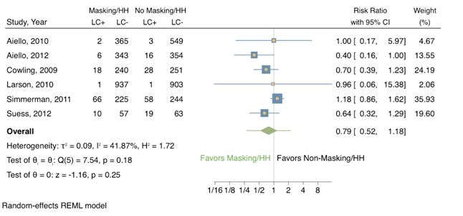LC+ = laboratory-confirmed respiratory infection; LC- = no laboratory-confirmed respiratory infection; HH = hand hygiene