**SFig.1** Graphical illustration of the difference-in-difference model.

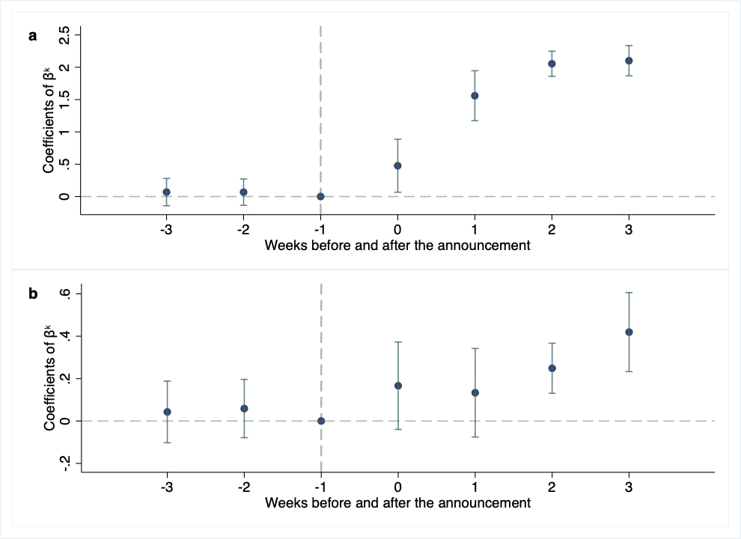

**SFig.2** The estimated coefficients of $β^{k}$ from equation (4) and their 95% confidence intervals relative to the coefficient at one week before the announcement on January 20, 2020. a, Effect of the announcement on the number of telemedicine use (in logarithm); b, Effect of the announcement on the number of active online physicians (in logarithm). The dummy variable indicating one week before the announcement is omitted from each regression.