**Supplemental Material – Appendix**

This appendix presents tables and figures relevant for the application of the simulation model.

Appendix 1. Common and scientific names of weed species, US codes, initial infestation areas, priorities and spread rates for the study area.

|  |  |  |  |  |
| --- | --- | --- | --- | --- |
| Weed  Common name (Scientific name) | Weed  (US Code) | Area  (ha) | Priority  (1: highest -  5: lowest) | Spread Rate (m yr-1) |
| Cheatgrass(*Bromus tectorum L.*) | BRTE | 2.3 | 5 | 10 |
| Spotted knapweed(*Centaurea biebersteinii DC.*) | CEBI2 | 332.2 | 2 | 10 |
| Diffuse knapweed (*Centaurea diffusa Lam.*) | CEDI3 | 0.2 | 1 | 100 |
| Rush skeletonweed(*Chondrilla juncea L.*) | CHJU | 664.4 | 2 | 1,000 |
| Common crupina (*Crupina vulgaris Cass.*) | CRVU2 | 9.3 | 5 | 10 |
| Dalmatian toadflax (*Linaria dalmatica (L.) P. Mill.*) | LIDA | 1.8 | 4 | 50 |
| Scotch thistle(*Onopordum acanthium L.*) | ONAC | 101.1 | 3 | 1,000 |
| Sulfur cinquefoil (*Potentilla recta L.*) | PORE5 | 4.9 | 5 | 10 |
| Puncturevine (*Tribulus terrestris L.*) | TRTE | 0.7 | 5 | 25 |
| Common mullein (*Verbascum thapsus L.*) | VETH | 32.9 | 4 | 50 |
| Total | | 1,149.8 |  |  |

Appendix 2. Vegetation cover types and susceptibility matrix for the study area.

|  |  |  |  |  |  |  |  |  |  |  |  |
| --- | --- | --- | --- | --- | --- | --- | --- | --- | --- | --- | --- |
| Vegetation | Area | Weed species (US Code) | | | | | | | | | |
| (ha) | BRTE | CEBI2 | CEDI3 | CHJU | CRVU2 | LIDA | ONAC | PORE5 | TRTE | VETH |
| *Abies grandis* (dry type) | 1,694 | D | I | D | D | C | D | C | D | C | D |
| *Abies grandis* (moist type) | 5,423 | D | I | D | D | C | D | C | D | C | D |
| *Abies grandis* (wet type) | 2,116 | D | I | D | D | C | D | C | D | C | D |
| *Abies lasiocarpa* (cold type) | 17 | I | D | D | D | C | D | C | D | C | D |
| *Abies lasiocarpa* (dry type) | 2,831 | I | D | D | D | C | D | C | D | C | D |
| *Abies lasiocarpa* (moist type) | 248 | I | D | D | D | C | D | C | D | C | D |
| *Abies lasiocarpa* (wet type) | 570 | I | D | D | D | C | D | C | D | C | D |
| Dry species grassland type | 3,473 | I | D | D | D | D | D | D | I | D | D |
| Dry species shrubland type | 137 | D | I | D | D | C | D | D | I | D | D |
| *Festuca idahoensis* (grassland type) | 378 | I | I | D | D | D | D | D | I | D | D |
| Mesic species shrubland type | 6 | I | D | D | D | C | D | D | D | D | D |
| *Pinus albicaulis* | 191 | C | C | C | C | C | D | C | C | C | C |
| *Pinus contorta* | 113 | D | D | D | D | D | D | C | D | D | D |
| *Pinus ponderosa* | 2,272 | I | I | D | D | D | D | D | I | D | D |
| *Pseudotsuga menziesii* (cool dry type) | 142 | I | I | D | D | D | D | C | I | D | D |
| *Pseudotsuga menziesii* (moist type) | 4,144 | I | I | D | D | D | D | C | I | D | D |
| *Pseudotsuga menziesii* (warm dry type) | 231 | I | I | D | D | D | D | C | I | D | D |
| Rock, barren areas, and mines | 719 | C | D | D | D | C | D | I | D | I | I |
| Water | 162 | C | C | C | C | C | C | C | C | C | C |

Where, I: vegetation is susceptible of invasion, C: vegetation is closed to invasion, and D: disturbance allows invasion.

Appendix 3. Disturbances (past prescribed burn and fire) identified across the landscape study area. Disturbance is used to determine susceptibility of individual weed species in the simulation model.

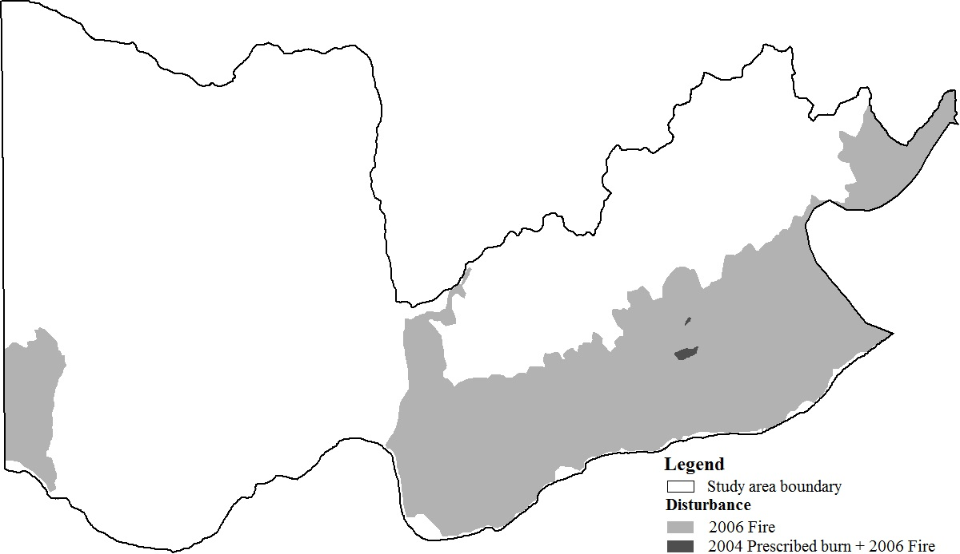

Appendix 4. Treatment options available to treat weed species within the study area. Each treatment is attributed with its cost per unit area, duration of effects, and applicability in riparian areas.

|  |  |  |  |  |
| --- | --- | --- | --- | --- |
| Weed | Treatment per hectare | Cost  ($ ha-1) | Duration  (years) | Riparian |
| Cheatgrass | Imazapic (Plateau) 0.2 kg ai + 0.25 % v/v NIS | 69.60 | 2 | Yes |
| Spotted knapweed | Aminopyralid (Milestone) 0.12 kg ai | 42.56 | 3 | Yes |
| Diffuse knapweed | Aminopyralid (Milestone) 0.12 kg ai | 42.56 | 3 | Yes |
| Rush skeletonweed | 2,4-D 2.1 kg ae | 13.15 | 1 | Yes |
| Common crupina | Metsulfuron (Escort) 0.04 kg ai + 0.25 % v/v NIS | 37.22 | 1 | Yes |
| Common crupina | Picloram (Tordon) 0.3 kg ae | 28.35 | 3 | No |
| Dalmatian toadflax | Chlorsulfuron (Telar) 0.1 kg ai + 0.25 % v/v NIS | 92.83 | 1 | Yes |
| Scotch thistle | Metsulfuron (Escort) 0.1 kg ai + 0.25 % v/v NIS | 73.06 | 1 | Yes |
| Scotch thistle | Picloram (Tordon) 0.2 kg ae | 21.26 | 2 | No |
| Sulfur cinquefoil | Aminopyralid (Milestone) 0.11 kg ai | 36.48 | 3 | Yes |
| Puncturevine | 2,4-D 2.1 kg ae | 13.15 | 1 | Yes |
| Common mullein | Metsulfuron (Escort) 0.04 kg ai + 0.25 % v/v NIS | 37.22 | 1 | Yes |

Appendix 5. Herbicide application methods considered in the analysis with their cost, minimum treatment size and distance limit from the existing roads and trails.

|  |  |  |  |
| --- | --- | --- | --- |
| Application method | Cost  ($ ha-1) | Minimum treatment size (ha) | Distance limit from trails or roads (m) |
| ATV | 74.2 | 0.20 | 15 |
| Horse | 370.7 | 0.04 | 15 |
| Truck | 123.6 | 8.00 | 20 |
| Backpack | 494.3 | 0.04 | unlimited |
| Helicopter | 49.4 | 20.00 | unlimited |

Appendix 6. Spatial prioritization for alternative weed treatment plans: a) prioritization based on weed species and b) prioritization based on sites.

