Supplementary material

Supplementary methods
Potential Centranthus ruber distribution in South Africa
We obtained Centranthus ruber occurrence records from the Global Biodiversity Information Facility (gbif.org/species) and included additional occurrences for South Africa (this study). Using the R package biogeo, we cleaned occurrence data by removing: duplicate records at a 30” spatial resolution, records in the sea, records with low precision (i.e., aggregated to spatial resolutions coarser than 30”), and dubious records that were identified as either geographical or environmental outliers and subsequently found to have inaccurate or missing locality information via a manual inspection. This resulted in a total of 6068 occurrences, of which 175 are in Australasia, 5587 in Eurasia, 123 in the USA and 183 in South Africa. The native range of C. ruber is Mediterranean Europe, so records in Eurasia include both its native and alien ranges, while records in Australasia, South Africa and the USA represent alien distributions. For modelling we used occurrence records of this species from both its native and alien ranges because this has been shown to provide better predictions of alien species’ distributions (Broennimann and Guisan 2008; Verbruggen et al. 2013).

To model the potential distribution of C. ruber in South Africa we used the approach suggested by Merow et al. (2016) using Maxent in R. This approach represents an advance on previous uses of Maxent in that one is able to use prior knowledge to inform predictions. Merow et al. (2016) refer to their approach, which relies on the minimisation of the relative entropy between the predicted distribution and a prior distribution, as “Minxent”. This approach has the benefits of being able to include additional biological information in the model (called “informative offsets” e.g., niche occupancy elsewhere in the world) and it can also account for sampling bias (“nuisance offsets”).

As informative offsets we modelled the distribution of C. ruber separately in three different parts of the world (i.e., its native range of Europe, and two alien ranges in Australasia and North America). We modelled each region separately because niche occupancy and sampling bias is possibly different in each region. We used five covariates to model the distribution of C. ruber in each region (informative offsets) that were selected for their biological relevance and because they are not collinear: the Priestley-Taylor alpha coefficient, which is an index from 0 to 1, with 0 indicating severe soil water stress, and 1 no water stress, for plants (Trabucco and Zomer, 2010); the Bioclim variables, isothermality (bio3), temperature seasonality (bio4), and maximum temperature of the warmest month (bio5) (Hijmans et al. 2005), and soil pH (Shangguan et al. 2014).

To account for sampling bias we modelled nuisance offsets in each range (including South Africa). We used occurrences of target group species as our response variables, which included GBIF occurrences for species in the family Caprifoliaceae (including C. ruber), as well as of the closely-related genus Apium, for all regions except South Africa. In South Africa we used all occurrences in the South African Plant Invaders Atlas (SAPIA; Henderson 1998) as our target group, because sampling for both this database and for C. ruber in this study was heavily biased towards roadsides and is concentrated in major metros. As predictors of these nuisance offsets we used the distance to roads (as derived from CIESIN 2013) and human population density (CIESIN 2005).

To produce a final modelled distribution for South Africa we minimised the entropy between a local modelled prediction of C. ruber occurrence (using the same covariates as for the other three regions) and four different priors. These included three informative offsets, which were projections to South Africa from each of the models for Australia, Europe and North America, and a local nuisance (sampling bias) offset (as described earlier).

As for Merow et al. (2016), Maxent software settings for all models were kept at default values, except that no threshold and hinge features were used (Merow et al. 2013). The size and choice of study extent has been shown to influence Maxent predictions (Barbet-Massin et al. 2010). The extent for each region was first limited to the following: the whole of mainland Australia, the parts of Eurasia and Africa to the west and north of 45° E and 14° N, the whole of North America, and southern Africa below the equator. Thereafter the extent was further limited to the Köppen-Geiger climate zones in each region in which C. ruber was present anywhere in the world (e.g., if any C. ruber occurrence occurred in “warm temperate, hot summer” climates (Cwa), then all Cwa climate regions were included in the study extent of each region; Webber et al. 2011). We mapped geographical areas for which the model was extrapolating into novel environmental space using a multivariate environmental similarity surface (MESS) approach (Elith et al. 2010). Ideally one should use a separate dataset for model evaluation (Merow et al., 2016), but this is often not feasible for invasive species (Elith et al., 2010). Furthermore, because in the “Minxent” approach we used, a number of different Maxent models are produced (including offsets), it is not straightforward to implement a simple cross-validation for model evaluation. We therefore ran the offset models ten times using 70% of the occurrences as training data and used these to produce ten independent Minxent potential distributions in South Africa. We then used the remaining 30% of the occurrences for model testing, calculating AUC, model sensitivity and specificity.

Supplementary results
The final Minxent predicted distribution of C. ruber in South Africa exhibited high accuracy (AUC = 0.9883 ± 0.0018; sensitivity = 0.9637 ± 0.0018), although a low true negative rate (specificity = 0.1293 ± 0.1820). This is however to be expected for an invasive species that has not spread to all suitable environments. Much of South Africa is predicted to be suitable for C. ruber, although the areas with highest suitability (high relative occurrence rate, ROR) are restricted to the south-western and southern Cape and some high altitude areas in the east of the country (Fig. S2 a). Centranthus ruber has a large potential distribution in Europe, in the Mediterranean (its native range) and up into much of the rest of Western Europe near the Atlantic Ocean (Fig. S2 e). In North America C. ruber is predicted to occur over much of the continent, except for the extreme northern parts, but the areas with highest suitability are along the western seaboard and in much of Mexico (Fig. S2 i). In Australasia, C. ruber is predicted to occur in the Mediterranean south-west of Australia and along the southern and eastern coastlines, Tasmania, and along the eastern seaboard of New Zealand (Fig. S2 m).

Target group sampling bias offsets were strongly influenced by proximity to roads in South Africa, Europe and North America (Fig. S2b,f,j), and to human population density in Australasia (Fig. S2 n). Relative to a model of C. ruber in South Africa using only a sampling bias offset (Fig. S2 c), the informative offset based on the European range of this species (Fig. S2 g) predicted an expanded potential distribution into Lesotho and the Drakensberg, and the offsets for North America and Australia contributed to an expanded potential distribution along the southern coast of South Africa (Fig. S2 k,o).

The multivariate environmental similarity surface (MESS) for South Africa suggests that model predictions in the region are for the most part not extrapolating into novel environmental space (Fig. S2 d). However, in Europe, North America and Australia, model predictions cover large areas of novel environmental space as indicated by negative MESS values (Fig. S2 h,l,p).

Variable importance is more complicated to calculate using the Minxent approach we adopted than when using a typical Maxent approach. However, response curves provide an indication of the relative influence of predictor variables when the response of one variable is plotted holding the values of all other variables at their mean value (Fig. S3). The relative occurrence rate (ROR) of C. ruber varied the most in response to temperature seasonality, with a high ROR at lower values for temperature seasonality (Fig. S3 c). There was far less variation in ROR with respect to the other variables, although ROR was highest at intermediate levels of soil aridity and for the maximum temperature of the warmest month (Fig. S3 a,d).
Supplementary figures

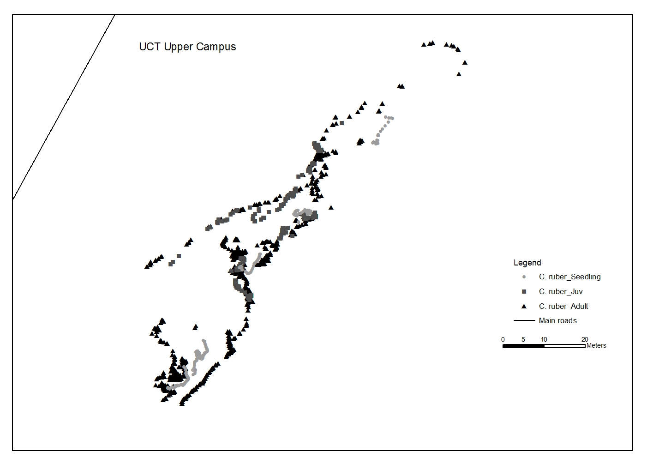
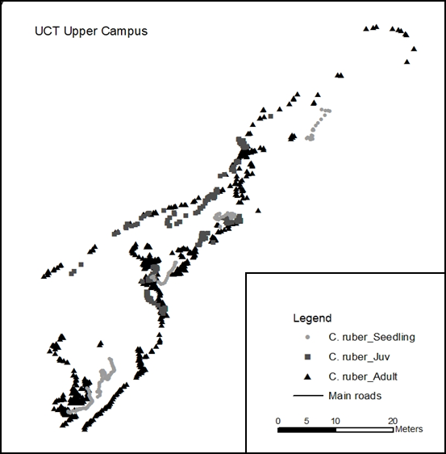
Figure S1. At the largest population consisting of 1473 plants of which 294 were seedlings, spread rate is slow with no seedlings further than 20 m from a reproducing plant.

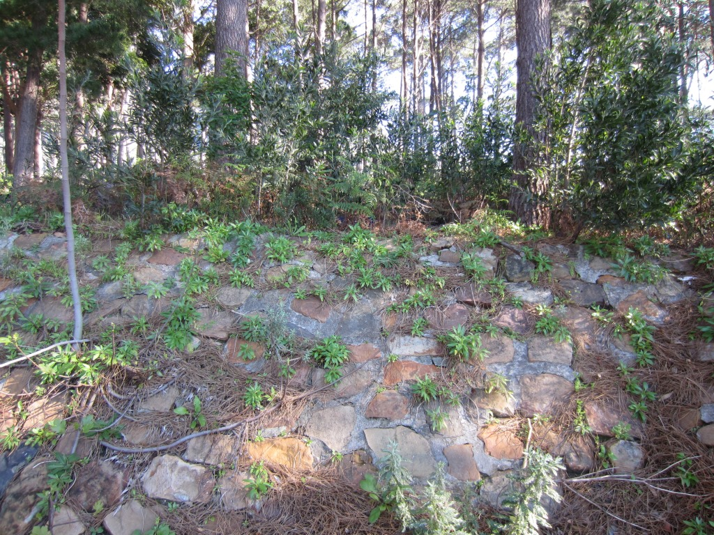
Fig S2. Centranthus ruber can colonise shady habitats, as this one under the canopy of a pine plantation.

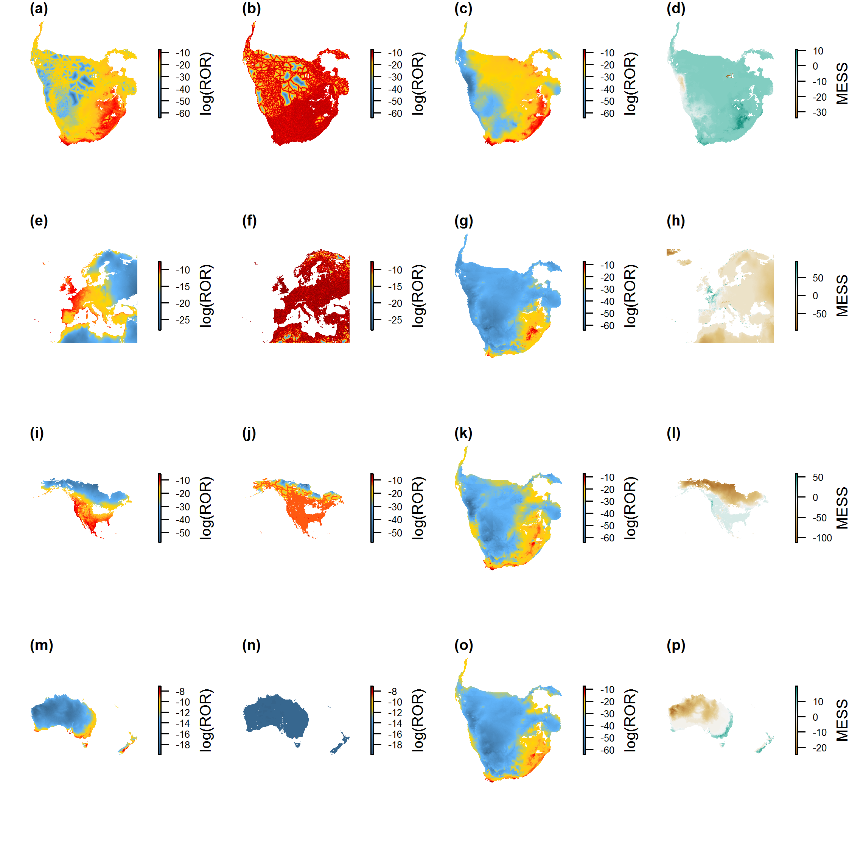Figure S3. Potential distribution of Centranthus ruber in (a) southern Africa, (e) Europe and surrounds, (i) North America, and (m) Australasia using a Minxent approach. Target-group sampling bias offsets predicted by proximity to roads and human population density are shown for each region (b,f,j,n). (g,k,o) Informative offsets, which are based on occurrences of C. ruber in each region. (c) Predicted distribution of C. ruber in South Africa using only a sampling bias offset (no informative offsets). (a) The potential distribution in southern Africa after accounting for sampling bias and informative offsets. Colours range from blue (low) to red (high) representing the relative occurrence rate (ROR), which is a measure of the probability of any given locality containing a presence (Merow et al., 2013). (d,h,l,p) Multivariate environmental similarity surfaces (MESS) for each region, indicating novel environmental space (negative MESS values; brown colours).

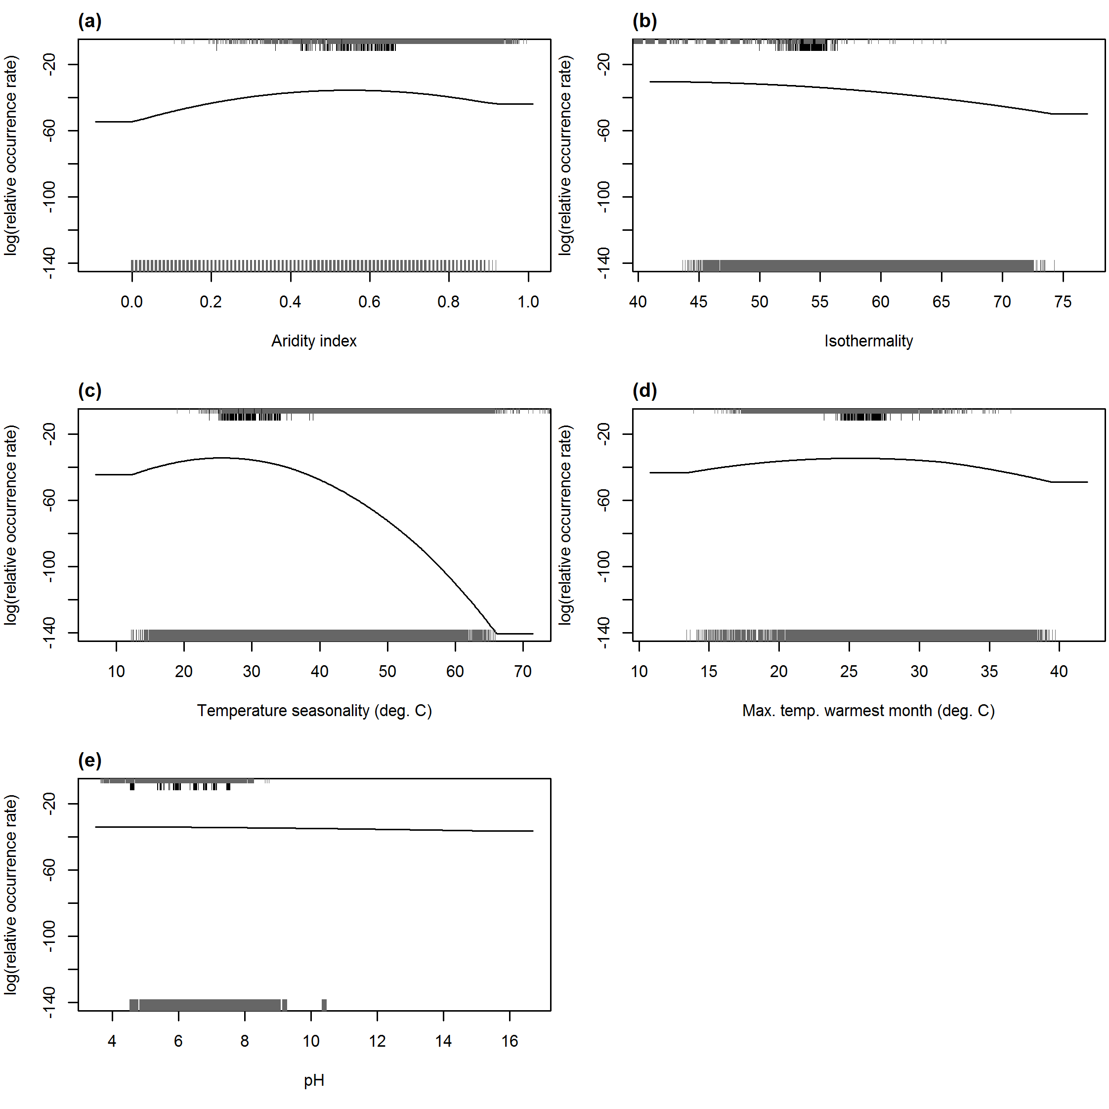
Figure S4. Response of the relative occurrence rate (ROR) of Centranthus ruber in relation to the five environmental predictors used to model this species’ distribution. Rugs on the upper x-axis represent values for occurrences of C. ruber, with longer rugs representing occurrences in South Africa. Rugs on the lower x-axis are for background points.

References
Barbet-Massin, M., Thuiller, W., Jiguet, F., 2010. How much do we overestimate future local extinction rates when restricting the range of occurrence data in climate suitability models? Ecography 33, 878–886.
Broennimann, O., Guisan, A., 2008. Predicting current and future biological invasions: both native and invaded ranges matter. Biology Letters 4, 585–589.
Center for International Earth Science Information Network – CIESIN – Columbia University, and Centro Internacional de Agricultura Tropical – CIAT. 2005. Gridded Population of the World, Version 3 (GPWv3): Population Density Grid. Palisades, NY: NASA Socioeconomic Data and Applications Center (SEDAC). http://dx.doi.org/10.7927/H4XK8CG2.
Center for International Earth Science Information Network – CIESIN – Columbia University, and Information Technology Outreach Services – ITOS – University of Georgia. 2013. Global Roads Open Access Data Set, Version 1 (gROADSv1). Palisades, NY: NASA Socioeconomic Data and Applications Center (SEDAC). http://dx.doi.org/10.7927/H4VD6WCT.
Elith, J., Kearney, M. and Phillips, S., 2010. The art of modelling range‐shifting species. Methods in ecology and evolution, 1, 330-342.
Henderson, L., 2007. Invasive, naturalized and casual alien plants in southern Africa: a summary based on the Southern African Plant Invaders Atlas (SAPIA). Bothalia 37, 215–248.
Hijmans, R.J., Cameron, S.E., Parra, J.L., Jones, P.G., Jarvis, A., 2005. Very high resolution interpolated climate surfaces for global land areas. Int. J. Climatol. 25, 1965–1978. doi:10.1002/joc.1276
Merow, C., Smith, M.J., Silander, J.A., 2013. A practical guide to MaxEnt for modeling species’ distributions: what it does, and why inputs and settings matter. Ecography 36, 1058–1069.
Merow, C., Allen, J.M., Aiello-Lammens, M., Silander, J.A., 2016. Improving niche and range estimates with Maxent and point process models by integrating spatially explicit information. Global Ecology and Biogeography 25, 1022–1036. doi:10.1111/geb.12453
Shangguan, W., Dai, Y., Duan, Q., Liu, B., Yuan, H., 2014. A global soil data set for earth system modeling. Journal of Advances in Modeling Earth Systems 6, 249–263.
Trabucco, A., Zomer, R.J. 2010. Global Soil Water Balance Geospatial Database. CGIAR Consortium for Spatial Information. Published online, available from the CGIAR-CSI GeoPortal at: http://www.cgiar-csi.org
Verbruggen, H., Tyberghein, L., Belton, G.S., Mineur, F., Jueterbock, A., Hoarau, G., Gurgel, C.F.D., De Clerck, O., 2013. Improving transferability of introduced species’ distribution models: new tools to forecast the spread of a highly invasive seaweed. PLoS One 8, e68337.
Webber, B.L., Yates, C.J., Le Maitre, D.C., Scott, J.K., Kriticos, D.J., Ota, N., McNeill, A., Le Roux, J.J., Midgley, G.F., 2011. Modelling horses for novel climate courses: insights from projecting potential distributions of native and alien Australian acacias with correlative and mechanistic models. Diversity and Distributions 17, 978–1000.

