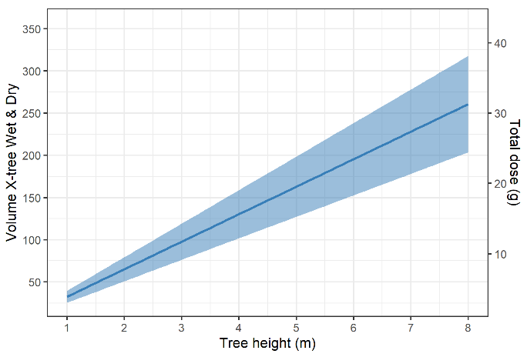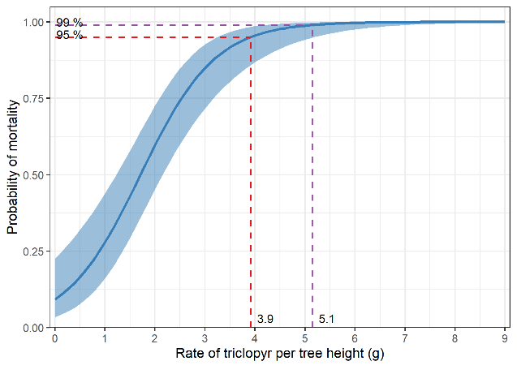

**Figure S1.** Left panel: the estimated probability of mortality over the rate of triclopyr (g) per unit tree height (m) obtained from model (ii). Right panel: The estimated volume product together with total dose (g) and their confidence intervals for tree height (the CIs were calculated from the lower and upper limits based on the 95% mortality prediction of model (ii)).

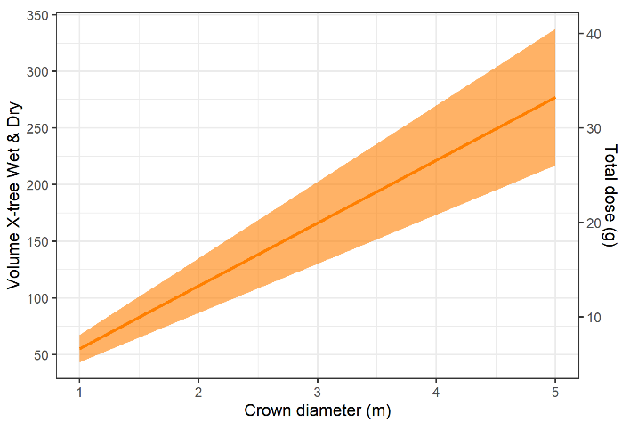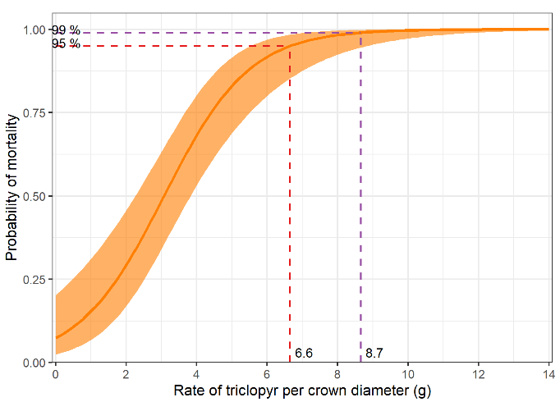

**Figure S2.** Left panel: the estimated probability of mortality over the rate of triclopyr (g) per unit crown diameter (m) obtained from model (iii). Right panel: The estimated volume product together with total dose (g) and their confidence intervals for crown diameter (the CIs were calculated from the lower and upper limits based on the 95% mortality prediction of model (iii)).

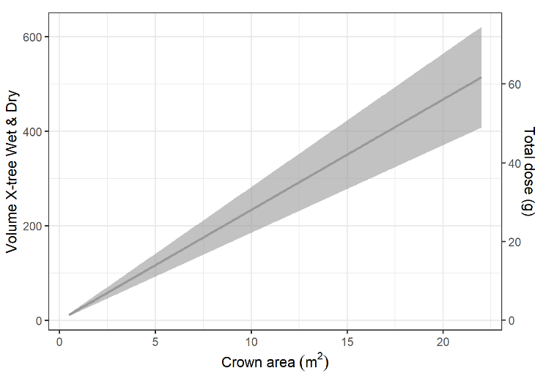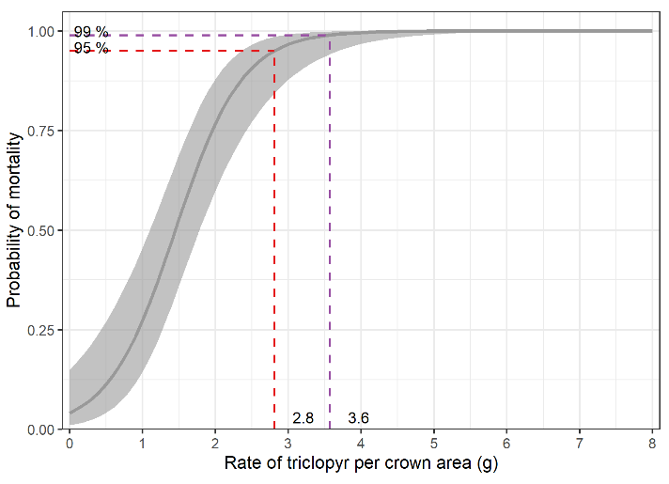

**Figure S3.** Left Panel: the estimated probability of mortality over the rate of triclopyr (g) per unit crown area (m2) obtained from model (iv). Right panel: The estimated volume product together with total dose (g) and their confidence intervals for crown area (the CIs were calculated from the lower and upper limits based on the 95% mortality prediction of model (iv)).

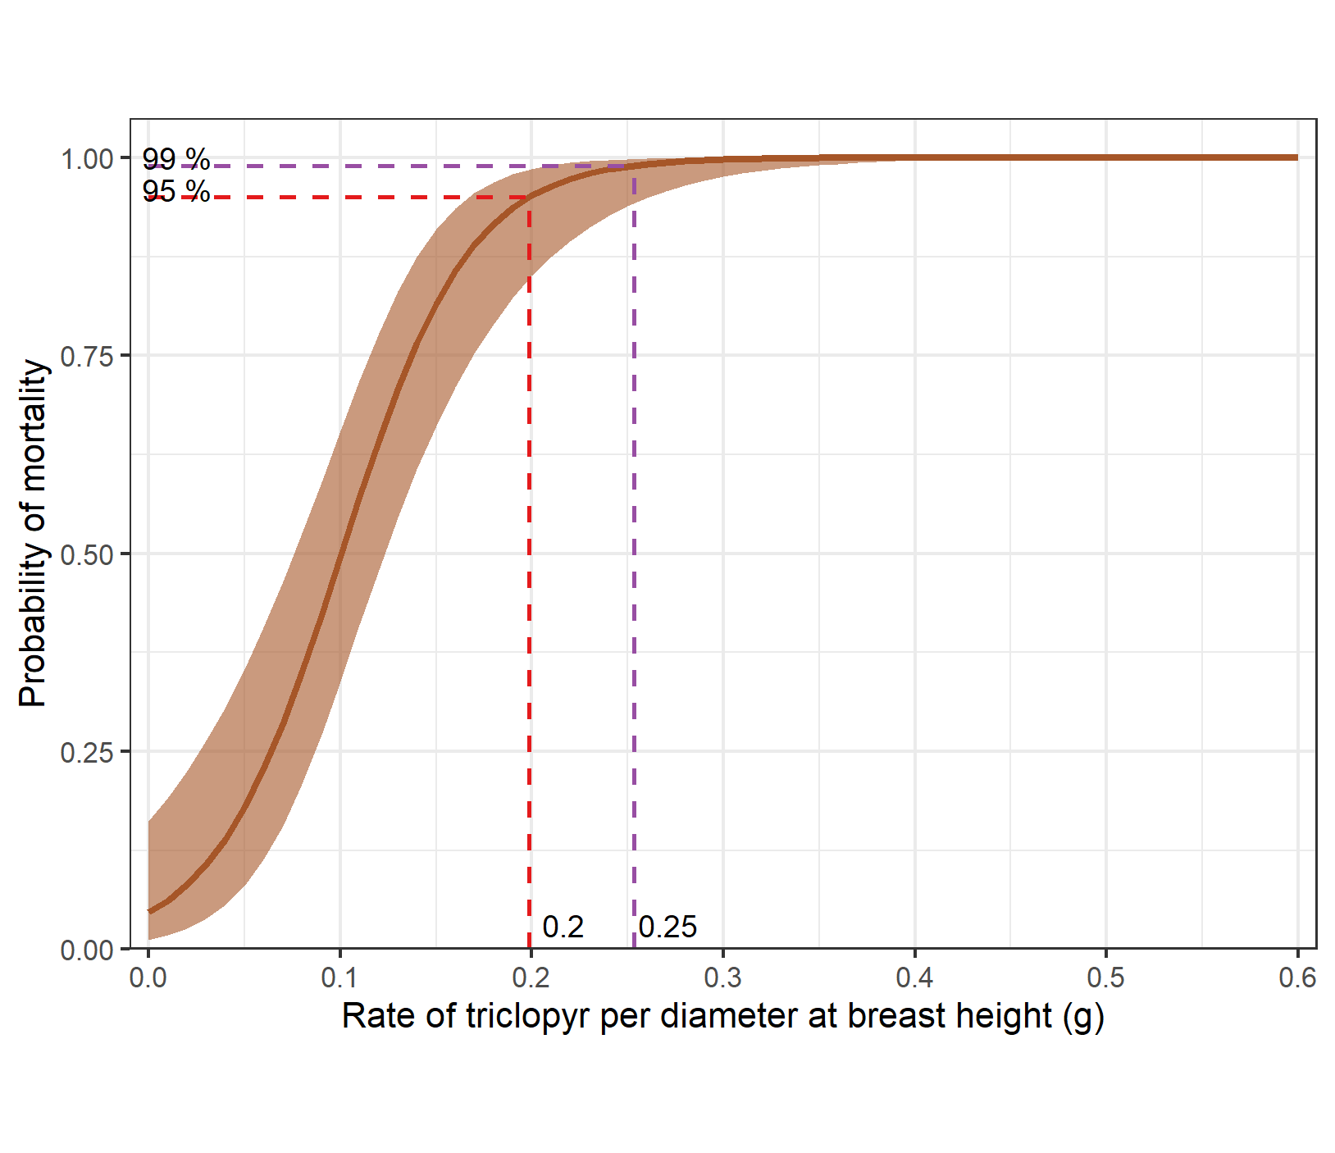 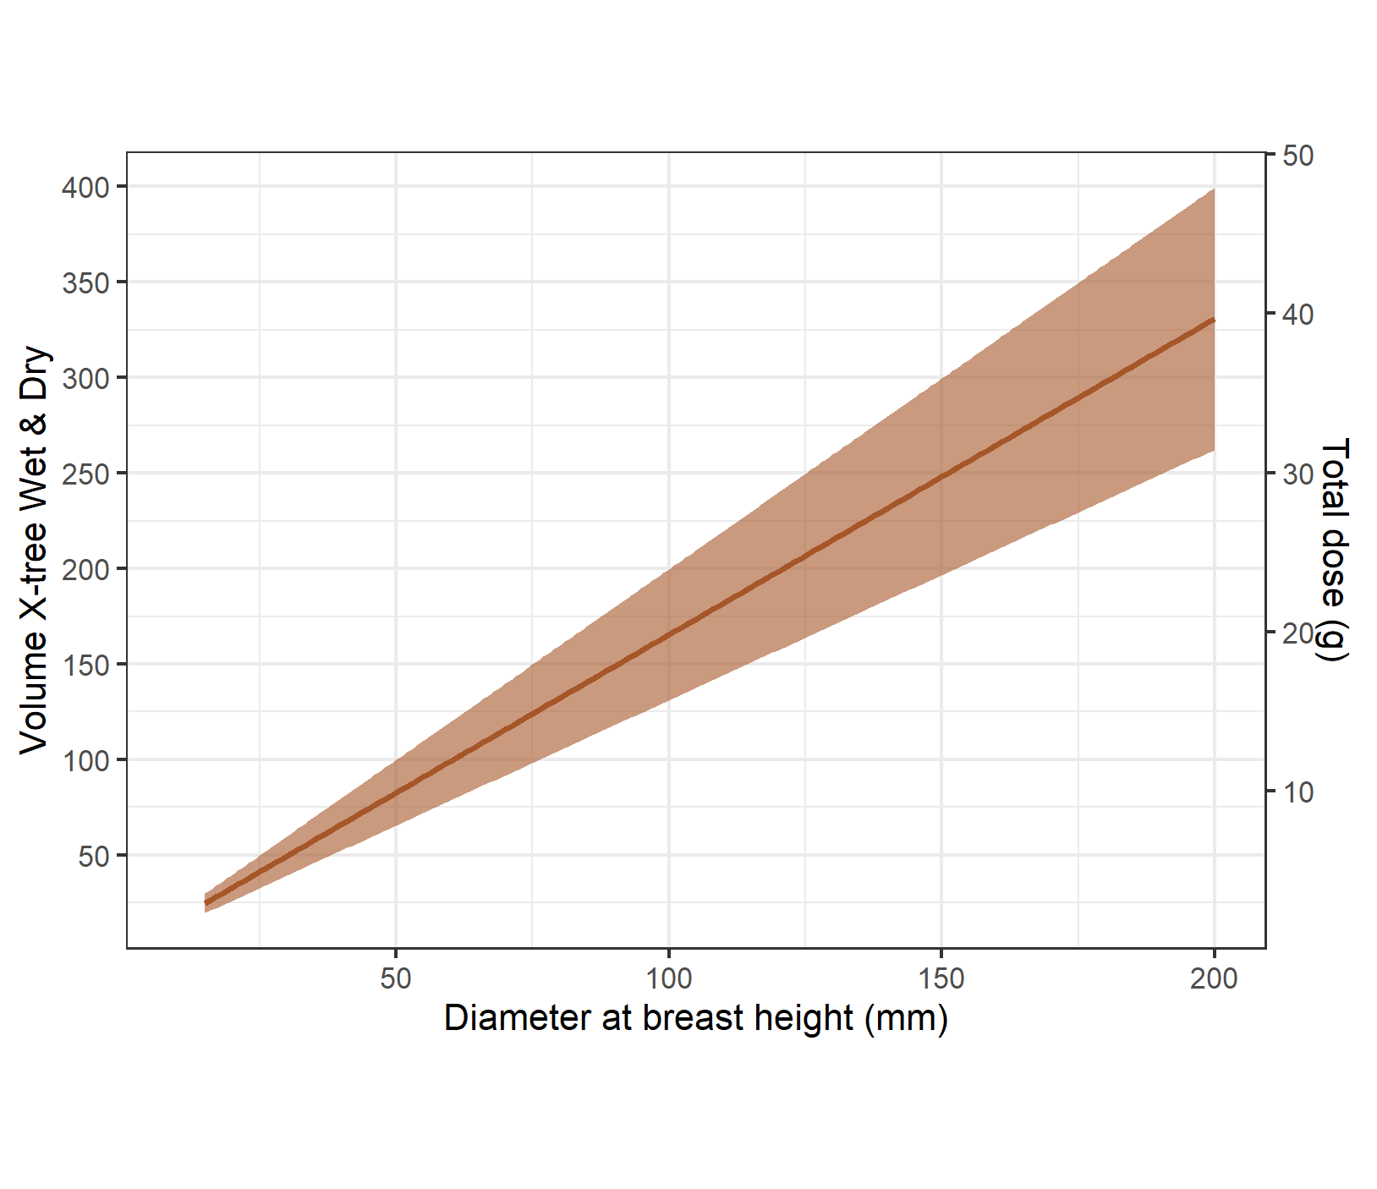

**Figure S4.** Left Panel: the estimated probability of mortality over the rate of triclopyr (g) per unit dbh (mm) obtained from model (v). Right panel: The estimated volume X-tree wet & dry together with total dose (g) and their confidence intervals for crown area (the CIs were calculated from the lower and upper limits based on the 95% mortality prediction of model (iv)).

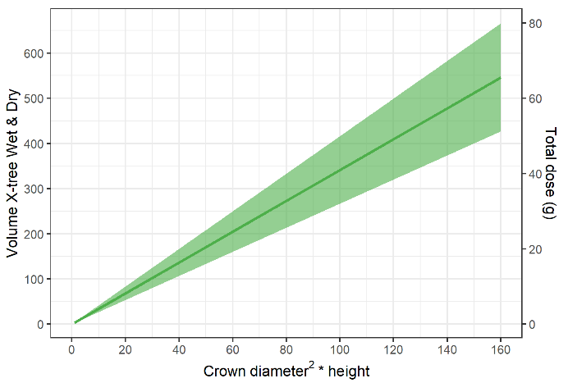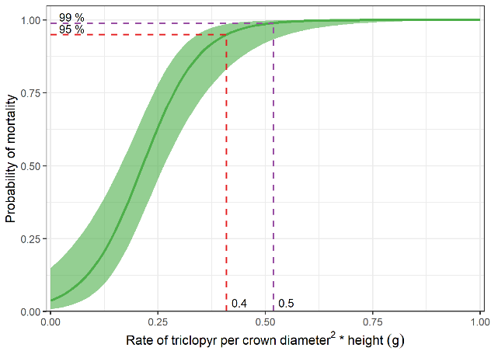

**Figure S5.** Left panel: the estimated probability of mortality over the rate of triclopyr (g) per unit volume 1 obtained from model (vi). Right panel: The estimated volume product together with total dose (g) and their confidence intervals for volume 1 (the CIs were calculated from the lower and upper limits based on the 95% mortality prediction of model (v)).