Supplementary data

Appendix 1: Body weight in RCO treated pregnant rats at different gestation periods

Groups(By gestation days)  N= 5 | Body weight(g) | Body weight(g) | Body weight(g)
Groups(By gestation days)  N= 5 | 1st Week | 2nd Week | 3rd Week
Control | 204±10.30 | 219±14.18 | 232±13.93
GD 1-7 | 202±11.14 | 227±12.61 | 250±12.65
GD 7-14 | 200±7.07 | 229±13.64 | 240±20.98
GD 14-21 | 202±11.14 | 223±10.44 | 238±16.25
GD 1-21 | 202±13.93 | 213±12.41 | 230±14.14

Appendix 2 Effects of maternal exposure to RCO at PND 21(third week), on weekly weight until weaning in F2 female and male pups
 | BW(gm)1st wk | BW(gm) 2nd week | BW(gm)3rd week
Control (F) | 11.66±0.47 | 21.98±0.55 | 32.21±0.69
Control (M) | 12.07±0.98 | 21.74±0.87 | 32.68±
GD 14-21 (F) | 10.24±0.29* | 17.16±0.44** | 25.70±0.90**
GD 14-21 (M) | 10.30±0.77 | 17.94±0.96* | 26.27±1.39**
* = p< 0.05, ** =p< 0.01
Control 20(5), GD 14-21 14(5) for no of pups (litter size)

Appendix 3 Morphometric data at birth in female F2 pups (from F1 male and female offspring of RCO treated parents)
Groups | BW(gm) | HD(cm) | AD(cm) | BL(cm)
Control  (Female) | 4.65±0.23 | 1.10±0.02 | 1.59±0.28 | 3.95±0.39
GD 14-21  (Female) | 4.68±0.14 | 1.11±0.01 | 1.21±0.03 | 4.40±0.03
Control  ( Male) | 4.74±0.23 | 1.10±0.02 | 1.31±0.03 | 4.31±0.14
GD 14-21 (Male) | 5.08±0.32 | 1.13±0.04 | 1.19±0.05 | 4.58±0.08

Control 20(5), GD 14-21 14(5) for no of pups (litter size)

Appendix 4 Anogenital distance in male and female (F2 pups)
Groups | AGD(cm) | AGD Index(cm/gm³)
Control (Female) | 0.18±0.006 | 0.11±0.004
GD 14-21 (Female) | 0.18±0.006 | 0.11±0.004
Control (Male) | 0.36±0.02 | 0.21±0.01
GD 14-21 (Male) | 0.41±0.09 | 0.30±0.05
Appendix 5 Morphometric data at birth in male F2 pups from mating of treated male and untreated female offspring

 | BW(gm) | HD(cm) | AD(cm) | BL(cm)
Control | 4.74±0.23 | 1.10±0.02 | 1.31±0.03 | 4.31±0.14
GD 1-7 | 6.90±0.05** | 1.20±0.01** | 1.53±0.04** | 4.90±0.08**
GD 7-14 | 4.34±0.19 | 1.06±0.03 | 1.25±0.02 | 4.13±0.04
GD 1-21 | 5.49±0.13* | 1.12±0.02 | 1.43±0.04* | 4.42±0.09
* = p< 0.05, ** =p< 0.01
Control 20(5), GD 1-7 15(5), GD 7-14 17 (5), GD 14-21 14(5), GD 1-21 14(5) for no of pups (litters)

Appendix 6 Anogenital distance at birth in male F2 pups (from treated male and untreated female F1)

 | AGD (cm) | AGD Index(cm/gm³)
Control | 0.36±0.02 | 0.212±0.008
GD 1-7 | 0.39±0.02 | 0.205±0.001
GD 7-14 | 0.30±0.02 | 0.186±0.013
GD 1-21 | 0.35±0.01 | 0.199±0.007
Appendix 7 Weekly body weight (g) in male F2 pups from mating of treated male and untreated female offspring

Groups body weight (g) body weight (g) body weight (g)
1st week 2nd week 3rd week
Control 12.07 21.74 32.68
GD 1-7 19.61* 32.20* 48.17*
GD 7-14 11.38 21.80 29.49
GD 1-21 12.80 21.22 32.22
* = P<0.05
Control 20(5), GD 1-7 15(5), GD 7-14 17 (5), GD 14-21 14(5), GD 1-21 14(5) for no of pups (litters)

Appendix 8 Body weight and day of puberty onset in F2 males and females (from F1 male and female of RCO treated dams)
Groups | Weight | Day of Puberty onset
Control(males) | 77.0± 1.1 | 46.8± 1.2
GD 14-21(males) | 79.4± 6.2 | 54.3±1.1**
Control (females) | 77.9± 2.2 | 46.8± 1.1
GD 14-21(females) | 64.4± 4.9 | 53.5± 0.6**

** =p< 0.01

Appendix 9 Body weight and day of puberty onset in F2 male and female (from F1 male RCO treated mothers and untreated female)
Groups(n=5) | Weight | Day of Puberty onset
Control(males) | 77.0±1.1 | 46.8± 1.2
GD 1-7(males) | 99.4± 2.9** | 45.3±0.3
GD 7-14(males) | 84.9± 0.6* | 51.3±0.3**
GD 1-21(males) | 90.2± 3.8** | 54.3±0.4**
Control(females) | 77.9± 2.2 | 44.5± 0.5
GD 1-7(females) | 101.8± 1.2** | 44.8± 0.3
GD 7-14(females) | 87.9± 2.6* | 53.0± 1.1**
GD 1-21(females) | 86.1± 1.8* | 51.3± 0.5**
* = p< 0.05, ** =p< 0.01
Control 20(5), GD 1-7 15(5), GD 7-14 17 (5), GD 14-21 14(5), GD 1-21 14(5) for no of pups (litters)

Appendix 10: Photomicrographs of the ovary of F1 females (PND 90) from rats treated with Ricinus communis oil at different gestation periods ( A, control; B, GD 1-7 with no visible lesion; C, GD 14-21, with no visible lesion; D, GD 1-21, no visible lesion arrow shows normal developing secondary follicle, mag X 200)

B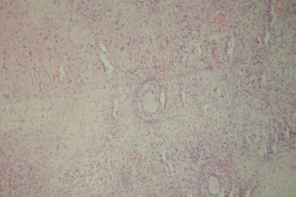C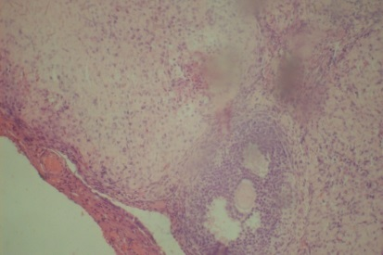D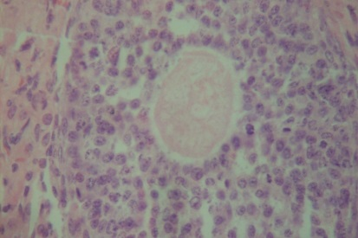

Appendix 11: Photomicrographs of the uterus of F1 females (PND 90) from rats treated with Ricinus communis oil at different gestation periods (A, control with no visible lesion; B, GD 1-7 with no visible lesion; C, GD 7-14 with slightly reduced mucosal depth; D, GD 14-21 glandular features are not prominent and E, GD 1-21 with no visible lesion, Mag X 200)

B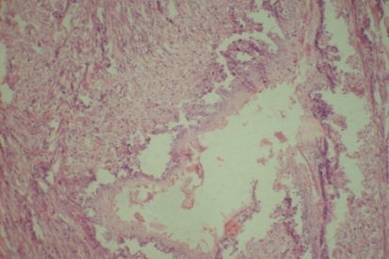 C 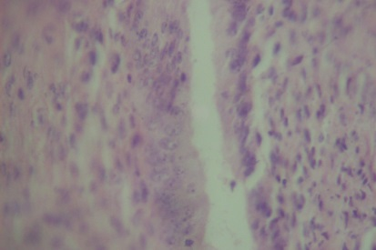 D 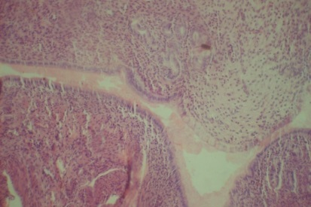

E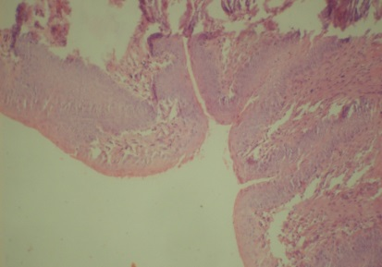

Appendix 12. REPRODUCTIVE INDICES FROM MATING EXPERIMENT OF MALE OFFSPRING (F₁) FROM TREATED MOTHERS WITH UNTREATED FEMALE

PARAMETERS | CONTROL | GD 1-7 | GD 7-14 | GD 14-21 | GD 1-21
MATING INDEX | 100% | 100% | 100% | 100% | 100%
FERTILITY INDEX | 100% | 100% | 100% | 100% | 100%
GESTATION INDEX | 100% | 100% | 100% | 100% | 100%
LIVE BIRTH INDEX | 100% | 100% | 100% | 100% | 100%
DAY SURVIVAL INDEX | 100% | 100% | 100% | 100% | 100%
LACTATION INDEX | 100% | 100% | 100% | 100% | 100%

