**Supplement 2 – maternal preconception BMI trajectories according to child development outcomes**

Two separate samples of children with different ages during assessment were used and so two separate trajectory models were needed to calculate the maternal BMI trajectories before conception of the index child.

**Maternal preconception BMI trajectories for the physical development (gross motor) domain of the Ages and Stages Questionnaire (ASQ)**

Figure S2a shows maternal BMI trajectories over 13 years prior to the conception of included children. The preconception BMI trajectories were estimated using five data points prior to conception of the index child. We found three distinct subgroups of women based on their BMI trajectories: named as normative (normal - stable BMI), chronically overweight (started overweight - remained overweight) and chronically obese (started obese - progressively severely obese). The average posterior probability for each trajectory was 0.96, 0.94 and 0.99, showing a high degree of accuracy of individual assignment to groups.

Nearly 95% of women with a normative BMI trajectory had a normal or underweight range of BMI in the survey prior to pregnancy. Approximately two-thirds (63.0%) and 22.6% of women with a chronically overweight BMI trajectory were overweight and obese in the survey prior to pregnancy, respectively. All women with a chronically obese BMI trajectory were overweight or obese in the survey prior to pregnancy.

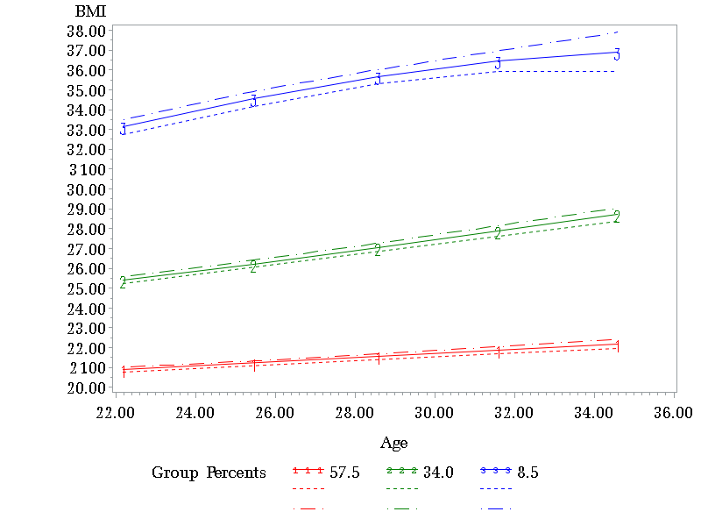

*Note broken lines show 95% CI.*

Fig S2a. Maternal BMI trajectories prior to the conception of included children (for ASQ child outcome, we used 5 maternal data points - making full use of all possible data before the conception of the index child)

**Maternal preconception BMI trajectories for the physical and cognitive development domains of the Australian Early Development Census (AEDC)**

We replicated the above analysis using linked data from the Australian Early Development Census (AEDC). Maternal BMI trajectories were calculated in a similar way to the ASQ child outcome, but at this time using three maternal BMI data points prior to conception because of the survey design: children eligible for the AEDC were born between Surveys 3 and 5. About 68.6%, 26.5% and 4.9% of mothers had normative, chronically overweight and chronically obese BMI trajectories before conception of the index child, respectively. The average group membership probability for each trajectory was 0.97, 0.93 and 0.95 (Fig S2b).

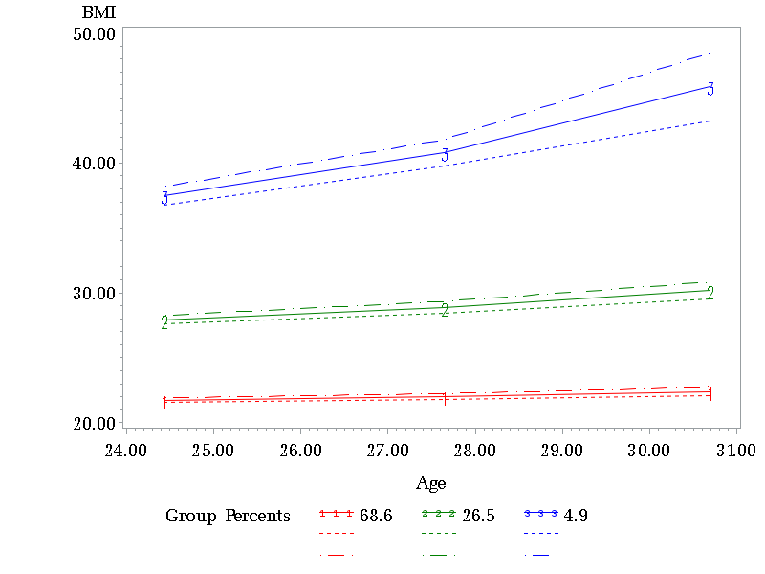

*Note broken lines show 95% CI.*

Fig S2b. Maternal BMI trajectories prior to the conception of included children (for AEDC child outcomes, we used 3 maternal data points because of the survey design)