**eFigure 1.** Duration of electrical service interruptions during the 1998 ice crisis. Source: Institut de Statistique du Québec (ISQ)

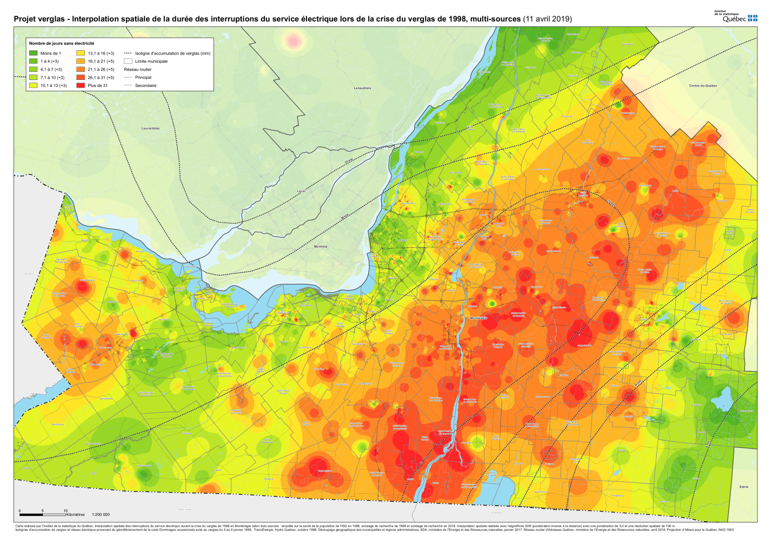

<1 day 13.1-16 days (+3) Ice accumulation isoline (mm)

1-4 days (+3) 16.1-21 days (+5) Municipal boundary

4.1-7 days (+3) 21.1-26 days (+5) Road network

7.1-10 days (+3) 26.1-31 days (+5) Main

10.1-13 days (+3) >31 days Secondary

Multiple data sources were used in order to estimate the number of days without power. After a thorough quality control, a total of 12757 data points were used (3051 in Montérégie) from three sources (*Enquête sur la santé des populations de 1998* by the provincial government, as well as two surveys from Dr. Suzanne King’s lab, in 1998 and 2018). Those data points were geocoded on a Quebec map split by administrative regions. The Inverse Distance Weighted (IDW) method was used to interpolate the power outage to get a continuum of number of days without power across the whole map. To reduce the impact of arbitrary parameter choices, a categorization of the number of days without electricity was done. Finally, to have a better estimate, the number and location of the dwellings within each postal code were taken into account to estimate the number of days without power within that postal code. On the map, a hotter color (from green to red) represents a higher number of days without power. The dotted lines represent the ice accumulation contour lines. The solid black lines represent the main highways. The gray lines delimit the municipal regions.

**eFigure 2.** Graphical evaluation of parallel trends assumption: Annual trends in birth outcomes based on birth year.

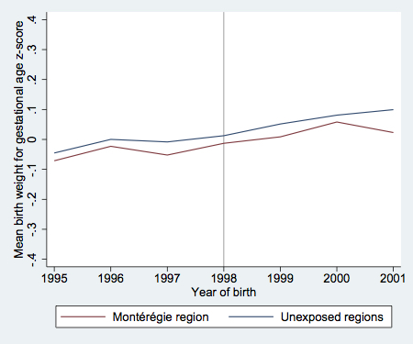 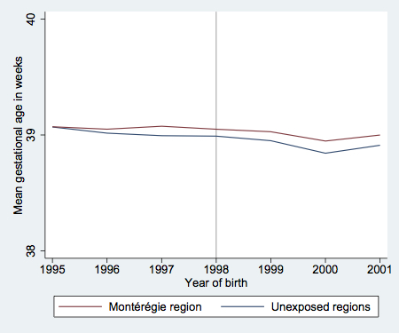

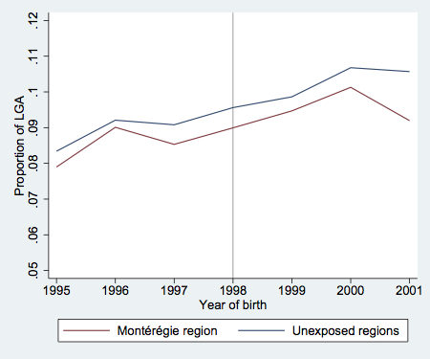 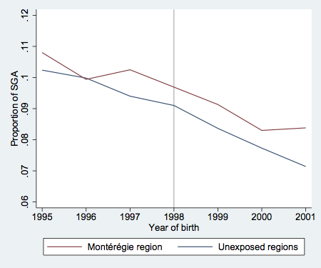

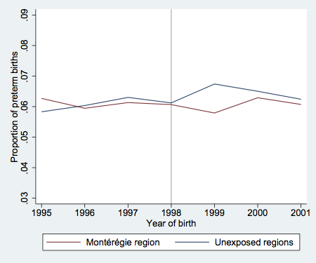

**eFigure 3.** Graphical evaluation of parallel trends assumption: Monthly trends in birth outcomes based on conception month

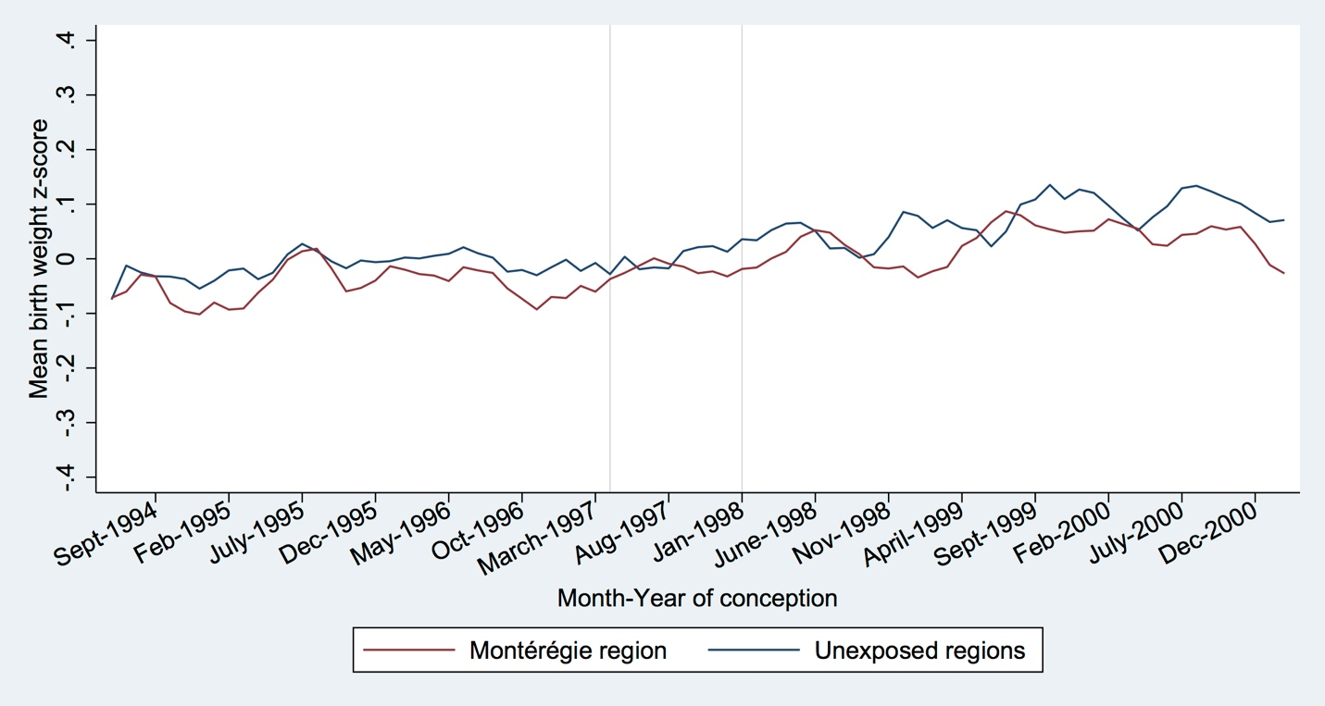

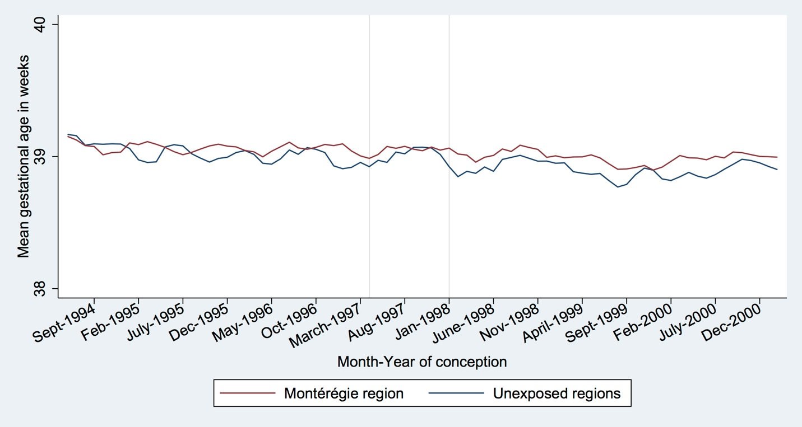

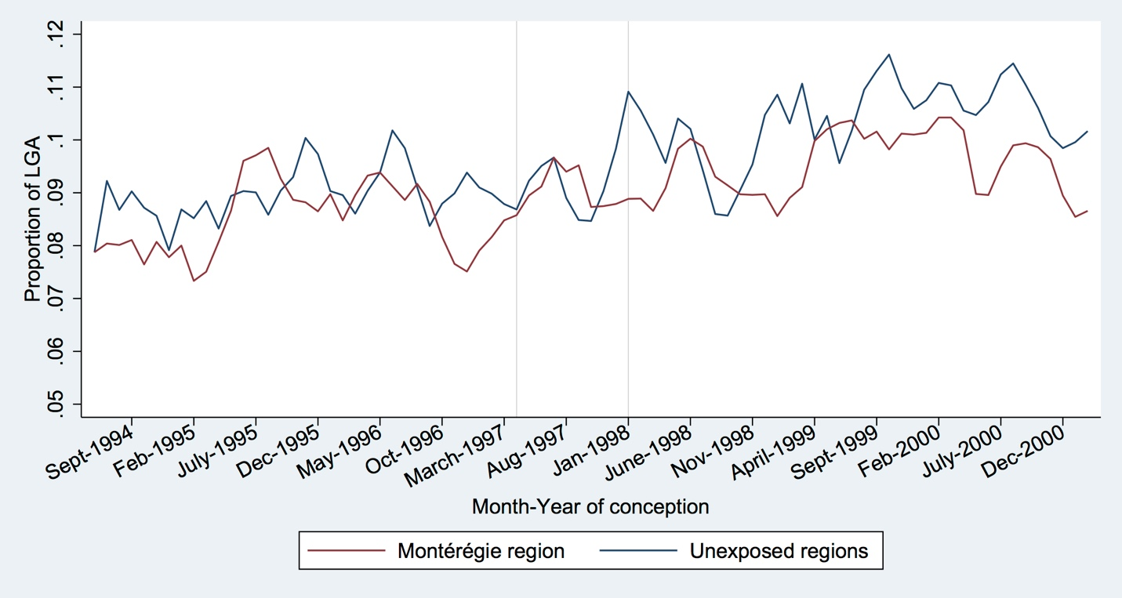

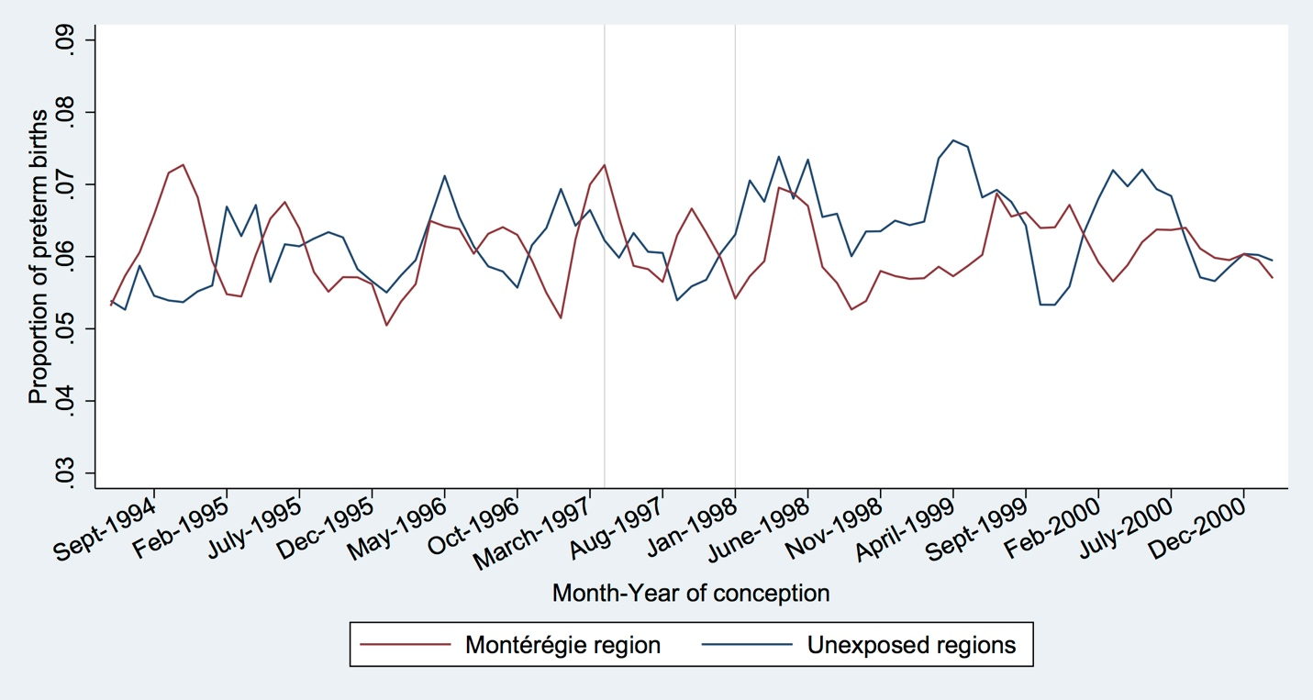

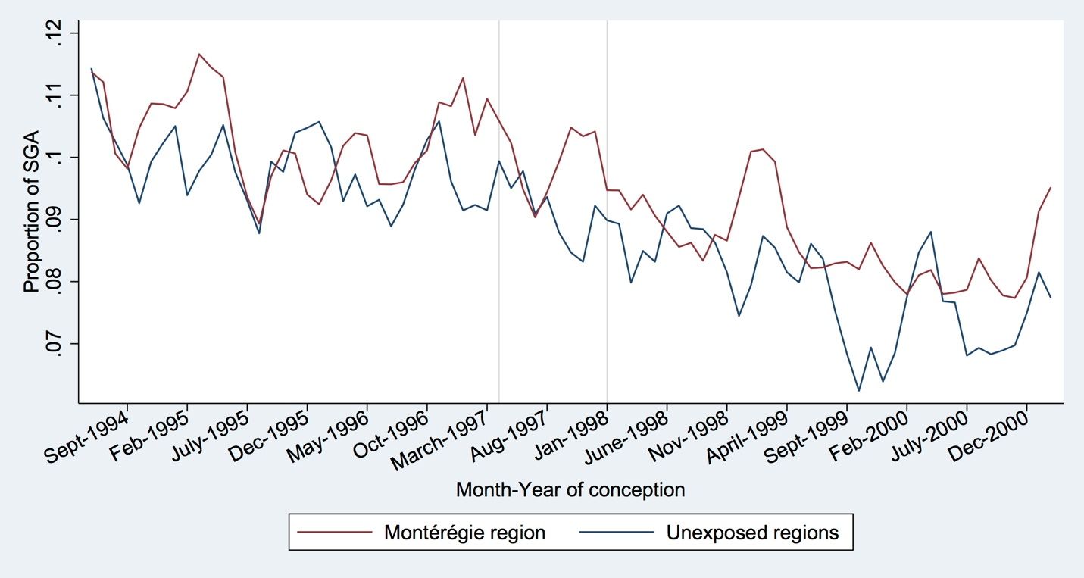

**eFigure 4.** Graphical evaluation of seasonal variation in birth outcomes (monthly trends in birth outcomes by year and region).

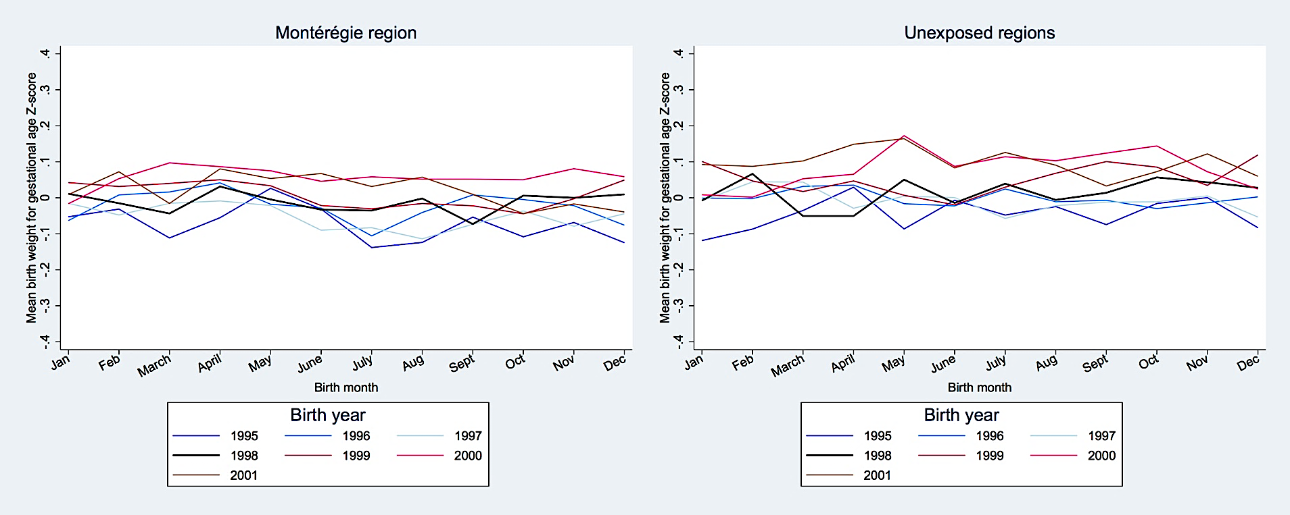

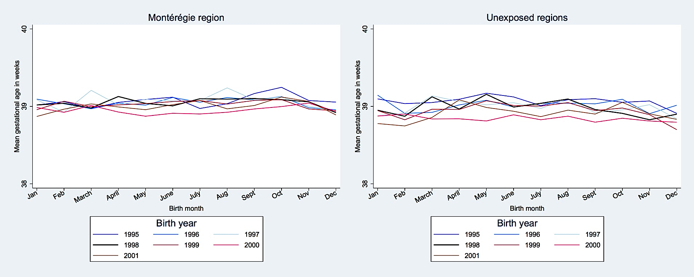

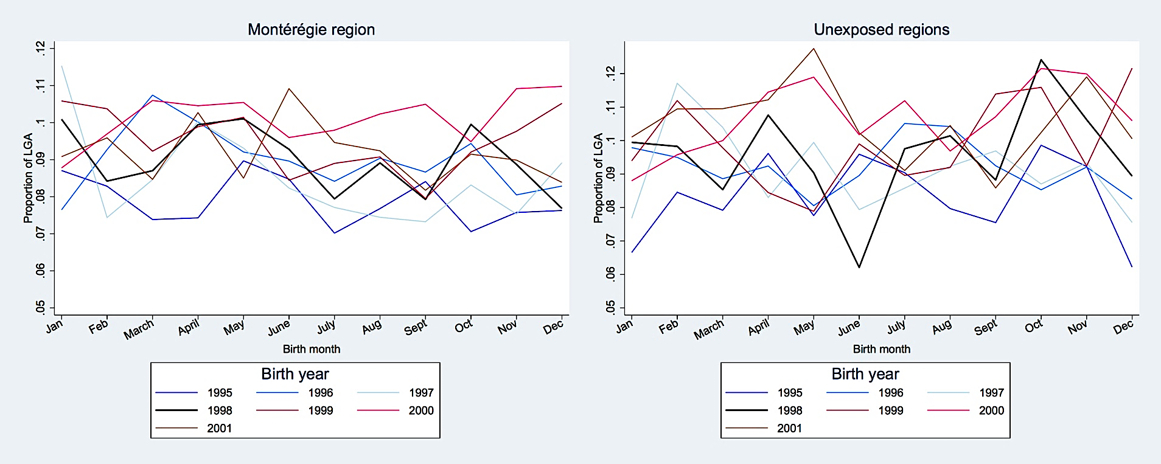

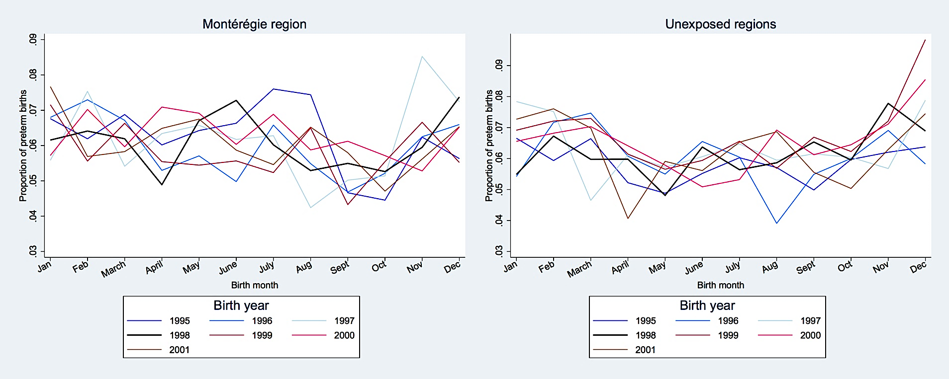

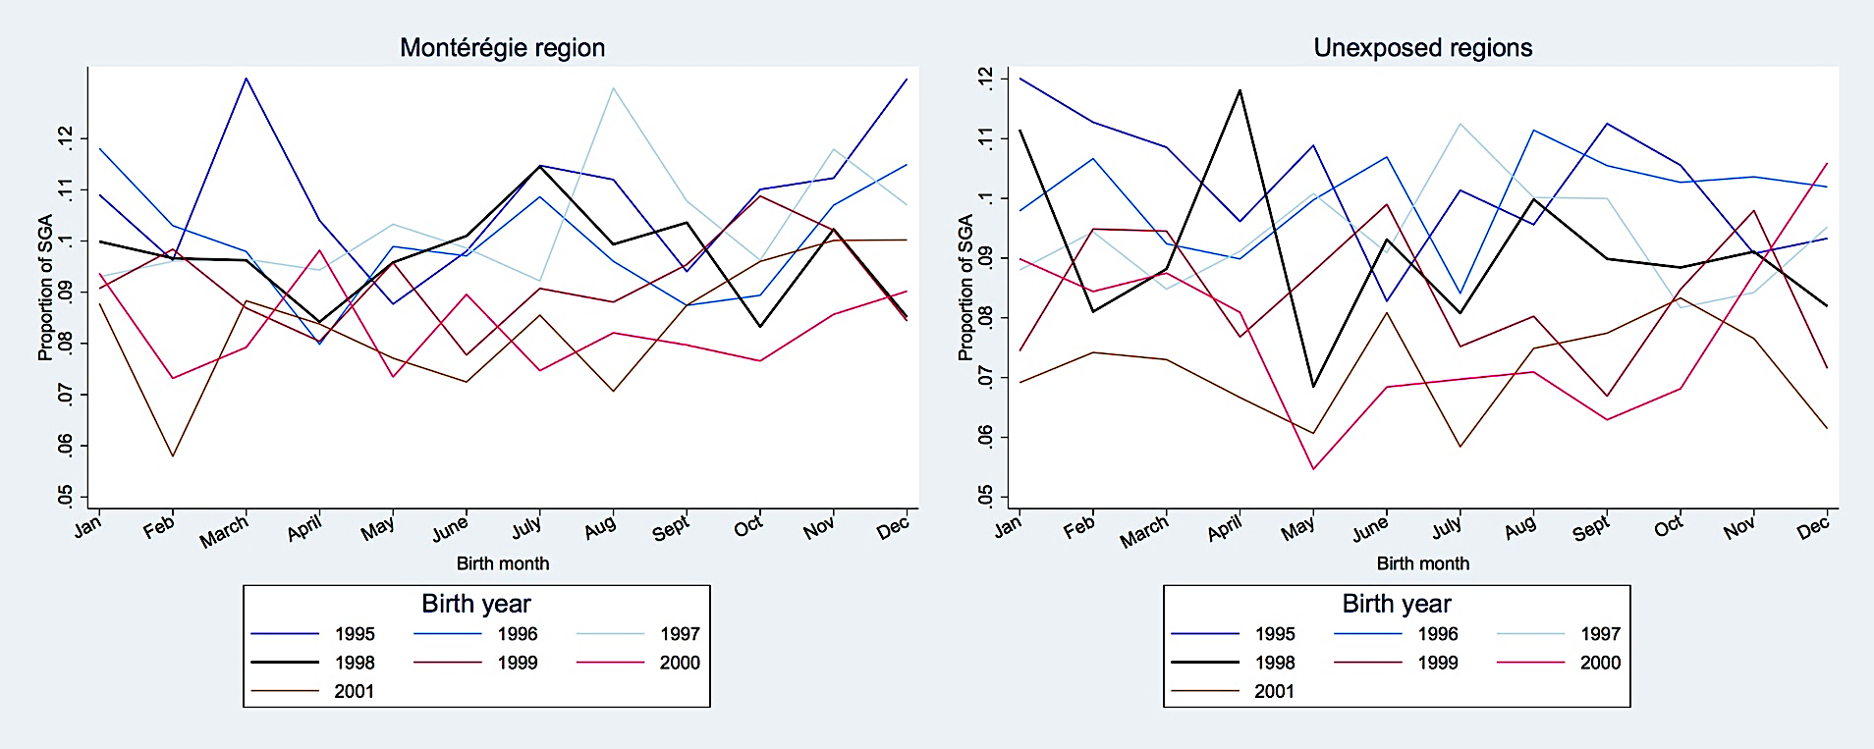

**eTable 1.** Characteristics of the study sample and by region and year of birth (n=147,349).

|  |  |  |  |  |  |  |  |
| --- | --- | --- | --- | --- | --- | --- | --- |
|  | **a. Montérégie Region of Québec (MRQ)** | | | | | | |
| **Characteristic** | **1995** | **1996** | **1997** | **1998** | **1999** | **2000** | **2001** |
| **Number of births** | 15,295 | 14,718 | 13,748 | 13,074 | 12,451 | 12,193 | 12,635 |
| **Birth weight,  (SD)** | 3361.4 (534.1) | 3379.3 (537.1) | 3371.8 (535.0) | 3384.1 (540.2) | 3392.6 (533.4) | 3402.6 (533.9) | 3394.2 (528.6) |
| **Birth weight z score,  (SD)** | 0.0 (1.0) | 0.0 (1.0) | 0.0 (1.0) | 0.0 (1.0) | 0.0 (1.0) | 0.0 (1.0) | 0.0 (0.9) |
| **Small for gestational age (SGA)**  **No**  **Yes** | 13,643 (89.2)  1,652 (10.8) | 13,255 (90.1)  1,463 (9.9) | 12,339 (89.8)  1,409 (10.3) | 11,807 (90.3)  1,267 (9.7) | 11,314 (90.9)  1,137 (9.1) | 11,181 (91.7)  1,012 (8.3) | 11,576 (91.6)  1,059 (8.4) |
| **Large for gestational age (LGA)**  **No**  **Yes** | 14,087 (92.1)  1,208 (7.9) | 13,392 (91.0)  1,326 (9.0) | 12,575 (91.5)  1,173 (8.5) | 11,898 (91.0)  1,176 (9.0) | 11,272 (90.5)  1,179 (9.5) | 10,958 (89.9)  1,235 (10.1) | 11,473 (90.8)  1,162 (9.2) |
| **Gestational age,  (SD)** | 39.1 (1.8) | 39.0 (1.8) | 39.1 (1.8) | 39.0 (1.8) | 39.0 (1.7) | 39.0 (1.8) | 39.0 (1.8) |
| **Preterm birth**  **No**  **Yes** | 14,336 (93.7)  959 (6.3) | 13,843 (94.1)  875 (6.0) | 12,905 (93.9)  843 (6.1) | 12,281 (93.9)  793 (6.1) | 11,730 (94.2)  721 (5.8) | 11,426 (93.7)  767 (6.3) | 11,868 (93.9)  767 (6.1) |
| **Child's sex**  **Male**  **Female** | 7,854 (51.4) 7,441 (48.7) | 7,452 (50.6) 7,266 (49.4) | 7,089 (51.6) 6,659 (48.4) | 6,685 (51.1) 6,389 (48.9) | 6,408(51.5) 6,043 (48.5) | 6,264 (51.4) 5,929 (48.6) | 6,477 (51.3) 6,158 (48.7) |
| **Maternal age,  (SD)** | 28.2 (5.0) | 28.3 (5.1) | 28.3 (5.1) | 28.3 (5.2) | 28.3 (5.2) | 28.3 (5.3) | 28.3 (5.3) |
| **Maternal age**  **<20**  **20-24**  **25-29**  **30-34**  **35+** | 712 (4.7)  2,871 (18.8)  5,478 (35.8)  4,677 (30.6)  1,557 (10.2) | 665 (4.5)  2,769 (18.8)  5,106 (34.7)  4,510 (30.6)  1,668 (11.3) | 609 (4.4)  2,593 (18.9)  4,855 (35.3)  4,049 (29.5)  1,642 (11.9) | 571 (4.4)  2,545 (19.5)  4,488 (34.3)  3,888 (29.7)  1,582 (12.1) | 544 (4.4)  2,524 (20.3)  4,240 (34.1)  3,542 (28.5)  1,601 (12.9) | 528 (4.3)  2,442 (20.0)  4,212 (34.5)  3,436 (28.2)  1,575 (12.9) | 538 (4.3)  2,523 (20.0)  4,419 (35.0)  3,525 (27.9)  1,630 (12.9) |
| **Mother’s years of education**  **No high school diploma (<11 yrs)**  **High school diploma (11 yrs)**  **Some post‐secondary (12-13 yrs)**  **Some university or more (>14 yrs)**  **Missing** | 1,839 (12.0)  1,719 (11.2)  4,041 (26.4)  6,959 (45.5)  737 (4.8) | 1,806 (12.3)  1,702 (11.6)  3,849 (26.2)  6,853 (46.6)  508 (3.5) | 1,583 (11.5)  1,461 (10.6)  3,393 (24.7)  6,762 (49.2)  549 (4.0) | 1,547 (11.8)  1,354 (10.4)  2,966 (22.7)  6,502 (49.7)  705 (5.4) | 1,344 (10.8)  1,159 (9.3)  2,900 (23.3)  6,245 (50.2)  803 (6.5) | 1,257 (10.3)  1,233 (10.1)  2,516 (20.6)  6,244 (51.2)  943 (7.7) | 1,272 (10.1)  1,168 (9.2)  2,519 (19.9)  6,525 (51.6)  1151 (9.1) |
| **Mother’s marital status**  **Single**  **Married**  **Other** | 7,598 (49.7)  7,107 (46.5)  590 (3.9) | 7,644 (51.9)  6,477 (44.0)  597 (4.1) | 7,452 (54.2)  5,821 (42.3)  475 (3.5) | 7,413 (56.7)  5,220 (39.9)  441 (3.4) | 7,257 (58.3)  4,762 (38.3)  432 (3.5) | 7,305 (59.9)  4,504 (36.9)  384 (3.2) | 7,712 (61.0)  4,543 (36.0)  380 (3.0) |
| **Parity**  **0**  **1**  **2**  **3+** | 6,545 (42.8)  5,832 (38.1)  2,200 (14.4)  718 (4.7) | 6,318 (42.9)  5,517 (37.5)  2,125 (14.4)  758 (5.2) | 5,974 (43.5)  5,090 (37.0)  1,973 (14.4)  711 (5.2) | 5,689 (43.5)  5,030 (38.5)  1,728 (13.2)  627 (4.8) | 5,634 (45.3)  4,706 (37.8)  1,546 (12.4)  565 (4.5) | 5,655 (46.4)  4,488 (36.8)  1,484 (12.2)  566 (4.6) | 5,762 (45.6)  4,869 (38.5)  1,462 (11.6)  542 (4.3) |
| **Mother's country of birth**  **Quebec**  **Elsewhere in Canada**  **Outside Canada**  **Unknown** | 13,540 (88.5)  648 (4.2)  896 (5.9)  211 (1.4) | 13,043 (88.6)  508 (3.5)  890 (6.1)  277 (1.9) | 12,216 (88.9)  465 (3.4)  966 (7.0)  101 (0.7) | 11,601 (88.7)  475 (3.6)  933 (7.1)  65 (0.5) | 11,059 (88.8)  490 (3.9)  862 (6.9)  40 (0.3) | 10,887 (89.3)  444 (3.6)  837 (6.9)  25 (0.2) | 11,245 (89.0)  417 (3.3)  919 (7.3)  54 (0.4) |
| **Mother's native language**  **French**  **English**  **Other**  **Unknown** | 13,091 (85.6)  1,352 (8.8)  749 (4.9)  103 (0.7) | 12,652 (86.0)  1,218 (8.3)  735 (5.0)  113 (0.8) | 11,819 (86.0)  1,141 (8.3)  671 (4.9)  117 (0.9) | 11,355 (86.9)  1,004 (7.7)  609 (4.7)  106 (0.8) | 10,805 (86.8)  973 (7.8)  556 (4.5)  117 (0.9) | 10,602 (87.0)  946 (7.8)  526 (4.3)  119 (1.0) | 10,985 (86.9)  894 (7.1)  622 (4.9)  134 (1.1) |
| **Father’s age,  (SD)** | 31.0 (5.5) | 31.0 (5.6) | 31.0 (5.7) | 31.1 (5.8) | 31.1 (5.9) | 31.1 (5.9) | 31.0 (5.9) |
| **Father’s age**  **<25**  **25-29**  **30-34**  **35-39**  **40+**  **Missing** | 1,598 (10.5)  4,419 (28.9)  5,400 (35.3)  2,320 (15.2)  899 (5.9)  659 (4.3) | 1,547 (10.5)  4,195 (28.5)  5,135 (34.9)  2,361 (16.0)  923 (6.3)  557 (3.8) | 1,528 (11.1)  3,850 (28.0)  4,615 (33.6)  2,281 (16.6)  916 (6.7)  558 (4.1) | 1,515 (11.6)  3,521 (26.9)  4,361 (33.4)  2,268 (17.4)  890 (6.8)  519 (4.0) | 1,503 (12.1)  3,372 (27.1)  4,000 (32.1)  2,195 (17.6)  902 (7.2)  479 (3.9) | 1,440 (11.8)  3,390 (27.8)  3,844 (31.5)  2,159 (17.7)  915 (7.5)  445 (3.7) | 1,510 (12.0)  3,617 (28.6)  3,926 (31.1)  2,201 (17.4)  955 (7.6)  426 (3.4) |
| **Father's native language**  **French**  **English**  **Other**  **Unknown** | 12,540 (82.0)  1,298 (8.5)  762 (5.0)  695 (4.5) | 1,2101 (82.2)  1,249 (8.5)  766 (5.2)  602 (4.1) | 11,226 (81.7)  1,156 (8.4)  702 (5.1)  664 (4.8) | 10,826 (82.8)  984 (7.5)  664 (5.1)  600 (4.6) | 10,330 (83.0)  962 (7.7)  589 (4.7)  570 (4.6) | 10,081 (82.7)  974 (8.0)  592 (4.9)  546 (4.5) | 10,514 (83.2)  932 (7.4)  643 (5.1)  546 (4.3) |

|  |  |  |  |  |  |  |  |
| --- | --- | --- | --- | --- | --- | --- | --- |
|  | **b. The Lower Saint Lawrence (LSL)** | | | | | | |
| **Characteristic** | **1995** | **1996** | **1997** | **1998** | **1999** | **2000** | **2001** |
| **Number of births** | 1,906 | 1,907 | 1,774 | 1,753 | 1,629 | 1,671 | 1,620 |
| **Birth weight,  (SD)** | 3333.4 (499.0) | 3359.7 (516.8) | 3347.8 (535.9) | 3335.8 (531.2) | 3350.1 (543.5) | 3350.7 (546.5) | 3405.8 (514.3) |
| **Birth weight z score,  (SD)** | 0.0 (0.9) | 0.0 (1.0) | 0.0 (0.9) | 0.0 (0.9) | 0.0 (1.0) | 0.0 (1.0) | 0.0 (0.9) |
| **Small for gestational age (SGA)**  **No**  **Yes** | 1,686 (88.5)  220 (11.5) | 1,697 (89.0)  210 (11.0) | 1,591 (89.7)  183 (10.3) | 1,570 (89.6)  183 (10.4) | 1,462 (89.8)  167 (10.3) | 1,515 (90.7)  156 (9.3) | 1,506 (93.0)  114 (7.0) |
| **Large for gestational age (LGA)**  **No**  **Yes** | 1,767 (92.7)  139 (7.3) | 1,757 (92.1)  150 (7.9) | 1,634 (92.1)  140 (7.9) | 1,622 (92.5)  131 (7.5) | 1,479 (90.8)  150 (9.2) | 1,525 (91.3)  146 (8.7) | 1,457 (89.9)  163 (10.1) |
| **Gestational age,  (SD)** | 39 (1.7) | 39 (1.7) | 39 (1.8) | 39 (1.8) | 39 (1.8) | 39 (1.9) | 39 (1.8) |
| **Preterm birth**  **No**  **Yes** | 1,805 (94.7)  101 (5.3) | 1,798 (94.3)  109 (5.7) | 1,658 (93.5)  116 (6.5) | 1,640 (93.6)  113 (6.5) | 1,518 (93.2)  111 (6.8) | 1,560 (93.4)  111 (6.6) | 1,514 (93.5)  106 (6.5) |
| **Child's sex**  **Male**  **Female** | 975 (51.2)  931 (48.9) | 992 (52.0)  915 (48.0) | 881 (49.7) 893 (50.3) | 899 (51.3) 854 (48.7) | 835 (51.3)  794 (48.7) | 875 (52.4) 796 (47.6) | 837 (51.7) 783 (48.3) |
| **Maternal age,  (SD)** | 27.9 (5.0) | 27.8 (5.1) | 27.8 (5.1) | 27.6 (5.1) | 27.9 (5.4) | 27.2 (5.0) | 27.5 (5.0) |
| **Maternal age**  **<20**  **20-24**  **25-29**  **30-34**  **35+** | 88 (4.6)  421 (22.1)  660 (34.6)  542 (28.4)  195 (10.2) | 85 (4.5)  451 (23.7)  656 (34.4)  526 (27.6)  189 (9.9) | 83 (4.7)  401 (22.6)  628 (35.4)  490 (27.6)  172 (9.7) | 80 (4.6)  439 (25.0)  617 (35.2)  441 (25.2)  176 (10.0) | 69 (4.2)  417 (25.6)  548 (33.6)  400 (24.6)  195 (12.0) | 89 (5.3)  428 (25.6)  608 (36.4)  403 (24.1)  143 (8.6) | 77 (4.8)  382 (23.6)  624 (38.5)  391 (24.1)  146 (9.0) |
| **Mother’s years of education**  **No high school diploma (<11 yrs)**  **High school diploma (11 yrs)**  **Some post‐secondary (12-13 yrs)**  **Some university or more (>14 yrs)**  **Missing** | 287 (15.1)  198 (10.4)  492 (25.8)  847 (44.4)  82 (4.3) | 280 (14.7)  196 (10.3)  442 (23.2)  912 (47.8)  77 (4.0) | 245 (13.8)  160 (9.0)  395 (22.3)  888 (50.1)  86 (4.9) | 254 (14.5)  157 (9.0)  376 (21.5)  875 (49.9)  91 (5.2) | 231 (14.2)  154 (9.5)  324 (19.9)  858 (52.7)  62 (3.8) | 232 (13.9)  165 (9.9)  342 (20.5)  830 (49.7)  102 (6.1) | 225 (13.9)  156 (9.6)  290 (17.9)  889 (54.9)  60 (3.7) |
| **Mother’s marital status**  **Single**  **Married**  **Other** | 1,032 (54.1)  822 (43.1)  52 (2.7) | 1,152 (60.4)  711 (37.3)  44 (2.3) | 1,126 (63.5)  600 (33.8)  48 (2.7) | 1,126 (64.2)  578 (33.0)  49 (2.8) | 1,113 (68.3)  485 (29.8)  31 (1.9) | 1,228 (73.5)  411 (24.6)  32 (1.9) | 1,172 (72.4)  410 (25.3)  38 (2.4) |
| **Parity**  **0**  **1**  **2**  **3+** | 838 (44.0)  667 (35.0)  299 (15.7)  102 (5.4) | 856 (44.9)  679 (35.6)  269 (14.1)  103 (5.4) | 814 (45.9)  633 (35.7)  246 (13.9)  81 (4.6) | 833 (47.5)  649 (37.0)  188 (10.7)  83 (4.7) | 774 (47.5)  571 (35.1)  202 (12.4)  82 (5.0) | 825 (49.4)  579 (34.7)  191 (11.4)  76 (4.6) | 776 (47.9)  586 (36.2)  193 (11.9)  65 (4.0) |
| **Mother's country of birth**  **Quebec**  **Elsewhere in Canada**  **Outside Canada**  **Unknown** | 1,809 (94.9)  45 (2.4)  23 (1.2)  29 (1.5) | 1,825 (95.7)  45 (2.4)  12 (0.6)  25 (1.3) | 1,699 (95.8)  29 (1.6)  15 (0.9)  31 (1.8) | 1,659 (94.6)  54 (3.1)  19 (1.1)  21 (1.2) | 1,533 (94.1)  54 (3.3)  18 (1.1)  24 (1.5) | 1,560 (93.4)  58 (3.5)  16 (1.0)  37 (2.2) | 1,503 (92.8)  62 (3.8)  22 (1.4)  33 (2.0) |
| **Mother's native language**  **French**  **English**  **Other**  **Unknown** | 1,821 (95.5)  7 (0.4)  12 (0.6)  66 (3.5) | 1,831 (96.0)  17 (0.9)  5 (0.3)  54 (2.8) | 1,715 (96.7)  5 (0.3)  7 (0.4)  47 (2.7) | -* | 1,586 (97.4)  13 (0.8)  6 (0.4)  24 (1.5) | 1,621 (97.0)  10 (0.6)  7 (0.4)  33 (2.0) | 1,573 (97.1)  8 (0.5)  13 (0.8)  26 (1.6) |
| **Father’s age,  (SD)** | 31 (5.4) | 31 (5.7) | 31 (5.7) | 31 (5.7) | 31.2 (6.0) | 31 (5.7) | 31 (5.7) |
| **Father’s age**  **<25**  **25-29**  **30-34**  **35-39**  **40+**  **Missing** | 202 (10.6)  494 (25.9)  719 (37.7)  322 (16.9)  114 (6.0)  55 (2.9) | 213 (11.2)  529 (27.7)  655 (34.4)  311 (16.3)  126 (6.6)  73 (3.8) | 211 (11.9)  499 (28.1)  584 (32.9)  313 (17.6)  110 (6.2)  57 (3.2) | 203 (11.6)  535 (30.5)  558 (31.8)  274 (15.6)  129 (7.4)  54 (3.1) | 212 (13.0)  421 (25.8)  526 (32.3)  270 (16.6)  145 (8.9)  55 (3.4) | 208 (12.5)  533 (31.9)  486 (29.1)  277 (16.6)  98 (5.9)  69 (4.1) | 200 (12.4)  505 (31.2)  498 (30.7)  274 (16.9)  96 (5.9)  47 (2.9) |
| **Father's native language**  **French**  **English**  **Other**  **Unknown** | 1,776 (93.2)  8 (0.4)  12 (0.6)  110 (5.8) | 1,765 (92.6)  10 (0.5)  6 (0.3)  126 (6.6) | -* | 1,642 (93.7)  8 (0.5)  10 (0.6)  93 (5.3) | 1,537 (94.4)  11 (0.7)  8 (0.5)  73 (4.5) | 1,540 (92.2)  14 (0.8)  15 (0.9)  102 (6.1) | 1,540 (95.1)  5 (0.3)  8 (0.5)  67 (4.1) |

|  |  |  |  |  |  |  |  |
| --- | --- | --- | --- | --- | --- | --- | --- |
|  | **c. The Quebec Capital Region (QCR)** | | | | | | |
| **Characteristic** | **1995** | **1996** | **1997** | **1998** | **1999** | **2000** | **2001** |
| **Number of births** | 6,739 | 6,378 | 6,034 | 5,631 | 5,448 | 5,250 | 5,495 |
| **Birth weight,  (SD)** | 3387.3 (543.6) | 3395.2 (551.0) | 3386.2 (543.0) | 3404.9 (548.2) | 3413.0 (532.6) | 3413.2 (537.0) | 3419.7 (546.4) |
| **Birth weight z score,  (SD)** | 0.0 (1.0) | 0.0 (1.0) | 0.0 (0.9) | 0.0 (1.0) | 0.0 (1.0) | 0.0 (0.9) | 0.0 (1.0) |
| **Small for gestational age (SGA)**  **No**  **Yes** | 6,074 (90.1)  665 (9.9) | 5,761 (90.3)  617 (9.7) | 5,483 (90.9)  551 (9.1) | 5,142 (91.3)  489 (8.7) | 5,023 (92.2)  425 (7.8) | 4,871 (92.8)  379 (7.2) | 5,101 (92.8)  394 (7.2) |
| **Large for gestational age (LGA)**  **No**  **Yes** | 6,157 (91.4)  582 (8.6) | 5,765 (90.4)  613 (9.6) | 5,465 (90.6)  569 (9.4) | 5,056 (89.8)  575 (10.2) | 4,900 (89.9)  548 (10.1) | 4,657 (88.7)  593 (11.3) | 4,906 (89.3)  589 (10.7) |
| **Gestational age,  (SD)** | 39.1 (1.8) | 39.0 (1.9) | 39.0 (1.8) | 39.0 (1.8) | 39.0 (1.7) | 39.0 (1.8) | 39.0 (1.8) |
| **Preterm birth**  **No**  **Yes** | 6,336 (94.0)  403 (6.0) | 5,987 (93.9)  391 (6.1) | 5,658 (93.8)  376 (6.2) | 5,292 (94.0)  339 (6.0) | 5,082 (93.3)  366 (6.7) | 4,911 (93.5)  339 (6.5) | 5,157 (93.9)  338 (6.2) |
| **Child's sex**  **Male**  **Female** | 3,478 (51.6) 3,261 (48.4) | 3,305 (51.8) 3,073 (48.2) | 3,042 (50.4) 2,992 (49.6) | 2,915 (51.8) 2,716 (48.2) | 2,761 (50.7) 2,687 (49.3) | 2,737 (52.1) 2,513 (47.9) | 2,858 (52.0) 2,637 (48.0) |
| **Maternal age,  (SD)** | 28.5 (4.9) | 28.7 (4.9) | 28.7 (5.0) | 28.8 (5.1) | 28.8 (5.1) | 28.6 (5.1) | 28.9 (5.0) |
| **Maternal age**  **<20**  **20-24**  **25-29**  **30-34**  **35+** | 223 (3.3)  1,176 (17.5)  2,471 (36.7)  2,152 (31.9)  717 (10.6) | 198 (3.1)  1,099 (17.2)  2,268 (35.6)  2,010 (31.5)  803 (12.6) | 189 (3.1)  1,065 (17.7)  2,107 (34.9)  1,942 (32.2)  731 (12.1) | 169 (3.0)  971 (17.2)  2,022 (35.9)  1,702 (30.2)  767 (13.6) | 179 (3.3)  982 (18.0)  1,924 (35.3)  1,585 (29.1)  778 (14.3) | 183 (3.5)  979 (18.7)  1,842 (35.1)  1,544 (29.4)  702 (13.4) | 145 (2.6)  904 (16.5)  2,013 (36.6)  1,689 (30.7)  744 (13.5) |
| **Mother’s years of education**  **No high school diploma (<11 yrs)**  **High school diploma (11 yrs)**  **Some post‐secondary (12-13 yrs)**  **Some university or more (>14yrs)**  **Missing** | 586 (8.7)  522 (7.8)  1,733 (25.7)  3,687 (54.7)  211 (3.1) | 440 (6.9)  540 (8.5)  1,569 (24.6)  3,533 (55.4)  296 (4.6) | 308 (5.1)  573 (9.5)  992 (16.4)  2,263 (37.5)  1,898 (31.5) | 308 (5.5)  920 (16.3)  844 (15.0)  3,363 (59.7)  196 (3.5) | 279 (5.1)  900 (16.5)  673 (12.4)  3,345 (61.4)  251 (4.6) | 335 (6.4)  859 (16.4)  565 (10.8)  3,116 (59.4)  375 (7.1) | 336 (6.1)  436 (7.9)  923 (16.8)  3,257 (59.3)  543 (9.9) |
| **Mother’s marital status**  **Single**  **Married**  **Other** | 3,390 (50.3)  3,146 (46.7)  203 (3.0) | 3,403 (53.4)  2,807 (44.0)  168 (2.6) | 3,516 (58.3)  2,332 (38.7)  186 (3.1) | 3,412 (60.6)  2,085 (37.0)  134 (2.4) | 3,397 (62.4)  1,940 (35.6)  111 (2.0) | 3,387 (64.5)  1,789 (34.1)  74 (1.4) | 3,482 (63.4)  1,852 (33.7)  161 (2.9) |
| **Parity**  **0**  **1**  **2**  **3+** | 3,312 (49.2)  2,415 (35.8)  782 (11.6)  230 (3.4) | 3,053 (47.9)  2,321 (36.4)  763 (12.0)  241 (3.8) | 2,913 (48.3)  2,223 (36.8)  662 (11.0)  236 (3.9) | 2,815 (50.0)  2,081 (37.0)  533 (9.5)  202 (3.6) | 2,739 (50.3)  2,017 (37.0)  516 (9.5)  176 (3.2) | 2,667 (50.8)  1,902 (36.2)  486 (9.3)  195 (3.7) | 2,752 (50.1)  2,055 (37.4)  511 (9.3)  177 (3.2) |
| **Mother's country of birth**  **Quebec**  **Elsewhere in Canada**  **Outside Canada**  **Unknown** | 6,284 (93.3)  92 (1.4)  309 (4.6)  54 (0.8) | 5,913 (2.7)  92 (1.4)  190 (3.0)  183 (2.9) | 5,633 (93.4)  61 (1.0)  290 (4.8)  50 (0.8) | 5,244 (93.1)  63 (1.1)  314 (5.6)  10 (0.2) | 5,058 (92.8)  73 (1.3)  311 (5.7)  6 (0.1) | 4,872 (92.8)  68 (1.3)  305 (5.8)  5 (0.1) | 5,066 (92.2)  107 (2.0)  307 (5.6)  15 (0.3) |
| **Mother's native language**  **French**  **English**  **Other**  **Unknown** | 6,377 (94.6)  123 (1.8)  205 (3.0)  34 (0.5) | 6,057 (95.0)  107 (1.7)  144 (2.3)  70 (1.1) | 5,740 (95.1)  93 (1.5)  91 (1.5)  110 (1.8) | 5,386 (95.7)  86 (1.5)  80 (1.4)  79 (1.4) | 5,205 (95.5)  76 (1.4)  95 (1.7)  72 (1.3) | 5,009 (95.4)  50 (1.0)  86 (1.6)  105 (2.0) | 5,217 (94.9)  66 (1.2)  129 (2.4)  83 (1.5) |
| **Father’s age,  (SD)** | 31.2 (5.4) | 31.4 (5.5) | 31.5 (5.6) | 31.4 (5.5) | 31.4 (5.7) | 31.5 (5.7) | 31.6 (5.8) |
| **Father’s age**  **<25**  **25-29**  **30-34**  **35-39**  **40+**  **Missing** | 631 (9.4)  1,817 (27.0)  2,495 (37.0)  1,125 (16.7)  396 (5.9)  275 (4.1) | 546 (8.6)  1,730 (27.1)  2,262 (35.5)  1,154 (18.1)  437 (6.9)  249 (3.9) | 503 (8.3)  1,712 (28.4)  1,985 (32.9)  1,144 (19.0)  438 (7.3)  252 (4.2) | 485 (8.6)  1,569 (27.9)  1,885 (33.5)  1,043 (18.5)  410 (7.3)  239 (4.2) | 514 (9.4)  1,493 (27.4)  1,851 (34.0)  968 (17.8)  432 (7.9)  190 (3.5) | 479 (9.1)  1,447 (27.6)  1,704 (32.5)  989 (18.8)  438 (8.3)  193 (3.7) | 487 (8.9)  1,503 (27.4)  1,792 (32.6)  1,086 (19.8)  436 (7.9)  191 (3.5) |
| **Father's native language**  **French**  **English**  **Other**  **Unknown** | 6,121 (90.8)  104 (1.5)  216 (3.2)  298 (4.4) | 5,824 (91.3)  79 (1.2)  158 (2.5)  317 (5.0) | 5,487 (90.9)  87 (1.4)  100 (1.7)  360 (6.0) | 5,158 (91.6)  95 (1.7)  77 (1.4)  301 (5.4) | 5,016 (92.1)  72 (1.3)  109 (2.0)  251 (4.6) | 4,818 (91.8)  73 (1.4)  79 (1.5)  280 (5.3) | 5,028 (91.5)  74 (1.4)  131 (2.4)  262 (4.8) |

* Count less than 5

**eTable 2.** Association of exposure to the 1998 Quebec Ice Storm with birth outcomes using the post-Ice Storm period (1999-2001) as the comparison group a

|  |  |  |  |  |
| --- | --- | --- | --- | --- |
|  | **Exposed at any time in pregnancy (n=** **78,850)** | | | |
| **Outcome** | **Crude** | | **Adjusted c** | |
| **Gestational age** | -0.08 (-0.14, -0.02) | | -0.08 (-0.14, -0.01) | |
| **Preterm birth b** | 0.82 (0.00, 1.65) | | 0.80 (-0.02, 1.63) | |
| **Birth weight z-score** | 0.03 (0.00, 0.07) | | 0.03 (0.00, 0.07) | |
| **SGA b** | -0.29 (-1.33, 0.76) | | -0.31 (-1.35, 0.73) | |
| **LGA b** | 0.76 (-0.29, 1.82) | | 0.77 (-0.28, 1.82) | |
|  | **1st trimester (n= 63,191)** | | **2nd trimester (n=65,183)** | |
| **Outcome** | **Crude** | **Adjusted** | **Crude** | **Adjusted** |
| **Gestational age** | -0.10 (-0.21, 0.01) | -0.10 (-0.21, 0.01) | -0.05 (-0.15, 0.04) | -0.05 (-0.14, 0.04) |
| **Preterm birth b** | 0.94 (-0.53, 2.41) | 0.98 (-0.49, 2.44) | 0.29 (-0.96, 1.53) | 0.28 (-0.96, 1.52) |
| **Birth weight z-score** | 0.01 (-0.05, 0.07) | 0.01 (-0.05, 0.06) | 0.05 (0.00, 0.10) | 0.05 (0.00, 0.10) |
| **SGA b** | 0.23 (-1.59, 2.06) | 0.34 (-1.47, 2.15) | -0.54 (-2.04, 0.95) | -0.57 (-2.05, 0.91) |
| **LGA b** | -0.20 (-1.96, 1.56) | -0.27 (-2.02, 1.48) | 1.55 (0.02, 3.07) | 1.53 (0.01, 3.05) |
|  | **3rd trimester (n=62,699)** | | **Preconception (n=62,998)** | |
| **Outcome** | **Crude** | **Adjusted** | **Crude** | **Adjusted** |
| **Gestational age** | -0.07 (-0.16, 0.02) | -0.06 (-0.15, 0.03) | 0.09 (0.02, 0.21) | 0.10 (-0.02, 0.21) |
| **Preterm birth b** | 1.16 (-0.01, 2.32) | 1.07 (-0.10, 2.82) | -1.12 (-2.67, 0.43) | -1.08 (-2.63, 0.47) |
| **Birth weight z-score** | 0.02 (-0.04, 0.08) | 0.03 (-0.03, 0.09) | -0.01 (-0.07, 0.05) | -0.02 (-0.08, 0.04) |
| **SGA b** | -0.49 (-2.38, 1.40) | -0.61 (-2.50, 1.27) | -0.14 (-1.90, 1.62) | -0.02 (-1.78, 1.73) |
| **LGA b** | 0.29 (-1.58, 2.16) | 0.41 (-1.45, 2.27) | -1.16 (-3.04, 0.71) | -1.32 (-3.19, 0.55) |

Notes

a Values above represent the coefficients of the interaction term between mother giving birth in the area exposed to the ice storm (Montérégie region) and whether the year of birth is within the exposure period (exposed births in 1998; reference period is 1999-2001). Analyses involved crude and multivariable linear models (i.e. linear probability models for binary outcomes). For trimester-specific analyses, births exposed in other trimesters were excluded from the analyses.

b Coefficients for binary outcomes were multiplied by 100 and therefore represent a change in percentage points.

c Adjusted models include the following covariates: mother’s education, age, parity, marital status, country of birth, and native language, father’s age and native language, and infant’s sex.

**eTable 3.** Association of exposure to the 1998 Quebec Ice Storm using all births over the 7 years (1995 – 2001) with birth year as the time indicator a

|  |  |  |  |  |
| --- | --- | --- | --- | --- |
|  | **Exposed at preconception or any time in pregnancy (all births of 1998) (n=147,349)** | | | |
| **Outcome** | **Crude** | | **Adjusted c** | |
| **Gestational age** | -0.02 (-0.09, 0.05) | | 0.02 (-0.06, 0.09) | |
| **Preterm birth b** | 0.11 (-0.84, 1.07) | | -0.18 (-1.15, 0.78) | |
| **Birth weight z-score** | 0.02 (-0.02, 0.06) | | 0.02 (-0.01, 0.05) | |
| **SGA b** | -0.26 (-1.43, 0.91) | | -0.46 (-1.63, 0.71) | |
| **LGA b** | -0.02 (-1.16, 1.13) | | -0.02 (-1.17, 1.12) | |
|  | **1st trimester (n=131,690)** | | **2nd trimester (n=133,682)** | |
| **Outcome** | **Crude** | **Adjusted** | **Crude** | **Adjusted** |
| **Gestational age** | -0.07 (-0.20, 0.07) | -0.03 (-0.16, 0.10) | -0.03 (-0.14, 0.08) | 0.01 (-0.10, 0.12) |
| **Preterm birth b** | 0.83 (-0.89, 2.54) | 0.59 (-1.13, 2.30) | 0.16 (-1.29, 1.60) | -0.18 (-1.64, 1.27) |
| **Birth weight z-score** | 0.02 (-0.04, 0.08) | 0.02 (-0.04, 0.08) | 0.05 (0.00, 0.11) | 0.06 (0.01, 0.11) |
| **SGA b** | -0.08 (-2.00, 1.83) | -0.16 (-2.07, 1.74) | -0.74 (-2.37, 0.89) | -0.93 (-2.55, 0.69) |
| **LGA b** | -0.49 (-2.32, 1.34) | -0.54 (-2.36, 1.28) | 1.21 (-0.41, 2.83) | 1.20 (-0.42, 2.82) |
|  | **3rd trimester (n=131,198)** | | **Preconception (n=131,497)** | |
| **Outcome** | **Crude** | **Adjusted** | **Crude** | **Adjusted** |
| **Gestational age** | -0.04 (-0.17, 0.08) | 0.00 (-0.13, 0.12) | 0.12 (-0.02, 0.26) | 0.15 (0.01, 0.30) |
| **Preterm birth b** | 1.14 (-0.40, 2.69) | 0.75 (-0.80, 2.30) | -1.15 (-3.00, 0.70) | -1.37 (-3.23, 0.49) |
| **Birth weight z-score** | 0.03 (-0.04, 0.09) | 0.04 (-0.03, 0.10) | -0.01 (-0.07, 0.06) | 0.01 (-0.07, 0.05) |
| **SGA b** | -0.80 (-2.77, 1.18) | -1.11 (-3.09, 0.86) | -0.16 (-2.05, 1.73) | -0.19 (-2.08, 1.69) |
| **LGA b** | 0.03 (-1.96, 1.89) | 0.09 (-1.83, 2.01) | -1.58 (-3.56, 0.39) | -1.71 (-3.68, 0.26) |

Notes

a Values above represent the coefficients of the interaction term between mother giving birth in the area exposed to the ice storm (Montérégie region) and whether the year of birth is 1998 (reference year is 1997). Analyses involved crude and multivariable linear models (i.e. linear probability models for binary outcomes). For trimester-specific analyses, births exposed in other trimesters were excluded from the analyses.

b Coefficients for binary outcomes were multiplied by 100 and therefore represent a change in percentage points.

c Adjusted models include the following covariates: mother’s education, age, parity, marital status, country of birth, and native language, father’s age and native language, and infant’s sex.

**eTable 4.** Risk ratios of the association of exposure to the 1998 Quebec Ice Storm with binary birth outcomes a

|  |  |  |  |  |
| --- | --- | --- | --- | --- |
|  | **Exposed at any time in pregnancy (n=84,351)** | | | |
| **Outcome** | **Crude** | | **Adjusted b** | |
| **Preterm birth** | 1.05 (0.9, 1.23) | | 1.04 (0.88, 1.22) | |
| **SGA** | 1.02 (0.9, 1.15) | | 1.01 (0.90, 1.15) | |
| **LGA** | 1.04 (0.91, 1.18) | | 1.03 (0.91, 1.17) | |
|  | **1st trimester (n=73,283)** | | **2nd trimester (n=75,275)** | |
| **Outcome** | **Crude** | **Adjusted** | **Crude** | **Adjusted** |
| **Preterm birth** | 1.08 (0.84, 1.39) | 1.08 (0.84, 1.40) | 0.96 (0.77, 1.20) | 0.95 (0.76, 1.18) |
| **SGA** | 1.07 (0.87, 1.32) | 1.09 (0.89, 1.34) | 0.99 (0.83, 1.19) | 0.99 (0.82, 1.19) |
| **LGA** | 0.93 (0.75, 1.15) | 0.92 (0.74, 1.14) | 1.15 (0.96, 1.38) | 1.14 (0.95, 1.37) |
|  | **3rd trimester (n=72,791)** | | **Preconception (n=73,090)** | |
| **Outcome** | **Crude** | **Adjusted** | **Crude** | **Adjusted** |
| **Preterm birth** | 1.24 (0.87, 1.79) | 1.21 (0.84, 1.74) | 0.77 (0.59, 1.00) | 0.77 (0.59, 1.00) |
| **SGA** | 0.99 (0.80, 1.23) | 0.97 (0.78, 1.21) | 1.04 (0.84, 1.30) | 1.06 (0.85, 1.32) |
| **LGA** | 0.99 (0.79, 1.24) | 1.00 (0.80, 1.25) | 0.84 (0.68, 1.04) | 0.82 (0.67, 1.02) |

Notes

a Values above represent the coefficients of the interaction term between mother giving birth in the area exposed to the ice storm (Montérégie region) and whether the year of birth is within the exposure period (exposed births in 1998; reference period is 1995-1997). Analyses involved crude and multivariable log-binomial regression. For trimester-specific analyses, births exposed in other trimesters were excluded from the analyses.

b Adjusted models include the following covariates: mother’s education, age, parity, marital status, country of birth, and native language, father’s age and native language, and infant’s sex.

**eTable 5.** association of exposure to the Ice Storm and birth weight in grams among term births only (>37 completed weeks) a

|  |  |  |  |
| --- | --- | --- | --- |
| **Exposed at any time in pregnancy (n=79,334)** | | | |
| **Crude** | | **Adjusted b** | |
| 5.79 (-11.26, 22.85) | | 7.00 (-9.69, 23.68) | |
| **1st trimester (n=68,812)** | | **2nd trimester (n=70,701)** | |
| **Crude** | **Adjusted** | **Crude** | **Adjusted** |
| -8.40 (-37.71, 20.89) | -9.14 (-37.61, 19.33) | 19.47 (-5.12, 44.07) | 18.86 (-5.17, 42.89) |
| **3rd trimester (n=68,473)** | | **Preconception (n=68,636)** | |
| **Crude** | **Adjusted** | **Crude** | **Adjusted** |
| 0.34 (-29.75, 30.44) | 4.84 (-24.53, 34.20) | 3.37 (-26.49, 33.24) | -3.17 (-32.39, 26.05) |

Notes

a Values above represent the coefficients of the interaction term between mother giving birth in the area exposed to the ice storm (Montérégie region) and whether the year of birth is within the exposure period (exposed births in 1998; reference period is births in 1995-1997). Analyses involved crude and multivariable linear models (i.e. linear probability models for binary outcomes). For trimester-specific analyses, births exposed in other trimesters were excluded from the analyses.

b Adjusted models include the following covariates: mother’s education, age, parity, marital status, country of birth, and native language, father’s age and native language, and infant’s sex.