Supplements
Supplement S1: Search strategy p. 2 - 4
Supplement S2: Risk of bias assessment p. 5 - 6
Supplement S3: Literature table (Supplementary Table 1) p. 7 – 10
Supplement S4: Subgroup analyses (Supplementary Figure 1) p. 11
Supplement S5: Publication bias (Supplementary Figure 2) p. 12

Supplement S1: Study protocol
Review questions
- Does expression of suicidal ideation predict subsequent completed suicide?
- What is the absolute risk of suicide after expression of suicidal ideation?
- Is suicidal ideation an independent predictor of subsequent completed suicide?

Searches
The following search strategies will be used in Pubmed and the results of search strategy part 1 and part 2 will be combined with OR. In addition, Embase, Web of Science, PsycINFO, PsycARTICLES, Psychology and Behavioral Sciences Collection, Cochrane, CINAHL, Academic Search Premier, and ScienceDirect will be searched for eligible articles, without language restrictions.
Search strategy part 1 focusing on prediction of suicide in adults
(((predict*[all fields] OR "predict"[all fields] OR "predictors"[all fields] OR "predictor"[all fields] OR "predictive"[all fields] OR "predicted"[all fields] OR "prediction"[all fields] OR "predictions"[all fields] OR predict*[all fields] OR traject*[all fields] OR "course"[all fields] OR "Time factors"[mesh] OR "Risk Factors"[mesh] OR "Risk"[mesh] OR "Probability"[mesh] OR "Prognosis"[mesh] OR prognos*[all fields] OR "time factors" [all fields] OR "risk factor"[all fields] OR "risk factors"[all fields]) AND ("Suicide"[majr:noexp] OR "Suicide, Attempted"[majr] OR "suicide"[ti] OR "completed suicide"[ti] OR "eventual suicide"[ti] OR "completed suicides"[ti] OR "eventual suicides"[ti] OR "later suicide"[ti] OR "later suicides"[ti] OR "subsequent suicide"[ti] OR "subsequent suicides"[ti] OR "suicide"[ti] OR "suicides"[ti] OR "suicidal behavior"[ti] OR "suicidal behaviour"[ti] OR "suicidal behaviors"[ti] OR "suicidal behaviours"[ti] OR "suicide behavior"[ti] OR "suicide behaviour"[ti] OR "suicide behaviors"[ti] OR "suicide behaviours"[ti]) AND ("Adult"[mesh] OR "adult"[all fields] OR "adults"[all fields])) OR ((predict*[all fields] OR "predict"[all fields] OR "predictors"[all fields] OR "predictor"[all fields] OR "predictive"[all fields] OR "predicted"[all fields] OR "prediction"[all fields] OR "predictions"[all fields] OR predict*[all fields] OR traject*[all fields] OR "course"[all fields] OR "Time factors"[mesh] OR "Risk Factors"[mesh] OR "Risk"[mesh] OR "Probability"[mesh] OR "Prognosis"[mesh] OR prognos*[all fields] OR "time factors" [all fields] OR "risk factor"[all fields] OR "risk factors"[all fields]) AND ("Suicide"[majr:noexp] OR "Suicide, Attempted"[majr] OR "suicide"[ti] OR "completed suicide"[ti] OR "eventual suicide"[ti] OR "completed suicides"[ti] OR "eventual suicides"[ti] OR "later suicide"[ti] OR "later suicides"[ti] OR "subsequent suicide"[ti] OR "subsequent suicides"[ti] OR "suicide"[ti] OR "suicides"[ti] OR "suicidal behavior"[ti] OR "suicidal behaviour"[ti] OR "suicidal behaviors"[ti] OR "suicidal behaviours"[ti] OR "suicide behavior"[ti] OR "suicide behaviour"[ti] OR "suicide behaviors"[ti] OR "suicide behaviours"[ti]) NOT ("Adolescent"[mesh] OR "Child"[mesh]) NOT "Adult"[mesh]))) AND ("Case-Control Studies"[mesh] OR "Case-Control"[all fields] OR "Case-Controlled"[all fields] OR "Retrospective"[all fields] OR Retrospectiv*[all fields] OR "Retrospective Studies"[all fields] OR "Retrospective Study"[all fields] OR "Cohort Studies"[mesh] OR "Cohort"[all fields] OR "Cohorts"[all fields] OR "Longitudinal Studies"[all fields] OR "Longitudinal Study"[all fields] OR "Follow-Up Studies"[all fields] OR "Follow-Up Study"[all fields] OR "Follow-Up"[all fields] OR "Prospective Studies"[all fields] OR "Prospective Study"[all fields] OR "Multivariate Analysis"[Mesh] OR "Multivariate"[all fields])
Search strategy part 2 focusing on suicidal ideation and suicide in adults
((("Suicidal Ideation"[mesh] OR "suicide ideation"[all fields] OR "suicidal ideation"[all fields] OR "suicide thoughts"[all fields] OR "suicide thought"[all fields] OR "suicidal thoughts"[all fields] OR "suicidal thought"[all fields] OR "suicide idea"[all fields] OR "suicide ideas"[all fields] OR "suicide ideator"[all fields] OR "suicide ideators"[all fields] OR "suicidal idea"[all fields] OR "suicidal ideas"[all fields] OR "suicidal ideator"[all fields] OR "suicidal ideators"[all fields] OR "suicidality"[all fields] OR "suicidal tendencies"[all fields] OR "death wishes"[all fields] OR "suicidal tendency"[all fields] OR "death wish"[all fields] OR "talk of suicide"[all fields] OR "threat of suicide"[all fields] OR "suicidal communication"[all fields]) AND (predict*[all fields] OR "predict"[all fields] OR "predictors"[all fields] OR "predictor"[all fields] OR "predictive"[all fields] OR "predicted"[all fields] OR "prediction"[all fields] OR "predictions"[all fields] OR predict*[all fields] OR traject*[all fields] OR "course"[all fields] OR "Time factors"[mesh] OR "Risk Factors"[mesh] OR "Risk"[mesh] OR "Probability"[mesh] OR "Prognosis"[mesh] OR prognos*[all fields] OR "time factors" [all fields] OR "risk factor"[all fields] OR "risk factors"[all fields]) AND ("Suicide"[mesh:noexp] OR "Suicide, Attempted"[mesh] OR "suicide"[all fields] OR "completed suicide"[all fields] OR "eventual suicide"[all fields] OR "completed suicides"[all fields] OR "eventual suicides"[all fields] OR "later suicide"[all fields] OR "later suicides"[all fields] OR "subsequent suicide"[all fields] OR "subsequent suicides"[all fields] OR "suicide"[all fields] OR "suicides"[all fields] OR "suicidal behavior"[all fields] OR "suicidal behaviour"[all fields] OR "suicidal behaviors"[all fields] OR "suicidal behaviours"[all fields] OR "suicide behavior"[all fields] OR "suicide behaviour"[all fields] OR "suicide behaviors"[all fields] OR "suicide behaviours"[all fields]) AND ("Adult"[mesh] OR "adult"[all fields] OR "adults"[all fields])) OR (("Suicidal Ideation"[mesh] OR "suicide ideation"[all fields] OR "suicidal ideation"[all fields] OR "suicide thoughts"[all fields] OR "suicide thought"[all fields] OR "suicidal thoughts"[all fields] OR "suicidal thought"[all fields] OR "suicide idea"[all fields] OR "suicide ideas"[all fields] OR "suicide ideator"[all fields] OR "suicide ideators"[all fields] OR "suicidal idea"[all fields] OR "suicidal ideas"[all fields] OR "suicidal ideator"[all fields] OR "suicidal ideators"[all fields] OR "suicidality"[all fields] OR "suicidal tendencies"[all fields] OR "death wishes"[all fields] OR "suicidal tendency"[all fields] OR "death wish"[all fields] OR "talk of suicide"[all fields] OR "threat of suicide"[all fields] OR "suicidal communication"[all fields]) AND (predict*[all fields] OR "predict"[all fields] OR "predictors"[all fields] OR "predictor"[all fields] OR "predictive"[all fields] OR "predicted"[all fields] OR "prediction"[all fields] OR "predictions"[all fields] OR predict*[all fields] OR traject*[all fields] OR "course"[all fields] OR "Time factors"[mesh] OR "Risk Factors"[mesh] OR "Risk"[mesh] OR "Probability"[mesh] OR "Prognosis"[mesh] OR prognos*[all fields] OR "time factors" [all fields] OR "risk factor"[all fields] OR "risk factors"[all fields]) AND ("Suicide"[mesh:noexp] OR "Suicide, Attempted"[mesh] OR "suicide"[all fields] OR "completed suicide"[all fields] OR "eventual suicide"[all fields] OR "completed suicides"[all fields] OR "eventual suicides"[all fields] OR "later suicide"[all fields] OR "later suicides"[all fields] OR "subsequent suicide"[all fields] OR "subsequent suicides"[all fields] OR "suicide"[all fields] OR "suicides"[all fields] OR "suicidal behavior"[all fields] OR "suicidal behaviour"[all fields] OR "suicidal behaviors"[all fields] OR "suicidal behaviours"[all fields] OR "suicide behavior"[all fields] OR "suicide behaviour"[all fields] OR "suicide behaviors"[all fields] OR "suicide behaviours"[all fields]) NOT ("Adolescent"[mesh] OR "Child"[mesh]) NOT "Adult"[mesh]))) AND ("Case-Control Studies"[mesh] OR "Case-Control"[all fields] OR "Case-Controlled"[all fields] OR "Retrospective"[all fields] OR Retrospectiv*[all fields] OR "Retrospective Studies"[all fields] OR "Retrospective Study"[all fields] OR "Cohort Studies"[mesh] OR "Cohort"[all fields] OR "Cohorts"[all fields] OR "Longitudinal Studies"[all fields] OR "Longitudinal Study"[all fields] OR "Follow-Up Studies"[all fields] OR "Follow-Up Study"[all fields] OR "Follow-Up"[all fields] OR "Prospective Studies"[all fields] OR "Prospective Study"[all fields] OR "Multivariate Analysis"[Mesh] OR "Multivariate"[all fields])
Type of studies to be included
Studies with the following characteristics will be included in the meta-analysis:
Population: all different kinds of study populations will be included, as long as the mean age of the study population is ≥ 18 years.
Determinant: expression of suicidal ideation versus no expression of suicidal ideation. Studies that analyse suicidal intent as a determinant will not be included.
Outcome: completed suicide versus no completed suicide. Studies that compare completed suicide as an outcome to attempted suicide or physician assisted suicide will not be included.
Control: studies that do not have a control group (like case series of completed suicides or studies in which every participant has suicidal ideation at baseline) will be excluded.
Study design: cohort or case-control studies. Reviews that address relevant research questions will be used to search the reference list for useful articles not identified by the search.

Study selection
Two reviewers will independently evaluate all retrieved references: first on title, then abstract and subsequently full-text to consider final eligibility. Disagreements with regard to final eligibility will be discussed to reach consensus or, if necessary, another independent reviewer will be involved. Reasons for exclusion of articles after abstract and full-text examination will be recorded. In addition, the reference lists of eligible articles and relevant review articles identified by the search strategy will be examined by one of the reviewers to search for eligible studies.
Data extraction
Two reviewers will independently extract data from the eligible articles according to a standardised form. Data to be extracted will include study characteristics (name of first author, year of publication, study design, in & exclusion criteria study population, sample size, number of suicides, follow-up time), sample characteristics (age, gender), measures (suicidal ideation assessment method and period, systematic/spontaneous assessment, completed suicide assessment method, inclusion of undetermined death causes/open verdicts) and outcome of interest (univariate and multivariate results on the relationship between suicidal ideation and subsequent completed suicide, and the variables, other than suicidal ideation, that are included in the multivariate model). Data extraction will be discussed between the two reviewers to reach consensus or, if necessary, another independent reviewer will be involved. When information necessary to compute the effect size will be missing, a request for the missing numbers will be emailed to the corresponding author.

Risk of bias (quality) assessment
Two reviewers will independently rate the risk of bias of the included studies. This assessment will be based on the Newcaste-Ottawa scale (Wells et al., n.d.) and framework by Altman, 2001 and will include the following items: selection of study population, assessment of determinant, assessment of outcome and loss to follow-up (for cohort studies) or missing determinant (for case-control studies).
Strategy for data synthesis
A random effects model will be used to pool the data.
Analysis of subgroups
If adequately reported in the included studies, we will conduct subgroup analyses on the following characteristics: study population (e.g. depression population/general population etc), suicidal ideation assessment method, time between expression of suicidal ideation and completed suicide, age of the study population, gender of the study population, risk of bias, and study design.
Stage of review at time of protocol:
The searches and piloting of study selection process are completed. The formal screening of search results against eligibility criteria is started but not completed. Piloting of data extraction is done, but formal data extraction is not yet started. Also risk of bias assessment and data analysis are not yet started.
Supplement S2 Risk of bias assessment
Based on items of the Newcastle-Ottawa scale (Wells et al., n.d.) and framework by Altman, 2001. As not all items were applicable to prognostic suicide research, the items of the Newcastle-Ottawa scale were adapted to address important sources of bias in prognostic research as identified by Altman, 2001 and answer categories were specified in more detail to improve transparency.
Case-control studies
- Selection of study population
(1) Adequate: Cases are a consecutive or obviously representative series of cases. Controls are a randomly selected sample from the cases’ source population.
(2) Inadequate or not reported: Selected cases are not representative or controls are not randomly selected from cases’ source population.
- Assessment of determinant (presence of suicidal ideation)
(1) Adequate: description of suicidal ideation assessment is provided and is the same for cases and controls, and information on presence of suicidal ideation is obtained from a source that was blind for the outcome (e.g. reported in medical record at time before suicide).
(2) Inadequate or not reported: no description of suicidal ideation assessment provided, or assessment is different for cases and controls, or information on presence of suicidal ideation came from a source that was not blind for the outcome (e.g. asked to next of kin after suicide).
- Assessment of outcome (completed suicide)
(1) Adequate: Use of death certificates/coroners verdicts/medical verdicts/registries to avoid misclassification of suicides.
(2) Inadequate or not reported: No use of death certificates/coroners verdicts/medical verdicts/registries, misclassification of suicides likely.
- Missing information on determinant (presence of suicidal ideation)
(1) Adequate: No or small number of participants with missing information on determinant: ≤10%.
(2) Inadequate or not reported: Large number of participants with missing information on determinant: > 10%. Participants who were eligible for participation but had missing medical files or no informant that was willing to provide information on the presence of suicidal ideation were considered as participants with missing information.
Cohort studies
- Selection of study population
(1) Adequate: Participants are a random (consecutive) sample of eligible patients, most important aspect: non-exposed cohort drawn from same community as the exposed cohort and at the same time point in course of disease.
(2) Inadequate or not reported: Participants are not a random sample of eligible patients, especially inadequate when non exposed cohort is drawn from different source or at different time point in course of disease.
- Assessment of determinant (presence of suicidal ideation)
(1) Adequate: description of suicidal ideation assessment provided.
(2) Inadequate: no description of suicidal ideation assessment provided.
- Assessment of outcome (completed suicide)
(1) Adequate: Use of death certificates/coroners verdicts/medical verdicts/registries to avoid misclassification of suicides.
(2) Inadequate or not reported: No use of death certificates/coroners verdicts/medical verdicts/registries, misclassification of suicides likely.
- Missing information on follow-up
(1) Adequate: no or small number of participants lost to follow-up: ≤10%. If death registries were used with expected coverage > 90%, this item was scored adequate.
(2) Inadequate or not reported: large number of participants lost to follow-up: >10%.
Scoring system
Total score is computed by adding scores on four items (range 0 – 4 points).
Low risk of bias: total score 4 points
Medium risk of bias: total score 5-6 points
High risk of bias: total score 7-8 points

Supplement S3 Literature table
Supplementary Table 1. Details of studies included in the meta-analysis for answering the primary research aim.
First author, year | Study designª | Sample size | Suicides | Age (years)^{b} | % female | SI assessment^{c} | Q1^{d} | Q2^{d} | Q3^{d} | Q4^{d}
Affective disorder
Berg, 2010 | Cohort | 20 | 3 | 40.3 | 50 | ? | 1 | 2 | ? | 1
Bradvik and Berglund, 1993 | Matched nested cc | 178 | 89 | 46.7 | 57.3 | Medical record | 1 | 1 | 1 | 1
Coryell and Young, 2005e | Cohort | 785 | 33 | 38.8 | 67.5 | Interview participant | 1 | 1 | 1 | 1
Coryell et al., 2016 CDS study | Cohort | 288 | 12 | 36.7 | 53.3 | Interview participant | 1 | 1 | 2 | 2
Coryell et al, 2016 Genomics study | Cohort | 1748 | 7 | 42.2 | 66 | Interview participant | 1 | 1 | 1 | 1
Dutta et al., 2007 | Cohort | 239 | 8 | 33.2 | 56.6 | Medical record | 1 | 1 | 1 | 1
Fawcett et al., 1990 | Cohort | 954 | 32 | 38.1 | 58.0 | Interview participant | 1 | 1 | 1 | ?
Goldstein et al., 1991 | Cohort | 1906 | 46 | 41.2 | 60.7 | Medical record | 1 | 1 | 1 | 1
Høyer et al., 2009 | Matched case control | 270 | 135 | 44% ≤ 55 | 51.1 | Medical record | 1 | 1 | 1 | 1
Kim et al., 2012 | Matched nested cc | 636 | 324 | 58 | 12.4 | Medical record | 1 | 1 | 1 | 1
McGirr et al., 2007 | Case control | 237 | 156 | 42.5 | 22.8 | Interview next of kin | 1 | 2 | 1 | 2
Psychiatric inpatients
Appleby et al., 1999a | Matched case control | 298 | 149 | median 38 | 35.7 | Medical record | 1 | 1 | 1 | 1
Baader-Matthei et al., 2004 | Matched nested cc | 64 | 32 | 46.1 | 46.9 | Medical record | 1 | 1 | 1 | 1
Bickley et al., 2013 | Case control | 200 | 100 | median 42 | 44 | Questionnaire clinician | 1 | 2 | 1 | 1
Bioulac et al., 2000 | Cohort | 200 | 10 | 41.2 | 54 | Interview participant | 1 | 1 | 2 | 1
Dingman and MacGlashan, 1986 | Cohort | 460 | 38 | ? | 54.2 | Medical record | 1 | 1 | 2 | 1
Dong et al., 2005 | Matched nested cc | 184 | 92 | 41.1 | 47.8 | Medical record | 1 | 1 | 1 | 1
Farberow et al., 1966 | Nested case control | 438 | 218 | 40.1 | 0 | Medical record | 1 | 1 | 1 | 1
Flood and Seager, 1968 | Matched nested cc | 216 | 73 | 49 | 65 | Medical record | 1 | 1 | 1 | 2
Hunt et al., 2007 | Matched nested cc | 444 | 222 | median 39 | 42.8 | Questionnaire clinician | 1 | 2 | 1 | 1
First author, year | Study designª | Sample size | # Suicides | Age (years)^{b} | % female | SI assessment^{c} | Q1^{d} | Q2 | Q3 | Q4
Hunt et al., 2009 | Matched nested cc | 476 | 238 | median 39.5 | 41.6 | Questionnaire clinician | 1 | 2 | 1 | 1
Hunt et al., 2013 | Matched nested cc | 214 | 107 | median 40 | 40.2 | Questionnaire clinician | 1 | 2 | 1 | 1
Kessler et al., 2015 | Cohort | 40820 | 68 | 65% is 23+ | 19.8 | Military record | 1 | 1 | 1 | 1
King et al., 2001a | Matched nested cc | 165 | 59 | ? | 45.8 | Medical record | 1 | 1 | 1 | 2
King et al., 2001b | Matched nested cc | 665 | 234 | 44.0 | 37.5 | Medical record | 1 | 1 | 1 | 2
Lin et al., 2014 | Matched nested cc | 203 | 41 | 34 | 49.3 | Medical record | 1 | 1 | 1 | 1
Lukaschek et al., 2014 | Matched nested cc | 202 | 101 | 40.3 | 36.6 | Medical record | 1 | 1 | 1 | 2
Park et al., 2013 | Cohort | 8403 | 96 | 41 | 57.2 | Medical record | 1 | 1 | 1 | 1
Powell et al., 2000 | Matched nested cc | 187 | 97 | 43.5 | 50.8 | Medical record | 1 | 1 | 1 | 2
Sani et al., 2011 | Matched nested cc | 288 | 96 | ? | 44.8 | Psychological autopsy | 1 | 2 | ? | 1
Shah and Ganesvaran 1997 | Matched nested cc | 120 | 60 | median 32 (s) | 45 | Medical record | 1 | 1 | 1 | 2
Spiessl et al., 2002 | Cohort | 21062 | 30 | 47.1 | 46.5 | Medical record | 1 | 1 | 1 | 1
Wolfersdorf et al., 2003a | Matched nested cc | 128 | 64 | 45.2 | 36 | Medical record | 1 | 2 | 1 | ?
Schizophrenia
Allebeck et al., 1987 | Nested case control | 96 | 32 | 36.8 | 52.1 | Medical record | 1 | 1 | 1 | ?
Bertelsen et al., 2007 | Cohort | 547 | 7 | 26 | 41 | Interview participant | 1 | 1 | 1 | 1
Cheng et al., 1990 | Matched nested cc | 148 | 74 | 31.1 | 41.9 | Medical record | 1 | 1 | ? | 1
de Hert et al., 2001 | Matched nested cc | 126 | 63 | 28.6 | 22.2 | Psychological autopsy | 1 | 2 | ? | 1
Drake and Cotton, 1986 | Cohort | 104 | 15 | 31.4 | 45.1 | Medical record | 1 | 1 | 1 | 1
Dutta et al., 2011 | Cohort | 2132 | 51 | 36.1 | 47.9 | Medical record | 1 | 1 | 1 | 1
Funahashi et al., 2000 | Matched case control | 160 | 80 | 35.6 | 23.8 | Medical record | 2 | 1 | 1 | ?
Kasckow et al., 2010 | Case control | 98 | 74 | 45.0 | 31.6 | Interview next of kin | 2 | 2 | 1 | 2
Kelly et al., 2004 | Case control | 97 | 15 | 48.1 | 35.1 | Psychological autopsy | 2 | 2 | ? | 2
Li et al., 2008 | Matched nested cc | 128 | 64 | 34.6 | 51.9 | Medical record | 1 | 1 | 1 | 1
Lui, 2009 | Cohort | 234 | 8 | 21.9 | 44.4 | Medical record | 1 | 1 | 1 | 1
Nyman and Jonsson, 1986 | Cohort | 110 | 10 | 30.4 (s) | 34.5 | Medical record | 1 | 1 | 1 | 1
First author, year | Study designª | Sample size | # Suicides | Age (years)^{b} | % female | SI assessment^{c} | Q1^{d} | Q2 | Q3 | Q4
Roos et al., 1992 | Matched case control | 66 | 33 | 34.5 | 30.3 | Psychological autopsy | 2 | 2 | ? | 1
Salama, 1988 | Cohort | 139 | 5 | ? | 39 | Medical record | 1 | 2 | 1 | 1
Stephens et al., 1999 | Cohort | 1212 | 28 | 28 | 52.6 | Medical record | 1 | 1 | 1 | 2
Taiminen et al., 2001 | Matched case control | 138 | 69 | 39.7 | 39.1 | Psychological autopsy | 1 | 2 | 1 | 1
Wolfersdorf and Neher 2003b | Matched case control | 160 | 80 | ? | ? | Medical record | 1 | 1 | 1 | 1
Mixed psychiatric
Brown et al., 2000 | Cohort | 6891 | 49 | 36.3 | 55.8 | Interview participant | 1 | 1 | 1 | 1
Bukstein et al., 1993 | Matched case control | 35 | 23 | 18.3 | 5.4 | Interview next of kin | 1 | 2 | 1 | 2
Conlon et al., 2007 | Matched nested cc | 78 | 39 | 41.8 | 28.2 | Medical record | 1 | 1 | 1 | ?
Kjelsberg et al., 1991 | Matched nested cc | 42 | 21 | 33.5 | 42.9 | Medical record | 1 | 1 | 1 | ?
Kullgren 1988^{f} | Case control | 14 | 8 | 34.1 | 0 | Medical record | 1 | 1 | 1 | 1
Kuo et al., 2011 | Matched nested cc | 114 | 38 | 28.9 | 18.4 | Medical record | 1 | 1 | 1 | 2
Murphy et al., 1992 | Case control | 315 | 67 | 45.1 | 0 | Historical data | 2 | 2 | 1 | 1
Simon et al., 2013 | Cohort | 84418 | 46 | ? | ? | Interview participant | 1 | 1 | 1 | 1
Thong et al., 2008 | Matched case control | 246 | 123 | 43 (s) | 45.4 | Medical record | 1 | 1 | 1 | 2
General population
Al-Sayegh et al., 2015 | Cohort | 6293 | 13 | 27 | 54.9 | Interview participant | 1 | 1 | 1 | 1
Appleby et al., 1999b | Matched case control | 148 | 84 | 26.7 | 19 | Psychological autopsy | 1 | 2 | 1 | 2
Castle et al., 2004 | Case control | 5624 | 1429 | 47.2 | 37 | Interview next of kin | 2 | 2 | 1 | 2
Colman et al., 2016 | Cohort | 101114 | 55 | 47 | 54 | Interview | 1 | 1 | 1 | 2
De Leo et al., 2013 | Case control | 443 | 261 | 57.5 | 24.2 | Interview next of kin | 2 | 2 | 1 | 2
Didham et al., 2006 | Matched nested cc | 884 | 221 | median 37.2 (s) | 25.8 (s) | Medical record | 1 | 1 | 1 | 1
Jollant et al., 2014 | Matched nested cc | 45 | 15 | 30 (s) | 47.7 | Interview next of kin | 1 | 2 | 2 | 1
Khang et al., 2010 | Cohort | 5414 | 13 | ˃30 | 53.4 | Interview participant | 1 | 1 | 1 | 1
Kleiman and Liu, 2014 | Cohort | 20014 | 25 | 47.6 | 53.1 | Interview participant | 1 | 1 | 1 | 1
First author, year | Study designª | Sample size | # Suicides | Age (years)^{b} | % female | SI assessment^{c} | Q1^{d} | Q2 | Q3 | Q4
Mock et al., 1996 | Matched nested cc | 84 | 21 | 21 | 20 | Medical record | 1 | 1 | 1 | 1
Palacio et al., 2007 | Matched case control | 216 | 108 | median 29 | 19.4 | Psychological autopsy | 2 | 2 | 1 | 1
Rowe et al., 2006 | Case control | 18 | 14 | 76.2 | 27.8 | Psychological autopsy | 1 | 2 | 1 | 2
Werbeloff et al., 2015 | Cohort | 4914 | 8 | 29.4 | 50.3 | Interview | 2 | 1 | 1 | 1
Zonda, 2006 | Matched case control | 200 | 100 | 52.2 | 33 | Interview next of kin | 2 | 2 | 1 | 1
Various
Brinkman et al., 2014 | Cohort | 10072 | 10 | 25.0 | 49.7 | Interview participant | 1 | 1 | 1 | 1
Crandall et al., 2006 | Cohort | 218263 | 408 | 34.5 | 49.0 | Medical record | 1 | 1 | 1 | 1
Fruehwald et al., 2004 | Matched nested cc | 660 | 220 | 34.2 | 2.7 | Medical record | 1 | 1 | 1 | 2
Hyman, 2012 | Cohort | 4045993 | 406 | 29.3 | 15.0 | Military record | 1 | 1 | ? | 1
Mahon et al., 2005 | Matched nested cc | 126 | 63 | 29 | 0 | Military record | 2 | 1 | 1 | 1
McEwan et al., 2010 | Cohort | 138 | 3 | 36.4 | 10.9 | Interview participant | 1 | 1 | 1 | 1
McManus et al., 2014 | Matched nested cc | 81 | 17 | 41.3 | 0 | Medical record | 1 | 1 | 1 | 1
Thoresen and Mehlum, 2004 | Nested case control | 88 | 43 | 30.5 | 0 | Interview next of kin | 2 | 2 | 1 | 2
(s) indicates the value is only given for the suicide group; CC, case control; SI, suicidal ideation; Q, quality criterion.
ª If case control studies only did time matching (e.g. same admission date) we did not consider this a matched case control study.
^{b} Mean age of study population is shown unless otherwise specified
^{c} Questionnaire clinician and interview next of kin were retrospective suicidal ideation assessment methods after the participant had reached study end point.
^{d} Risk of bias assessment. Eighty-five percent of the studies adequately selected the study population (Q1), 70% adequately assessed the presence of suicidal ideation (Q2), 86% adequately assessed completed suicide (Q3), and 67% had <10% missing information (Q4) (see supplement S2 for specification of the items of the risk of bias assessment).
^{e} Study participants who attempted suicide were excluded before calculation of the effect size because it was unclear whether they had expressed suicidal ideation.
^{f} Only data for male participants is used as the suicidal ideation effect size could only be calculated for males in this study.

Supplement S4 Subgroup analyses
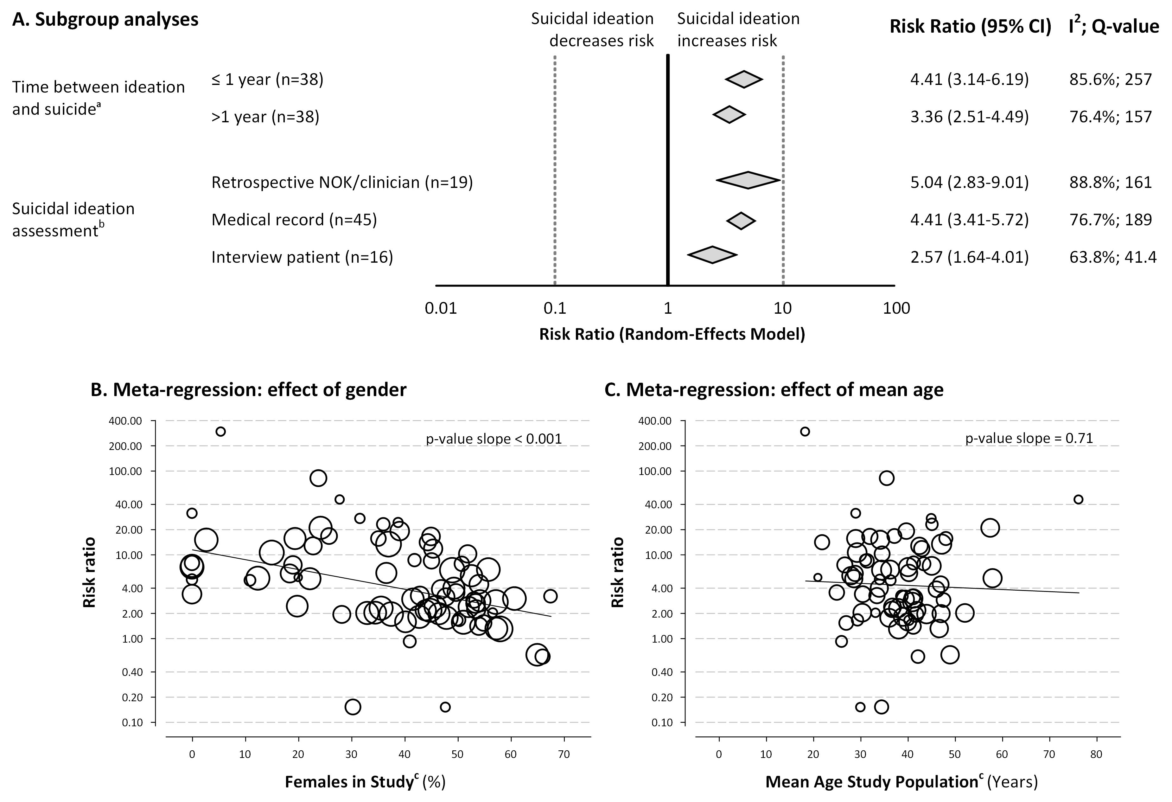
p-value=0.08
p-value=0.23

Supplementary Figure 1. Subgroup analyses showing the association between the expression of suicidal ideation and subsequent completed suicide in different subgroups.
CI indicates confidence interval; NOK, next of kin. B & C: Maximum likelihood meta-regression analysis with % of females in study (for B) and mean age of the study population (for C) as determinant and log_{e}-transformed risk ratio as outcome presented on logarithmic scales. The bubble size is proportional to the study’s weight.ª Total does not add up to 81, as in 8 studies the time interval could not be extracted and in 3 studies separate outcomes for ≤ and > 1 year were reported. When suicidal ideation was assessed at admission and suicide during admission, we assumed a time ≤ 1 year unless otherwise specified in the article. ^{b} Total does not add up to 81, as suicidal ideation assessment method was missing in 1 study. The subgroup medical record also includes studies that assessed suicidal ideation using military records, the subgroup interview patient includes both studies that used face-to-face interviews and those that used self-report questionnaires. ^{c} In 2 studies the % of females and in 9 studies the mean age of the study population was not provided.
Supplement S5 Publication bias
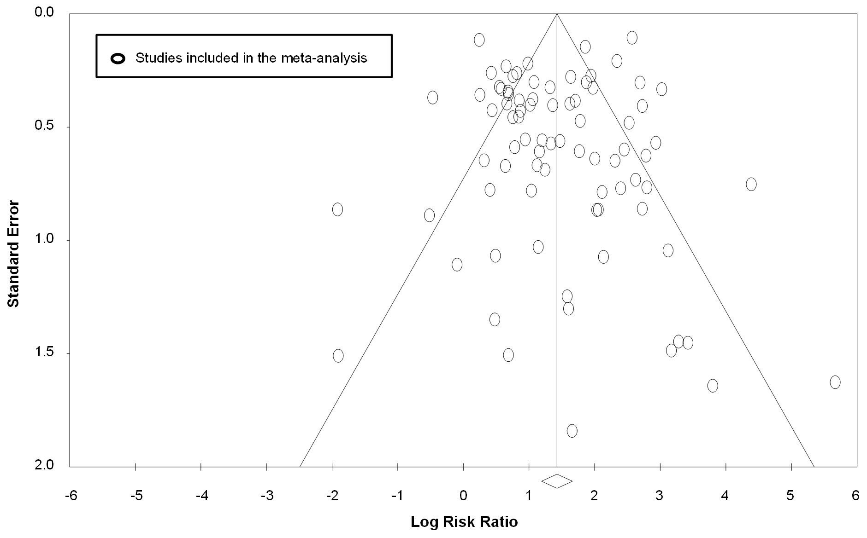
Supplementary Figure 2. Funnel plot displaying effect estimates from included studies.
Egger’s test for funnel plot asymmetry: 2-tailed p-value=0.94

