Appendix A: Experiment Instructions
(Group and Between-Responder Communication Treatment)
Instructions – Part I (Periods 1-12)
This is an experiment in the economics of multi-person strategic decision making. The National Science Foundation has provided funds for this research. If you follow the instructions and make appropriate decisions, you can earn an appreciable amount of money. The currency used in the experiment is francs. Your francs will be converted to U.S. Dollars at a rate of 8 francs to one dollar. At the end of today’s session, you will be paid in private and in cash.
It is important that you remain silent and do not look at other people’s work. If you have any questions, or need assistance of any kind, please raise your hand and an experimenter will come to you. If you talk, laugh, exclaim out loud, etc., you will be asked to leave and you will not be paid. We expect and appreciate your cooperation.
The experiment consists of 36 decision making periods. The experiment is divided into three parts, and each part consists of 12 decision making periods. We are now reading the instructions for Part I, and instructions for the other parts will be made available later. The 18 participants in today’s experiment will be randomly split between three equal-sized groups, designated as Person 1, Person 2 and Person 3 groups. If you are designated as a Person 1, then you remain in this same role throughout all the three parts of the experiment. Participants who are not designated as a Person 1 switch randomly between the Person 2 and Person 3 roles at specific points in the experiment when the participants are re-grouped, as explained later.
At the beginning of this experiment you will be randomly grouped with two other participants to form a three-person group, with one person of each type in each group. You will be grouped with these same two participants for 12 periods throughout Part I of the experiment. At the end of the 12th period, all participants will be re-grouped, as explained later after the completion of Part I of the experiment.
Your Choice in Part I
During each period, you and all other participants will make one choice. Earnings tables are provided on separate papers which tell you the earnings you receive given the choices that you and others in your group make during Part I of the experiment. If you are Person 1 then you choose the earnings square, either A, B, C or D. You make this choice before the other two people in your group make their choice, on a decision screen as shown in Figure 1 on the next page.
After learning which earnings square the Person 1 chose, then Persons 2 and 3 make their choices, on a decision screen as shown in Figure 2 on the next page. They make this choice simultaneously; for example, if you are Person 2 then you do not learn the choice of Person 3 until after you make your choice. Both Persons 2 and 3 may choose either X or Y.

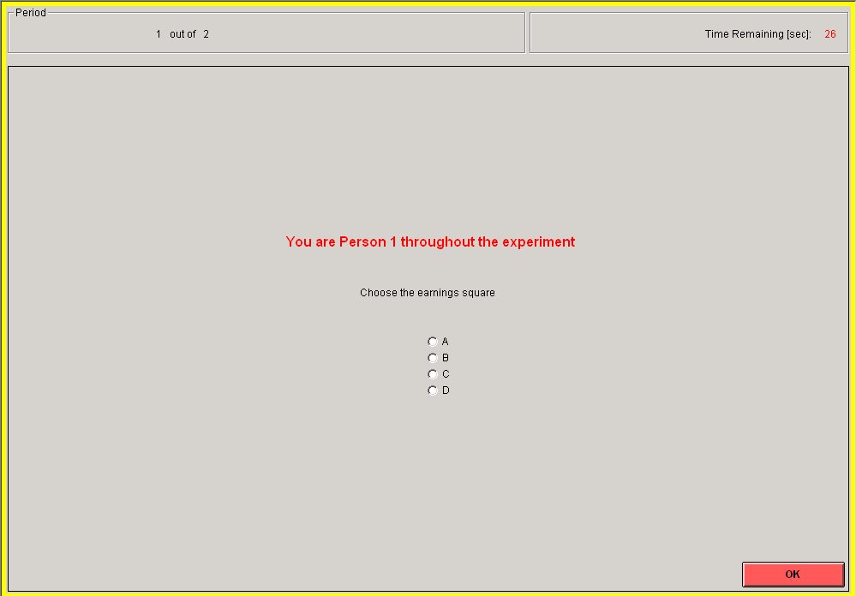
Decision Screen for Person 1

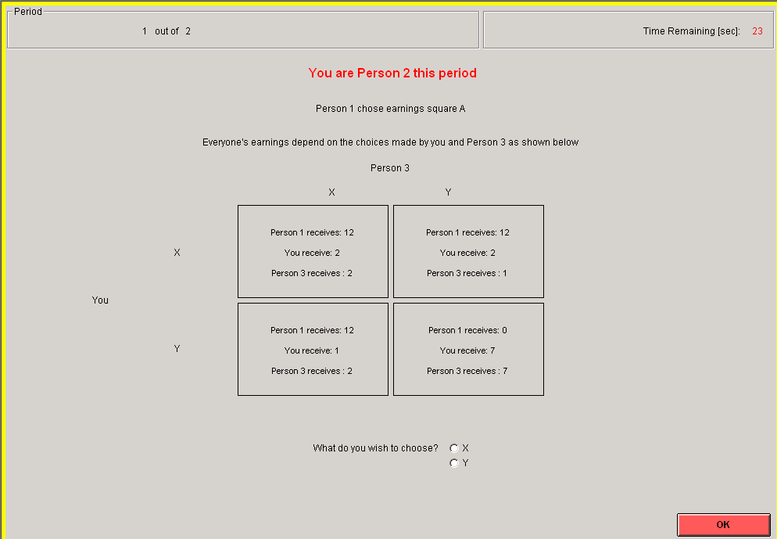
Decision Screen for Person 2 (Person 3’s is very similar)

Your earnings from the choices each period are found in the box determined by you and the other two people in your group. If both Persons 2 and 3 choose X, then earnings are paid as shown in the box in the upper left on the screen. If both Persons 2 and 3 choose Y, then earnings are paid as shown in the box in the lower right on the screen. The other two boxes indicate earnings when one chooses X and the other chooses Y. To illustrate with a random example: if Person 1 chooses earnings square A, Person 2 chooses X and Person 3 chooses Y, then Person 1 earns 12, Person 2 earns 2, and Person 3 earns 1. You can find these amounts by looking at the appropriate square and box in your page of earnings tables.

The End of the Period in Part I
After everyone has made choices for the current period you will be automatically switched to the outcome screen, as shown below. This screen displays your choice as well as the choices of the people in your group. It also shows your earnings for this period and your earnings for Part I of the experiment so far.
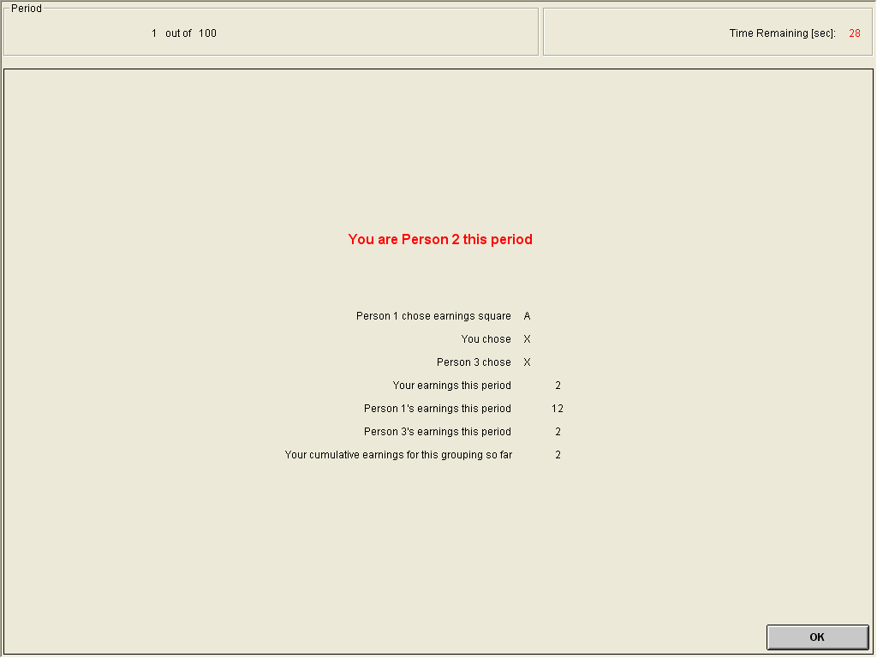
Example Outcome Screen (Shown for Person 2)

Once the outcome screen is displayed you should record your choice and the choice of the others in your group on your Personal Record Sheet for Part I. Also record your current and cumulative earnings for this period. Click on the OK button on the lower right of your screen when the experimenter instructs you.
The Ending to Part I
Recall that Part I will last for 12 periods, that is, from periods 1-12 of the experiment. You will be grouped with the same two participants for 12 periods throughout Part I of the experiment. At the end of the 12th period, the current grouping for Part I will be terminated.
We will now pass out a questionnaire to make sure that all participants understand how to read the earnings tables and understand other important features of these instructions for Part I of the experiment. Please fill it out now. Raise your hand when you are finished and we will collect it. If there are any mistakes on any questionnaire, I will summarize the relevant part of the instructions again. Do not put your name on the questionnaire.
Earnings Tables– Person 1
Earnings Square A:
Person 3’s Choice
 |  | X | Y
 | X | Person 1 receives 12  Person 2 receives 2  Person 3 receives 2 | Person 1 receives 12  Person 2 receives 2  Person 3 receives 1
Person 2’s Choice:
 | Y | Person 1 receives 12  Person 2 receives 1  Person 3 receives 2 | Person 1 receives 0  Person 2 receives 7  Person 3 receives 7

Earnings Square B:
Person 3’s Choice
 |  | X | Y
 | X | Person 1 receives 8  Person 2 receives 2  Person 3 receives 9 | Person 1 receives 8  Person 2 receives 2  Person 3 receives 8
Person 2’s Choice:
 | Y | Person 1 receives 8  Person 2 receives 1  Person 3 receives 9 | Person 1 receives 0  Person 2 receives 7  Person 3 receives 7

Earnings Square C:
Person 3’s Choice
 |  | X | Y
 | X | Person 1 receives 8  Person 2 receives 9  Person 3 receives 2 | Person 1 receives 8  Person 2 receives 9  Person 3 receives 1
Person 2’s Choice:
 | Y | Person 1 receives 8  Person 2 receives 8  Person 3 receives 2 | Person 1 receives 0  Person 2 receives 7  Person 3 receives 7

Earnings Square D:
Person 3’s Choice
 |  | X | Y
 | X | Person 1 receives 6  Person 2 receives 8  Person 3 receives 8 | Person 1 receives 6  Person 2 receives 8  Person 3 receives 7
Person 2’s Choice:
 | Y | Person 1 receives 6  Person 2 receives 7  Person 3 receives 8 | Person 1 receives 0  Person 2 receives 7  Person 3 receives 7
Earnings Tables - Use this sheet when designated as Person 2
Earnings Square A:
Person 3’s Choice
 |  | X | Y
 | X | Person 1 receives 12  You receive 2  Person 3 receives 2 | Person 1 receives 12  You receive 2  Person 3 receives 1
You
 | Y | Person 1 receives 12  You receive 1  Person 3 receives 2 | Person 1 receives 0  You receive 7  Person 3 receives 7

Earnings Square B:
Person 3’s Choice
 |  | X | Y
 | X | Person 1 receives 8  You receive 2  Person 3 receives 9 | Person 1 receives 8  You receive 2  Person 3 receives 8
You
 | Y | Person 1 receives 8  You receive 1  Person 3 receives 9 | Person 1 receives 0  You receive 7  Person 3 receives 7

Earnings Square C:
Person 3’s Choice
 |  | X | Y
 | X | Person 1 receives 8  You receive 9  Person 3 receives 2 | Person 1 receives 8  You receive 9  Person 3 receives 1
You
 | Y | Person 1 receives 8  You receive 8  Person 3 receives 2 | Person 1 receives 0  You receive 7  Person 3 receives 7

Earnings Square D:
Person 3’s Choice
 |  | X | Y
 | X | Person 1 receives 6  You receive 8  Person 3 receives 8 | Person 1 receives 6  You receive 8  Person 3 receives 7
You
 | Y | Person 1 receives 6  You receive 7  Person 3 receives 8 | Person 1 receives 0  You receive 7  Person 3 receives 7

Personal Record Sheet for a Person 2 or 3-Part I (Periods 1-12)

Period | Person 1’s Choice  (circle one) | Your Person Number  (circle) | Your choice  (circle) | Other Person 2 or 3’s choice | Your earnings this period | Total earnings in Part I of the  experiment so far
1 | A B C D | 2 3 | X Y | X Y
2 | A B C D | 2 3 | X Y | X Y
3 | A B C D | 2 3 | X Y | X Y
4 | A B C D | 2 3 | X Y | X Y
5 | A B C D | 2 3 | X Y | X Y
6 | A B C D | 2 3 | X Y | X Y
7 | A B C D | 2 3 | X Y | X Y
8 | A B C D | 2 3 | X Y | X Y
9 | A B C D | 2 3 | X Y | X Y
10 | A B C D | 2 3 | X Y | X Y
11 | A B C D | 2 3 | X Y | X Y
12 | A B C D | 2 3 | X Y | X Y

Total earnings in Part I: _______(Francs)
Instructions--Part II (Periods 13-24)
At the beginning of the 13th period, you will be randomly grouped with eight other participants to form a nine-person group. Each nine-person group will consist of three of those participants who were randomly chosen to be person 1 in the beginning of the experiment, and six of those participants who were chosen as persons 2 or 3 in the beginning of the experiment. The three person 1 participants will form a three member Team 1 for Part II of the experiment. Three of the other six participants who were chosen as persons 2 or 3 in the beginning of the experiment will be randomly grouped together to form a Team 2, and the remaining other three participants will be grouped together to form a Team 3. You will be grouped with these same eight participants for 12 periods throughout Part II of the experiment, that is, from periods 13-24 of the experiment, and you will always belong to the same three-person team that you are randomly assigned to in the beginning of Part II of the experiment. At the end of the 24th period, all participants will be re-grouped, as explained later at the beginning of Part III.
Your Choice in Part II
During each period, you and all other participants will make one choice. Earnings tables for Part II are provided on separate papers, which tell you the earnings each participant receives given the choices that your team and the other two teams in your group make. Your earning in each period will be one-third of your team’s earning in that period. Team 1 chooses the earnings square, either A, B, C or D. Team 1 make this choice before the other Teams 2 and 3 make their choice. Before making their team’s actual choice, members in Team 1 have an opportunity to privately communicate with each other for 1 minute in a chat window. (After period 16 of the experiment this chat period will be reduced to 40 seconds.) After the communication, each member of Team 1 will indicate the earning square he/she wants his/her team to choose in an individual decision screen for members of Team 1 shown in the figure below.
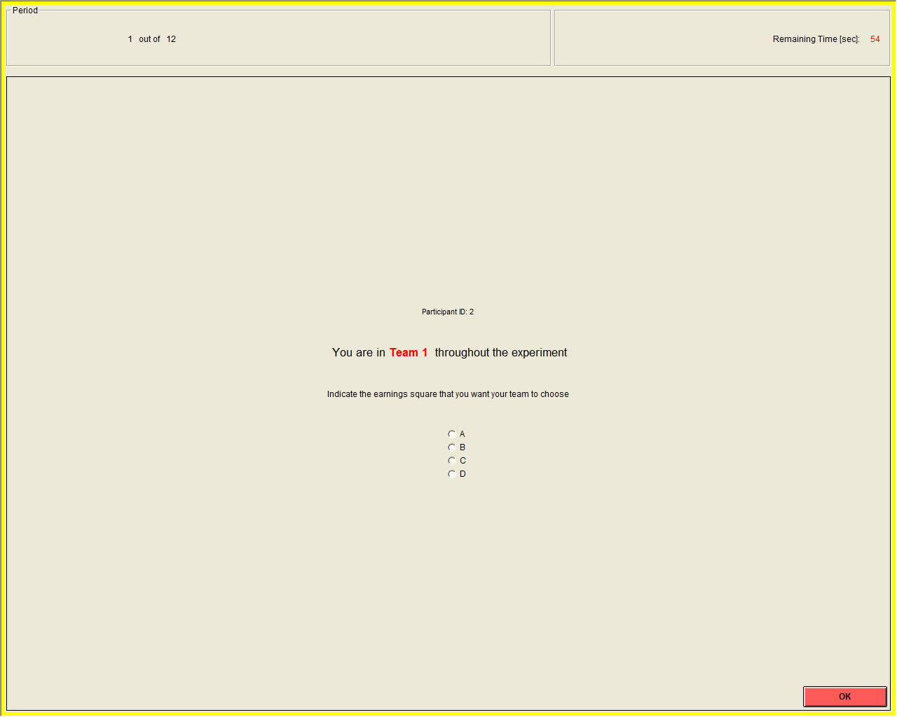
Decision Screen for a member of Team 1
If all members of Team 1 agree on a particular earning square, then the computer will implement this as the action chosen by Team 1. If there is disagreement, then members of Team 1 will have 5 more rounds to reach a unanimous decision, but with no additional opportunity to chat during these rounds. During each round, members of Team 1 will be asked to indicate the earning square that he/she wants his/her team to choose. If a unanimous decision is reached in any round, then that unanimous decision will be implemented by the computer. If members of Team 1 fail to reach a unanimous decision after 6 rounds, the computer will randomly choose one of the earning squares among those that were indicated as preferred choices by members of Team 1 in the last (that is, the 6th) round.
After learning which earnings square Team 1 chose, then Teams 2 and 3 make their choices simultaneously. That is, if you are a member of Team 2 then you do not learn the choice of Team 3 until after you make your choice. Both Teams 2 and 3 may choose either X or Y. However, after learning Team 1’s earnings square choice but before making their team’s actual choice, the six participants who are designated as members of Team 2 or Team 3 will have the opportunity to privately communicate among themselves in a chat window for 90 seconds.(After period 16 of the experiment this chat period will be reduced to 1 minute.). Although we will record the messages that you send, only you and the other participants who are designated as members of Team 2 or Team 3 in your nine-person group will see them. The participants who are designated as members of Team 1 will not observe these chat messages.
After the six participants who are designated as members of Team 2 or Team 3 privately communicate among themselves, each member in Team 2 and Team 3 has an opportunity to privately communicate with other members in his/her own three-person team for 1 minute in a separate chat window. (After period 16 of the experiment this chat period will be reduced to 40 seconds.) That is, this communication will only take place separately in two chat windows among the three members of a Team 2 or Team 3. After this communication, each member of a Team 2 or Team 3 will indicate the action he/she wants his/her team to choose in an individual decision screen as shown in the figure below.
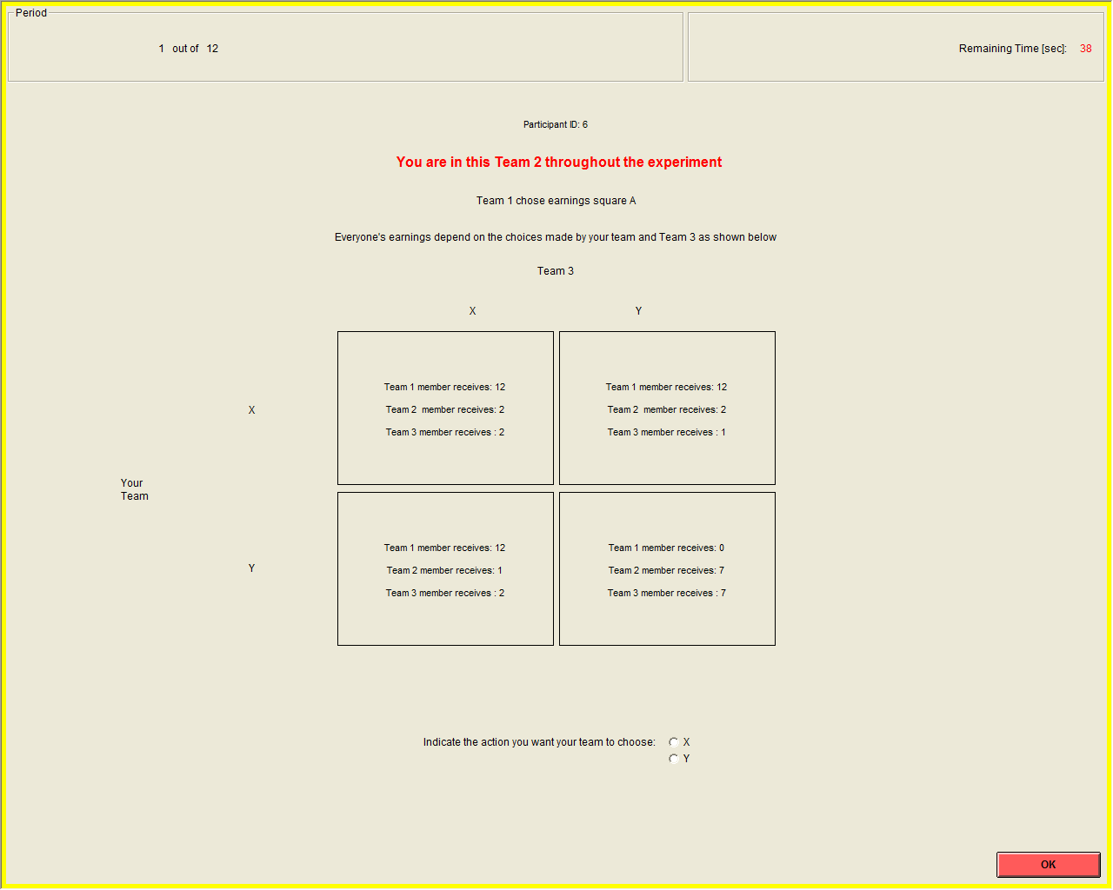
Decision Screen for a member of Team 2 (Team 3 member’s is very similar)

If all members of a Team 2 or Team 3 agree on a particular action, then the computer will implement this as the action chosen by the team. If there is disagreement, then members of a Team 2 or Team 3 will have 5 more rounds to reach a unanimous decision, but with no additional opportunity to chat during these rounds. During each round, members of a Team 2 or Team 3 will be asked to indicate the action he/she wants his/her team to choose. If a unanimous decision is reached in any round, then that unanimous decision will be implemented by the computer. If members of Team 2 or Team 3 fail to reach a unanimous decision after 6 rounds, the computer will randomly choose one of the actions among those that were indicated as preferred choices by members of the team in the last (that is, the 6th) round.
To sum up, regardless of what team you are in, before you indicate your preferred choice for your team, you will have the opportunity to privately communicate with the other two persons in your own team. Although we will record the messages that you send, only you and the other two persons in your own team will see them. For example, if you are a member of Team 1, you will be communicating with the other two members in your team, but members in Team 2 and Team 3 will not observe your chat messages. In addition, after learning Team 1’s earnings square choice, the six participants who are members of Team 2 or Team 3 will have the opportunity to privately communicate among themselves. The participants who are members of Team 1 will not observe these chat messages. This communication between the six participants who are members of Team 2 or Team 3 will take place after they learn Team 1’s earnings square choice but before the separate communication that will take place between the three members of a Team 2 or Team 3. Note, in sending messages back and forth between you and the other persons we request that you follow two simple rules: (1) Be civil to each other and use no profanity and (2) Do not attempt to identify yourself in any way.

The End of the Period in Part II
After every team has made choices for the current period you will be automatically switched to the outcome screen, as shown on the next page. This screen displays each team’s choice as well as the choices of the other teams in your group. It also shows your team’s earnings and your earnings for this period and your earnings for Part II of the experiment so far. Once the outcome screen is displayed you should record the relevant information on your Personal Record Sheet for Part II.

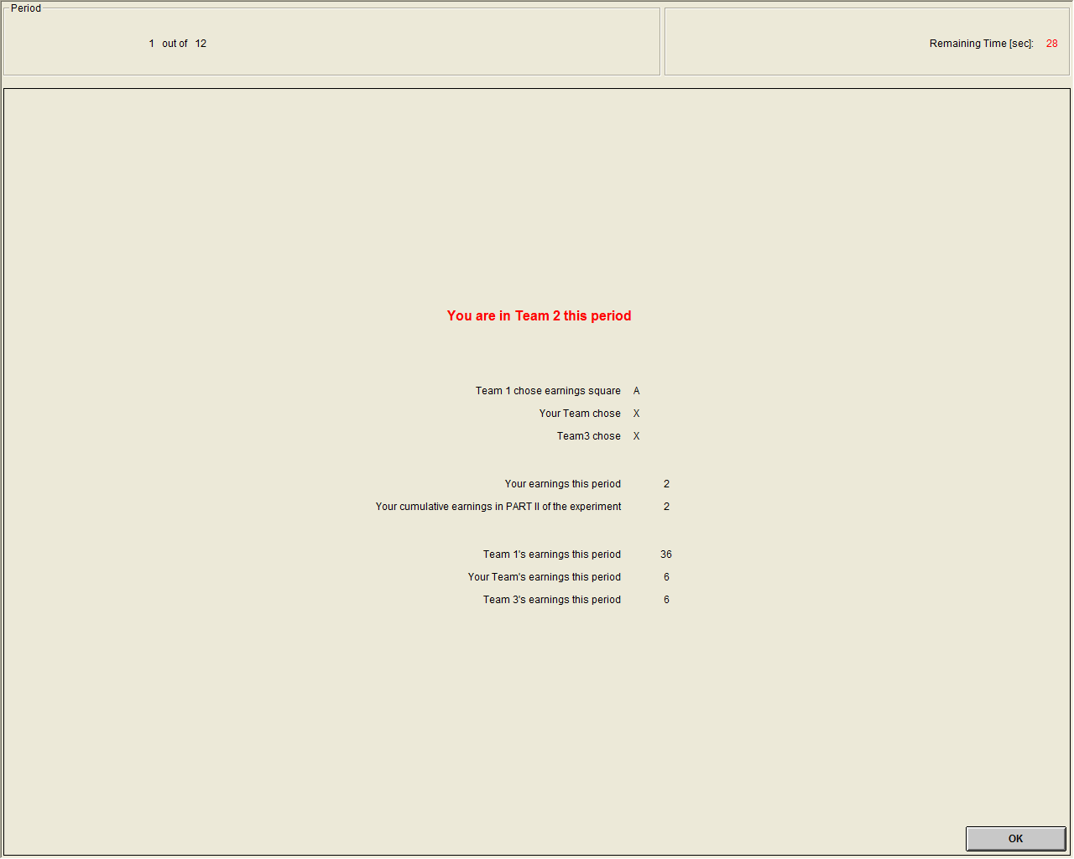
Example Outcome Screen (Shown for a member of Team 2)

The Ending to Part II
Recall that Part II will last for 12 periods, that is, from periods 13-24 of the experiment. You will be grouped with the same eight participants throughout Part II, and you always remain in the same team. At the end of the 24th period, the current grouping for Part II will be terminated.
We will now pass out a questionnaire to make sure that all participants understand how to read the earnings tables and understand other important features of these instructions for Part II of the experiment. Please fill it out now. Raise your hand when you are finished and we will collect it. If there are any mistakes on any questionnaire, I will summarize the relevant part of the instructions again. Do not put your name on the questionnaire.

Instructions--Part III (Periods 25-36)
At the beginning of the 25th period, you will be randomly grouped with two other participants to form a three-person group, with one person of each type in each group. You will be grouped with these same two participants for 12 periods throughout Part III of the experiment, that is, from periods 25-36 of the experiment. You will make choices according to the same rules as those in Parts I and II, however you will not be matched with any of the two participants that you were matched with in either Part I or Part II to form the three person group in this last Part of the experiment.

