Impaired long-term outcomes of patients with schizophrenia spectrum disorder after coronary artery bypass surgery: nationwide case-control study

Mika Kallio, MD¹ , Jyrki Korkeila MD PhD^{2,3}, Markus Malmberg, MD, PhD⁴, Jarmo Gunn, MD, PhD⁴, Päivi Rautava, MD, PhD^{5,6}, Päivi Korhonen, MD, PhD⁷, and Ville Kytö, MD, PhD^{4,8,9,10,11}

¹Department of Psychiatry, University of Turku and Turku University Hospital, Turku, Finland.
²Department of Psychiatry, Hospital District of Satakunta, Pori, Finland.
³Heart Center, Turku University Hospital and University of Turku, Turku, Finland.
⁴Department of Public Health, University of Turku, Turku, Finland,
⁵Turku Clinical Research Centre, Turku University Hospital, Turku, Finland.
⁶Department of General Practice, University of Turku and Turku University Hospital, Turku, Finland.
⁷Research Center of Applied and Preventive Cardiovascular Medicine, University of Turku, Turku, Finland.
⁸Center for Population Health Research, Turku University Hospital and University of Turku, Turku, Finland
⁹Administrative Center, Hospital District of Southwest Finland, Turku, Finland
¹⁰Department of Public Health, Faculty of Medicine, University of Helsinki, Helsinki, Finland.

Correspondence:
Ville Kytö, MD PhD
Heart Center, Turku University Hospital
PO Box 52, 20521 Turku, Finland
Tel.: +358 2 3130000
email: ville.kyto@utu.fi

Figures

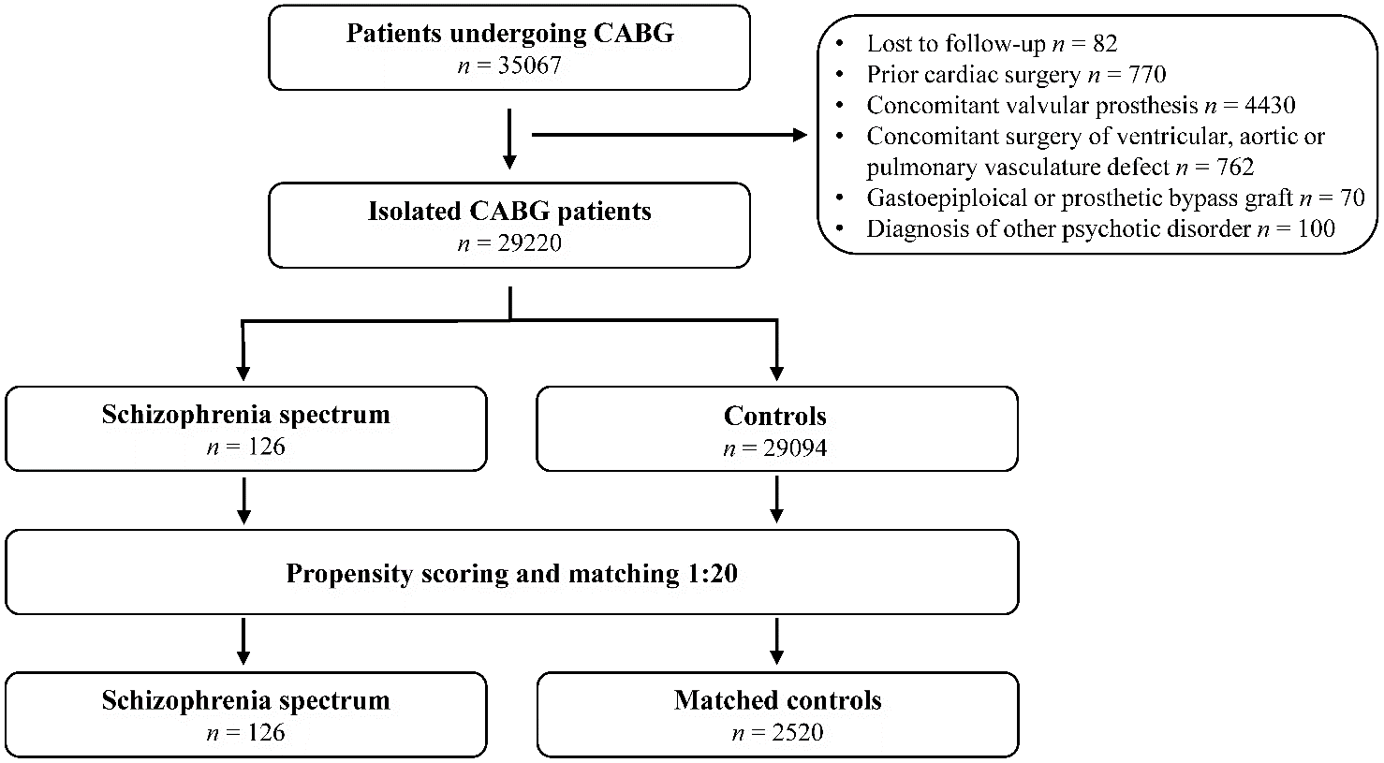

Supplemental Figure 1. Study flowchart. CABG = coronary artery bypass grafting surgery

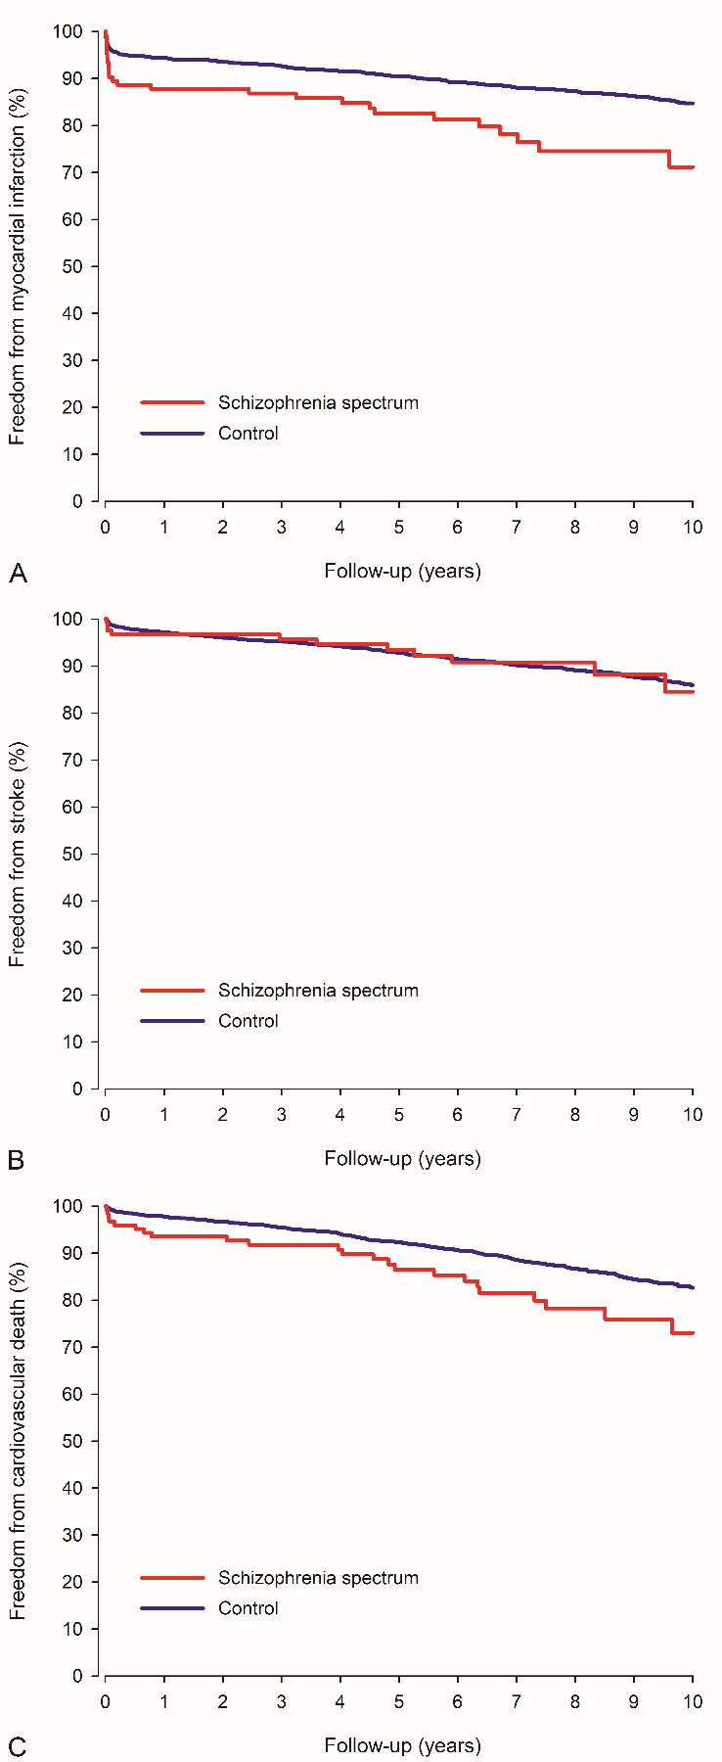

Supplemental Figure 2. Freedom from myocardial infarction (A), stroke (B), and cardiovascular death (C) in patients with schizophrenia spectrum disorder and in matched control patients after coronary artery bypass grafting.

Drug |  | ATC codes
ADP inhibitor |  | B01AC04 , B01AC05, B01AC22, B01AC24
Anticoagulant |  | B01AA, B01AE, B01AF, B01AX06
Antidepressant |  | N06A, N06CA
Antidiabetic |  | A10
 | Insulin | A10A
 | Non-insulin | A10B
Antipsychotic |  | N05A, N06CA01, N06CA02, N06CA03
ACEi or ARB |  | C09, C10BX04, C10BX06, C10BX07, C10BX10, C10BX11, C10BX12, C10BX13, C10BX14, C10BX15
Antiarrhythmic |  | C01B
Benzodiazepine |  | N05BA, N05CD
Beta-blocker |  | C07, C09BB, C09DA, C09BX02, C09DX05
Calcium channel blocker |  | C08, C07FB, C09BB, C09DB, C09DX01, C09DX03, C09DX06, C09XA53, C09XA54, C10BX03, C10BX07, C10BX09, C10BX11, C10BX14
Digitalis |  | C01A
Diuretic |  | C03, C02L, C07B, C07C, C07D, C08G, C09BA, C09DA, C09BX01, C09BX03, C09DX01, C09DX03, C09DX05, C09DX06, C10BX13
Nitrate |  | C01DA
Statin |  | C10AA, C10BA, C10BX

Supplemental Table 1. Anatomical Therapeutic Chemical (ATC) classification codes for studied cardiovascular prescription drugs. ADP = adenosine diphosphate, ACEi = angiotensin-converting enzyme inhibitor, ARB = angiotensin receptor blocker.

Statin | Low or moderate | High
 | mg/day | mg/day
Atorvastatin | < 40 | ≥ 40
Fluvastatin | Any | -
Lovastatin | Any | -
Pravastatin | Any | -
Rosuvastatin | < 20 | ≥ 20
Simvastatin | < 80 | ≥ 80

Supplemental Table 2. Definitions for intensity of statin therapy. Intensity of therapy after coronary artery bypass grafting was determined from first drug purchase after hospital discharge.

Outcome (10-year) |  |  |  |  | Proportion of patients with SCZ | Univariable |  | Multivariable
 |  |  | Variable |  | Proportion of patients with SCZ | HR/sHR (95% CI) | P-value | HR/sHR (95% CI) | P-value
All-cause mortality
 | Psychiatric ward admission |  |  |  | 7.6% | 1.53 (0.54-4.37) | 0.422 | 0.91 (0.21-4.00) | 0.901
 | Antipsychotic
 |  |  |  | Any usage | 75.4% | 1.27 (0.55-2.92) | 0.571 | 0.89 (0.25-3.15) | 0.857
 |  |  |  | Regular usage | 58.6% | 1.01 (0.51-1.99) | 0.986 | 1.07 (0.41-2.75) | 0.896
 | Antidepressant
 |  |  |  | Any usage | 28.0% | 0.90 (0.41-2.00) | 0.802 | 1.55 (0.46-5.30) | 0.482
 |  |  |  | Regular usage | 13.6% | 1.60 (0.66-3.87) | 0.297 | 3.41 (0.76-15.33) | 0.109
 |  | Benzodiazepine
 |  |  |  | Any usage | 22.0% | 1.14 (0.50-2.62) | 0.761 | 1.59 (0.53-4.74) | 0.409
 |  |  |  | Regular usage | 19.5% | 1.37 (0.60-3.15) | 0.460 | 2.02 (0.69-5.99) | 0.202
MACE
 | Psychiatric ward admission |  |  |  | 7.6% | 1.31 (0.51-3.33) | 0.578 | 0.51 (1.12-2.11) | 0.350
 | Antipsychotic
 |  |  |  | Any usage | 75.4% | 0.98 (0.49-1.97) | 0.962 | 0.84 (0.35-2.02) | 0.702
 |  |  |  | Regular usage | 58.6% | 0.97 (0.52-1.79) | 0.912 | 0.91 (0.39-2.13) | 0.911
 | Antidepressant
 |  |  |  | Any usage | 28.0% | 0.81 (0.39-1.69) | 0.569 | 0.95 (0.29-3.10) | 0.927
 |  |  |  | Regular usage | 13.6% | 0.92 (0.37-2.29) | 0.851 | 1.23 (0.38-3.95) | 0.729
 | Benzodiazepine
 |  |  |  | Any usage | 22.0% | 1.00 (0.46-2.18) | 0.999 | 1.35 (0.58-3.13) | 0.491
 |  |  |  | Regular usage | 19.5% | 1.19 (0.55-2.60) | 0.658 | 1.73 (0.72-4.17) | 0.223

Supplemental Table 3. Association of psychiatric ward admission and psychiatric medications (antipsychotic, antidepressant, or benzodiazepine) before coronary artery bypass surgery with 10-year all-cause mortality and major adverse cardiovascular event (MACE) in patients with schizophrenia spectrum disease (SCZ). HR = hazard ratio, CI = confidence interval, sHR = subdistribution HR. Multivariable models were adjusted according to age, sex, atrial fibrillation, cerebrovascular disease, chronic pulmonary disease, diabetes, heart failure, hypertension, malignancy, myocardial infarction (new and prior), peripheral vascular disease, rheumatic disease, renal failure, type of bypass graft, off-pump surgery, number of grafted anastomoses, and surgical center.

