Appendix A. Descriptive Statistics

Table A1: Descriptives
Variable | YouGov | United States Census Bureau
Gender
Male | 49.05% | 48.60%
Female | 50.95% | 51.40%
Age
34 and under | 23.85% | 26.36%
35 - 54 | 28.18% | 34.91%
55 - 64 | 26.70% | 17.65%
65+ | 21.27% | 21.08%
Education
Less than high school | 3.25% | 8.87%
High school graduate / GED | 37.80% | 28.85%
Some college / associate degree | 31.17% | 30.14%
Bachelor’s degree or higher | 27.78% | 32.14%
Employment
Employed | 45.12% | 58.23%
Unemployed | 9.21% | 5.08%
Not in labor force | 43.09% | 36.26%
Household income
$29,999 and under | 23.04% | 25.04%
$30,000 - $59,999 | 28.32% | 26.34%
$60,000 - $99,999 | 21.95% | 23.39%
$100,000+ | 12.06% | 25.23%
Median | $40,000 - $49,999 | $58,096
Marital status
Single | 22.76% | 26.89%
Married | 56.64% | 53.11%
Separated | 0.95% | 1.56%
Widowed | 4.88% | 6.79%
Divorced | 10.57% | 11.64%
Domestic partnership | 4.20% | N/A
Note: This table compares the YouGov data used in the green card experiment to data on white Americans provided by the United States Census Bureau. All United States Census Bureau data comes from American FactFinder, the American Community Survey (ACS) Five-Year Estimates, 2009 – 2013. Values in the table display the share of the given population that encompasses each value of a variable (with the exception of the household income medians). Census Bureau data on respondents’ gender and age includes respondents who are 18 years and older, educational data pertains to respondents who are 25 years and older, employment status represents people who are 16 years and older, and marital status applies to those who are 15 years and older. All YouGov data includes respondents who are 18 years and older. Among YouGov respondents, 19 people (2.57%) did not provide employment information, and 108 individuals (about 15%) preferred not to state their income. The United States Census Bureau data does not provide information on domestic partnerships.

Appendix B. Question Wording
Experimental Conditions
- Mexican, fluent in English, American football fan:
“Juan Martinez is a Mexican immigrant. He is 33 years old and married, but has no children. He is in the United States on a temporary visa and works in construction. Juan is fluent in English. He enjoys spending time cheering for his favorite NFL football team.”
- European, fluent in English, American football fan:
“[Jakub Kowalski / Ivan Kuznetsov / Maxim Kovalenko / Victor Jensen / Bram Jansen] is a [Polish / Russian / Ukrainian / Danish / Dutch] immigrant. He is 33 years old and married, but has no children. He is in the United States on a temporary visa and works in construction. [Jakub / Ivan / Maxim / Victor / Bram] is fluent in English. He enjoys spending time cheering for his favorite NFL football team.”
- Note: After being assigned to a European condition, respondents were assigned
to one of five possible European immigrants. The order that the names are listed in the brackets corresponds to the respective country that appears in brackets. In other words, Jakub Kowalski is from Poland, Ivan Kuznetsov is from Russia, etcetera.
- Mexican, not fluent in English, American football fan:
“Juan Martinez is a Mexican immigrant. He is 33 years old and married, but has no children. He is in the United States on a temporary visa and works in construction. Juan is not fluent in English. He enjoys spending time cheering for his favorite NFL football team.”
- European, not fluent in English, American football fan:
“[Jakub Kowalski / Ivan Kuznetsov / Maxim Kovalenko / Victor Jensen / Bram Jansen] is a [Polish / Russian / Ukrainian / Danish / Dutch] immigrant. He is 33 years old and married, but has no children. He is in the United States on a temporary visa and works in construction. [Jakub / Ivan / Maxim / Victor / Bram] is not fluent in English. He enjoys spending time cheering for his favorite NFL football team.”
- Mexican, fluent in English, foreign soccer fan:
“Juan Martinez is a Mexican immigrant. He is 33 years old and married, but has no children. He is in the United States on a temporary visa and works in construction. Juan is fluent in English. He enjoys spending time cheering for the Mexican National Soccer Team.”
- European, fluent in English, foreign soccer fan:
“[Jakub Kowalski / Ivan Kuznetsov / Maxim Kovalenko / Victor Jensen / Bram Jansen] is a [Polish / Russian / Ukrainian / Danish / Dutch] immigrant. He is 33 years old and married, but has no children. He is in the United States on a temporary visa and works in construction. [Jakub / Ivan / Maxim / Victor / Bram] is fluent in English. He enjoys spending time cheering for the [Polish / Russian / Ukrainian / Danish / Dutch] National Soccer Team.”
- Mexican, not fluent in English, foreign soccer fan:
“Juan Martinez is a Mexican immigrant. He is 33 years old and married, but has no children. He is in the United States on a temporary visa and works in construction. Juan is not fluent in English. He enjoys spending time cheering for the Mexican National Soccer Team.”
- European, not fluent in English, foreign soccer fan:
“[Jakub Kowalski / Ivan Kuznetsov / Maxim Kovalenko / Victor Jensen / Bram Jansen] is a [Polish / Russian / Ukrainian / Danish / Dutch] immigrant. He is 33 years old and married, but has no children. He is in the United States on a temporary visa and works in construction. [Jakub / Ivan / Maxim / Victor / Bram] is not fluent in English. He enjoys spending time cheering for the [Polish / Russian / Ukrainian / Danish / Dutch] National Soccer Team.”
Variables
- Prejudice: Stereotype Measure
• Before receiving the stereotype questions, respondents saw an introduction screen that
read: “Next we’ll show you scales on which the characteristics of the people in a group can be rated. Which group you will be asked about first was chosen randomly by the computer.”
• Respondents then read: “Where would you rate [group] in general on this scale?” The
word, “group” in the bracketed text was replaced with an ethnic or racial group, where all respondents were asked about African Americans, whites, and Hispanics.
• Respondents viewed two seven-point scales, under the stereotype questions. The poles
on one scale read “Hard-working” and “Lazy.” The poles on the second scale read, “Intelligent” and “Unintelligent.” Positive characteristics were represented by a value of one (intelligent and hardworking), negative characteristics were represented by a value of seven, or respondents could place themselves somewhere in between at points two through six.
• The final prejudice measure was created by summing responses to questions about
African Americans and Hispanics. The correlation coefficients for questions about African Americans and Hispanics are high (ranging between 0.42 and 0.78), allowing for a combination of the scores into one overall measure of anti-minority affect. The measure was recoded to range from 0 to one.
• Figure B1, below, displays the distribution of respondents along the prejudice measure.
- Ideology: “In general, how would you describe your own political viewpoint?”
• Answer options: Very liberal, liberal, moderate, conservative, and very conservative.
- Partisanship: “Generally speaking, do you think of yourself as a…?”
• Answer options: Democrat, Republican, independent, other, and not sure.
• People who identified as Democrats or Republicans were asked a follow-up question
(their party was piped in to the question, as reflected in the bracketed text): “Would you call yourself a strong [Democrat / Republican] or a not very strong [Democrat / Republican]?”
• Respondents who answered “independent,” “other,” or “not sure” were asked a different
follow-up question: “Do you think of yourself as closer to the Democratic or the Republican party?”
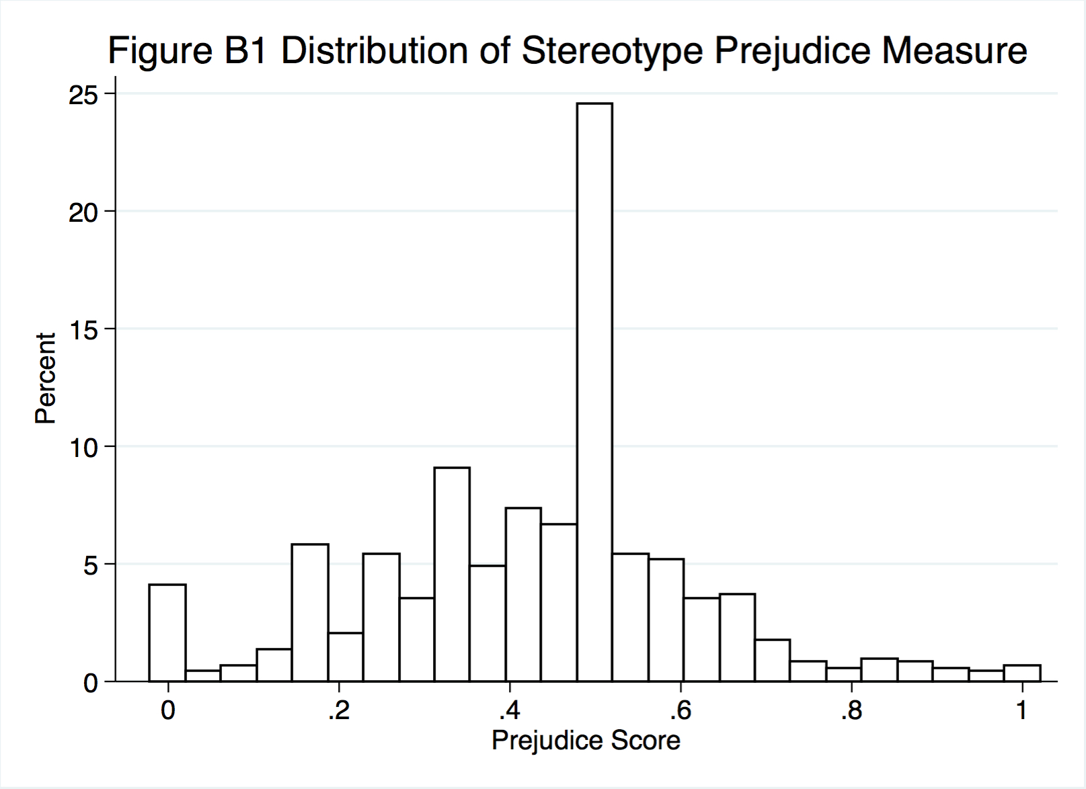
- Answer options: the Democratic party, the Republican party, neither, and not
sure.
• The final seven-point measure codes respondents as either strong Democrats, not very
strong Democrats, lean Democratic, independents, lean Republican, not very strong Republicans, or strong Republicans.
- Age: “In what year were you born?”
• Respondents entered their birth year in a text box.
• The measure ranges from 0 to one, where the youngest respondents are placed at 0 (18
years old) and the oldest respondent (93 years old) is coded as one.
- Education: “What is the highest level of education you have completed?”
• Answer options: Did not graduate from high school, high school graduate, some college
but no degree (yet), two-year college degree, four-year college degree, and postgraduate degree (MA, MBA, MD, JD, PhD, etc.).
- Gender: “Are you male or female?”
- Racial Resentment: “Do you agree or disagree with the following statements?” Respondents then evaluated the following four statements:
• Irish, Italians, Jews and many other minorities overcame prejudice and worked their
way up. Blacks should do the same without any special favors.
• Generations of slavery and discrimination have created conditions that make it difficult
for blacks to work their way out of the lower class.
• Over the past few years, blacks have gotten less than they deserve.
• It’s really a matter of people not trying hard enough; if blacks would only try harder
they could be just as well off as whites.
- Answer options for all statements: Disagree strongly, disagree somewhat, neither
agree nor disagree, agree somewhat, and agree strongly.

Appendix C. Prejudice
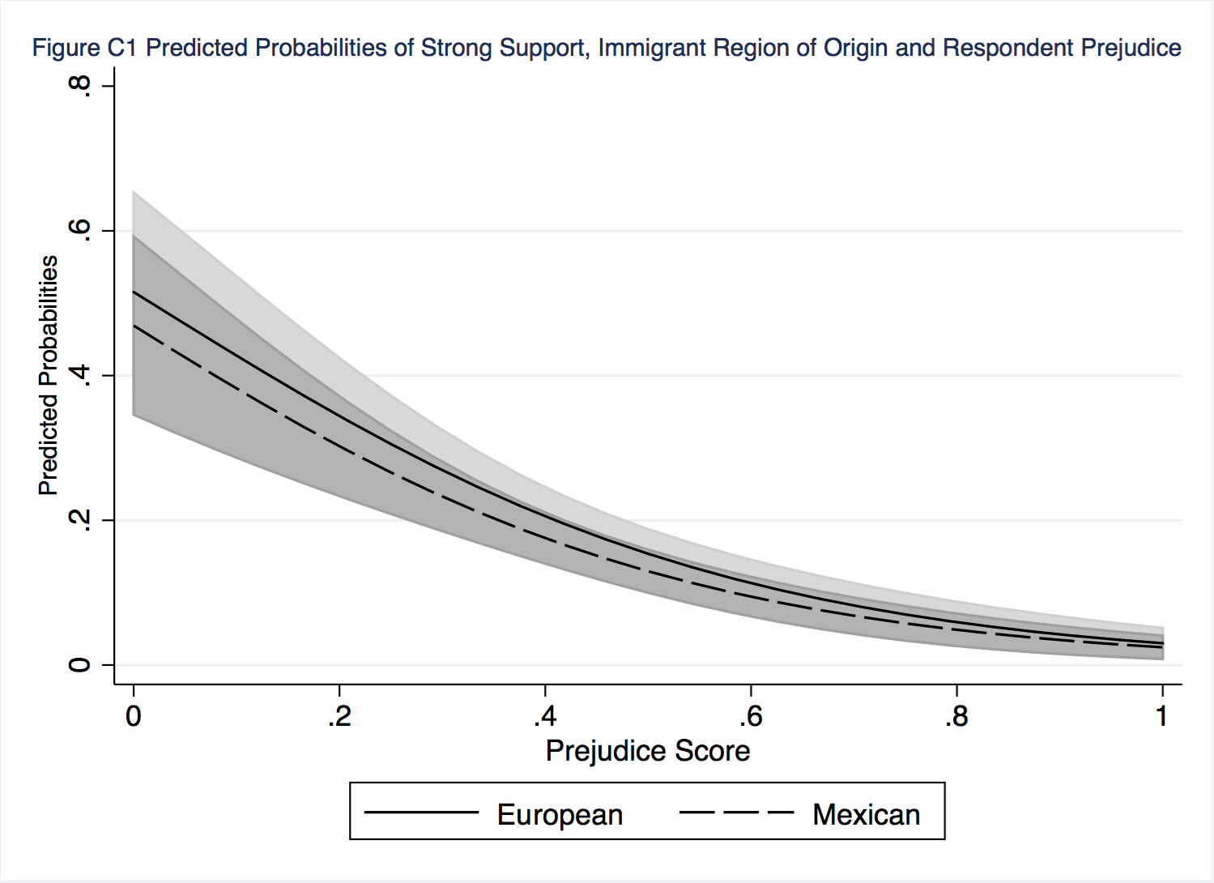
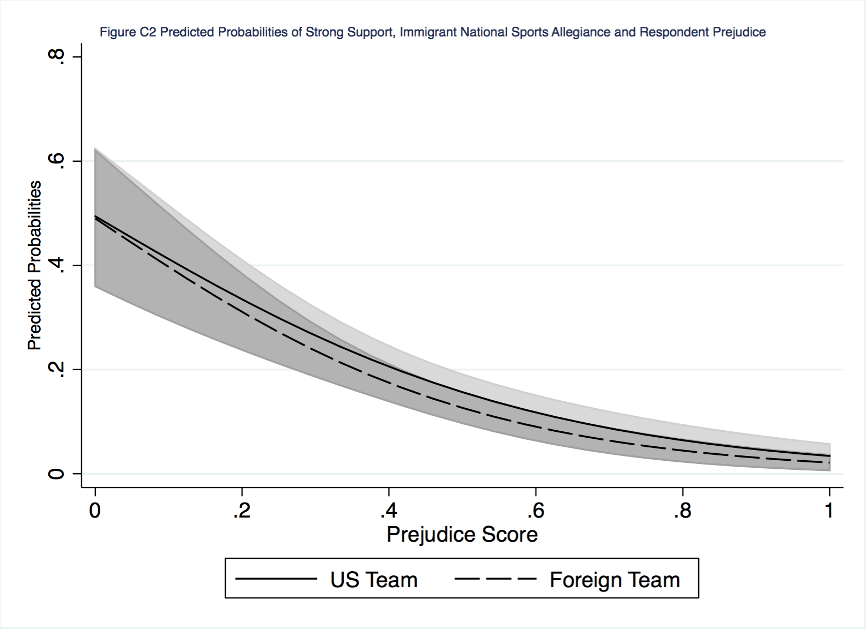

Appendix D. Partisanship
Table D1: Partisanship Interactions
 | I |  | II |  | III
Variable | ß | S.E. | ß | S.E. | ß | S.E.
Mexican | 0.11 | 0.23 | -0.20 | 0.14 | -0.20 | 0.14
Not fluent | -0.94*** | 0.14 | -1.03*** | 0.24 | -0.96*** | 0.14
Foreign team | -0.21 | 0.14 | -0.21 | 0.14 | 0.17 | 0.23
Party | 0.02 | 0.33 | -0.37 | 0.32 | -0.24 | 0.32
Mexican x party | -0.61 | 0.37
Not fluent x party |  |  | 0.15 | 0.38
Foreign team x party |  |  |  |  | -0.11 | 0.37
Age | -0.43 | 0.31 | -0.41 | 0.31 | -0.41 | 0.31
Education | 0.41† | 0.25 | 0.42† | 0.25 | 0.42† | 0.25
Gender | -0.08 | 0.14 | -0.08 | 0.14 | -0.08 | 0.14
Ideology | -1.45*** | 0.32 | -1.43*** | 0.32 | -1.43*** | 0.32
Prejudice | -3.54*** | 0.41 | -3.55*** | 0.41 | -3.55*** | 0.41
Log-likelihood | -1063.59 |  | -1064.83 |  | -1064.88
Ordered logistic regression, n = 682.
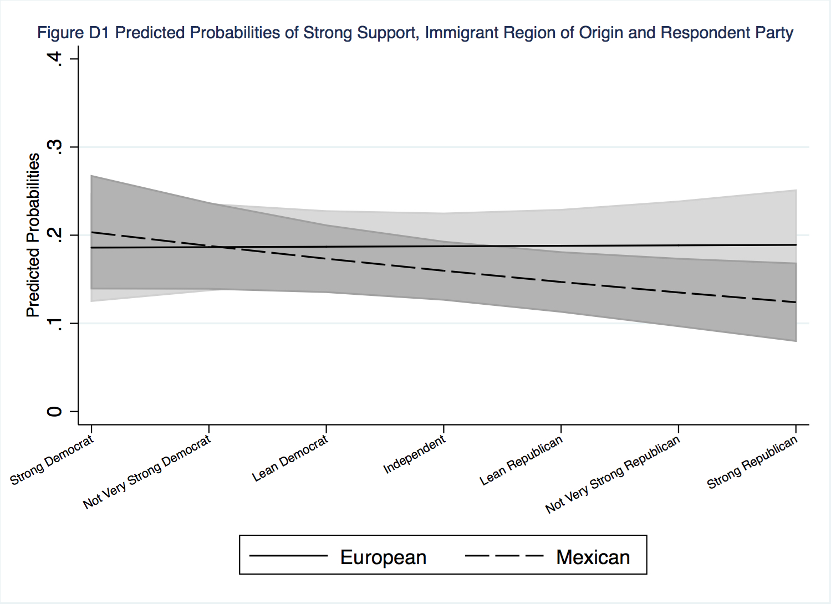
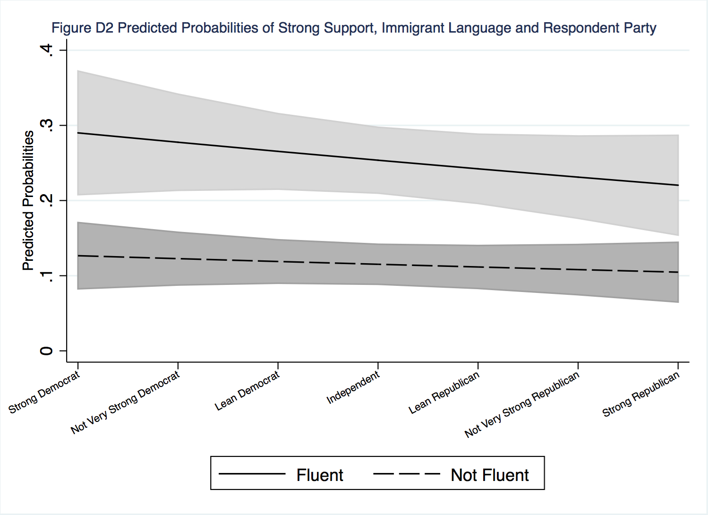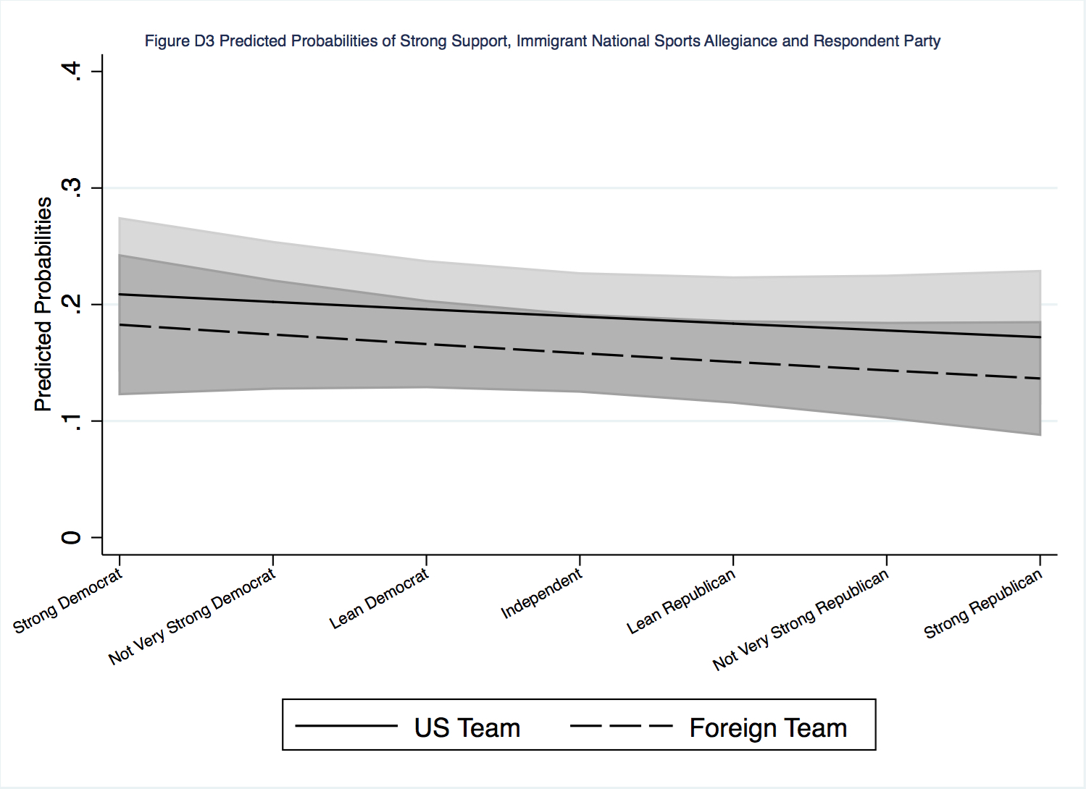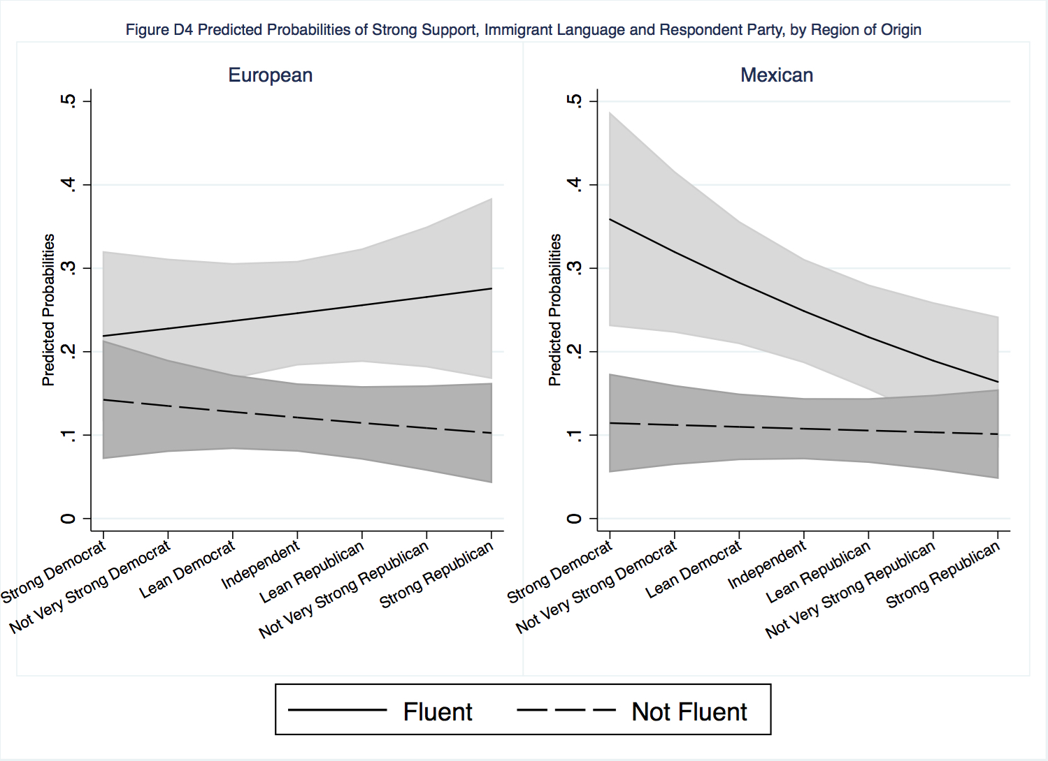

Appendix E. Ideology
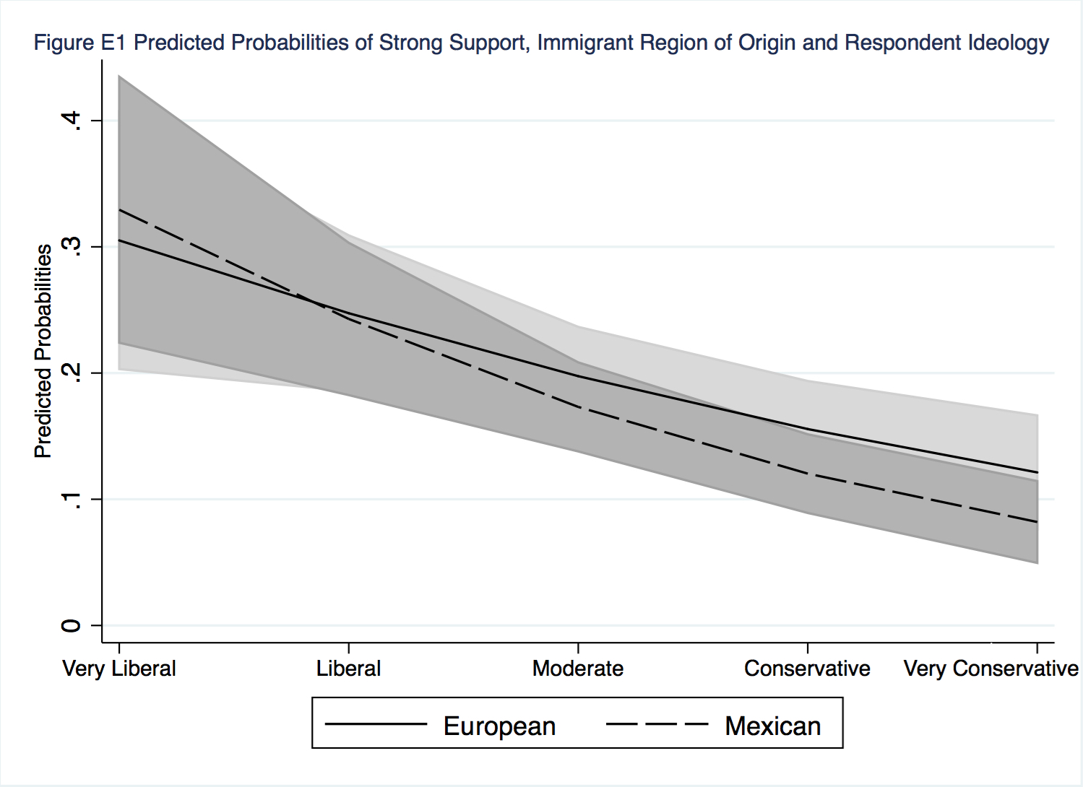
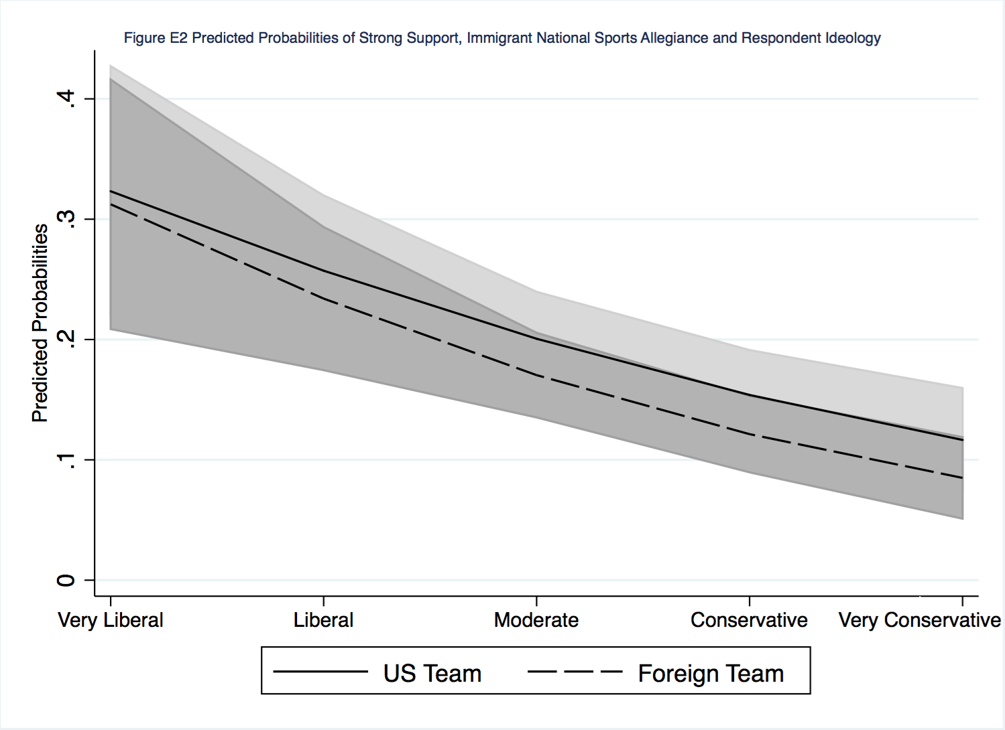

Table E1: Ideology and National Sports Allegiance Interactions, by Region of Origin
 | I. European |  | II. Mexican
Variable | ß | S.E. | ß | S.E
Foreign team | 0.11 | 0.41 | -0.22 | 0.41
Ideology | -1.25* | 0.57 | -1.29* | 0.53
Foreign team x ideology | -0.49 | 0.64 | -0.09 | 0.63
Fluency | -0.89*** | 0.21 | -0.99*** | 0.20
Age | 0.13 | 0.45 | -0.91* | 0.44
Education | 0.19 | 0.34 | 0.69* | 0.36
Gender | 0.01 | 0.20 | -0.10 | 0.20
Party | -0.04 | 0.39 | -0.58 | 0.37
Prejudice | -3.60*** | 0.62 | -3.48*** | 0.55
Log-likelihood | -514.90 |  | -544.87
n | 332 |  | 350

