**Appendix**

Figure 1: Attack news story (black target, Democratic primary)

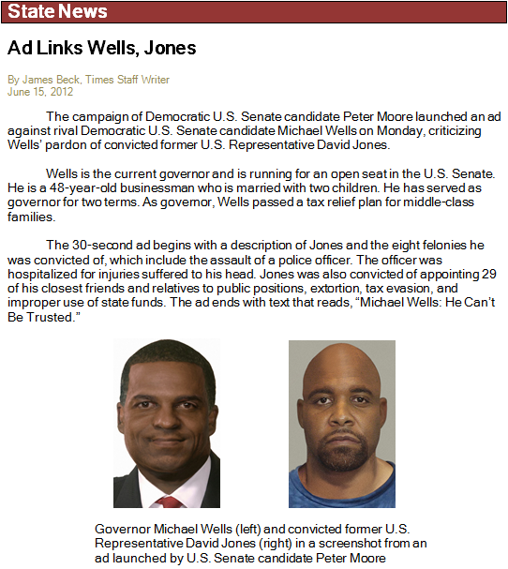

Figure 2: *Racial* (black target)



Figure 3: *Justify* (black target)



Figure 4: *Justify + racial* (black target)



Figure 5: Control



Figure 6: The impact of rebuttals on target-attacker evaluations, Democratic respondents only. Positive values indicate that the rebuttal helped the target. Error bars represent 84% confidence intervals, which is consistent with a two-tailed test of overlap at p=0.05. In other words, values are significantly different where error bars do not overlap. The “rebuttal effect” is the average change in target-attacker rating from post-attack to post-rebuttal for each rebuttal.

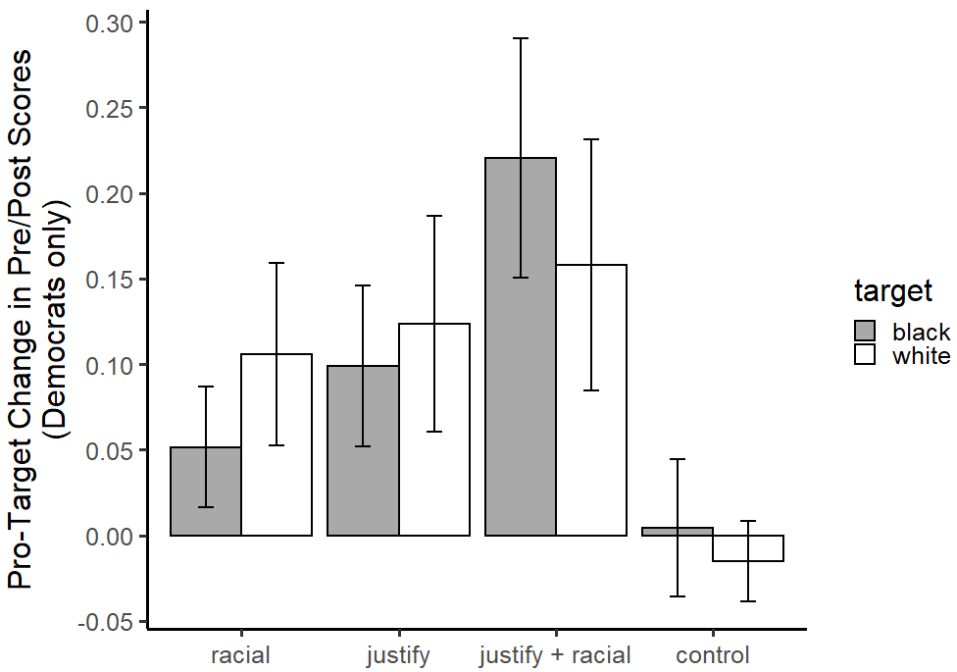

Figure 7: The impact of rebuttals on target-attacker evaluations, Republican respondents only. Positive values indicate that the rebuttal helped the target. Error bars represent 84% confidence intervals, which is consistent with a two-tailed test of overlap at p=0.05. In other words, values are significantly different where error bars do not overlap. The “rebuttal effect” is the average change in target-attacker rating from post-attack to post-rebuttal for each rebuttal.

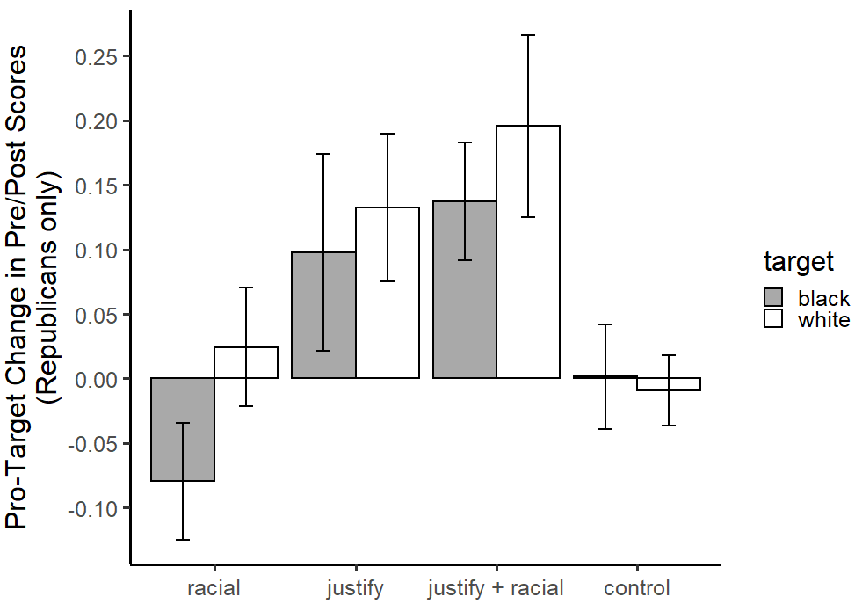

Figure 8: The impact of rebuttals on target-attacker evaluations, Independent respondents only. Positive values indicate that the rebuttal helped the target. Error bars represent 84% confidence intervals, which is consistent with a two-tailed test of overlap at p=0.05. In other words, values are significantly different where error bars do not overlap. The “rebuttal effect” is the average change in target-attacker rating from post-attack to post-rebuttal for each rebuttal.

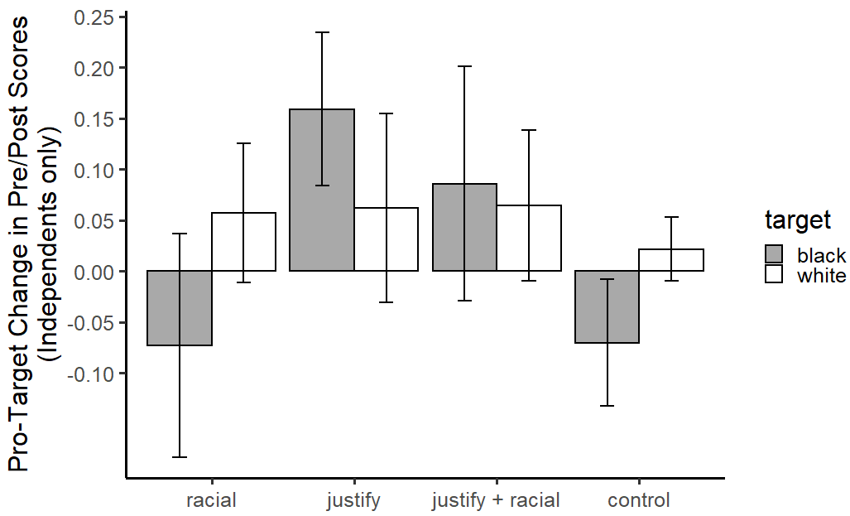

Figure 9: Impact of rebuttals on target evaluations. Positive values indicate that the rebuttal helped the target. Error bars represent 84% confidence intervals, which is consistent with a two-tailed test of overlap at p=0.05. In other words, values are significantly different where error bars do not overlap.

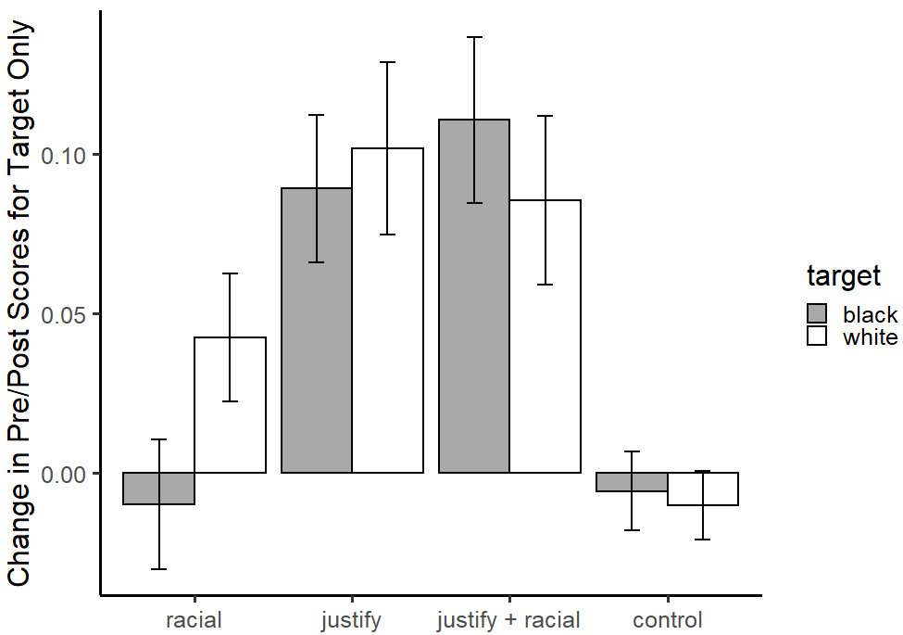

Figure 10: Impact of rebuttals on attacker evaluations. Positive values indicate that the rebuttal helped the attacker. Error bars represent 84% confidence intervals, which is consistent with a two-tailed test of overlap at p=0.05. In other words, values are significantly different where error bars do not overlap.

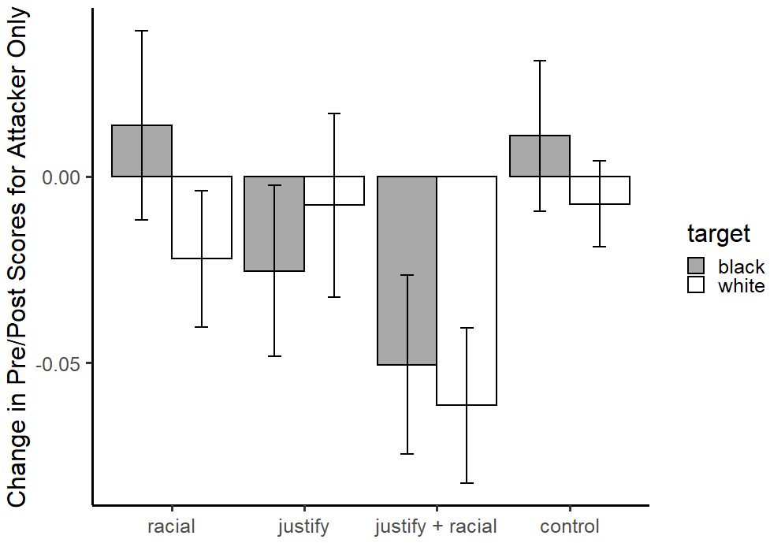

Figure 11: Rebuttal effects among medium racial resentment respondents only (middle third of the sample, corresponding with racial resentment > 0.5 and < 0.6875 on a 0-1 scale). Positive values indicate that the rebuttal helped the target. Error bars represent 84% confidence intervals, which is consistent with a two-tailed test of overlap at p=0.05. In other words, values are significantly different where error bars do not overlap.

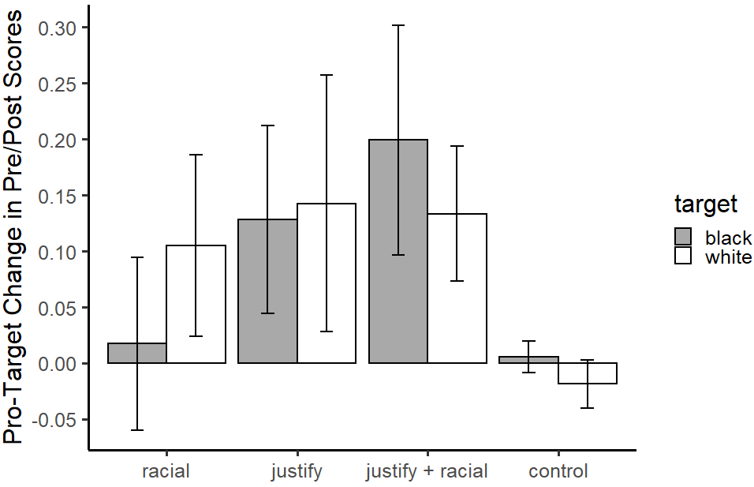

Table 1: Rebuttal effect for each rebuttal in each experiment (standard errors displayed in parentheses)

|  |  |  |  |  |
| --- | --- | --- | --- | --- |
|  | Black target | | White target | |
|  | Exp. 1 | Exp. 2 | Exp. 1 | Exp. 2 |
| Racial | 0.01  (0.03)  n=36 | -0.05  (0.04)  n=41 | 0.04  (0.04)  n=30 | 0.08  (0.03)  n=50 |
| Justify | 0.12  (0.05)  n=28 | 0.11  (0.03)  n=47 | 0.19  (0.04)  n=36 | 0.06  (0.04)  n=52 |
| Justify + racial | 0.24  (0.04)  n=33 | 0.10  (0.04)  n=45 | 0.19  (0.04)  n=31 | 0.11  (0.04)  n=46 |
| Control | -0.02  (0.02)  n=38 | -0.01  (0.03)  n=48 | -0.01  (0.02)  n=33 | -0.00  (0.01)  n=51 |

Table 2: Sample demographics

|  |  |  |
| --- | --- | --- |
| Variable | Response Options | Percentage |
| Age | 18-24 | 13.6 |
|  | 25-34 | 31.5 |
|  | 35-44 | 16.4 |
|  | 45-54 | 14.1 |
|  | 55-64 | 12.2 |
|  | 65-74 | 10.5 |
|  | 75 and older | 1.6 |
| Income | Below $15,000 | 8.1 |
|  | $15,000 - $24,999 | 11.3 |
|  | $25,000 - $34,999 | 12.3 |
|  | $35,000 - $49,999 | 16.5 |
|  | $50,000 - $74,999 | 22.0 |
|  | $75,000 - $99,999 | 14.8 |
|  | $100,000 - $149,999 | 9.9 |
|  | $150,000 - $199,999 | 2.0 |
|  | $200,000 or more | 1.2 |
|  | Don’t know | 1.9 |
| Education | Some high school or less | 2.2 |
|  | High school diploma or | 14.4 |
|  | equivalent certificate |  |
|  | Some college or two-year degree | 36.2 |
|  | College degree | 34.5 |
|  | Post-college degree | 12.7 |
| Gender | Male | 53.6 |
|  | Female | 46.4 |
| Partisanship | Strong Democrat | 14.6 |
|  | Weak Democrat | 10.5 |
|  | Independent – Democrat | 14.4 |
|  | Independent – Independent | 20.0 |
|  | Independent – Republican | 14.9 |
|  | Weak Republican | 9.3 |
|  | Strong Republican | 10.1 |
|  | Haven’t thought | 6.2 |
|  | much about this |  |

Table 3: Treatment assignment and covariates (balance table)

|  |  |  |  |  |  |  |  |  |
| --- | --- | --- | --- | --- | --- | --- | --- | --- |
|  | Black *racial* | White *racial* | Black *justify* | White *justify* | Black *justify + racial* | White *justify + racial* | Black control | White control |
| Age | 39 | 41 | 43 | 41 | 42 | 43 | 40 | 39 |
| Income  (0-1 scale) | 0.39 | 0.41 | 0.44 | 0.43 | 0.45 | 0.45 | 0.39 | 0.43 |
| At least some college | 86% | 83% | 83% | 83% | 83% | 86% | 79% | 86% |
| Male | 43% | 49% | 60% | 59% | 54% | 58% | 50% | 56% |
| Partisanship (0-1 scale) | 0.47 | 0.48 | 0.49 | 0.48 | 0.46 | 0.47 | 0.46 | 0.49 |

Age, income, education, and partisanship had no significant relationship with treatment assignment, according to two-sample t-tests. The percent male was significantly lower in black *racial* (43%) compared to black *justify* (60%) and white *justify* (59%) (p=.03 for black *racial* versus black *justify* and p=.04 for black *racial* vs. white *justify*). However, rebuttal effects did not significantly differ by gender for any of the rebuttal conditions, as shown in Appendix Table 4.

Table 4: Rebuttal effects by gender (standard errors displayed in parentheses)

|  |  |  |  |
| --- | --- | --- | --- |
|  | Male | Female | p-value |
| Black *racial* | 0.01  (0.03) | -0.05  (0.04) | 0.19 |
| White *racial* | 0.08  (0.03) | 0.05  (0.03) | 0.51 |
| Black *justify* | 0.14  (0.04) | 0.08  (0.04) | 0.24 |
| White *justify* | 0.13  (0.04) | 0.08  (0.04) | 0.35 |
| Black *justify + racial* | 0.16  (0.05) | 0.16  (0.04) | 0.96 |
| White *justify + racial* | 0.12  (0.04) | 0.19  (0.05) | 0.23 |
| Black control | -0.02  (0.03) | -0.01  (0.02) | 0.90 |
| White control | -0.01  (0.01) | 0.01  (0.02) | 0.35 |