Appendix A: Survey demographics
Female | 49.8% (51.0, ACS 2016)
Age 18-34 | 32% (26.0, ACS 2016)
35-44 | 16% (14.5, ACS 2016)
45-64 | 39.6% (35.5, ACS 2016)
65-84 | 12.4% (20.5, ACS 2016)
85+ | 0.0% (3.1, ACS 2016)
Income < $30,000 | 30.8% (22.5, ACS 2016)
$30,000 - $69,999 | 36.6% (35.1, ACS 2016)
$70,000 - $99,999 | 13.8% (13.0, ACS 2016)
$100,000 - $200,000 | 17.4% (21.9, ACS 2016)
> $200,000 | 1.3% (7.3, ACS 2016)
Less than high school | 2.7% (7.5, ACS 2016)
High school graduate | 20.4% (27.3, ACS 2016)
Some college | 44% (30.0, ACS 2016)
4-year-degree | 24.2% (21.5, ACS 2016)
Advanced degree | 8.7% (13.3, ACS 2016)
Democrat | 43%
Republican | 38.2%
Independent | 18.4%
Liberal | 33.3% (26, Gallup 01/2019)
Conservative | 34.7% (35, Gallup 01/2019)
Moderate | 32% (35, Gallup 01/2019)
Table A.1. Sample demographics compared to ACS benchmarks

Appendix B: Regression tables from models in main paper
 | Dependent Variable
 | Perception of Incivility
Slurs | 0.146***
 | (0.016)
Threats | 0.016
 | (0.019)
Civility Policing | -0.017
 | (0.014)
Elite Speaker | 0.001
 | (0.009)
Elite Target | -0.001
 | (0.010)
Speaker In-Party | -0.009
 | (0.015)
Target In-Party | 0.057***
 | (0.014)
Female Speaker | 0.023*
 | (0.013)
Female Target | 0.046***
 | (0.013)
White Speaker | -0.009
 | (0.009)
White Target | -0.017*
 | (0.009)
Constant | 0.568***
 | (0.020)
Observations | 2,528
Adjusted R² | 0.046
F Statistic | 12.164*** (df = 11; 2516)
Table 1. | *p < 0.10 **p < 0.05 ***p < 0.01

 | Dependent Variable
 | Perception of Incivility
 | H6a Racial Resentment | H6a SDO
Slurs | 0.145*** | 0.144***
 | (0.016) | (0.016)
Threats | 0.013 | 0.016
 | (0.019) | (0.019)
Civility Policing | -0.016 | -0.015
 | (0.014) | (0.014)
Elite Speaker | 0.002 | 0.0005
 | (0.009) | (0.009)
Elite Target | -0.001 | -0.0001
 | (0.010) | (0.010)
Speaker In-Party | -0.009 | -0.012
 | (0.015) | (0.015)
Target In-Party | 0.053*** | 0.052***
 | (0.014) | (0.014)
Female Speaker | 0.022* | 0.026**
 | (0.013) | (0.013)
Female Target | 0.046*** | 0.050***
 | (0.013) | (0.013)
Black Target | 0.025* | 0.028**
 | (0.013) | (0.013)
Black Speaker | 0.009 | -0.007
 | (0.023) | (0.021)
Racial Resentment | -0.099*
 | (0.051)
Black Speaker*RR | 0.006
 | (0.051)
SDO |  | -0.373***
 |  | (0.066)
Black Speaker*SDO |  | 0.084
 |  | (0.064)
Constant | 0.594*** | 0.644***
 | (0.029) | (0.026)
Observations | 2,524 | 2,522
Adjusted R² | 0.051 | 0.082
F Statistic | 11.334*** (df = 13; 2510) | 18.351*** (df = 13; 2508)
Table B.2 | *p < 0.10 **p < 0.05 ***p < 0.01

 | Dependent Variable
 | Perception of Incivility
 | H6b Racial Resentment | H6b SDO
Slurs | 0.145*** | 0.144***
 | (0.016) | (0.016)
Threats | 0.012 | 0.015
 | (0.019) | (0.019)
Civility Policing | -0.016 | -0.015
 | (0.014) | (0.013)
Elite Speaker | 0.001 | 0.0001
 | (0.009) | (0.009)
Elite Target | -0.001 | -0.0002
 | (0.010) | (0.010)
Speaker In-Party | -0.010 | -0.012
 | (0.015) | (0.014)
Target In-Party | 0.053*** | 0.052***
 | (0.014) | (0.014)
Female Speaker | 0.021 | 0.024*
 | (0.013) | (0.013)
Female Target | 0.045*** | 0.049***
 | (0.013) | (0.013)
Black Speaker | 0.010 | 0.014
 | (0.013) | (0.012)
Black Target | 0.061** | 0.065***
 | (0.025) | (0.022)
Racial Resentment | -0.053
 | (0.051)
Black Target*RR | -0.087
 | (0.054)
SDO |  | -0.259***
 |  | (0.068)
Black Target*SDO |  | -0.142*
 |  | (0.077)
Constant | 0.576*** | 0.616***
 | (0.029) | (0.027)
Observations | 2,524 | 2,522
Adjusted R² | 0.052 | 0.083
F Statistic | 11.578*** (df = 13; 2510) | 18.604*** (df = 13; 2508)
Table B.3 | *p < 0.10 **p < 0.05 ***p < 0.01

Appendix C: Supplemental dyadic analyses
 | Dependent Variable
 | Perception of Incivility
Slurs | 0.583***
 | (0.065)
Threats | 0.067
 | (0.076)
Civility Policing | -0.066
 | (0.055)
Constant | 3.484***
 | (0.065)
Observations | 2,528
Adjusted R² | 0.035
F Statistic | 31.999*** (df = 3; 2524)
Table C.1 | *p < 0.10 **p < 0.05 ***p < 0.01

 | Dependent Variable
 | Perception of Incivility
 | Model 1 | Model 2
Slurs | 0.583*** | 0.567***
 | (0.065) | (0.089)
Threats | 0.068 | 0.058
 | (0.076) | (0.107)
Civility Policing | -0.067 | -0.031
 | (0.055) | (0.078)
Speaker Elite | 0.008
 | (0.036)
Speaker Non-Elite x Target Elite |  | 0.054
 |  | (0.072)
Constant | 3.484*** | 3.444***
 | (0.065) | (0.087)
Observations | 2,528 | 1,291
Adjusted R² | 0.035 | 0.031
F Statistic | 24.002*** (df = 4; 2523) | 11.356*** (df = 4; 1286)
Table C.2 | *p < 0.10 **p < 0.05 ***p < 0.01

 | Dependent Variable
 | Perception of Incivility
 | Partisanship | Gender | Race
Slurs | 0.553*** | 0.571*** | 0.399***
 | (0.100) | (0.087) | (0.084)
Threats | 0.129 | 0.027 | 0.069
 | (0.109) | (0.104) | (0.106)
Civility Policing | -0.162* | -0.031 | -0.126*
 | (0.085) | (0.082) | (0.074)
Speaker Out-Party x Target In-Party | 0.128  (0.083)
Speaker Out-Gender x Target In-Gender |  | -0.022  (0.072)
Speaker Out-Race x Target In-Race |  |  | 0.115  (0.074)
Constant | 3.594*** | 3.441*** | 3.457***
 | (0.095) | (0.088) | (0.084)
Observations | 1,034 | 1,228 | 1,257
Adjusted R² | 0.035 | 0.033 | 0.019
F Statistic | 10.463*** (df = 4; 1029) | 11.569*** (df = 4; 1223) | 7.168*** (df = 4; 1252)
Table C.3 | *p < 0.10 **p < 0.05 ***p < 0.01

 | Dependent Variable
 | Perception of Incivility
 | Partisanship | Gender | Race
Slurs | 0.487*** | 0.613*** | 0.571***
 | (0.099) | (0.088) | (0.082)
Threats | 0.067 | -0.043 | 0.128
 | (0.105) | (0.108) | (0.105)
Civility Policing | -0.178** | -0.097 | -0.076
 | (0.089) | (0.076) | (0.073)
Speaker Out-Party x Target In-Party | 0.258***  (0.081)
Speaker Out-Gender x Target In-Gender |  | -0.147*  (0.076)
Speaker Out-Race x Target In-Race |  |  | -0.049  (0.075)
Constant | 3.502*** | 3.602*** | 3.534***
 | (0.095) | (0.083) | (0.090)
Observations | 1,002 | 1,265 | 1,302
Adjusted R² | 0.035 | 0.043 | 0.032
F Statistic | 10.150*** (df = 4; 997) | 15.218*** (df = 4; 1260) | 11.834*** (df = 4; 1297)
Table C.4 | *p < 0.10 **p < 0.05 ***p < 0.01

 | Dependent Variable
 | Perception of Incivility
 | Partisanship | Gender | Race
Slurs | 0.594*** | 0.556*** | 0.541***
 | (0.101) | (0.087) | (0.087)
Threats | 0.057 | 0.073 | 0.078
 | (0.118) | (0.096) | (0.098)
Civility Policing | -0.213** | -0.027 | -0.069
 | (0.087) | (0.070) | (0.073)
Speaker In-Party x Target Out-Party | -0.133*  (0.077)
Speaker In-Gender x Target Out-Gender |  | 0.125*  (0.074)
Speaker In-Race x Target Out-Race |  |  | 0.161**  (0.078)
Constant | 3.626*** | 3.433*** | 3.388***
 | (0.098) | (0.086) | (0.086)
Observations | 1,056 | 1,267 | 1,247
Adjusted R² | 0.041 | 0.033 | 0.031
F Statistic | 12.236*** (df = 4; 1051) | 11.745*** (df = 4; 1262) | 10.869*** (df = 4; 1242)
Table C.5 | *p < 0.10 **p < 0.05 ***p < 0.01

 | Dependent Variable
 | Perception of Incivility
 | Partisanship | Gender | Race
Slurs | 0.653*** | 0.561*** | 0.599***
 | (0.079) | (0.089) | (0.090)
Threats | 0.071 | 0.176* | 0.006
 | (0.097) | (0.099) | (0.098)
Civility Policing | 0.002 | -0.038 | -0.058
 | (0.069) | (0.076) | (0.074)
Speaker In-Party x Target In-Party | 0.157*  (0.083)
Speaker In-Gender x Target In-Gender |  | -0.042  (0.074)
Speaker In-Race x Target In-Race |  |  | -0.153**  (0.074)
Constant | 3.333*** | 3.457*** | 3.533***
 | (0.082) | (0.088) | (0.090)
Observations | 1,526 | 1,263 | 1,226
Adjusted R² | 0.045 | 0.030 | 0.039
F Statistic | 19.009*** (df = 4; 1521) | 10.852*** (df = 4; 1258) | 13.579*** (df = 4; 1221)
Table C.6 | *p < 0.10 **p < 0.05 ***p < 0.01

 | Dependent Variable
 | Perception of Incivility
 | Racial Resentment | SDO | Sexism
Slurs | 0.575*** | 0.573*** | 0.681***
 | (0.064) | (0.063) | (0.096)
Threats | 0.057 | 0.067 | 0.177
 | (0.076) | (0.075) | (0.113)
Civility Policing | -0.062 | -0.060 | -0.110
 | (0.055) | (0.054) | (0.080)
Black Speaker | 0.040 | -0.016
 | (0.091) | (0.082)
Racial Resentment | -0.414**
 | (0.205)
Black Speaker:Racial Resentment | 0.009  (0.203)
SDO |  | -1.457***
 |  | (0.263)
Black Speaker:SDO |  | 0.278
 |  | (0.256)
Female Speaker |  |  | 0.199
 |  |  | (0.158)
Hostile Sexism |  |  | -0.225
 |  |  | (0.275)
Female Speaker:Hostile Sexism |  |  | -0.341  (0.283)
Constant | 3.636*** | 3.837*** | 3.461***
 | (0.101) | (0.093) | (0.168)
Observations | 2,524 | 2,522 | 1,260
Adjusted R² | 0.041 | 0.071 | 0.049
F Statistic | 18.812*** (df = 6; 2517) | 32.964*** (df = 6; 2515) | 11.892*** (df = 6; 1253)
Table C.7 | *p < 0.10 **p < 0.05 ***p < 0.01

 | Dependent Variable
 | Perception of Incivility
 | Racial Resentment | SDO | Sexism
Slurs | 0.577*** | 0.577*** | 0.674***
 | (0.064) | (0.063) | (0.095)
Threats | 0.048 | 0.060 | 0.178
 | (0.076) | (0.075) | (0.113)
Civility Policing | -0.060 | -0.058 | -0.105
 | (0.055) | (0.054) | (0.080)
Black Target | 0.258*** | 0.270***
 | (0.098) | (0.089)
Racial Resentment | -0.218
 | (0.204)
Black Target:Racial Resentment | -0.386*  (0.216)
SDO |  | -1.010***
 |  | (0.274)
Black Target:SDO |  | -0.608**
 |  | (0.307)
Female Target |  |  | 0.145
 |  |  | (0.156)
Hostile Sexism |  |  | -0.531*
 |  |  | (0.273)
Female Target:Hostile Sexism |  |  | 0.255  (0.272)
Constant | 3.528*** | 3.694*** | 3.491***
 | (0.103) | (0.096) | (0.167)
Observations | 2,524 | 2,522 | 1,260
Adjusted R² | 0.043 | 0.073 | 0.059
F Statistic | 19.962*** (df = 6; 2517) | 34.298*** (df = 6; 2515) | 14.115*** (df = 6; 1253)
Table C.8 | *p < 0.10 **p < 0.05 ***p < 0.01

 | Dependent Variable
 | Perception of Incivility
 | Model 1 | Model 1 + Race | Model 1 + Gender
Slurs | 0.584*** | 0.584*** | 0.585***
 | (0.064) | (0.065) | (0.064)
Threats | 0.069 | 0.072 | 0.070
 | (0.076) | (0.076) | (0.076)
Civility Policing | -0.068 | -0.069 | -0.067
 | (0.056) | (0.056) | (0.056)
Black Speaker |  | 0.251**
 |  | (0.128)
Female Speaker |  |  | 0.151
 |  |  | (0.133)
System Justification | 0.186 | 0.431 | 0.267
 | (0.256) | (0.286) | (0.277)
Black Speaker:SJ |  | -0.486*
 |  | (0.270)
Female Speaker:SJ |  |  | -0.172
 |  |  | (0.282)
Constant | 3.406*** | 3.279*** | 3.332***
 | (0.127) | (0.143) | (0.135)
Observations | 2,528 | 2,528 | 2,528
Adjusted R² | 0.036 | 0.037 | 0.036
F Statistic | 24.507*** (df = 4; 2523) | 17.054*** (df = 6; 2521) | 16.793*** (df = 6; 2521)
Table C.9 | *p < 0.10 **p < 0.05 ***p < 0.01

Appendix D: Full survey wording

Q168 Please indicate how much you disagree or agree with the following statements:

RR1 It’s really a matter of some people not trying hard enough; if blacks would only try harder they could be just as well off as whites.
- Strongly agree (1)
- Somewhat agree (2)
- Somewhat disagree (3)
- Strongly disagree (4)

RR2 Irish, Italian, Jewish and many other minorities overcame prejudice and worked their way up. Blacks should do the same.
- Strongly agree (1)
- Somewhat agree (2)
- Somewhat disagree (3)
- Strongly disagree (4)

RR3 Generations of slavery and discrimination have created conditions that make it difficult for blacks to work their way out of the lower class.
- Strongly agree (1)
- Somewhat agree (2)
- Somewhat disagree (3)
- Strongly disagree (4)

RR4 Over the past few years, blacks have gotten more economically than they deserve.
- Strongly agree (1)
- Somewhat agree (2)
- Somewhat disagree (3)
- Strongly disagree (4)

Start of Block: SDO7

Q173 Please indicate how much you disagree or agree with the following statements:

SDO1
An ideal society requires some groups to be on top and others to be on the bottom.
- Strongly agree (1)
- Somewhat agree (2)
- Neither agree nor disagree (3)
- Somewhat disagree (4)
- Strongly disagree (5)

SDO2
Some groups of people are simply inferior to other groups.
- Strongly agree (1)
- Somewhat agree (2)
- Neither agree nor disagree (3)
- Somewhat disagree (4)
- Strongly disagree (5)

SDO3
No one group should dominate in society.
- Strongly agree (1)
- Somewhat agree (2)
- Neither agree nor disagree (3)
- Somewhat disagree (4)
- Strongly disagree (5)

SDO4
Groups at the bottom are just as deserving as groups at the top.
- Strongly agree (1)
- Somewhat agree (2)
- Neither agree nor disagree (3)
- Somewhat disagree (4)
- Strongly disagree (5)

SDO5
Group equality should be our primary goal.
- Strongly agree (1)
- Somewhat agree (2)
- Neither agree nor disagree (3)
- Somewhat disagree (4)
- Strongly disagree (5)
SDO6
It is unjust to try to make groups equal.
- Strongly agree (1)
- Somewhat agree (2)
- Neither agree nor disagree (3)
- Somewhat disagree (4)
- Strongly disagree (5)

SDO7
We should do what we can to equalize conditions for different groups.
- Strongly agree (1)
- Somewhat agree (2)
- Neither agree nor disagree (3)
- Somewhat disagree (4)
- Strongly disagree (5)

SDO8
We should work to give all groups an equal chance to succeed.
- Strongly agree (1)
- Somewhat agree (2)
- Neither agree nor disagree (3)
- Somewhat disagree (4)
- Strongly disagree (5)

End of Block: SDO7

Start of Block: Intro to tasks

Q19 We are interested in the things that Americans find newsworthy. What follows will be six different excerpts from recent newspaper articles on political interactions that took place in town hall meetings. For each scenario, please consider how newsworthy the interaction is, the emotions it makes you feel, and how uncivil it seems. For each scenario, mark the responses that most accurately reflect your opinions (Reminder: there are six scenarios, total).

uncivilsym_1 How uncivil do you think the above scenario was?
- Not at all uncivil (1)
- Slightly uncivil (2)
- Somewhat uncivil (3)
- Mostly uncivil (4)
- Very uncivil (5)

Appendix E: Replication of Frimer and Skitka (2020)
 | Dependent Variable
 | Perception of Incivility
Speaker In-Party Elite | 0.028
 | (0.019)
Slurs | 0.150***
 | (0.026)
Threats | 0.011
 | (0.030)
Civility Policing | -0.050**
 | (0.022)
Female Speaker | -0.008
 | (0.020)
Female Target | 0.047**
 | (0.021)
White Speaker | -0.007
 | (0.014)
White Target | -0.035**
 | (0.015)
Constant | 0.605***
 | (0.027)
Observations | 1,056
Adjusted R² | 0.047
F Statistic | 7.508*** (df = 8; 1047)
Table E.1 | *p < 0.10 **p < 0.05 ***p < 0.01
Appendix F: First scenario analyses
 | Dependent Variable
 | Perception of Incivility
Slurs | 0.095***
 | (0.035)
Threats | 0.001
 | (0.045)
Civility Policing | -0.004
 | (0.031)
Elite Speaker | 0.010
 | (0.021)
Elite Target | -0.007
 | (0.021)
Speaker In-Party | -0.031
 | (0.031)
Target In-Party | 0.069**
 | (0.030)
Female Speaker | 0.005
 | (0.031)
Female Target | 0.071**
 | (0.031)
White Speaker | 0.026
 | (0.021)
White Target | -0.019
 | (0.022)
Constant | 0.603***
 | (0.037)
Observations | 430
Adjusted R² | 0.024
F Statistic | 1.944** (df = 11; 418)
Table F.1 | *p < 0.10 **p < 0.05 ***p < 0.01

Appendix G: AMCE replication
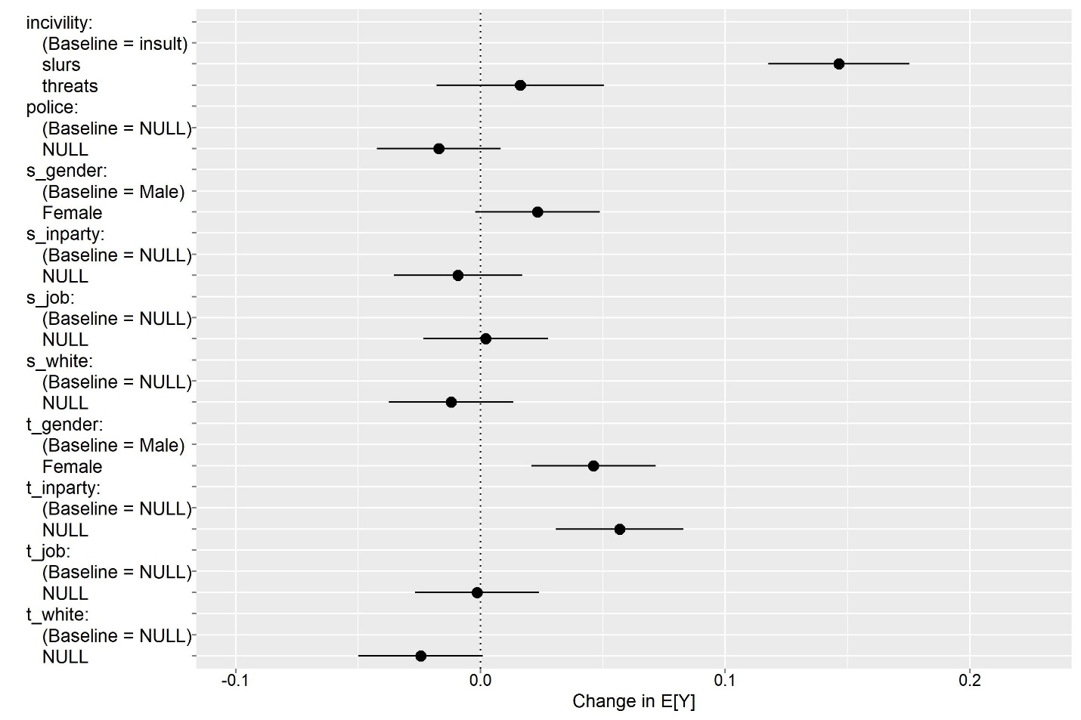

Appendix H: Speaker x target combinations (perception of incivility)
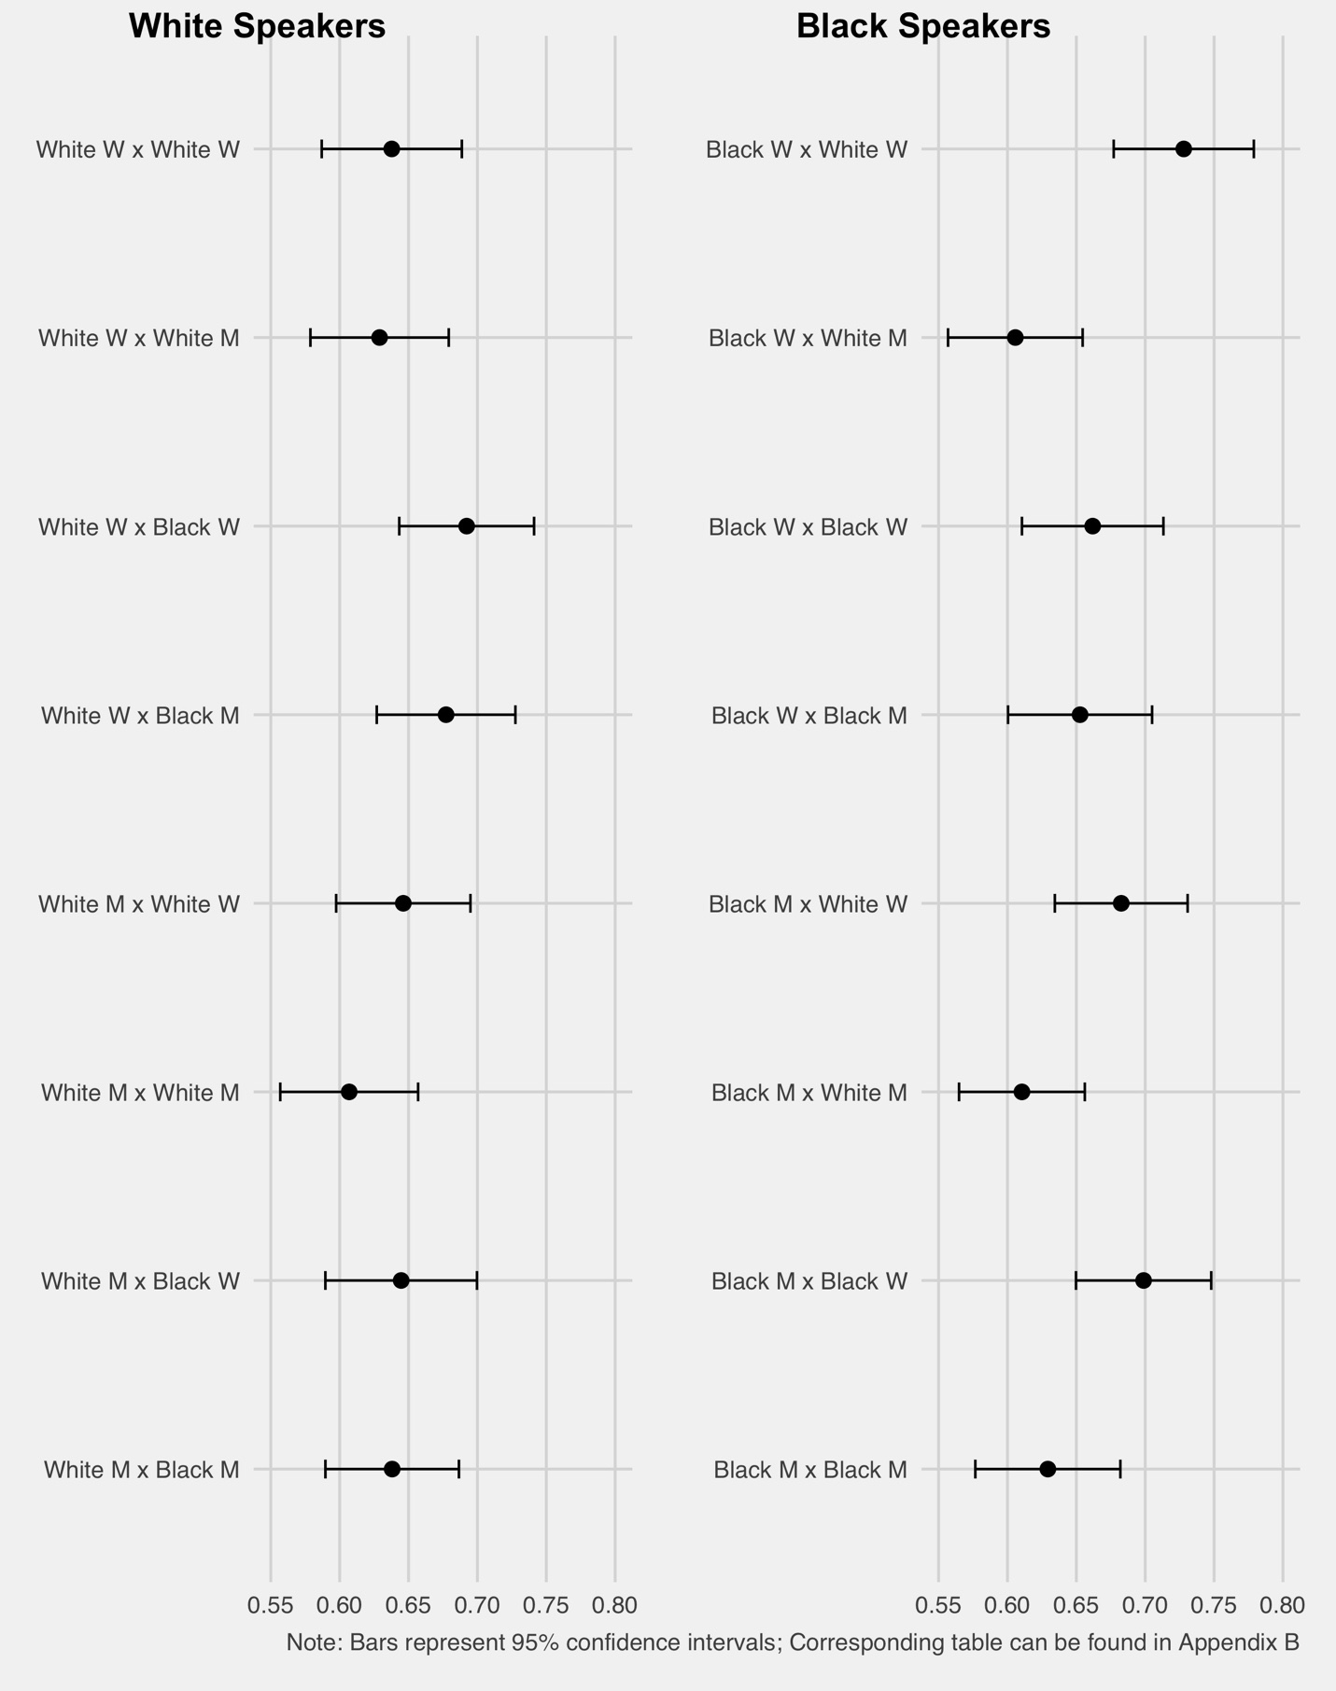

Appendix I: Names used in study
Black last names: | Black male first names: | Black female names: | White last names: | White male names: | White female names:
Banks | DaShawn* | Denisha | Walsh | Hunter | Katelyn
Jackson | Tremayne | Taniya | Decker | Jake | Claire
Washington | Jamal | Heaven | Becker | Seth | Laurie
Booker | DaQuan* | Ashanti | Nielsen | Zachary | Stephanie
Jefferson | DeAndre | Tyra | McGrath | Todd | Abigail
Mosley | Tyrone | Ebony | Andersen | Matthew | Megan
 | Keyshawn | Shanice | Larsen | Logan | Kristen
 | Denzel | Latoya* | Meyer | Ryan | Emily
 | Latrell | Keyana | Hartman | Scott | Sarah
 | Jayvon | Tionna |  | Dustin | Molly
 | Terrell | Latonya* |  | Brett | Jill
 | DeShawn | Lakisha* |  | Ethan | Hilary
 | Rasheed | Janae |  | Connor | Meredith
 | D’Andre | Tamika* |  | Neil | Margaret
 | Kareem | Tanisha |  | Steven | Amy
* indicates names that are low on SES, according to Gaddis (2017).

Appendix J: In-gender/out-gender analyses

 | Dependent variable:
 | Perceptions of incivility
Slurs | 0.588***
 | (0.061)
Threats | 0.065
 | (0.069)
Civility policing | -0.069
 | (0.052)
Speaker elite | -0.014
 | (0.052)
Target elite | -0.004
 | (0.052)
Speaker in-party | -0.046
 | (0.054)
Target in-party | 0.220***
 | (0.054)
Speaker in-gender | 0.057
 | (0.052)
Target in-gender | -0.099*
 | (0.052)
Black target | 0.096*
 | (0.052)
Black speaker | 0.048
 | (0.052)
Constant | 3.370***
 | (0.081)
Observations | 2,528
R² | 0.046
Adjusted R² | 0.042
Residual Std. Error | 1.302 (df = 2516)
F Statistic | 11.124*** (df = 11; 2516)
Note: | *p**p***p<0.01

