**Modelling national transformations to achieve the SDGs within planetary boundaries in small island developing States**

**Cameron Allen, Graciela Metternicht, Thomas Wiedmann, Matteo Pedercini**

**Supplementary Information**

**_______________**

**Supplementary Text 1. Additional background on Fiji and SDGs priorities**

Fiji is an upper-middle income country which in 2018 had an estimated population of 883,483, aggregate GDP of US$5.5 billion, and GDP per capita of US$6,267 (The World Bank, 2018). Fiji’s annual GDP growth averaged 3.7% over the period 2010 to 2018, comprising 13.5% agriculture (mainly sugarcane), 17.4% industry, and 69.1% services in 2018 (The World Bank, 2018). Fiji’s largest industries include tourism, sugar processing, clothing, mining and fisheries. Earnings from the tourism industry, with an estimated 842,884 tourists visiting in 2017, and remittances from Fijians working abroad are the country’s largest foreign exchange earners (CIA, 2017). Fiji’s major export sectors include food and beverages (sugar, bottled water), gold, animal products (fish), textiles and vegetable products (FBoS, 2019, Lenzen et al., 2013). Government debt as a proportion of GDP was 44% in 2017, reduced slightly from 48.4% in 2014, and the government has a national target of reducing debt to 35% GDP by 2036 (Government of Fiji, 2017c).

The 2019 SDG Index ranked Fiji as 62 out of 162 countries across a range of sustainable development indicators with an overall index score of 70.1 out of 100 (Sachs et al., 2019). Fiji performed better on goals relating to poverty (Goal 1), education (Goal 4), and sustainable cities (Goal 11), while performance lagged behind for goals relating to food and nutrition (Goal 2), gender (Goal 5), sustainable industry (Goal 9), life on land (Goal 15) and life under water (Goal 14). However, data was missing for a range of indicators.

Fiji has a robust long-term policy and planning framework including a medium- and long-term National Development Plan (NDP) (Government of Fiji, 2017c), a Green Growth Framework (Government of Fiji, 2014), and a range of sectoral strategies which set out both economy-wide and sector-specific development targets for Fiji. Addressing climate change is a strategic priority and Fiji adopted an ambitious National Determined Contribution Implementation Roadmap (Government of Fiji, 2017b) followed by a Low Emissions Development Strategy (LEDS) which sets out a vision for a net zero emission Fiji by 2050 (Government of Fiji, 2018a). The LEDS estimates that Fiji’s emissions would more than double under a BAU scenario. Fiji also has a detailed climate change vulnerability assessment and national adaptation plan (Government of Fiji, 2018b, Government of Fiji, 2017a)

To achieve the goals and targets set out in NDPs and SDGs, Fiji has flagged the need for significant public investment, private investment and financial contributions. Investment requirements for Fiji’s NDP through to 2036 are expected to reach FJD50 billion including both capital expenditures and provision of social services. As a subset of these investments, the government estimates that the total cost of implementing Fiji’s NDC Implementation Roadmap at FJD6.3 billion. Fiji’s climate change vulnerability assessment estimates additional required resources of FJD9.3 billion over 10 years. The Fijian Government envisions mobilising both domestic revenues (tax and non-tax) and international financial resources, including funding from multilateral development partners, as well as an increasing financing from private sector and climate finance sources (Government of Fiji, 2017c).

Fiji submitted its first Voluntary National Review on the SDGs to the High Level Political Forum for Sustainable Development in 2019 (Government of Fiji, 2019). The Government reports that priority goals and targets have been mainstreamed into its NDP and implementation of the SDGs will be driven through the national planning processes led by the Ministry of Economy. Fiji’s NDP addresses many of the cross-cutting themes of the SDGs, and many targets have been localised into the plan. Based on Fiji’s VNR, 15 SDGs are explicitly integrated into the corresponding 29 strategic priorities of the NDP, while SDG 10 (reduce inequalities), SDG 12 (responsible consumption and production) and SDG 13 (climate action) are treated as cross-cutting issues across the NDP. Consequently, the SDG implementation and its monitoring hinge on the NDP processes including the overall monitoring and evaluation.

The Fijian Government recognises that economic development, climate change adaptation and mitigation, disaster risk reduction, and environmental protection objectives are deeply inter-woven and that without increased effort to address these linkages, trade-offs will become increasingly difficult to manage. Fiji reports that its capacity to achieve the SDGs will depend entirely on global action to address climate change, and that improved capabilities for strategic foresight, managing interdependencies between social dynamics, environmental hazards, economic risks, development impacts and climate change and evidence-based decision making will be critical (Government of Fiji, 2019).

There have been a range of modelling studies undertaken in Fiji for various purposes, including investment and exports (Narayan, 2013, Narayan et al., 2007, Narayan and Narayan, 2006), exchange rates (Narayan et al., 2009), tourism (Pratt, 2015, Pratt, 2014), energy (Lal and Raturi, 2012), water (Senokonoko, 2014), food and health (Snowdon et al., 2011), climate (Lal et al., 2008), and coastal inundation (McInnes et al., 2014). A range of sectoral models were also used to support the development of Fiji’s LEDS (Government of Fiji, 2018a). However, there has not yet been any integrated assessment modelling focused on SDGs.

**SUPPLEMENTARY TEXT 2. ADDITIONAL DESCRIPTION OF THE ISDG-FIJI MODEL**

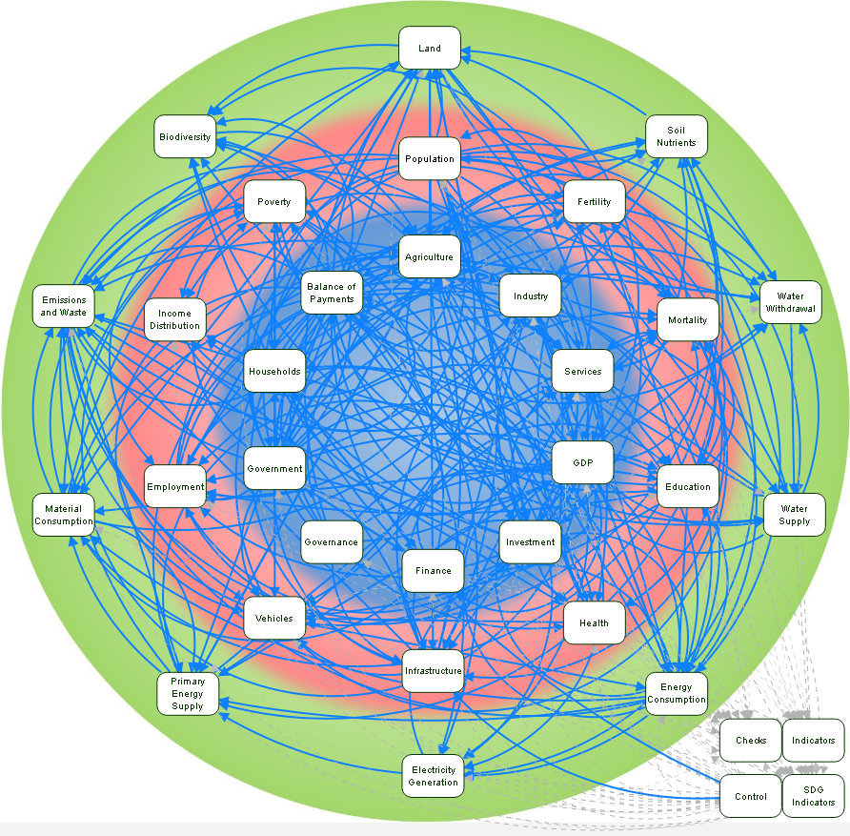

**Brief description of the iSDG model and key modules**

The *iSDG* tool is an integrated macroeconomic model that is built in the system dynamics modelling language in both Vensim (Ventana Systems Inc., 2018) and Stella Architect (ISEE Systems, 2018) software. The base *iSDG* model has a stock and flow structure and is formulated as a system of differential equations comprising approximately 3,000 variables organised across 30 sectors, covering key economic, social and environmental domains. A description of each of the sectoral modules along with their assumptions and source literature is available in the model documentation (Millennium Institute, 2017). Further description of the model and some of the key modules is provided in Allen et al. (2019).

A description of each of the sectoral modules, assumptions and source literature is available in the model documentation (Millennium Institute, 2017). In brief, economic production in the core of the model is divided into agriculture, industry and services (which are further disaggregated by sub-sector) and production is based on Cobb-Douglas production functions which are expanded to include effects of education, health, climate change, governance, infrastructure and other factors on total factor productivity. Investment is endogenously based on public investment, private savings and foreign investment and is allocated across sectors based on the rate of return on investment (Arrow, 1964). Conventional closing rules are used to assure consistency of the macroeconomic framework (Lofgren et al., 2002).

The population module includes endogenous treatment of fertility and mortality along with dynamics for the main factors that influence these variables, while migration is set exogenously. Population is disaggregated into 100 age cohorts and by gender. Births are based on the size of the reproductive age of the population and total fertility rate, while mortality rates are based on income, health, education, exposure to risks and other factors. This also enables estimation of life expectancy.

The government sector is structured according to a standard accounting framework (International Monetary Fund, 2014), with tax and non-tax revenues from the households and private sector used for public consumption, investment and transfers. At a functional level, expenditure is allocated for education, health, agriculture, infrastructure, etc. which represent key policy variables that the analyst can set as a desired proportion of GDP or per capita level. Additional financing needs of government are met through domestic and foreign financing.

The land sector simulates land use for different purposes based on standard land cover classifications (FAO, 1998) and includes endogenous representation of the main factors that shift land between categories (e.g. capital, labour, population growth, protection/restoration); and the soil sector keeps track of macro nutrients and organic carbon density in the soil based on natural nutrients cycles and agriculture production. The water demand sector simulates medium- to long-term trends in water withdrawal by major category (industry, agriculture, domestic), which is met through water supply from renewable sources in the water supply module. The energy consumption module represents major drivers of national final energy demand from economic sectors, residential, transportation and other uses. Electricity demand is met through the electricity generation module which simulates total electricity production from fossil fuels, nuclear and renewables, with capacity expanding to meet expected future demand. The energy supply sector represents primary energy supply of gas, oil, coal, biomass and electricity based on the International Energy Agency’s energy balances (International Energy Agency, 2016). Demographic and economic growth and energy consumption are then used to calculate material consumption, emissions, and waste.

Finally, SDG expenditure, financing and performance modules are used to introduce additional SDG expenditure and financing interventions, as well as calculating SDG performance at the indicator and aggregated levels.

**SUPPLEMENTARY TABLE 1. SCENARIO SETTINGS – MAIN DRIVERS/ENTRY POINTS AND QUALITATIVE AND QUANTITATIVE ASSUMPTIONS AND SETTINGS**

|  |  |  |  |  | **SCENARIOS** |  |  |  |
| --- | --- | --- | --- | --- | --- | --- | --- | --- |
|  |  |  | **SSP5, SSP4** | **SSP2 + SSP1 (ENV)** | **BAU (SSP2)** | **SSP5 + SSP1(EQUALITY)** | **SSP1** |  |
| **Drivers** | **Assumption/ Policy** | **Attributes** | **1. Growth at all Cost** | **2. Green Economy** | **BAU projected values for 2030** | **3. Inclusive Growth** | **4. Sustainability Transition;**  **5. ST_CLIMATE;**  **6. ST_SDG** | **Source/Notes for Quantitative Settings** |
| **1. Demographics** | Assumption | Population growth | Medium | Medium | Existing trends  [971,306] | Medium | Medium | Qualitative. SSP narratives (O’Neill et al., 2017). |
|  | Assumption | Fertility | Medium (~2.7) | Medium (~2.7) | Existing trends  [2.7] | Medium (~2.7) | Medium (2.7) | UN population  fertility data for Fiji (United Nations, 2019); parameterised based on historic values (max 3.5; min 2.75). |
|  | Assumption | Mortality | Medium | Medium | Existing trends | Low | Low | Qualitative. SSP narratives (O’Neill et al., 2017). |
|  | Assumption | Migration | Low-Medium | Medium | Existing trend | Low-Medium | Medium | Qualitative. Based on scenario narratives. |
|  | Assumption | Urbanization | High | Medium | Historical pattern | Medium | High, well-managed | Qualitative. SSP narratives (O’Neill et al., 2017) |
|  | Policy | Annual net migration target 2030 per 1,000 people* | (-6 per 1000 people) | (-8 per 1000 people) | -8 per 1,000  [per year by 2030] | (-6 per 1000 people) | (-8 per 1000 people) | UN population net migration data (United Nations, 2019). Parameterised based on historic values (min -18.6; max -5.6). |
|  |  |  |  |  |  |  |  |  |
| **2. Human development and wellbeing** | Assumption | Education | Medium/unequal | Medium | Existing trends | High | High | Qualitative. SSP narratives (O’Neill et al., 2017) |
|  | Assumption | Access to health | Medium (private focus) | Medium | Existing trends | High | High | Qualitative. SSP narratives (O’Neill et al., 2017). |
|  | Assumption | Gender equality/equity | Low-Medium | Low-Medium | Existing trend | Medium-High | Medium-High | Qualitative. SSP narratives (O’Neill et al., 2017). |
|  | Assumption | Social cohesion | Low-medium; stratified | Medium | Existing trend | High | High | Qualitative. SSP narratives (O’Neill et al., 2017). |
|  | Assumption | Societal participation | Medium | Medium | Existing trend | High | High | Qualitative. SSP narratives (O’Neill et al., 2017). |
|  | Policy | Education expenditure (% GDP) | 3.84% pa  (-1%) | 4.34% pa  (-0.5%) | 4.84% pa | 5.84% pa  (+1%) | 5.3% pa  (+0.5%)  ST_SDG: +5% GDP pa | Settings parameterized based on data on public education expenditure as share GDP (The World Bank, 2018) over period 1990-2015 (min = 4.66%; max = 7.3%) |
|  | Policy | Health expenditure (% GDP) | 1.71% pa  (-1%) | 2.21% pa  (-0.5%) | 2.71% pa | 3.71% pa  (+1%) | 3.21% pa  (+0.5%)  ST_SDG: +4% GDP pa | Settings parameterized based on data on public health expenditure as share GDP (The World Bank, 2018) over period 1990-2015 (min = 2.5%; max = 3.3%) |
|  | Policy | Water and sanitation expenditure (% GDP) | Reduce (-0.1 % GDP)  0.107% GDP | Reduce (-0.1 % GDP)  0.107% GDP | 0.207% GDP | Maintain | Maintain | Water and sanitation coverage data from WHO/UNICEF Joint Monitoring Programme (The World Bank, 2018) and expenditure estimated based on water and sanitation cost data for Fiji (WHO, 2012). Additional expenditure allocated as 20% share to safely managed water; 80% to sanitation. |
|  | Assumption# | Gender - Target effect of Social & Market framework on gender gap in employment | Medium (0.35) | Medium (0.35) | 0.33 | Higher (0.25) | Higher (0.25)  ST_SDG: 22 | SSPs narratives. Parameterised based on i*SDG* model settings (Millennium Institute, 2017); adjusted for higher/lower gender equality. |
|  | Assumption# | Political stability and absence of violence target | Low  0.4 | Moderate  0.6 | 0.5803 | Moderate  0.6 | High  1  ST_SDG: 1.5 | World Bank Worldwide Governance indicator data (Kaufman and Kraay, 2016) for Fiji (1990-2016); parameterised based on low-high global benchmark values and Fiji historic values for Political Stability indicator. Scores -2.5 to +2.5; Global Max (2015) = 1.94; Fiji min =  -0.27 and max = 0.85 |
|  | Assumption# | Voice and accountability | Low  0 | Low  0 | 0.02777 | Moderate-High  0.4 | Moderate-High  0.4  ST_SDG: 1.5 | World Bank Worldwide Governance indicator data (Kaufman and Kraay, 2016) for Fiji (1990-2016); parameterised based on low-high values for Voice and Accountability indicator. Scores -2.5 to +2.5; Global Max (2015) = 1.69; Fiji min =  -1.1 and max = 0.226 |
|  | Policy | Redistribution of fiscal pressure (Relative fiscal pressure by percentile)* | Reduction for middle-high income  (0.8, 1, 1, 1, 0.8, 0.8) | Reduction for middle-high income  (0.8, 1, 1, 1, 0.8, 0.8) | Existing trend  (0.8, 1, 1, 1, 1) | Increase for high income earners/decreased for low income earners  (0.5,0.8, 1, 1, 1.1, 1.5) | Increased for high/ decreased for low income earners  (0.5,0.8, 1, 1, 1.1, 1.5)  ST_SDG:  0.2, 0.4, 0.8, 1, 1.5, 2.5 | Parameters based on i*SDG* model settings (Millennium Institute, 2017) calibrated on Fiji income distribution and poverty data (The World Bank, 2018, Government of Fiji, 2010, Government of Fiji, 2004). Adjusted for additional fiscal pressure on high/low income quintiles. |
|  | Policy | Subsidies & transfers (% GDP)* | Low  0.04234  (-2.5% GDP) | Moderate  0.05234  (-2% GDP) | Existing trend  6.734% (0.06734) | High  0.08734  (+2% GDP) | High  0.07734  (+1% GDP)  ST_SDG: +4% | Fiji General Government expenditure data 1990-2015 (The World Bank, 2018, IMF, 2018, IMF, 2017). Parameterised based on historic timeseries (min = 0.042; max = 0.067) |
|  | Policy | Redistribution of subsides (target subsidies & transfers distribution curve)* | Reduction overall – same for all percentiles  (1:100=1) | Reduction overall – same for all percentiles  (1:100=1) | Existing trend (higher for bottom 10%)  (1:10=1.6; 11:100=1) | Higher for low-income bottom 20%  (1:20=2; 21:100=1) | Higher for low-income bottom 20%  (1:20=2; 21:100=1)  ST_SDG:  (1-20=3; 21-40=2; 41-100=1) | Parameterised based on iSDG model settings (Millennium Institute, 2017) and Fiji poverty benefits policies (Government of Fiji, 2019) with adjustments to increase share to low-income earners. |
|  |  |  |  |  |  |  |  |  |
| **3. Economy and lifestyle** | Assumption | Growth  (real GDP per capita) | High | Medium | Existing trend  [FJD9.973] | Medium | Medium | Qualitative. SSP narratives (O’Neill et al., 2017). |
|  | Assumption | Inequality  (Gini coefficient) | Medium-High | Medium-High | Existing trend  (Gini 0.334) | Low | Low | Qualitative. SSP narratives (O’Neill et al., 2017). |
|  | Assumption | International trade & globalization | High | Moderate | Moderate | Moderate | Moderate | Qualitative. SSP narratives (O’Neill et al., 2017). |
|  | Assumption | Consumption and diet | Material-intensive | Low growth in material consumption | Existing trend  [PC-DMC: 7.89t] | Material-intensive | Low growth in material consumption | Qualitative. SSP narratives (O’Neill et al., 2017). |
|  | Assumption | Demand for resources – exports and production | Remain stable | Remain stable | Existing trend  Metal ore production: 808,491 t/yr | Remain stable | Remain stable. | Fiji has no domestic extraction of fossil fuels (West and Lieber, 2018) and the mining sector is primarily gold extraction and non-metallic minerals (construction). Gold is a significant export commodity and price forecast for gold is for relatively stable prices over period to 2030, with slight decline in real terms (World Bank, 2019). Fiji data extraction of metals: CAGR=-0.9%; max = 1,233,780 t/yr; min = 7,250 t/yr |
|  | Assumption | Demand for agriculture – exports & consumption: crops (RLCU value added per ton) | Price decline in real terms on BAU (-10%)  `: FJD145 | Real prices stable  157.849225954 | Existing trend  Production value/ton Cereals: FJD480.22  Rest: FJD155.09  Real prices stable. | Price decline in real terms on BAU (-10%)  Rest: FJD145 | Real prices stable  157.849225954 | Agricultural commodity and production data from for Fiji 1990-2016 from FAOSTAT database (FAO, 2017). Sugar is the main export commodity. Parameterised based on OECD and FAO (2019) Agricultural Outlook. World sugar prices are expected to rebound over 2020-2023 and then follow a slight downtrend to 2028 (USD 285/Mt). Through until 2028, global sugar production is projected to expand by 14%. Fiji Rest CAGR: -0.61% pa; total: -14.8% |
|  | Assumption | Agriculture input costs – fertilizer price per ton of nutrient | Real prices stable | Real prices stable | Existing trend (prices stable)  N: USD1,268.9  P: USD1,380.0  K: USD1,001.7 | Real prices stable | Real prices stable | Fertilizer costs estimated for each nutrient (USDA, 2017). Forecasted prices for 2030 are relatively stable in nominal terms or slight decline in real terms. |
|  |  | Demand for agriculture exports & consumption – meat: (prices RLCU per ton) | Price decline in real terms on BAU (-10%)  Livestock: $2444.4  Fish: $1,800.58 | Real prices stable  Livestock: 2716.30263079  Fish: 2000.64093 | Existing trend  Livestock: $2,716.30  Fish: $2000.64  Real prices stable. | Price decline in real terms on BAU (-10%)  Livestock: $2444.4  Fish: $1,800.58 | Real prices stable  Livestock: 2716.30263079  Fish: 2000.64093 | Agricultural commodity data from for Fiji from FAOSTAT database (FAO, 2017). Parameterised on OECD and FAO (2017) Agricultural Outlook. Meat production to increase by 15% by 2027; fish by 13%. Prices for meat to remain stable or decline slightly in real terms. Fish prices stable in real terms.  Livestock CAGR: 1.26%pa; total 38.5%  Fish CAGR: -2.08% pa; total -42.1%. |
|  | Assumption | Interest rates on debt (domestic/foreign)* | Maintain | Maintain | Existing trend  Rate: 6.386% | Maintain | Maintain | General government rate based on data on interest payments and government debt from government finance statistics for Fiji (IMF, 2017, The World Bank, 2018). Stabilised across all scenarios. |
|  | Policy | Tax rate on international trade (Taxes on int’l trade as share of imports; Additional taxes on international trade as share of GDP)* | Low  (reduce by 1% as share GDP) | Low  (reduce by 1% as share GDP) | Existing trend  Share imports: 9.347%  Share GDP: 6.679% | Medium  (increase by 2% as share GDP) | Medium  (increase by 2% as share GDP)  ST_SDG: +5% GDP pa | International trade tax rates based on IMF data for Fiji 1990-2016 (IMF, 2017, The World Bank, 2018). Low-medium parameters estimated based on BAU and timeseries data (max = 8.2%; min = 4.2% GDP). |
|  | Policy | Infrastructure expenditure (% GDP – transport; SDG expenditure paved road; SDG expenditure rail as % GDP) | High for roads  (3%; +road expenditure 0.5% GDP) | No additional | Existing trend  2.497% GDP  (0.02497) | High  (3%; +road expenditure 0.25% GDP) | -0.2% GDP on roads  ST_CLIMATE -0.25% GDP pa on roads  ST_SDG: -0.35% GDP pa (roads)  +0.15% GDP pa (rail) | Road expenditure estimates based on available data on government expenditure (Fiji Roads Authority, 2016, Collier et al., 2015, World Bank, 2015) and transportation infrastructure (The World Bank, 2018). |
|  | Policy | Agriculture expenditure – sustainable biomass | None | Additional for sustainable biomass  +0.1% p/a | None | None | Additional for sustainable biomass  +0.1% p/a  ST_SDG: +0.5% GDP pa | Additional expenditure parameterised based on Government of Fiji investment estimates included in NDC Roadmap (Government of Fiji, 2017b) and LEDS (Government of Fiji, 2018a). Investments estimated for period 2020 to 2030. Additional investment needs:  2021-2025: US$7m (4,000 ha)  2026-2030: US$19m (14,000ha)  Total = US$26m |
|  | Policy | Tax rate on income and profits (% GDP; additional taxes on income and profits as % GDP)* | Low  (-2% = 0.051) | Low  (-2% = 0.051) | Existing trend 7.087% GDP  0.07687 | High  (+2% = 0.o9) | Moderate  (+1% = 0.08)  ST_CLIMATE +2% GDP pa  ST_SDG: +4% GDP pa | Tax rate on income and profits based on IMF data for Fiji 1990-2016 (IMF, 2017, The World Bank, 2018). Low-medium parameters estimated based on BAU and timeseries data (max = 10.4%; min = 6.8%) |
|  | Policy | Tax rate on consumption (GST) (% GDP; additional taxes on consumption as % GDP)* | Low  12% GDP (-2%) | High  17% GDP (+3%) | Existing trend  14% GDP  0.13996 | Medium  13% GDP (-1%) | High  17% GDP (+3%)  ST_CLIMATE +5% GDP pa  ST_SDG: +5% GDP pa | Tax rate on consumption based on IMF data for Australia 1990-2016 (IMF, 2017, The World Bank, 2018). Low to high parameters based on BAU and timeseries data (max = 15.1; min = 5.7%) |
|  | Assumption | Official Exchange Rate | Remain stable  2.087 FJD/USD | Remain stable  2.087 FJD/USD | Existing trend  2.087 FJD/USD | Remain stable  2.087 FJD/USD | Remain stable  2.087 FJD/USD | Official exchange rate data for Fiji 1990-2018 (The World Bank, 2018). Future projection based on assumption of constant real exchange rate, and US inflation at 2.5%. |
|  |  |  |  |  |  |  |  |  |
| **4. Energy & Environment** | Assumption | Fossil constraints | None | Shift away from fossil fuels | Existing trend | None | Shift away from fossil fuels | Qualitative. SSP narratives (O’Neill et al., 2017). |
|  | Assumption | Environment | Serious degradation | Improving conditions over time | Existing trend  Forest cover: 52.1%  Red List Index: 0.61 | Continued degradation | Improving conditions over time | Qualitative. SSP narratives (O’Neill et al., 2017). Forest cover data (FAO, 2017) and threatened species data (IUCN, 2019) |
|  | Assumption | Land use | Limited regulation; continued deforestation; rapid conversion of land for agriculture/settlements | Strong regulations to manage environmental trade-offs; reforestation increases forest area | Existing trend | Limited regulation; continued deforestation; rapid conversion of land for agriculture/settlements | Strong regulations to manage environmental trade-offs; reforestation increases forest area | Qualitative. SSP narratives (O’Neill et al., 2017). |
|  | Assumption | Agriculture | Increase in large-scale farming; highly managed, resource-intensive; productivity limited by climate | Increased spread of sustainable farming practices, water efficiency and productivity | Existing trend | Increase in large-scale farming; highly managed, resource-intensive; productivity limited by climate | Increased spread of sustainable farming practices, water efficiency and productivity | Qualitative. SSP narratives (O’Neill et al., 2017). |
|  | Assumption | Electricity capacity costs | No change | No change | Existing trend (CSIRO cost projections; EIA)  2030 estimates (USD10/kw):  Oil: 982.5  Gas: 982.5  Coal: 2,000  Hydro: 4,000  Wind: 1,600  Solar: 1,200  Nuclear: 6,100  Bio/WTE: 1,600  Biogas: 3,000 | No change | No change | Electricity capacity costs are estimates based on global, regional and national cost projections  (Hayward and Graham, 2017) (Prasad and Raturi, 2019, IRENA, 2018, Government of Fiji, 2018a, Government of Fiji, 2017b). Renewable energy projections estimated based on Fiji’s NDC Roadmap investment requirements (Government of Fiji, 2017b) |
|  | Policy | SDG Expenditure on solar (% GDP) | None | +1% GDP p/a small scale  (90% private; 10% public) | None | None | +1% GDP p/a small scale  (90% private; 10% public)  ST_CLIMATE +2% GDP small-scale solar and +1% GDP large-scale solar  ST_SDG: +4% GDP pa small-scale and 4% pa large scale | Additional expenditure parameterised based on Government of Fiji investment estimates included in NDC Roadmap (Government of Fiji, 2017b) and LEDS (Government of Fiji, 2018a). Investments estimated for period 2020 to 2030. Additional investment needs= ~US$200m + US$700m grid upgrades/storage. Estimated costs for solar PV @ US$1,200 to 1,800. |
|  | Policy | SDG Expenditure on large-scale biomass | None | +0.5% GDP p/a  (50% private; 50% public) | None | None | +0.5% GDP p/a  (50% private; 50% public) | Additional expenditure parameterised based on Government of Fiji investment estimates included in NDC Roadmap (Government of Fiji, 2017b) and LEDS (Government of Fiji, 2018a). Investments estimated for period 2020 to 2030. Additional investment needs = US$146m. Estimated costs for biomass @ US$1,600 per KW to US$4,000 per KW (biomass/biogas) |
|  | Policy | SDG Expenditure on large-scale hydro | None | +1.5% GDP p/a  (50% private; 50% public) |  |  | +1.5% GDP p/a  (50% private; 50% public)  ST_CLIMATE +2.5% GDP pa  ST_SDG: +3% GDP pa | Additional expenditure parameterised based on Government of Fiji investment estimates included in NDC Roadmap (Government of Fiji, 2017b) and LEDS (Government of Fiji, 2018a). Investments estimated for period 2020 to 2030. Additional investment needs:US$523m. Estimated costs for hydro @US$6,000 per KW |
|  | Policy | SDG Expenditure for vehicle efficiency | None | +0.6% GDP p/a | None | None | +0.6% GDP p/a  ST_CLIMATE: +1% GDP pa  ST_SDG: +1.5% GDP pa | Additional expenditure parameterised based on Government of Fiji investment estimates for transport GHG mitigation (Government of Fiji, 2018a, Government of Fiji, 2017b). Includes a vehicle replacement program (US$940m) and truck fuel efficiency (US$3m). |
|  | Policy | HEVs – hybrid and electric vehicles | Same as baseline | Final 25% new vehicles electric | Present ~0.5% of new vehicles electric | Same as baseline | Final 25% new vehicles electric  ST_CLIMATE: 100% new vehicles electric  ST_SDG: 100% new vehicles electric | Based on Fiji LEDS (Government of Fiji, 2018a). BAU is based on the LEDS BAU unconditional scenario. GE and ST based on High Ambition Scenario in LEDS. Note the additional cost of EV passenger vehicle is USD5,000. Reaching 100% EVs is estimated at around USD 1.1 billion. Financial incentive schemes will be needed to encourage adoption of EVs. For ST/GE set at 25%; and 80% for very high ambition. |
|  | Policy | SDG Expenditure for energy efficiency of industry | None | +0.1% GDP p/a | None | None | +0.1% GDP p/a  ST_HIGH +0.8% GDP pa  ST_SDG: 1.5% GDP pa | Additional expenditure parameterised based on Fiji LEDS (Government of Fiji, 2018a). Includes energy efficiency program for business costed at USD2m over short-term. A further USD4m is allocated for public sector energy efficiency. |
|  | Policy | SDG Expenditure for energy efficiency households | None | +0.1% GDP p/a | None | None | +0.1% GDP p/a  ST_HIGH +0.8% GDP pa  ST_SDG: +1% GDP pa | Additional expenditure parameterised based on Fiji LEDS (Government of Fiji, 2018a). Includes energy efficiency measures for households. Efficient appliances (~FJD2,000 per household) and domestic lighting (~45 FJD/household). 2030 target is for 100% households with efficient lights and fridge). Total number of households in Fiji in 2013 was ~180,000.  Energy performance standards and labelling at $1.5m over short-term and building standards at$0.5m. |
|  | Assumption | Environment  (Forest cover % land area; SoC density; Benefits index for biodiversity) | Serious degradation | Improving conditions over time | Existing trend | Continued degradation | Improving conditions over time | Qualitative. SSP narratives (O’Neill et al., 2017). |
|  | Assumption | Land use | Limited regulation; deforestation; more rapid conversion of land for agriculture/settlements | Strong regulations to manage environmental trade-offs; reforestation increases forest area | Existing trend  Forest cover: 52.1% (0.521) | Limited regulation; continued deforestation; more rapid conversion of land for agriculture/settlements | Strong regulations to manage environmental trade-offs; reforestation increases forest area | Qualitative. SSP narratives (O’Neill et al., 2017). Data on forest cover for Fiji 1990-2017 from FAO (FAO, 2017). |
|  | Assumption | Agriculture | Increase in large-scale farming; highly managed, resource-intensive; productivity limited by climate | Increased spread of sustainable farming practices, water efficiency and productivity | Existing trend | Increase in large-scale farming; highly managed, resource-intensive; productivity limited by climate | Increased spread of sustainable farming practices, water efficiency and productivity | Qualitative. SSP narratives (O’Neill et al., 2017). |
|  | Policy | Expenditure on reforestation as % GDP | Existing trends  (no additional SDG expenditure) | +0.2% GDP p/a | Existing trends  (no additional SDG expenditure) | Existing trends  (no additional SDG expenditure) | +0.2% GDP p/a | Fiji LEDS BAU scenario is for no change; High Ambition scenario is for 10,000 ha reforested with hardwood by 2050 and costed at USD12m (Government of Fiji, 2018a). This equates to $1,200/ha. Fiji very high ambition scenario propose to establish ~80,000 hectares additional forest over 15 years (Forest Carbon Partnership Facility, 2016, Government of Fiji, 2018a) = $96m.  Forest carbon stock estimated at mean = 170 tCO2-e per hectare based on carbon stock assessment (Payton and Weaver, 2011) |
|  | Policy | Additional SDG expenditure on sustainable agriculture training ($) | None | +0.3% GDP p/a | None | None | +0.3% GDP p/a | Agriculture training expenditure estimated based on Fiji agricultural employment data (The World Bank, 2018) and agriculture expenditure data (FBoS, 2016) and existing sustainable agriculture projects (USAID, 2017, UNDP, 2016). Funding per farmer ranged from USD320 to USD2,500. Total employment in farming = ~70,000 in 2016. USD1000 per farmer. Agricultural land under sustainable management assumes -30% in reference level mineral fertilizer application per hectare (Fixen et al., 2005, Clark and Tilman, 2017). |
|  | Policy | Expenditure for terrestrial protected areas (% GDP) | Reduce  0.02% GDP pa | +0.25% GDP p/a | Existing trend  0.0588% GDP  [0.0005879] | NA | +0.25% GDP p/a | Expenditure for terrestrial protected areas estimated based on (James et al., 1999, James et al., 2001, Adams et al., 2011) and protected areas data for Fiji (The World Bank, 2018). Costs estimated  @ $2,000 per km2 per year (USD2010). |
|  | Policy | Expenditure for marine protected areas (% GDP) | Reduce  0.06% GDP pa | +0.5% GDP p/a | Existing trend  0.212% GDP  0.002193 | NA | +0.5% GDP p/a  ST_SDG: +0.8% GDP pa | Expenditure for marine protected areas estimated based on Balmford et al. (2004), McCrea-Strub et al. (2011) and Ban et al. (2011) and marine protected areas data (The World Bank, 2018).  Costs estimated  @ $2,000 per km2 per year (USD2010). |
|  |  |  |  |  |  |  |  |  |
| **5. Technology advancement** | Assumption | Development & Change | Slow from fossil fuels | Rapid in green sectors; renewables | Existing trends | Slow from fossil fuels | Rapid in green sectors; renewables | Qualitative. SSP narratives (O’Neill et al., 2017).. |
|  | Assumption | Carbon intensity | High | Low | Existing Trend | High | Low | Qualitative. SSP narratives (O’Neill et al., 2017). |
|  | Assumption | Energy intensity | High | Low | Existing Trend | High | Low | Qualitative. SSP narratives (O’Neill et al., 2017). |
|  | Assumption | Climate change – temperature (above pre-industrial)* | 1.555C (2030) and 2.217 (2050) | 1.486C (2030) and 1.769 (2050) | Existing trend (SSP2_4.5)  1.486 (2030) and 1.965 (2050) | 1.555C (2030) and 2.217 (2050) | 1.486C (2030) and 1.769 (2050)  ST_CLIMATE: 1.558 (2050)  ST_SDG: 1.558 (2050) | Average temperature estimated based on SSP database (Riahi et al., 2017) and national data (Fiji Meteorological Service et al., 2011).  SSP1_2.6: 1.486C (2030) and 1.769 (2050)  SSP2_4.5: 1.486 (2030) and 1.965 (2050)  SSP5_6.0: 1.555C (2030) and 2.217 (2050)  SSP1_low value 2050 = 1.558 |
|  | Assumption | Expected global energy intensity change per annum | Global average | Global average | Existing trend (IEA)  -1.25% | Global average | Global average | Expected energy intensity changes estimated based on  Enerdata (2018) and International Energy Agency (2017). 1.2%pa improvement in 2017; historical trend is 1.5%pa. |
|  | Assumption | Global average yearly change in material consumption per unit output | Global average  -0.775% | Global average  -0.775% | Existing trend (model setting)  -0.775%  (-0.00775/year) | Global average  -0.775% | Global average  -0.775% | Material efficiency changes estimated based on  International Resource Panel (2017) and Sustainable Europe Research Institute (2009).  MP of G7 countries improved by 1.9% pa since 1970.  Global improvement 0.4%pa  IRP projection – improve by 36-54% by 2050. |
|  | Assumption | Relative average global water efficiency | Global average | Global average | Existing trend (OECD)  1.625 | Global average | Global average | Global water efficiency change estimated based on global data on water productivity (The World Bank, 2018) and long-term outlook (Organisation for Economic Cooperation and Development, 2012) |
|  | Policy | Final target material consumption efficiency improvement percentage | No additional target; existing trend  [0] | 10% by 2030  (-1%pa)  [0.1] | None | No additional target; existing trend  [0] | 10% by 2030  (-1%pa)  [0.1]  ST_SDG: 15% by 2030 | Material efficiency target estimated based on CSIRO material flows data for Fiji 1990-2017 (West and Lieber, 2018). Fiji DMC is comparatively low (~9 t/person/year) and SDG target is set at 10% reduction on baseline. World average is ~10, so Fiji is below world average. |
|  | Policy | SDG Climate change – adaptation expenditure | No increase  0.2% GDP | 1% GDP  [+0.8%] | 0.2% GDP (~FJD10m pa in 2020) | No increase  0.2% GDP | 1% GDP  [+0.8%]  ST_SDG: 1.1% GDP pa | Fiji Climate Vulnerability Assessment (Government of Fiji, 2017a) includes costings for adaptation investments needed over 10 years of FJ$9.3 billion, plus additional operation costs and social expenditures or recurrent costs of FJ$226-491m.  This is said to be FJ$5 billion in additional investment (beyond the NDP) and at least tens of millions per year in maintenance operation costs. Estimated losses from climate change impacts are FJD500m per annum, representing ~5% GDP. Effects of climate change on productivity include linear and non-linear effects calibrated on Burke et al. (2015). Adaptation expenditure requirement estimated at FJD$1bn by 2030 (1% GDP per degree) |
|  |  |  |  |  |  |  |  |  |
| **6. Governance, policy and institutions** | Assumption | Institutions | Effective for elite, not for rest | Modest effectiveness | Existing trend | Increasingly effective | Effective | Qualitative. SSP narratives (O’Neill et al., 2017). |
|  | Assumption | International cooperation | Relatively weak  [1.9% GDP]  -1% GDP | Effective  [3.5% GDP]  +0.6%GDP  (+ climate finance) | Existing trend  [grants = 2.9% GDP] | Moderate  [+0.6%GDP] | Highly Effective  [4.1% GDP]  +1.2% GDP  (+ climate finance and + SDG finance)  ST_CLIMATE :+3.8% GDP pa  ST_SDG: +15% GDP pa | Qualitative. SSP narratives (O’Neill et al., 2017). Grants received calculated based on revenue data 1990-2015 (The World Bank, 2018). Parameterised based on timeseries data (max = 4.7%; min = 1.5%) |
|  | Assumption | Environmental policy | Little concern with environment and global goals/problems | Improved management of local and global issues | Existing trend | Low priority for environmental issues | Improved management of local and global issues. | Qualitative. SSP narratives (O’Neill et al., 2017). |
|  | Assumption | Policy orientation | Oriented towards economic development, free markets, small government, highly engineered infrastructure | Oriented towards greening of economic development, role for government in correcting markets | Existing trend | Oriented towards inclusive growth and addressing inequality, free markets, role for government in redistribution; rapid human development, reduced inequality | Oriented towards sustainable development, role for government in correcting markets and redistribution | Qualitative. SSP narratives. |
|  | Assumption | Government effectiveness [WGIs score]* | Low  -0.3 | Moderate  0.2 | Existing trend  [-0.291] | Moderate-High  0.5 | High  0.8  ST_SDG: 1.5 | World Bank Worldwide Governance indicator data (Kaufman and Kraay, 2016) for Fiji (1990-2016). Parameterised based on low-high values for Government Effectiveness indicator  Scores -2.5 to +2.5; Global Max (2015) = 2.24. Fiji historic max = 0.14; min = -0.8. |
|  | Assumption | 6.3 Control of corruption | Low-Moderate  0.15 | Moderate  0.5 | Existing trend  0.17 | Moderate-High  0.8 | High  1  ST_SDG: 1.5 | World Bank Worldwide Governance indicator data (Kaufman and Kraay, 2016) Parameterised based on low-high values for Control of Corruption indicator Global Max (2015) = 2.28; Fiji historic max = 0.66; min = -0.46 |
|  | Assumption | 6.4 Rule of law | Moderate  0 | Moderate-High  0.3 | Existing trend  -0.4 | High  0.6 | High  0.6  ST_SDG: 1.5 | World Bank Worldwide Governance indicator data (Kaufman and Kraay, 2016) for Fiji (1990-2016). Parameterised based on low-high values for Rule of Law; Global Max (2015) = 2.06; Fiji historic max = 0.32; min = -0.85 |
|  | Assumption | 6.6 Regulatory quality | Low-Moderate  -0.3 | Moderate-High  0.1 | Existing trend  -0.36 | High  0.5 | High  0.5  ST_SDG: 1.5 | World Bank Worldwide Governance indicator data (Kaufman and Kraay, 2016) for Fiji (1990-2016). Parameterised based on low-high values for Regulatory quality; Global Max (2015) = 2.26. Fiji historic max = 0.08; min = -0.96. |
|  |  |  |  |  |  |  |  |  |

**SUPPLEMENTARY TABLE 2. SDG EVALUATION FRAMEWORK – FIJI’S SDG TARGETS AND INDICATORS FOR EVALUATING SCENARIO PERFORMANCE**

| **Goal** | **Target (52)** | **D#** | **Indicators** | **Indicator in *iSDG-Fiji* (97)** | **Baseline Value (2015)** | **Target value 2030** | **Type** | **Target source** |
| --- | --- | --- | --- | --- | --- | --- | --- | --- |
| 1 | 1.1 By 2030, eradicate extreme poverty for all people everywhere | Ec | 1.1.1 | 1.1.1 Proportion of population below the international poverty line (% population) | 0.02 | 0.02 | Rel | SDG Target 1.1 is to eliminate – interpreted as =<2% (United Nations General Assembly, 2015). |
|  | 1.2 By 2030, reduce at least by half the proportion of men, women and children of all ages living in poverty in all its dimensions according to national definitions | Ec | 1.2.1 | Proportion of population below national poverty line (% population) | 0.35 | 0.175 | Rel | SDG Target 1.2 is to halve baseline value (United Nations General Assembly, 2015). |
|  | 1.4 By 2030, ensure that all men and women, in particular the poor and the vulnerable, have equal rights to economic resources, as well as access to basic services… | S | 1.4.1 | Average access to basic health care (% population) | 0.99 | 0.99 | Ab | SDG Target 1.4 already achieved for Fiji. Maintain performance. |
|  | 1.5 By 2030, build the resilience of the poor and those in vulnerable situations and reduce their exposure and vulnerability to climate-related extreme events and other economic, social and environmental shocks and disasters | S | 1.5.1a | Mortality due to disasters 5-year average (% population) | 0.0000094 | 0.0000047 | Rel | Sendai Framework DRR targets for 2030 are to ‘substantially reduce’ (United Nations, 2015); target set as 50% improvement on baseline value. |
|  |  | S | 1.5.1b | Population affected by disasters 5-year average (% population) | 0.039 | 0.02 | Rel | Sendai Framework DRR targets for 2030 are to ‘substantially reduce’ (United Nations, 2015); target set as 50% improvement on baseline value. |
|  | 1.5 | Ec | 1.5.2 | Economic damage due to natural disasters as share of GDP five-year average (% GDP) | 0.0087 | 0.0044 | Rel | Sendai Framework DRR targets are to ‘substantially reduce’ (United Nations, 2015); target set as 50% improvement on baseline value. |
|  |  |  |  |  |  |  |  |  |
| 2 | 2.1 By 2030, end hunger and ensure access by all people, in particular the poor and people in vulnerable situations, including infants, to safe, nutritious and sufficient food all year round | S | 2.1.1 | Prevalence of undernourishment | 0.01 | 0.01 | Ab | SDG Target 2.1 is to ‘end hunger’ (United Nations General Assembly, 2015). Baseline value is very low for Fiji. Target set as maintain or improve on baseline. |
|  | 2.2 By 2030, end all forms of malnutrition, including achieving, by 2025, the internationally agreed targets on stunting and wasting in children under 5 years of age… | S | 2.2.1 | Prevalence of stunting | 0.044 | 0.03 | Ab | 2.2.1 baseline value is low for Fiji. Target set as <4%. |
|  | 2.2 | S | 2.2.2 | Prevalence of malnutrition | 0.07 | 0.03 | Ab | 2.2.2 baseline value is quite low for Fiji. Target set as <4%. |
|  | 2.3 By 2030, double the agricultural productivity and incomes of small-scale food producers, in particular women, indigenous peoples, family farmers, pastoralists and fishers… | Ec | 2.3.1 | Total agriculture production in tons per labor unit (t/person) | 15.73 | 20.5 | Rel | SDG Target 2.3 is to double productivity for small-scale food producers compared to baseline value (United Nations General Assembly, 2015). Target set at 30% improvement on baseline. |
|  | 2.4 By 2030, ensure sustainable food production systems and implement resilient agricultural practices that increase productivity and production… | En | 2.4.1 | Proportion of harvested area sustainably managed (%) | 0.0436 | 0.5 | A | SDG Target is vague. Target set as 50% harvested area, calibrated as significant increase off historic data from FAO (increase from 0 to ~5% since 2010) (FAO, 2017). |
|  |  |  |  |  |  |  |  |  |
| 3 | 3.1 By 2030, reduce the global maternal mortality ratio to less than 70 per 100,000 live births | S | 3.1.1 | Maternal mortality ratio (per 100,000 live births) | 38.01 | 70 | A | SDG Target 3.1 is 70. Target already achieved for Fiji. Maintain performance. |
|  | 3.1 | S | 3.1.2 | Average access to basic health care (%) | 0.99 | 0.99 | A | SDG Target 1.4 already achieved for Fiji. Maintain performance. |
|  | 3.2 By 2030, end preventable deaths of newborns and children under 5 years of age, with all countries aiming to reduce neonatal mortality to at least as low as 12 per 1,000 live births and under‑5 mortality to at least as low as 25 per 1,000 live births | S | 3.2.1 | Under five mortality rate (per 1,000 live births) | 27.8 | 25 | A | SDG Target 3.2 value is 25. |
|  | 3.2 | S | 3.2.2 | Neonatal mortality rate (per 1,000 live births) | 12.07 | 9 | A | SDG Target 3.2 value is 12 while Fiji’s national target is 9 from their NDP. |
|  | 3.4 By 2030, reduce by one third premature mortality from non-communicable diseases through prevention and treatment and promote mental health and well-being | S | 3.4.1 | Cardiovascular neoplasm diabetes and respiratory mortality (per 1,000 population) | 0.006 | 0.004 | Rel | SDG Target 3.4 is to reduce by 1/3 on baseline value (United Nations General Assembly, 2015) |
|  | 3.4 | S | 3.4.1ALT | Average life expectancy (years) | 66.75 | 72 | A | Fiji’s NDP sets targets for 2031 for males at 69.7 and females at 74.8. Target set as 72 for 2030. |
|  | 3.6 By 2020, halve the number of global deaths and injuries from road traffic accidents | S | 3.6.1 | Total road fatalities (mortality rates by cause[roads]) | 0.0001 | 0.00005 | Rel | SDG Target 3.6 is to halve baseline value (United Nations General Assembly, 2015) |
|  | 3.7 By 2030, ensure universal access to sexual and reproductive health-care services… | S | 3.7.1 | Contraceptive prevalence rate (%) | 0.51 | 0.6 | A | Target set as 20% increase on baseline value. Population growth in Fiji is slow due to negative net migration. Note average for OECD countries of 70.5% (The World Bank, 2018). |
|  | 3.7 | S | 3.7.2 | Adolescent birth rate (per 1,000) | 54.0 | 45.9 | Rel | Target set as 15% improvement on baseline value; calibrated from historic data and BAU projection (The World Bank, 2018) |
|  | 3.8 Achieve universal health coverage | S | 3.8.1 | Average access to basic health care | 0.99 | 0.99 |  | SDG Target 3.8 already achieved for Fiji. Maintain performance. |
|  |  |  |  |  |  |  |  |  |
| 4 | 4.1 By 2030, ensure that all girls and boys complete free, equitable and quality primary and secondary education leading to relevant and effective learning outcomes | S | 4.1.1 | Proportion of population age 20 to 24 that has completed secondary school (%) | 0.68 | 0.9 | A | SDG Target 4.1 is ‘universal completion’ (United Nations General Assembly, 2015). Target level of 0.9 set based on historic data and BAU projection (The World Bank, 2018) |
|  | 4.3 By 2030, ensure equal access for all women and men to affordable and quality technical, vocational and tertiary education, including university | S | 4.3.1 | Proportion of population age 20 to 29 that has enrolled in tertiary education (%) | 0.18 | 0.4 | A | Target set as double baseline; calibrated off historic data and BAU projection (The World Bank, 2018) |
|  | 4.5 By 2030, eliminate gender disparities in education and ensure equal access to all levels of education and vocational training for the vulnerable, including persons with disabilities, indigenous peoples and children in vulnerable situations | S | 4.5.1 | Adult literacy gender gap ratio | 0.01 | 0.01 | A | SDG Target 4.5 is to ‘eliminate gender disparity’ (United Nations General Assembly, 2015). Target set as maintain at ~0% (+/-0.01%). |
|  | 4.6 By 2030, ensure that all youth and a substantial proportion of adults, both men and women, achieve literacy and numeracy | S | 4.6.1 | Average adult literacy rate (%) | 0.96 | 0.97 | A | SDG Target 4.6 is a ‘substantial proportion’ of adults ’ (United Nations General Assembly, 2015). Target already achieved for Fiji. Maintain performance. |
|  |  |  |  |  |  |  |  |  |
| 5 | 5.5 Ensure women’s full and effective participation and equal opportunities for leadership at all levels of decision-making in political, economic and public life | S | 5.5.1 | Proportion of female legislators senior officials and managers (%) | 0.18 | 0.27 | Rel | SDG Target 5.5 is for ‘equal opportunity’ (United Nations General Assembly, 2015). Target set as 50% improvement on baseline value by 2030. |
|  | 5.6 Ensure universal access to sexual and reproductive health and reproductive rights… | S | 5.6.1 | Contraceptive prevalence rate (%) | 0.51 | 0.6 | A | Target set as 20% increase on baseline value. Population growth in Fiji is slow due to negative net migration. Note average for OECD countries of 70.5% (The World Bank, 2018). |
|  |  |  |  |  |  |  |  |  |
| 6 | 6.1 By 2030, achieve universal and equitable access to safe and affordable drinking water for all | S | 6.1.1 | Average access to improved water source (%) | 0.96 | 1 | A | SDG Target 6.1 is for universal access = 100%. |
|  | 6.2 By 2030, achieve access to adequate and equitable sanitation and hygiene for all | S | 6.2.1 | Average access to improved sanitation facility (%) | 0.93 | 1 | A | SDG Target 6.2 is for universal access = 100%. |
|  | 6.4 By 2030, substantially increase water-use efficiency across all sectors and ensure sustainable withdrawals and supply of freshwater… | En | 6.4.1 | Total water withdrawal per unit of GDP (m3/$real GDP) | 0.01 | 0.007 | Rel | SDG Target 6.4 is for a ‘substantial increase’ (United Nations General Assembly, 2015). Target set as 30% improvement on baseline value; calibrated from historic trend data, BAU projection and global trend and outlook (FAO, 2018, Organisation for Economic Cooperation and Development, 2012) |
|  | 6.4 | En | 6.4.2 | Water resources vulnerability index (%) | 0.003 | 0.1 | Rel | SDG Target 6.4 is for ‘sustainable withdrawal and supply’. Index score is low for Fiji. A country is considered water scarce if annual withdrawals are between 20 and 40% of annual supply, and severely water scarce if withdrawals exceed 40% (Raskin et al., 1997). Target set as maintain at 10% or below. |
|  |  |  |  |  |  |  |  |  |
| 7 | 7.1 By 2030, ensure universal access to affordable, reliable and modern energy services | S | 7.1.1 | Percentage of population with access to electricity (%) | 94.7 | 100 | A | SDG Target 7.1 is for universal access = 100%. Same as NDP target. |
|  | 7.2 By 2030, increase substantially the share of renewable energy in the global energy mix | En | 7.2.1 | Renewable share in total final energy consumption (%) | 0.35 | 0.5 | R | SDG Target.2 is for a substantial increase. Set at 50% above baseline or 0.5; based on global energy data (The World Bank, 2018) |
|  | 7.2 | En | 7.2.1.ALT | Renewable share in electricity (%) | 0.47 | 0.8 | R | Target set based Fiji NDP target value for 2031; 70% improvement on baseline by 2030 |
|  | 7.3 By 2030, double the global rate of improvement in energy efficiency | En | 7.3.1 | Energy intensity level of primary energy (MJ/USD11) | 4.1 | 2.8 | A | SDG Target 7.3 is to double the rate of improvement. Target set at 2.8 calibrated from historic timeseries data and BAU. |
|  |  |  |  |  |  |  |  |  |
| 8 | 8.1 Sustain per capita economic growth in accordance with national circumstances… | Ec | 8.1.1 | Real pc GDP growth rate 5-year average (% pa) | 0.02 | 0.025 | A | SDG Target 8.1 is to ‘sustain’ growth. Fiji’s NDP and LEDS have a target of 4-5% average GDP growth rate. Based on timeseries data historic max was ~2%. Target set at 2.5% |
|  | 8.1 | Ec | 8.1.1.ALT | Per capita real disposable income (real $/person/year) | 6,798 | 11,567 | R | Fiji’s NDP includes a target to double income per capita. Target set as 70% increase on baseline value by 2030;  calibrated from timeseries data and BAU projection (The World Bank, 2018) |
|  | 8.2 Achieve higher levels of economic productivity through diversification, technological upgrading and innovation, including through a focus on high-value added and labour-intensive sectors | Ec | 8.2.1 | GDP per employed person growth rate (%) | 0.03 | 0.03 | A | SDG Target 8.2 is higher productivity. Target set as 3% pa; calibrated from timeseries data and BAU projections (historic max 4%) |
|  | 8.4 Improve progressively, through 2030, global resource efficiency in consumption and production and endeavor to decouple economic growth from environmental degradation | En | 8.4.1a | PC material footprint (t/person/year) | 7.4 | 7.2 | Rel | Target set at globally sustainable level as per (O’Neill et al., 2018); calibrated from global data (West and Lieber, 2018). World average = 11.4. Baseline is comparatively low for Fiji. |
|  | 8.4 | En | 8.4.1b | Material footprint per unit of output (kg/USD11) | 1.2 | 0.7 | Rel | Target set at 30% total improvement on baseline by 2030; calibrated from global data and BAU projection (West and Lieber, 2018). |
|  | 8.4 | En | 8.4.2a | PC domestic material consumption (t/person/year) | 8.67 | 7.8 | Rel | Target set at 10% total improvement on baseline by 2030; calibrated from global data and BAU projection (West and Lieber, 2018). World average = 10.06. Baseline is comparatively low for Fiji. |
|  | 8.4 | En | 8.4.2b | Domestic material consumption per unit of output (kg/USD11) | 1.01 | 0.7 | Rel | Target set at 30% improvement on baseline by 2030; calibrated from global data and BAU projection (West and Lieber, 2018), and IRP target 36-54% by 2050 (International Resource Panel, 2017). |
|  | 8.5 By 2030, achieve full and productive employment and decent work for all women and men, including for young people and persons with disabilities, and equal pay for work of equal value | Ec | 8.5.2 | Unemployment rate (%) | 0.056 | 0.05 | A | SDG Target 8.5 is ‘full employment’. Target set at >95% employment (i.e. approximately ‘natural rate’ of unemployment) |
|  | 8.6 By 2020, substantially reduce the proportion of youth  not in employment, education or training | Ec | 8.6.1 | 8.6.1 Proportion of youth (aged 15–24 years) not in education, employment or training | 0.4 | 0.2 | Rel | SDG Target 8.6 is for a ‘substantial reduction’. Target set as halve baseline value by 2030; calibrated from historic timeseries data and BAU  (max 0.5, min 0.18) |
|  |  |  |  |  |  |  |  |  |
| 9 | 9.1 Develop quality, reliable, sustainable and resilient infrastructure, including regional and transborder infrastructure, to support economic development and human well-being, with a focus on affordable and equitable access for all | Ec | 9.1.1 | Proportion of the rural population who live within 2 km of an all-season road (Rural Access Index) | 0.71 | 0.9 | A | SDG Target 9.1 is for affordable and equitable access for all. Target set at 90% coverage calibrated from BAU projection and local conditions. |
|  | 9.2 Promote inclusive and sustainable industrialization and, by 2030, significantly raise industry’s share of employment and gross domestic product, in line with national circumstances, and double its share in least developed countries | Ec | 9.2.1a | Industry production as share of GDP at factor cost (%) | 0.2 | 0.24 | Rel | SDG Target 9.2 is to increase share. Target set at 20% increase on baseline value; calibrated from timeseries data (max 0.194) and BAU. |
|  | 9.2 | Ec | 9.2.1b | PC industry production (real $/person/year) | 1708.5 | 2050.2 | Rel | SDG Target 9.2 is to increase share. Target set at 20% improvement on baseline; calibrated off timeseries data and BAU (1487.8) |
|  | 9.2 | Ec | 9.2.2 | Industry employment as share of total employment | 0.14 | 0.15 | Rel | SDG Target 9.2 is to increase share. Target set as 10% improvement on baseline; calibrated from timeseries data (max 0.15) and BAU (0.14). |
|  | 9.4 By 2030, upgrade infrastructure and retrofit industries to make them sustainable, with increased resource-use efficiency and greater adoption of clean and environmentally sound technologies and industrial processes, with all countries taking action in accordance with their respective capabilities | En | 9.4.1 | CO2 emissions per unit of value added (kg CO2-e/USD 2011) | 0.31 | 0.17 | A | SDG Target 9.4 is to increase efficiency. Target set as 0.17 calibrated from timeseries data (max = 0.348, min = 0.19) and global data (OECD average = 0.21) (OECD, 2017) |
|  |  |  |  |  |  |  |  |  |
| 10 | 10.1 By 2030, progressively achieve and sustain income growth of the bottom 40 per cent of the population at a rate higher than the national average | Ec | 10.1.1 | Bottom 40 percent income growth to average income growth gap (i.e. real average income growth rate – real average income of bottom 40% growth rate) | -0.006 | -0.007 | A | SDG Target 10.1 is to achieve and sustain growth. Target set as sustaining higher growth for bottom 40% at rate of =>0.7%. |
|  | 10.1 | Ec | 10.1.1.ALT | Gini coefficient income | 0.37 | 0.24 |  | Fiji NDP target is for halving of Gini Coefficient by 2031.  SDG Index green threshold sets value at 0.29 (Schmidt-Traub et al., 2017, Sachs et al., 2017). Target set at 0.24 calibrated from timeseries data (The World Bank, 2018) |
|  | 10.2 By 2030, empower and promote the social, economic and political inclusion of all, irrespective of age, sex, disability, race, ethnicity, origin, religion or economic or other status | Ec | 10.2.1 | Proportion of population below half median income | 0.17 | 0.14 | Rel | SDG Target 1.2 is to halve the baseline value (United Nations General Assembly, 2015). Target set as 20% reduction on baseline. |
|  | 10.4 Adopt policies, especially fiscal, wage and social protection policies, and progressively achieve greater equality | Ec | 10.4.1 | Average labor share of GDP, comprising wages and social protection transfers | 0.66 | 0.66 | A | Share is already quite high for Fiji. Target set as maintain baseline level of 0.67; calibrated from timeseries data and BAU projection. |
|  |  |  |  |  |  |  |  |  |
| 11 | 11.5 By 2030, significantly reduce the number of deaths and the number of people affected and substantially decrease the direct economic losses relative to global gross domestic product caused by disasters, including water-related disasters, with a focus on protecting the poor and people in vulnerable situations | S | 11.5.1a | Mortality due to disasters five-year average (% population) | 0.0000094 | 0.0000047 | Rel | Sendai Framework DRR targets for 2030 are to ‘substantially reduce’ (United Nations, 2015); target set as 50% improvement on baseline value. |
|  | 11.5 | S | 11.5.1b | Proportion of population affected by natural disasters five-year average (%) | 0.039 | 0.02 | Rel | Sendai Framework DRR targets for 2030 are to ‘substantially reduce’ (United Nations, 2015); target set as 50% improvement on baseline value. |
|  | 11.5 | Ec | 11.5.2 | Economic damage due to natural disasters as share of GDP five-year average (% GDP) | 0.0087 | 0.0044 | Rel | Sendai Framework DRR targets are to ‘substantially reduce’ (United Nations, 2015); target set as 50% improvement on baseline value. |
|  | 11.6 By 2030, reduce the adverse per capita environmental impact of cities, including by paying special attention to air quality and municipal and other waste management | En | 11.6.1 | Proportion of urban waste collected and disposed (%) | 0.89 | 1 | A | SDG Target 11.6 is not specific. Target set at 100% of waste collected and disposed. |
|  | 11.6 | En | 11.6.2 | PM 25 mean annual exposure (μg/m3) | 8.64 | <10 | A | Baseline is below the recommended guideline of 10 μg/m3 (WHO, 2005). SDG Target 3.2 already achieved for Fiji. Maintain performance. |
|  |  |  |  |  |  |  |  |  |
| 12 | 12.2 By 2030, achieve the sustainable management and efficient use of natural resources | En | 12.2.1a | PC material footprint (t/person/year) | 7.4 | 7.2 | Rel | Target set at globally sustainable level as per (O’Neill et al., 2018); calibrated from global data (West and Lieber, 2018). World average = 11.4. Baseline is comparatively low for Fiji. |
|  | 12.2 | En | 12.2.1b | Material footprint per unit of output (kg/USD11) | 1.2 | 0.7 | Rel | Target set at 30% total improvement on baseline by 2030; calibrated from global data and BAU projection (West and Lieber, 2018). |
|  | 12.2 | En | 12.2.2a | PC domestic material consumption (t/person/year) | 8.67 | 7.8 | Rel | Target set at 20% total improvement on baseline by 2030; calibrated from global data and BAU projection (West and Lieber, 2018). World average = 10.06. Baseline is comparatively low for Fiji. |
|  | 12.2 | En | 12.2.2b | Domestic material consumption per unit of output (kg/USD11) | 1.01 | 0.7 | Rel | Target set at 30% improvement on baseline by 2030; calibrated from global data and BAU projection (West and Lieber, 2018), and IRP target 36-54% by 2050 (International Resource Panel, 2017). |
|  |  |  |  |  |  |  |  |  |
| 13 | 13.1 Strengthen resilience and adaptive capacity to climate-related hazards and natural disasters in all countries | S | 13.1.2a | Mortality due to disasters five-year average (% population) | 0.0000094 | 0.0000047 | Rel | Sendai Framework DRR targets for 2030 are to ‘substantially reduce’ (United Nations, 2015); target set as 50% improvement on baseline value. |
|  | 13.1 | S | 13.1.2b | Proportion of population affected by natural disasters five-year average (%) | 0.039 | 0.02 | Rel | Sendai Framework DRR targets for 2030 are to ‘substantially reduce’ (United Nations, 2015); target set as 50% improvement on baseline value. |
|  | 13.2 Integrate climate change measures into national policies, strategies and planning | En | 13.2.1ALT | Total net greenhouse gas emissions in CO2 equivalent (tons CO2-e), including LULUCF | 2,924,568 | 1,754,759 | R | Target set as 40% reduction in GHG emissions below 2015 baseline value. Based on Fiji’s Nationally Determined Contribution (NDC) of 30% reduction on 2013 value. |
|  |  |  |  |  |  |  |  |  |
| 14 | 14.4 By 2020, effectively regulate harvesting and end overfishing, illegal, unreported and unregulated fishing and destructive fishing practices and implement science-based management plans, in order to restore fish stocks in the shortest time feasible, at least to levels that can produce maximum sustainable yield as determined by their biological characteristics | En | 14.4.1 | Proportion of fish stocks sustainably exploited (%) | 0.59 | 0.75 | A | Target set as restore to 75%; calibrated from timeseries data (max= 0.73) (Kleisner et al., 2015, Pauly and Zeller, 2015) |
|  | 14.5 By 2020, conserve at least 10 per cent of coastal and marine areas, consistent with national and international law and based on the best available scientific information | En | 14.5.1 | Proportion of territorial waters protected (%) | 0.054 | 0.5 | A | SDG Target of 10% (United Nations General Assembly, 2015). Fiji’s NDP target is 35% by 2021 – adopted as 55% as target for 2030 (United Nations, 2018, IUCN and UNEP-WCMC, 2017) |
|  |  |  |  |  |  |  |  |  |
| 15 | 15.1 By 2020, ensure the conservation, restoration and sustainable use of terrestrial and inland freshwater ecosystems and their services, in particular forests, wetlands, mountains and drylands, in line with obligations under international agreements | En | 15.1.1 | Forest cover (as proportion of total land area) (%) | 0.55 | 0.6 | R | SDG Target 15.1 is ensure conservation, while SDG Target 15.3 is for ‘land degradation neutrality’ or LDN (United Nations Development Group, 2015). UN Global Forest Goals include to ‘reverse the loss of forest cover’ (United Nations, 2017). UNCCD guidelines set as no net loss (Orr et al., 2017). Target set as 10% increase on baseline value; calibrated from timeseries data and BAU projection. |
|  | 15.1 | En | 15.1.2 | Proportion of terrestrial area protected (%) | 0.05 | 0.4 | A | Aichi target of 17% terrestrial areas protected by 2020 (United Nations Convention on Biological Diversity, 2010). Target set at 40% by 2030; calibrated from timeseries data and BAU projection (29.5%) (IUCN and UNEP-WCMC, 2017). |
|  | 15.5 Take urgent and significant action to reduce the degradation of natural habitats, halt the loss of biodiversity and, by 2020, protect and prevent the extinction of threatened species | En | 15.5.1 | Red List Index | 0.71 | 0.71 | A | Target 15.5 is to ‘halt loss’. Target set as maintain baseline value; calibrated from timeseries data (Global Environment Facility, 2005, The World Bank, 2018, Pandey et al., 2006). |
|  |  |  |  |  |  |  |  |  |
| 16 | 16.1 Significantly reduce all forms of violence and related death rates everywhere | S | 16.1.1 | Total mortality rate - violence | 0.00003 | 0.00016 | A | SDG Target 16.1 is to ‘significantly reduce’. Baseline is low for Fiji. Target set 40% reduction; calibrated from timeseries data (WHO, 2018, United Nations, 2018). |
|  | 16.5 Substantially reduce corruption and bribery in all their forms | S | 16.5.2 | Bribery incidence (score 0-1) | 0.12 | 0.08 | R | SDG Target 16.5 is to substantially reduce. Baseline is low for Fiji. Target set at 30% improvement (Transparency International, 2016) |
|  | 16.6 Ensure responsive, inclusive, participatory and representative decision-making at all levels | S | 16.6.2 | Normalized average governance index (proxy score 0-1) | 0.442 | 0.663 | R | Target set as 50% improvement on baseline on normalized scale; calibrated from BAU projection and World Bank governance data (Kaufman and Kraay, 2016). |
|  |  |  |  |  |  |  |  |  |
|  | 17.1 Strengthen domestic resource mobilization, including through international support to developing countries, to improve domestic capacity for tax and other revenue collection | Ec | 17.1.1a | Domestic revenue as share of GDP (%) | 0.26 | 0.31 | R | SDG Target 17.1 is to strengthen. Target set at 20% increase on baseline; calibrated from timeseries data (max = 0.32) (The World Bank, 2018) |
|  | 17.1 | Ec | 17.1.1b | Direct taxes as share of GDP (%) | 0.058 | 0.086 | R | Target set at 50% increase on baseline; calibrated from timeseries data (max = 0.09) (The World Bank, 2018) |
|  | 17.1 | Ec | 17.1.1c | Indirect taxes as share of GDP | 0.17 | 0.18 | R | Target set at 10% increase on baseline; calibrated from timeseries data (max = 0.18; min = 0.12) (The World Bank, 2018) |
|  | 17.1 | Ec | 17.1.2 | Tax burden – proportion of domestic budget funded by domestic taxes | 0.8 | 0.88 | R | Target set at 10% increase on baseline; calibrated off historic data and BAU projection (max = 1.08) (The World Bank, 2018) |
|  | 17.3 Mobilize additional financial resources for developing countries from multiple sources | Ec | 17.3.1 | FDI and ODA as a proportion of total domestic budget - grants as share of domestic revenue | 0.09 | 0.11 | R | Target 17.3 is to mobilize additional resources. Target set as 20% increase on baseline. |
|  | 17.4 Assist developing countries in attaining long-term debt sustainability through coordinated policies aimed at fostering debt financing, debt relief and debt restructuring, as appropriate, and address the external debt of highly indebted poor countries to reduce debt distress | Ec | 17.4.1 | Interest on public debt as share of export | 0.056 | 0.051 | R | Target set at 10% improvement on baseline value; calibrated from timeseries data (IMF, 2017, The World Bank, 2018). |
|  | 17.4 | Ec | 17.4.1ALT | Public debt as share of GDP (%) | 0.46 | 0.4 | A | Fiji’s NDP sets a target for 2031 of 40% GDP. |
|  |  |  |  |  |  |  |  |  |

**SUPPLEMENTARY TABLE 3.** **ERROR ANALYSIS OF BAU SIMULATIONS FOR A SELECTION OF VARIABLES**

|  |  |  |  |  |  |  |
| --- | --- | --- | --- | --- | --- | --- |
| **Variable** | **R2** | **ME** | **RSME** | **MAE** | **MPE** | **MAPE** |
| Total population (persons) | 0.980 | -3732.221 | 10508.63 | 9102.983 | -0.516 | 1.124 |
| Real GDP ($ 2011) | 0.965 | -0.067 | 0.198 | 0.143 | -1.162 | 2.534 |
| Total investment ($) | 0.806 | -39743716 | 216406706 | 168171589 | -5.013 | 20.614 |
| Employment (persons) | 0.946 | -7212.71 | 10856.19 | 8832.37 | -2.341 | 2.821 |
| Government Expenditure ($) | 0.997 | 0.0111 | 0.038 | 0.032 | 0.830 | 2.667 |
| Government Revenue ($) | 0.997 | 3136009 | 33876807 | 27472002 | 0.064 | 2.770 |
| Renewable energy generation (Bkwh) | 0.925 | -0.008 | 0.017 | 0.01 | -1.929 | 2.341 |
| Infrastructure (roads, km) | 0.859 | 79.172 | 102.132 | 88.395 | 4.647 | 5.172 |
| CO2 emissions (excl LULUCF) (tons) | 0.493 | -0.266 | 0.533 | 0.384 | -18.591 | 24.930 |
| Average life expectancy (years) | 0.672 | 0.451 | 0.583 | 0.480 | 0.682 | 0.723 |

**SUPPLEMENTARY TABLE 4. Parameters and input ranges for testing the sensitivity of key assumptions**

|  |  |
| --- | --- |
| **Assumption** | **Sensitivity analysis input settings** |
| **Average gross value added (GVA) from agriculture commodities** | Fiji’s major export commodities include seafood (20.3%) and raw sugar (11%) (OEC, 2017, FBoS, 2019, Lenzen et al., 2013). Assumptions regarding future commodity prices used in the scenarios are based on OECD and FAO (2017) and OECD and FAO (2019) which project an increase in fish production by 13% and stable prices in real terms, and that sugar production will expand 14% and that real prices will increase over 2020-2023 and then follow a slight downturn. Prices are calibrated in the model based on data for Fiji from the FAOSTAT database (FAO, 2017). For the SA, a plausible range was set based on timeseries data with a range set at +/-30% beyond the historic min/max values for average fish value added per ton and non-cereal crops per ton. This resulted in min/max values as follows: Fish: FJD1,355 to 5,505; Sugar: FJD61 to 218. This more than adequately covered the range of assumptions used in the alternative scenarios (up to -10% change in prices) |
| **Average global temperature** | The SA input range for global average temperatures was based on climate change projections included in the SSPs (Riahi et al., 2017) as well as CSIRO projections for Fiji (Fiji Meteorological Service et al., 2011). Climate results in the SSPs are based on MAGICC 6.8 and values range from 1.552 to 2.527oC above pre-industrial levels in 2050, while CSIRO present projections across different emissions scenarios within the range of 0.5 to 1.9C by 2055. For the purposes of the SA, min/max levels were set at 1-3oC by 2050. This range adequately captures the assumptions used in the alternative scenarios (i.e. 1.558 to 2.217oC across different scenarios). |
| **Required increase in adaptation capital per degree of increase in temp** | Another key assumption in the model relates to the cost of adaptation to climate change impacts. Global studies on the costs of climate change adaptation for developing countries start at USD28 billion per annum by 2030 (UNFCCC, 2007) to around USD140 billion to USD300 billion by 2030 (UNEP, 2016). Based on a rough estimate of total GDP of approximately USD47 trillion in 2030 (low and middle income countries; 4% growth rate per annum from 2018-2030) (The World Bank, 2018), this would equate to between 0.06 to 0.65% GDP of developing countries in 2030. Average temperature is projected to increase by up to 1.2C by 2030 (Fiji Meteorological Service et al., 2011). Fiji’s vulnerability assessment highlights projected losses of FJD500 million annually or 5% GDP from floods and cyclones, with total adaptation investment needs over ten years of FJD9.3 billion or approximately 10% GDP per annum in 2020, declining to around 7% GDP per annum by 2030. However, there is considerable overlap with other development expenditure. For the SA, the min/max range was set from 0.05% to 2% GDP per degree of warming in required capital investment. This range adequately captures the assumption used in the alternative scenarios (0.9% GDP per degree of warming). |
| **Grants** | Fiji as a SIDS is heavily reliant on international assistance to support development needs, including climate change action. Historic timeseries data shows that grants as a % of GDP have ranged from 1.5 to 4.7% (The World Bank, 2018). Fiji’s national strategies foresee much greater access to international finance to address priorities such as climate change mitigation and adaptation. For the foundation scenarios, assumptions for average grants received as a % GDP from 2020-2030 remain within historic ranges. For the high-ambition scenarios, grants range from 4.9% to 6.7% GDP per annum for ST_CLIMATE and 4.9 to 17.9% GDP in ST_SDG. For the SA, we use min/max values of 1% to 20% which adequately capture the assumptions used in the alternative scenarios. |
| **Governance** | Fiji’s baseline scores on the five World Bank Governance Indicators are quite low. Assumptions around improvements in these affect scenario performance as a result of productivity and service delivery. In the model, assumptions are set based on narratives as well as historic time series data for Fiji and global comparisons (Kaufman and Kraay, 2016). For the high ambition ST_SDG scenario, levels are set beyond historic ranges for Fiji. We test the sensitivity the results to governance target assumptions using min/max values of -0.4 to 1.6 for all metrics, which encompasses the range of assumptions used in the alternative scenarios). |

**FIGURE SI.1: Expenditure and revenue simulations for each scenario 1990 to 2030**

**Figure SI.1a Government expenditure (FJD billions)**

**Figure SI.1b Government expenditure as share of GDP (%)**

**Figure SI.1c Domestic revenue as share of GDP (%)**

**Figure SI.1d Domestic revenue and grants as share of GDP (%)**

**Figure SI.1e Total debt to GDP ratio (%)**

**Figure SI1.f Total population**

**FIGURE SI.2: Scenario performance on key economic indicators (2015-2030)**

**Figure SI.2a Real GDP (Billion FJD)**

**Figure SI.2b Real GDP per capita (FJD)**

**Figure SI.2c Real per capita disposable income (FJD)**

**Figure SI.2d Unemployment rate (%)**

**FIGURE SI.3: Scenario performance on key social indicators (2015-2030)**

**Figure SI.3a Proportion of population below national poverty line (%)**

**Figure SI.3b Gini coefficient**

**Figure SI.3c Average years of schooling**

**Figure SI.3d Average life expectancy (years)**

**FIGURE SI.4: Scenario performance on key Environmental indicators (2015-2030)**

**Figure SI.4a CO2 emissions (Mt CO2-e)**

**Figure SI.4b Greenhouse gas emissions including land use change (Mt CO2-e)**

**Figure SI.4c Proportion of electricity from renewable energy (%)**

**Figure SI.4d Renewable share in total final energy consumption (%)**

**Figure SI.4e Forest cover (%)**

**Figure SI.4f Proportion of territorial waters protected (%)**

**SUPPLEMENTARY FIGURE SI.5 Long-TERM Projections to 2050 – all scenarios**

|  |  |
| --- | --- |
|  | |
| **SI.5a. Real GDP** | **SI.5b. Net GHG emissions including land use** |
| **SI.5c Per capita carbon dioxide emissions** | **SI.5d Overall SDG progress score (%)** |

**supplementary Figure SI.6 Sensitivity analysis results for BAU scenario in 2030**

Sensitivity of results for goal scores for each of the 17 SDGs plus aggregate score for ‘All Goals’ (index scale 0 to 1, where 1 = 100% progress or goal achieved). The line in the box represents the median; the edges of the box are the lower range (25th percentile; Q1) and the upper edge (the 75th percentile, Q3), and the whiskers extend to 1.5*(Q3-Q1). Outliers represent values beyond the whiskers (i.e. beyond 1.5*(Q3-Q1)).

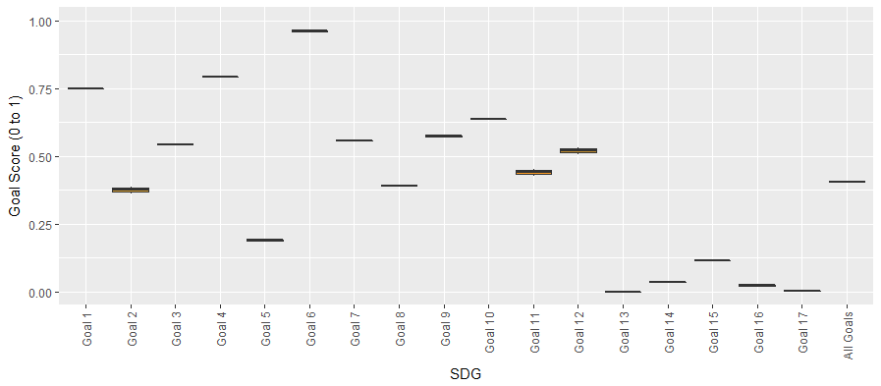

**Figure SI.6a BAU sensitivity analysis results – expected average temperature change**

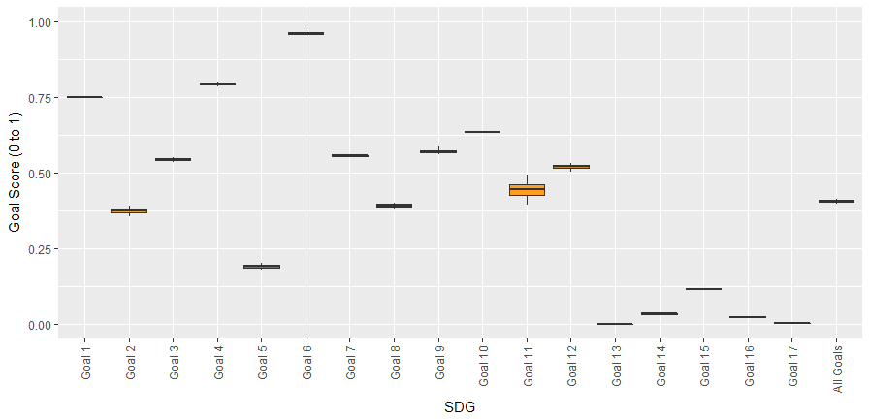

**Figure SI.6b BAU sensitivity analysis results – value added per ton of fish and sugar**

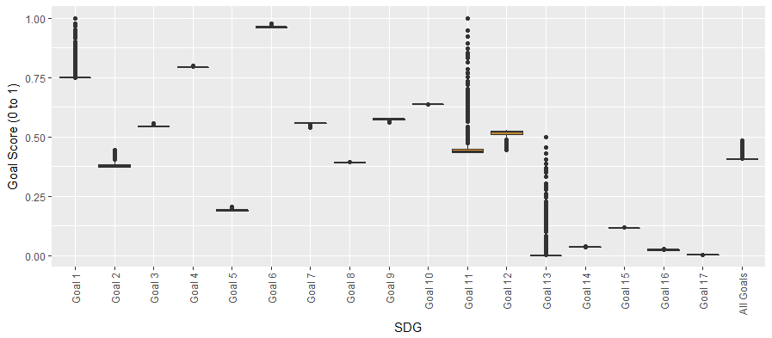

**Figure SI.6c BAU sensitivity analysis results – estimated cost of adaptation per degree of warming**

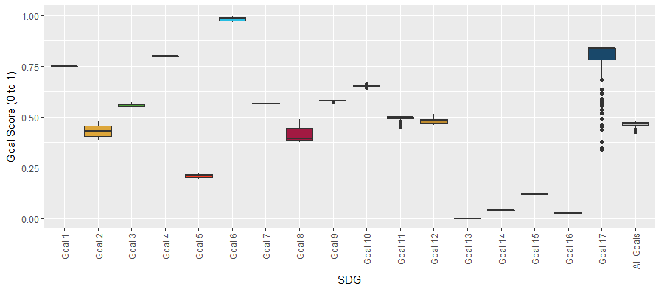

**Figure SI.6d BAU sensitivity analysis results – grants as share of GDP**

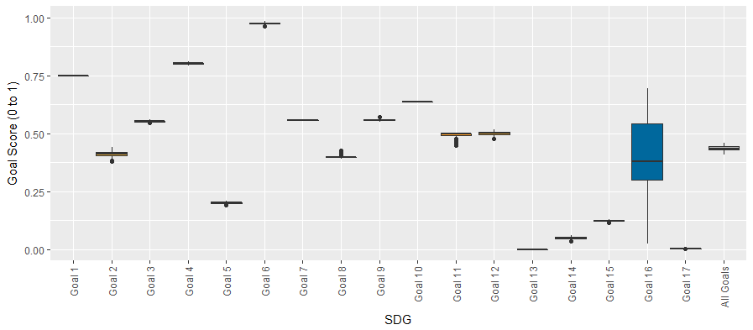

**Figure SI.6e BAU sensitivity analysis results – governance parameters**

**supplementary Figure SI.7 Sensitivity analysis results for ‘Sustainability Transition’ scenario in 2030**

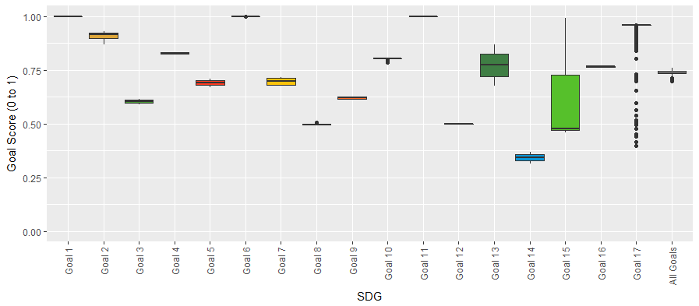

**Figure SI.7a ‘ST’ sensitivity analysis results – grants as share of GDP**

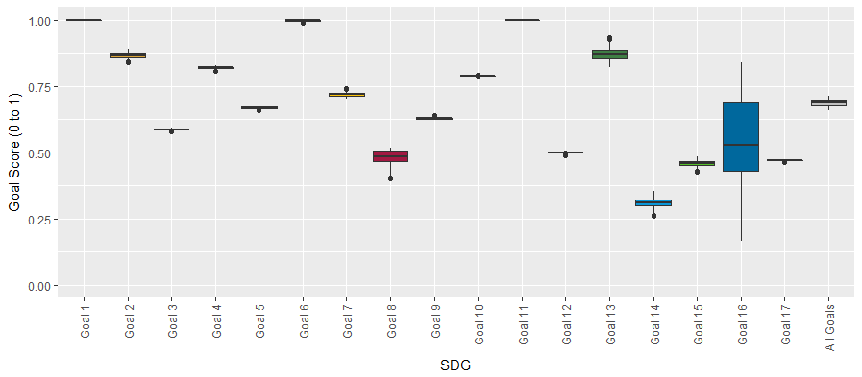

**Figure SI.7b ‘ST’ sensitivity analysis results – governance parameters**

**supplementary Figure SI.8 Sensitivity analysis results for ‘ST_CLIMATE’ scenario in 2030**

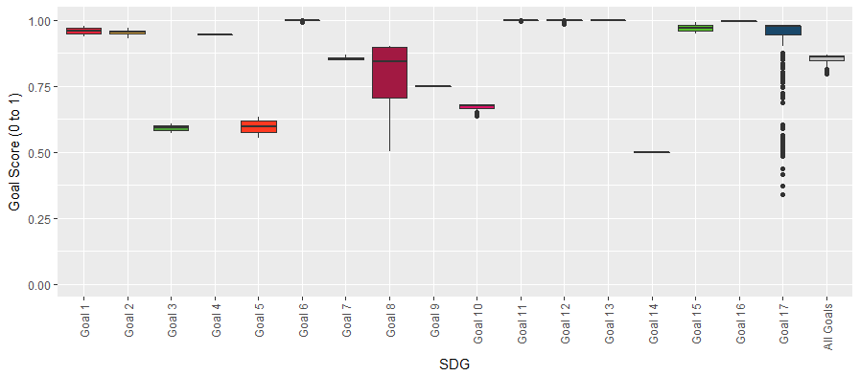

**Figure SI.8a ‘ST_CLIMATE’ sensitivity analysis results – grants as share of GDP**

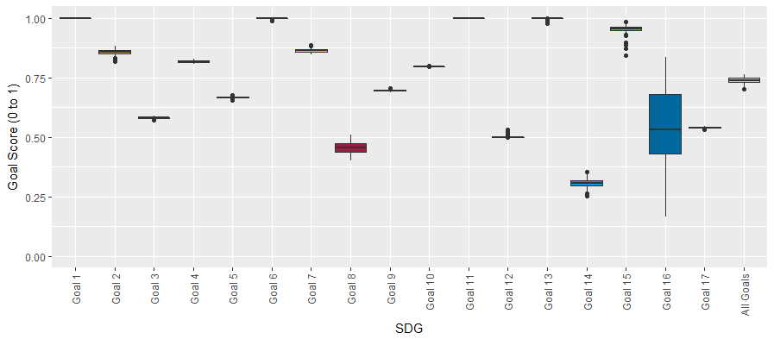

**Figure SI.8b ‘ST_CLIMATE’ sensitivity analysis results – governance parameters**

**supplementary Figure SI.9 Sensitivity analysis results for ‘ST_SDG’ scenario in 2030**

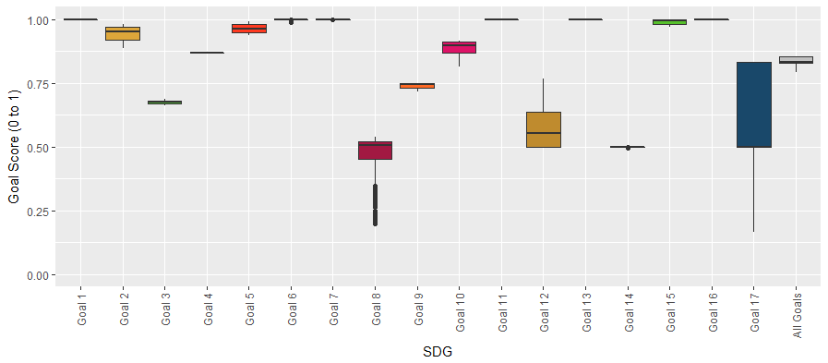

**Figure SI.9a ‘ST_SDG’ sensitivity analysis results – grants as share of GDP**

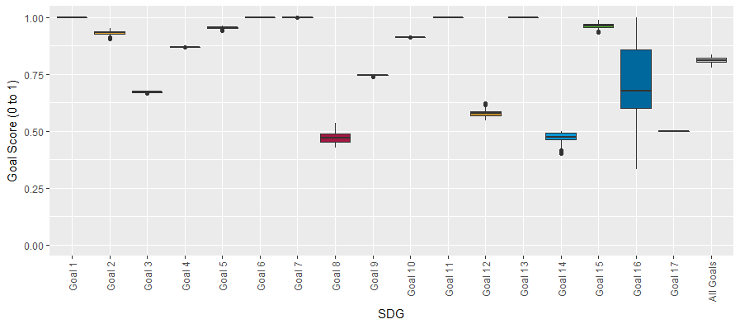

**Figure SI.9b ‘ST_SDG’ sensitivity analysis results – governance indicator score targets**

**supplementary Figure SI.10 Extreme conditions tests for ‘ST_SDG’ scenario in 2030**

The extreme conditions tests simulated the ‘ST_SDG’ scenario maintaining all scenario settings and assumptions except the assumption for additional grants, which were reduced by 50% (‘S4_SDG_half grants’) and 100% (‘S4_SDG_no_grants’), respectively. This shows the sustainability of the ‘ST_SDG’ scenario in the absence of additional financial assistance in the form of grants.

**Figure SI.10a Real GDP projection for 2030, including simulation results for ‘ST_SDG_half grants’ ‘ST_SDG_no_grants’ simulations**

**Figure SI.10b Debt-to-GDP projection for 2030, including simulation results for ‘ST_SDG_half grants’ ‘ST_SDG_no_grants’ simulations**

**Figure SI.10c Interest payment projection for 2030, including simulation results for ‘ST_SDG_half grants’ ‘ST_SDG_no_grants’ simulations**

**Figure SI.10d Overall SDG progress projection for 2030, including simulation results for ‘ST_SDG_half grants’ ‘ST_SDG_no_grants’ simulations**

**SUPPLEMENTARY DISCUSSION**

**Additional Discussion on study caveats and limitations**

The ‘ST’ and high ambition scenarios see strong GDP growth and improved environmental performance, which may seem unintuitive. Fiji’s economy is very small by international standards and the scale of additional investment included in these scenarios is significant as a proportion of GDP, most of which is government expenditure, and which drives more rapid economic growth. This investment can only be sustained in the long-term through generous assumptions around international grants. The sensitivity analysis reveals that without these grants, for the ‘ST_SDG’ scenario, performance on economy and jobs (Goal 8) and means of implementation would decline by more than half (from around 50% to around 20% progress) (**Supplementary Figure SI.8a**). Smaller reductions are also apparent in social goals, including income equality (Goal 10). While overall SDG progress does not decline significantly (-4% progress on the SDGs), this is because the negative effects on economy and debt are partly balanced out by positive effects from reduced material consumption on sustainable consumption and production (Goal 12) and related targets in Goal 8 (economy). If the ‘ST_SDG’ scenario is re-simulated removing all additional grants while keeping all other settings the same, real GDP plateaus and shows signs of collapse over the long-term as public debt increases exponentially to nearly 200% GDP by 2030 along with unsustainable interest payments (**Supplementary Figure SI.10**). The scenario should therefore be viewed as exploratory, testing what might be possible with very generous international assistance and policy settings.

This highlights a second point, that while environmental sustainability outcomes are achieved with higher GDP growth, it does not necessarily mean that increasing GDP is the mechanism for delivering such outcomes. A large share of the additional investment under the ‘ST’ scenarios is allocated to the environment with ambitious investments and settings in energy and fuel efficiency, renewable energy, reforestation, electric vehicles, sustainable agriculture and, to a lesser degree, resource efficiency. The results show that while GDP increases, the measures are adequate to reduce per capita emissions (particularly net emissions) and to maintain per capita MF at more or less the same level. Again, national context is critical. For Fiji, baseline levels in the indicators are very low by international comparison and not far from global sustainability thresholds, and the challenge is to moderately reduce these footprints over time. For a large developed country with large material and carbon footprints, a much greater transformation would be needed to bring them in line with global thresholds, as shown by Allen et al. (2019) for Australia, which would have very different implications for GDP growth and SDG performance. This is also supported by the modelling results and sensitivity analysis for Fiji, as seen by the improved performance on sustainable consumption and production (Goal 12) as GDP growth slows or declines. The results also suggest that for Fiji and other developing countries with similar characteristics such as low resource footprints, there may be potential for them to ‘leap-frog’ resource intensive development pathways followed by the developed world.

Additional expenditure and investment in the *iSDG-Fiji* model is expressed as a proportion of GDP. As such, if GDP accelerates more rapidly, generally so does investment. If this expenditure is on environmental policies, for example on marine or terrestrial protected areas or reforestation, then additional progress is also made towards SDG targets for these indicators. As such, for some indicators, there may be an indirect link between increased GDP and improved environmental outcomes as a result of increased green investment. However, environmental impacts associated with GDP growth are also important for some indicators such as energy and resource consumption which generally increase as GDP growth accelerates, as in the case of MF described above.

Another important caveat is that the PBs thresholds used in the SJS framework for this study rely primarily on territorial or production-based metrics. As such they do not include consumption associated with international trade which have been used in other studies (O’Neill et al., 2018) and which are important for assessing absolute sustainability. An area for further model development is to convert territorial metrics to consumption-based metrics which could be achieved by coupling the *iSDG* system dynamics model with multi-regional input-output models.

The projections to 2050 reveal that scenarios with limited investment in climate change adaptation (BAU, GC, IG) suffer reduced economic performance in the longer-term to 2050 (**Supplementary Figure SI.5**). The effects of climate change are related to the amount of global warming and global efforts to mitigate climate change as well as underlying national vulnerability and capacity to respond. Future effects are uncertain, and it is difficult to calibrate the socio-economic impacts and resource requirements needed to adapt to climate change over the long-term.

Our study relied on climate change projections included in the SSPs (Riahi et al., 2017) and projections for Fiji (Fiji Meteorological Service et al., 2011), as well as global (UNFCCC, 2007, UNEP, 2016) and national (Government of Fiji, 2017a) studies on the costs of climate change adaptation. However, we acknowledge the uncertainty and considerable variability in some of the estimates used. For example, global estimates on climate change adaptation costs range from around 0.06% to 0.65% GDP per annum. Our sensitivity analysis encompasses these possibilities (0.05 to 2% GDP), and shows that assumptions on adaptation costs can have substantial effects on each of the goals that incorporate climate change vulnerability indicators (Goal 1, Goal 11 and Goal 13) (**Supplementary Figure SI.6c)** and impacts overall SDG performance. These effects will become more severe moving beyond 2030 to 2050.

Fiji’s baseline performance on governance Indicators is relatively low, particularly for regulatory quality, government effectiveness, and rule of law (**Supplementary Table 1**). For most scenarios, we assume improved performance on governance metrics as Fiji progresses towards 2030, in particular the ‘ST_SDG’ scenario which assumes significant improvements. The sensitivity analysis shows that scenario performance on Goal 16 (governance) is sensitive to these assumptions, which also have a small impact on overall SDG performance (**Supplementary Figures SI.6e, 7b, 8b, and 9b**).

All alternative scenarios (except ‘GC’) also assume additional international financial assistance. For ‘GE’, ‘IG’ and ‘ST’, additional grants are considered moderate and within historic levels. However, for the high ambition scenarios these amounts increase significantly under the assumption of increasing access to climate and SDG finance. The sensitivity analysis shows increased sensitivity of SDG performance under the high ambition scenarios to the availability of international finance (**Supplementary Figures SI.8a and 9a**). For the ‘ST_SDG’ scenario, strong performance on food and nutrition (Goal 2), economy and jobs (Goal 8), inequality (Goal 10) and means of implementation (Goal 17) would all depend to some degree on receipt of additional international support.

This highlights the importance of governance (Goal 16) and partnerships and international collaboration for the goals (Goal 17), and it underscores that SIDS such as Fiji will not be able to achieve the SDGs without the international community scaling up its support.

**REFERENCES**

ADAMS, V. M., SEGAN, D. B. & PRESSEY, R. L. 2011. How much does it cost to expand a protected area system? Some critical determining factors and ranges of costs for Queensland. *PloS one,* 6**,** e25447.

ALLEN, C., METTERNICHT, G., WIEDMANN, T. & PEDERCINI, M. 2019. Greater gains for Australia by tackling all SDGs but the final steps will be the most challenging. *Nature Sustainability,* 2**,** 1041-1050.

ARROW, K. J. 1964. Optimal capital policy, the cost of capital, and myopic decision rules. *Annals of the Institute of Statistical Mathematics,* 16**,** 21-30.

BALMFORD, A., GRAVESTOCK, P., HOCKLEY, N., MCCLEAN, C. J. & ROBERTS, C. M. 2004. The worldwide costs of marine protected areas. *Proceedings of the National Academy of Sciences,* 101**,** 9694-9697.

BAN, N. C., ADAMS, V., PRESSEY, R. L. & HICKS, J. 2011. Promise and problems for estimating management costs of marine protected areas. *Conservation Letters,* 4**,** 241-252.

BURKE, M., HSIANG, S. M. & MIGUEL, E. 2015. Global non-linear effect of temperature on economic production. *Nature,* 527**,** 235.

CIA 2017. The World Factbook - Fiji. Washington DC: Central Intelligence Agency.

CLARK, M. & TILMAN, D. 2017. Comparative analysis of environmental impacts of agricultural production systems, agricultural input efficiency, and food choice. *Environmental Research Letters,* 12**,** 064016.

COLLIER, P., KIRCHBERGER, M. & SÖDERBOM, M. 2015. The cost of road infrastructure in low and middle income countries. Washington DC: The World Bank.

ENERDATA 2018. Global Energy Statistical Yearbook 2018. <https://yearbook.enerdata.net/total-energy/world-energy-intensity-gdp-data.html>.

FAO 1998. Land Cover Classification System: Classification Concepts and User Manual. Rome, Italy: Food and Agriculture Organisation of the United Nations.

FAO 2017. FAOSTAT database. Rome, Italy.

FAO 2018. AQUASTAT. Rome, Italy: Food and Agriculture Organisation of the United Nations.

FBOS 2016. Central Government Final Consumption Expenditure. *In:* STATISTICS, F. B. O. (ed.). Suva, Fiji: Fiji Bureau of Statistics.

FBOS 2019. Merchandise Trade Statistics. *In:* STATISTICS, F. B. O. (ed.). Suva, Fiji: Fiji Bureau of Statistics.

FIJI METEOROLOGICAL SERVICE, AUSTRALIAN BUREAU OF METEOROLOGY & CSIRO 2011. Current and future climate of the Fiji Islands. Canberra: Australian Government.

FIJI ROADS AUTHORITY 2016. 2016 Corporate Plan & Statement of Corporate Intent. Suva, Fiji: Fiji Roads Authority.

FIXEN, P. E., JIYUN, J., TIWARI, K. & STAUFFER, M. D. 2005. Capitalizing on multi-element interactions through balanced nutrition—A pathway to improve nitrogen use efficiency in China, India and North America. *Science in China Series C: Life Sciences,* 48**,** 780-790.

FOREST CARBON PARTNERSHIP FACILITY 2016. Emission Reductions Program Idea Note (ER-PIN). Suva, Fiji: World Bank.

GLOBAL ENVIRONMENT FACILITY 2005. Technical Paper on the GEF Resource Allocation Framework. Washington DC, USA: Global Environment Facility.

GOVERNMENT OF FIJI 2004. Millennium Development Goals Fiji National Report. Suva, Fiji: Government of Fiji.

GOVERNMENT OF FIJI 2010. Millennium Development Goals 2nd Report, 1990-2009. Suva, Fiji: Government of Fiji.

GOVERNMENT OF FIJI 2014. A Green Growth Framework for Fiji. Suva, Fiji: Government of Fiji.

GOVERNMENT OF FIJI 2017a. Climate Vulnerability Assessment. Fiji: Government of Fiji.

GOVERNMENT OF FIJI 2017b. Fiji NDC Implementation Roadmap 2017-2030. Suva, Fiji: Government of Fiji.

GOVERNMENT OF FIJI 2017c. Transforming Fiji: 5-Year and 20-Year National Development Plan. Suva, Fiji: Government of Fiji.

GOVERNMENT OF FIJI 2018a. Fiji Low Emission Development Strategy 2018-2050. Fiji: Government of the Republic of Fiji.

GOVERNMENT OF FIJI 2018b. National Adaptation Plan. Fiji: Government of Fiji.

GOVERNMENT OF FIJI 2019. Voluntary National Review: Fiji's Progress in the Implementation of the Sustainable Development Goals. Suva, Fiji: Government of Fiji.

HAYWARD, J. & GRAHAM, P. 2017. Electricity generation technology cost projections, 2017-2015. Australia: CSIRO.

IMF 2017. Government Finance Statistics. *In:* FUND, I. M. (ed.). Washington, USA.

IMF 2018. IMF Country Report Republic of Fiji. *2018 Article IV Consultation.* Washington DC: International Monetary Fund.

INTERNATIONAL ENERGY AGENCY 2016. Global energy database. Paris, France.

INTERNATIONAL ENERGY AGENCY 2017. Energy Efficiency 2017, Market Report Series. Paris: IEA.

INTERNATIONAL MONETARY FUND 2014. Government finance statistics manual. Washington DC, USA: International Monetary Fund.

INTERNATIONAL RESOURCE PANEL 2017. Resource Efficiency: Potential and Economic Implications. . Paris: UN Environment.

IRENA 2018. Renewable power generation costs in 2017. Abu Dhabi: International Renewable Energy Agency.

ISEE SYSTEMS 2018. Stella Architect. Lebanon, USA: ISEE Systems.

IUCN 2019. Red List Index. *In:* PROGRAMME, I. G. S. (ed.). Cambridge: IUCN.

IUCN & UNEP-WCMC 2017. World Database on Protected Areas. International Union for the Conservation of Nature and United Nations Environment Programme World Conservation Monitoring Centre.

JAMES, A., GASTON, K. J. & BALMFORD, A. 2001. Can we afford to conserve biodiversity? *BioScience,* 51**,** 43-52.

JAMES, A., GREEN, J. & PAINE, J. 1999. A Global Review of Protected Area Budgets and Staff. Cambridge, U.K.: World Conservation Monitoring Centre.

KAUFMAN, D. & KRAAY, A. 2016. Worldwide Governance Indicators. Washington, USA: The World Bank.

KLEISNER, K., BRENNAN, C., GARLAND, A., LINGARD, S., TRACEY, S., SAHLQVIST, P., TSOLOS, A., PAULY, D. & ZELLER, D. 2015. Australia: Reconstructing estimates of total fisheries removal, 1950-2010. British Columbia: University of British Columbia.

LAL, M., MCGREGOR, J. L. & NGUYEN, K. C. 2008. Very high-resolution climate simulation over Fiji using a global variable-resolution model. *Climate Dynamics,* 30**,** 293-305.

LAL, S. & RATURI, A. 2012. Techno-economic analysis of a hybrid mini-grid system for Fiji islands. *International Journal of Energy and Environmental Engineering,* 3**,** 10.

LENZEN, M., MORAN, D., KANEMOTO, K. & GESCHKE, A. 2013. BUILDING EORA: A GLOBAL MULTI-REGION INPUT–OUTPUT DATABASE AT HIGH COUNTRY AND SECTOR RESOLUTION. *Economic Systems Research,* 25**,** 20-49.

LOFGREN, H., HARRIS, R. L. & ROBINSON, S. 2002. *A standard computable general equilibrium (CGE) model in GAMS,* Washington DC, USA, International Food Policy Research Institute.

MCCREA-STRUB, A., ZELLER, D., SUMAILA, U. R., NELSON, J., BALMFORD, A. & PAULY, D. 2011. Understanding the cost of establishing marine protected areas. *Marine Policy,* 35**,** 1-9.

MCINNES, K. L., WALSH, K. J., HOEKE, R. K., O’GRADY, J. G., COLBERG, F. & HUBBERT, G. D. 2014. Quantifying storm tide risk in Fiji due to climate variability and change. *Global and Planetary Change,* 116**,** 115-129.

MILLENNIUM INSTITUTE 2017. iSDG Model Documentation. Washington D.C.: Millennium Institute.

NARAYAN, P. K. & NARAYAN, S. 2006. Savings behaviour in Fiji: an empirical assessment using the ARDL approach to cointegration. *International journal of social economics,* 33**,** 468-480.

NARAYAN, P. K., NARAYAN, S., CHAND PRASAD, B. & PRASAD, A. 2007. Export-led growth hypothesis: evidence from Papua New Guinea and Fiji. *Journal of Economic Studies,* 34**,** 341-351.

NARAYAN, P. K., NARAYAN, S. & PRASAD, A. 2009. Modelling Fiji–US exchange rate volatility. *Applied Economics Letters,* 16**,** 831-834.

NARAYAN, S. 2013. A structural VAR model of the Fiji Islands. *Economic Modelling,* 31**,** 238-244.

O’NEILL, B. C., KRIEGLER, E., EBI, K. L., KEMP-BENEDICT, E., RIAHI, K., ROTHMAN, D. S., VAN RUIJVEN, B. J., VAN VUUREN, D. P., BIRKMANN, J. & KOK, K. 2017. The roads ahead: narratives for shared socioeconomic pathways describing world futures in the 21st century. *Global Environmental Change,* 42**,** 169-180.

O’NEILL, D. W., FANNING, A. L., LAMB, W. F. & STEINBERGER, J. K. 2018. A good life for all within planetary boundaries. *Nature Sustainability,* 1**,** 88.

OEC. 2017. *OEC Trade Database: Fiji Country Profile* [Online]. Massachusetts: The Observatory of Economic Complexity, MIT Available: <https://oec.world/en/profile/country/fji/> [Accessed].

OECD 2017. OECD.stat Green Growth Indicators. Organisation for Economic Cooperation and Development.

OECD & FAO 2017. OECD-FAO Agricultural Outlook 2018-2027. Rome, Italy: Organisation for Economic Cooperation and Development and the UN Food and Agricultural Organisation.

OECD & FAO 2019. Agricultrual Outlook 2019-2028. Paris: OECD.

ORGANISATION FOR ECONOMIC COOPERATION AND DEVELOPMENT 2012. OECD Environmental Outlook to 2050: The consequences of inaction. Paris: OECD.

ORR, B., COWIE, A., CASTILLO SANCHEZ, V., CHASEK, P., CROSSMAN, N., ERLEWEIN, A., LOUWAGIE, G., MARON, M., METTERNICHT, G. & MINELLI, S. Scientific conceptual framework for land degradation neutrality. Bonn, Germany: United Nations Convention to Combat Desertification (UNCCD), 2017. 1-98.

PANDEY, K. D., BUYS, P., CHOMITZ, K. & WHEELER, D. 2006. Biodiversity Conservation Indicators: New Tools for Priority-Setting at the Global Environment Facility. *World Bank Development Research Group Working Paper.*

PAULY, D. & ZELLER, D. 2015. Seas Around Us Concepts, Design and Data. British Columbia: University of British Columbia.

PAYTON, I. & WEAVER, S. 2011. Fiji National Forest Carbon Stock Assessment. Suva, Fiji: Secretariat of the Pacific Community.

PRASAD, R. D. & RATURI, A. 2019. Low carbon alternatives and their implications for Fiji's electricity sector. *Utilities Policy,* 56**,** 1-19.

PRATT, S. 2014. A general equilibrium analysis of the economic impact of a devaluation on tourism: The case of Fiji. *Tourism Economics,* 20**,** 389-405.

PRATT, S. 2015. The economic impact of tourism in SIDS. *Annals of Tourism Research,* 52**,** 148-160.

RIAHI, K., VAN VUUREN, D. P., KRIEGLER, E., EDMONDS, J., O’NEILL, B. C., FUJIMORI, S., BAUER, N., CALVIN, K., DELLINK, R. & FRICKO, O. 2017. The shared socioeconomic pathways and their energy, land use, and greenhouse gas emissions implications: an overview. *Global Environmental Change,* 42**,** 153-168.

SACHS, J., SCHMIDT-TRAUB, G., KROLL, C., DURAND-DELACRE, D. & TEKSOZ, K. 2017. SDG Index and Dashboards Report 2017. *Bertelsmann Stiftung and Sustainable Development Solutions Network (SDSN): New York, NY, USA*.

SACHS, J., SCHMIDT-TRAUB, G., KROLL, C., LAFORTUNE, G. & FULLER, G. 2019. Sustainable Development Report 2019. New York: Betelsmann Stiftung and Sustainable Development Solutions Network.

SCHMIDT-TRAUB, G., KROLL, C., TEKSOZ, K., DURAND-DELACRE, D. & SACHS, J. D. 2017. National baselines for the Sustainable Development Goals assessed in the SDG Index and Dashboards. *Nature Geoscience,* 10.

SENOKONOKO, K. B. 2014. Hydraulic modelling of the water distribution system of Tavua-Vatukoula, Fiji. Brisbane: University of Queensland.

SNOWDON, W., MOODIE, M., SCHULTZ, J. & SWINBURN, B. 2011. Modelling of potential food policy interventions in Fiji and Tonga and their impacts on noncommunicable disease mortality. *Food Policy,* 36**,** 597-605.

SUSTAINABLE EUROPE RESEARCH INSTITUTE 2009. Resource efficiency for sustainable growth: global trends and European policy scenarios. Brussels: UNIDO.

THE WORLD BANK 2018. World Development Indicators DataBank. Washington, USA.

TRANSPARENCY INTERNATIONAL 2016. Corruption Perception Index. Berlin: Transparency International.

UNDP. 2016. *Chemical Free Farming Paves the Way to Sustainability in Fiji* [Online]. Suva, Fiji: United Nations Development Programme and Global Environmentl Facility Small Grants Programme. Available: <https://www.sgp.undp.org/index.php?option=com_content&view=article&id=425:chemical-free-farming-paves-the-way-to-sustainability-in-fiji&catid=36:our-stories&Itemid=253> [Accessed 10 December 2019].

UNEP 2016. Adaptation Finance Gap Report. Nairobi: United Nations Environment Progrmme.

UNFCCC 2007. Investment and Financial Flows to Address Climate Change. Bonn: United Nations Framework Convention on Climate Change.

UNITED NATIONS 2015. Sendai Framework for Disaster Risk Reduction 2015-2030. New York: United Nations Office for Disaster Risk Reduction.

UNITED NATIONS 2017. United Nations Strategic Plan for Forests 2017-2030. New York: United Nations.

UNITED NATIONS 2018. United Nations Global SDG Database. New York: United Nations.

UNITED NATIONS 2019. World Population Prospects. *In:* DIVISION, U. P. (ed.). New York: UN Population Division.

UNITED NATIONS CONVENTION ON BIOLOGICAL DIVERSITY 2010. Strategic Plan for Biodiversity 2011-2020. Montreal, Canada: United Nations.

UNITED NATIONS DEVELOPMENT GROUP 2015. Mainstreaming the 2030 Agenda for Sustainable Development: Interim Reference Guide to UN Country Teams.

UNITED NATIONS GENERAL ASSEMBLY 2015. Transforming our world: the 2030 Agenda for Sustainable Development, outcome document of the United Nations summit for the adoption of the post-2015 agenda. *RES/A/70/L.1.* New York: United Nations.

USAID 2017. Climate Change Adaptation Through Sustainable Agriculture. Suva, Fiji: USAID.

USDA 2017. National Agricultural Statistics. *In:* SERVICE, N. A. S. (ed.). USA: United States Department of Agriculture.

VENTANA SYSTEMS INC. 2018. Vensim DSS 7.3. Harvard, USA: Ventana Systems Inc.

WEST, J. & LIEBER, M. 2018. Global Material Flows Database. Paris, France.

WHO 2005. WHO Air quality guidelines for particulate matter, ozone, nitrogen dioxide and sulfur dioxide. Switzerland: World Health Organisation.

WHO 2012. Global costs and benefits of drinking-water supply and sanitation interventions to reach the MDG target and universal coverage. Geneva: World Health Organization.

WHO 2018. Global Health Estimates: Desease burden by Cause, Age, Sex, Country and Region. Switzerland: World Health Organisation.

WORLD BANK 2015. Project Appriasal Document on a Proposed Loan in the Amount of US$50 Million to the Republic of Fiji for a Transport Infrastructure Project. Washington DC: World Bank.

WORLD BANK 2019. Commodity Markets Outlook. Washington DC: World Bank.