Supplementary information for

**Quasi-Continuously Tuning the Size of Graphene Quantum Dots via an Edge-Etching Mechanism**

Shujun Wang1,2, Ivan S. Cole3 , Dongyuan Zhao4, and Qin Li1,2*

1 Queensland Miro- and Nanotechnology Centre, Griffith University, Nathan Campus, Brisbane, QLD 4111, Australia

2 School of Engineering (Environmental), Griffith University, Nathan Campus, Brisbane, QLD 4111, Australia

3CSIRO Materials Science and Engineering, –Gate 5, Normanby Road, Clayton, VIC 3168, Australia

4Department of Chemistry & Laboratory of Advanced Materials, Fudan University, Shanghai, 200433, P.R. China,

*Corresponding author at: Nathan campus Griffith University,170 Kessels Road, Nathan, QLD 4111, Au; E-mail address: [qinli@griffith.edu.au](mailto:qinli@griffith.edu.au); Tel.: (07) 373 57514

1. **Sizes of crystallites in carbon black**

The sizes of crystallites of carbon black was derived from two techniques, XRD and Raman. From XRD by using the well-known Scherrer equation1-3 the crystallite dimension along the stacking direction (thickness of the crystallites) could be derived.

Lc=Kλ/βcosϴ (S1)

Where, K is a constant and for carbon black the value is 0.89; λ is the wavelength of X-Ray since Cu Kα X-Ray is used, λ=1.54A; β is the full width at half maximum intensity (FWHM) of the diffraction peak. ϴ is half the Bragg angle. Both units of β and ϴ in the formula are Radians.

Figure.S1a presented one of the XRD spectrum collected for CB employed in this study. The parameters for Eq.S1 are obtain via spectrum fitting with the software Highscore Plus. By applying Eq.S1 on diffraction peak of 002, the Lc for the spectrum as shown could be calculated as follow Lc=0.89X0.154/((0.073)*cos(0.217))=1.915 (nm)

The in plane dimension (basal plane size) of the crystallite was calculation through applying the Tuinstra-Koenig relationship (Eq.S2) in which Raman spectra are utilized4. Figure.S1b is one of the Raman spectrum acquired from the CB.

La=4.35/(ID/IG) (S2)

Where, ID and IG are the intensity of D and G bands of the Raman spectrum respectively.

All the parameters used in Eq.S2 are obtained through spectrum fitting with software WiRE.3.

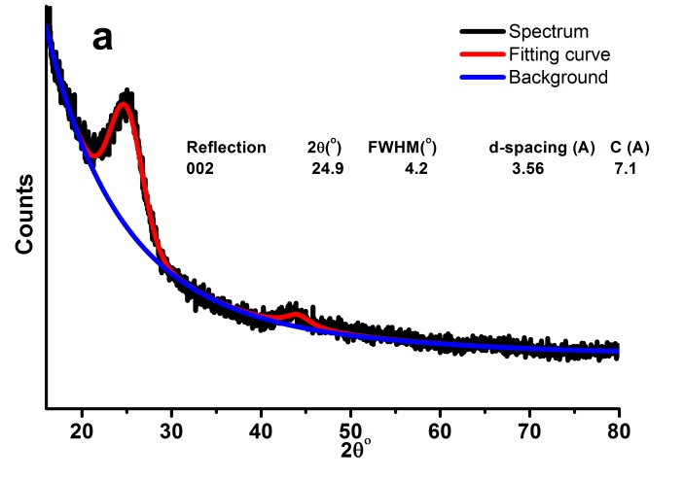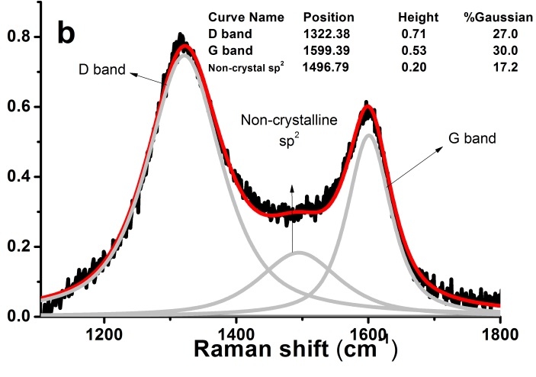

Figure S1. XRD and Raman spectra for CB employed in this research

1. **Photoluminescence of graphene quantum dots from carbon black**

Like most of GQDs synthesized so far, GQDs synthesized in this study possess excitation dependent photoluminescence (PL) as shown in Figure S1.



Figure S2. PL emission spectra of G20

1. **Size of GQDs**

For the size of GQDs, since they are free sp2 crystallites exfoliated from CB, the La derived from Raman (Fig. S 3) could be regarded as their particle size and the results agree well with the particle size from the dynamic light scattering measurement (Fig. S 4).

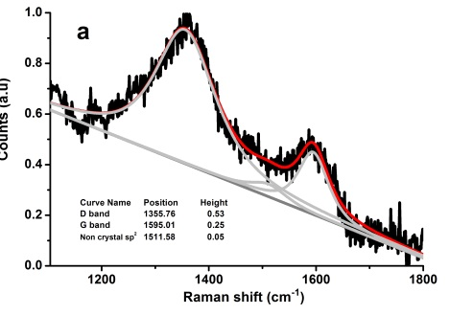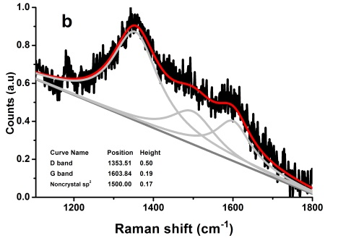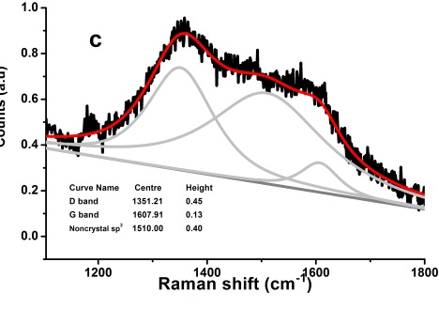

Figure S3. Raman profile fitting: a), G20; b), G80; c) G210

Table S1. Summary of Raman features

|  |  |  |  |  |  |
| --- | --- | --- | --- | --- | --- |
|  | D (cm-1) | G (cm-1) | sp2non-crystal(cm-1) | ID/IG | La |
| CB | 1320 | 1598 | 1510 | 1.34±0.06 | 3.25±0.13 |
| G20 | 1356 | 1595 | 1511 | 2.15±0.22 | 2.02±0.20 |
| G80 | 1354 | 1603 | 1510 | 2.63±0.21 | 1.65±0.14 |
| G210 | 1351 | 1607 | 1510 | 3.47±0.25 | 1.25±0.10 |



Figure S4. Particle size distribution from dynamic light scattering

**Reference**

1. B. E. Warren, Phys Rev **59** (9), 693-698 (1941).

2. J. Biscoe, Journal of Applied Physics **13** (6), 364 (1942).

3. A. Manivannan, M. Chirila, N. C. Giles and M. S. Seehra, Carbon **37** (11), 1741-1747 (1999).

4. F. Tuinstra, The Journal of Chemical Physics **53** (3), 1126 (1970).