SUPPLEMENTARY MATERIAL: Nanoscale temperature of plasmonic HAMR heads by polymer imprint thermal mapping

Gregory T. Hohensee¹, Tan Nguyen¹, Ella Pek², Wan Kuang^{1,3}, Ozgun Suzer¹, and Marc Finot¹
¹Western Digital Corporation, 1250 Reliance Way, Fremont CA 94539, U.S.A.
²Department of Materials Science and Engineering, Materials Research Laboratory, University of Illinois at Urbana-Champaign, Urbana, IL 61801, U.S.A.
³Department of Electrical and Computer Engineering, Boise State University, Boise, ID 83725, U.S.A.

CALIBRATION

To calibrate the polymer thickness change versus temperature for Figure 1 in the main text, we performed AFM step-height measurements across scratches in the polymer film deposited on a silicon wafer. The step heights are created by scratching the polymer film with 20 micron radius steel microtools; we verified that our scratches do not cut into the Si itself by getting similar results with wider scratches made by Teflon-tipped tweezers. AFM step-height scans were taken before and after heating the polymer/Si coupon to 200-300 ○C in 25 ○C steps. The AFM step-heights were taken exclusively within a few microns of one another, because we observed 10% polymer thickness variations at the centimeter scale on the wafer. We also measured Δh for two separate polymer-coated Si coupons which were heated directly to 100 and 200 ○C, respectively, rather than in increments of 25 ○C. We confirmed that there is no Δh/ΔT bias between incremental and direct heating to elevated temperature. We also confirmed that the polymer Δh/ΔT on the device substrate was the same as the Δh/ΔT on the Si wafer upon which the device substrates were mounted in the polymer i-CVD chamber.
Each heating step was done on a hot plate in air for 3 minutes, and all device laser power ON times were also for 3 minutes. The original PITM study found that the polymer Δh response at a given temperature is logarithmic with a time scale of seconds.[1] After 3 minutes, the local Δh/Δt is 0.1 nm/min, so small deviations in heating time have negligible impact. We considered pulsing the device laser at a low duty cycle rather than 3 minutes CW, to examine whether CW heating leads to a background temperature rise versus low duty cycle. Exploratory measurements (not shown) suggested no major differences in thermal imprint on a device between 3 minutes at 10% duty cycle, 30 minutes at 10% duty cycle, and 3 minutes CW laser stress.
The calibration data in Figure 1 were for depositions with different target thicknesses but otherwise similar recipes: independent of target thickness, they have some major differences in initial onset of temperature response and Δh/ΔT. Additional polymer depositions with the same nominal recipe also showed different Δh/ΔT.
We believe the Δh/ΔT slope is determined by the initial degree of cross-linking, where less cross-linking causes a steeper slope. This may be controlled by deposition rate and substrate temperature, but more work needs to be done to control the deposition process for a more systematic investigation. In Table S1, we present results from five other films with varied deposition conditions that GVD chose not to disclose, which at least show how variable the slope can be across different films. Within a single film, measurements at different positions spaced mm to cm apart and on different substrates (amorphous sample substrate vs. the Si carrier wafer) showed initial thicknesses that differed by 10-20%, but the fractional thickness change at specific temperatures (100 ○C, 200 ○C) was constant across the wafer to within our error bars.

Run ID | Initial thickness (nm) | Thickness after 3 min @ 200 ○C, same spot (nm) | Δh % after 200 ○C | Roughness Rq (nm) | R(peak-valley) (nm)
A1_S4 | 57.2 +/- 1 | 41.9 +/- 1 | -27 +/- 2% | 0.53 +/- 0.02 | 5.69
B5_S4 | 50.5 | 47.2 | -6.5 | 0.66 | 7.6
C10_S4 | 84.6 | 68.5 | -19 | 0.62 | 5.86
D15_S2.1 | 55.3 | 42.8 | -23 | 0.50 | 5.62
E20_S2 | 49.9 | 45.5 | -8.8 | 0.61 | 6.93
Table S1. Characterization of five additional films, aside from the two shown in Figure 1. These films were deposited under varying, undisclosed process conditions by GVD Corporation. We took AFM step-height data before and after heating to 200 ○C to get a rough percent thickness change (Δh %) that indicates the temperature responsivity of the film, and also measured the initial polymer film roughness on Si by two metrics (Rq, Rpv). Typical uncertainties are expressed in the first row for film A1_S4. “same spot” indicates that we measured the post-temperature step-height in a 20x20 micron AFM scan centered less than 5 microns from the initial scan; all such measurements are done across the same scratch pre- and post-temperature, and we observed no “creep” or flowing of any polymer scratch border with temperature.

EXPERIMENTAL METHOD

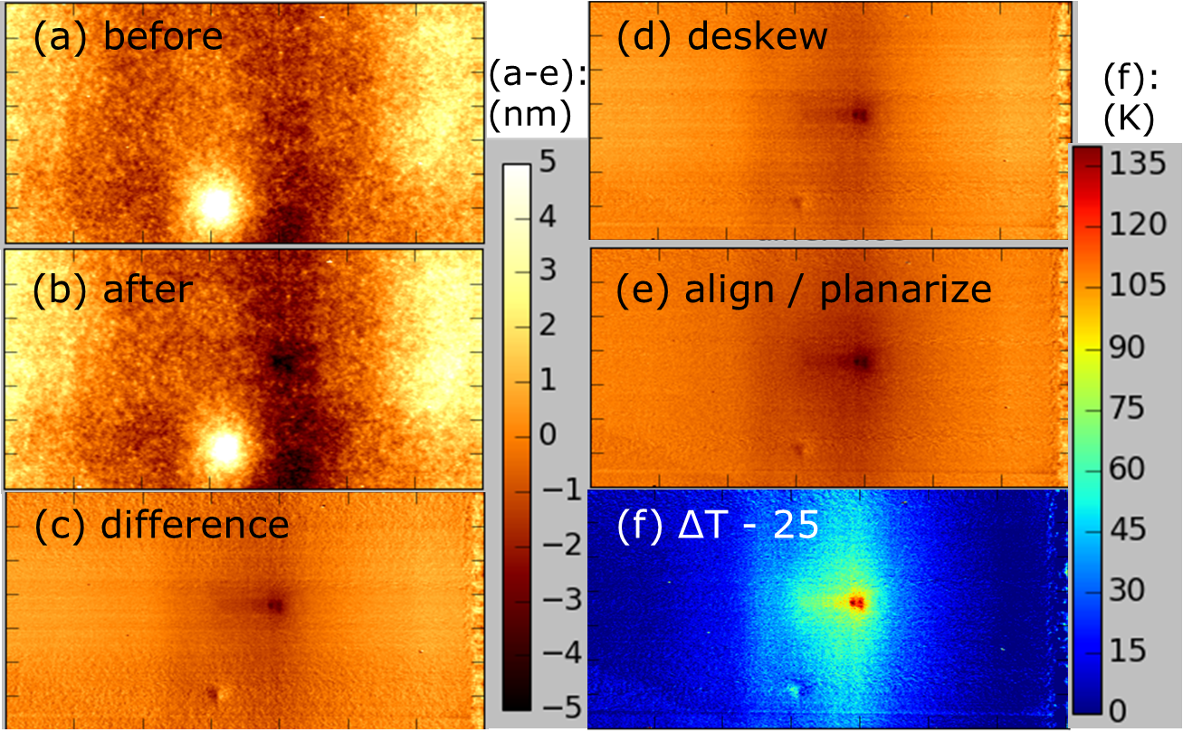
Figure S1. (a) raw AFM scan before powering the device. The microscale height variations, aside from the trapped dirt peak on the bottom-middle of the image, are due to the underlying topography of the device. (b) AFM scan after powering to high power. (c) The difference (b) - (a) using subpixel image registration. (d) Difference after de-skewing (b) relative to (a) by line-by-line correlation and removing the linear skew trend of pixel shift versus horizontal scan line. (e) Line-by-line median subtraction, followed by planarization away from temperature imprint, assuming zero DT sufficiently far away. (f) Temperature map by applying the calibration of Figure 1 to (e), with local initial polymer film thickness measured by a nearby step-height scan (not shown). The ΔT in (f) is offset by 25 K from the true ΔT because the polymer only responds above 50 ○C absolute temperature (see Figure 1, main text).

The raw AFM data and PITM processing steps are visualized in Figure S1. Figures S1(a) and S1(b) are AFM data before and after powering the device. The polymer surface before device heating shows few hints as to where the plasmonic NFT actually is; to locate it for the reference image, we do an exploratory AFM scan while powering the device barely above laser threshold, which does not generate enough heat to impact the polymer, but creates an AFM scanning artifact as the tip passes over the near-field excitation. In the second scan after device heating, we see the local polymer imprint, and observe no change (no temperature gradient) in the polymer topography away from the device. These outer areas are our reference for image registration, subtraction, and planarization, on the assumption that ΔT = 0 K (or at least uniform) away from the device.
After an initial planarization and median row alignment, we register the two images using a standard algorithm for subpixel cross-correlation in Fourier space.[2] After subtracting the AFM data to get Figure S1(c), we see skew artifacts: the relative position of the AFM tip and sample drift in the scan-line direction (horizontal axis) at different rates for different AFM scans, so the registration gets worse away from the center. To correct for skew, we take the 2D-registered images and then compute the additional line-by-line mis-registration by 1D Fourier correlation, which gives us a linear trend of pixels per horizontal scan-line between the two images. We exclude outliers associated with the thermal signature in the center of the second image, apply a linear fit, and use that to de-skew the second image relative to the first. The result is Figure S1(d), which carries a residual relative tilt from the slightly different planarizations of the two data sets. We apply another planarization to the zero ΔT reference regions away from the polymer imprint. This gives us Figure S1(e), and then S1(f) after applying Δh/ΔT calibration from Figure 1.
Another category of artifacts, not shown in Figure S1 but visible in S2(a), is changes in the AFM tip shape between the original reference scan and subsequent scans on the same device. If the tip picks up dirt or degrades abruptly during the half-dozen or more AFM scans taken for a PITM data set, a subtle non-uniform background may develop that wasn’t present in the original AFM scan. In our case, we use ScanAsyst tips in Bruker’s ScanAsyst scanning mode, where tip degradation can show up as vertical stripes or phase changes in the In-phase and Quadrature signals, which carry over to the ZSensor (height sensor) channel. If the tip degrades or is swapped out with a new one after the original reference scan, the phase pattern changes and shows up in the PITM data. The relative phase pattern between the reference and subsequent AFM scans can likely be normalized out of the PITM signal with further analysis.

CONTROL EXPERIMENT
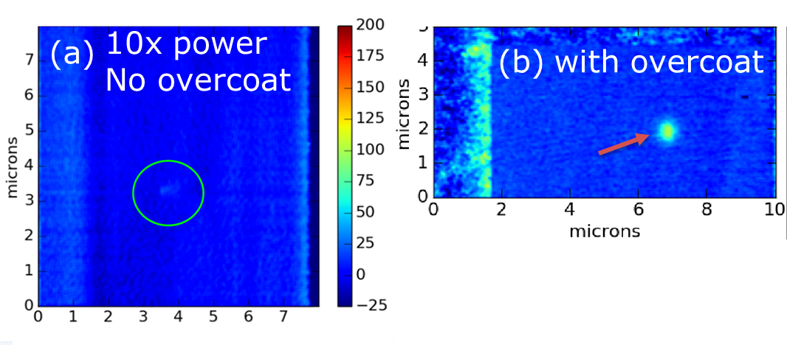
Figure S2. Control experiments showing PITM signal from two waveguide-only parts without any plasmonic or metal structures nearby: (a) with no overcoat, and (b) with an optically absorbing overcoat. Both figures share the same color scale. There is no PITM signal near the waveguide (inside green circle) from (a) despite receiving 10x higher laser power than (b). The faint signal above background in that region was a piece of dust trapped under the polymer, a hundred nm offset from the waveguide. The vertical stripe at x = 2 microns in (a) is a phase artifact from the AFM image subtraction process, where the AFM tip shape changed between the reference and final AFM scans. It is not a thermal signal.

Figure S2 shows the control experiment where we tested whether the polymer film is directly heated or affected by the device laser. Since the head overcoat of a typical recording head is somewhat optically absorbing, we tested a waveguide-only device with no head overcoat layer, hence no optical heat load in the system. Figure S2(a) shows an absence of PITM signal from that device despite a very high laser power input to the waveguide. For a comparable device with a head overcoat at 1/10th the input laser power, the PITM data shows a distinct thermal imprint in the polymer film, Figure S2(b). The polymer film is completely non-absorbing and non-reactive to the presence of high optical field intensity. This agrees with our ellipsometry data (not shown), where the optical absorption coefficient of the polymer at our wavelength was found to be k = 0.

SIGNAL NONLINEARITY VERSUS INPUT POWER

For a resistively heated device, we might expect a nonlinear relationship between, say, input voltage and Joule heating. For a HAMR head, the temperature rise should be linear with the input laser power, up to a damage or deformation threshold power.
There are four main reasons why the PITM signal would be nonlinear vs. laser power over certain regions, aside from the ΔT > 25 K signal floor inherent in our polymer (see Figure 1 in the main text). First, there could be an AFM scanning artifact that wasn’t fully corrected in the data processing, such as AFM tip degradation leading to a phase artifact as in Figure S2(a).
Second, microscale dirt could be trapped under the polymer near the device, and respond in its own way to high temperatures and high optical field intensity; it’s important for samples to be clean prior to polymer deposition.
Third, the PITM signal will go nonlinear if the device surface plastically deforms, due for example to stresses built up in a 3D structure of materials with different thermal expansion coefficients. The resulting protrusion or recession of device surface features will cause apparent decrease or increase in PITM temperature over certain device features. Since the polymer thickness reduction is irreversible, a decrease in apparent PITM temperature is a clear sign of device surface protrusion. Plastic deformation can be anticipated from prior testing, or recognized visually by a non-thermal shape or match with device structure contours.
The fourth reason for nonlinear PITM trends is more universal, where the device is damaged by temperature in a way that changes the heat load it experiences. For a HAMR head, that means a change in plasmonic performance due to deformation, diffusion, or oxidation of materials around the NFT structure, even if the device surface remains unchanged.

SPATIAL RESOLUTION ANALYSIS

PITM temperature data represents the through-thickness average temperature of the polymer film that coats the device surface, not the device surface temperature itself. We find by simulations, however, that the polymer temperature on a powered device is nearly equivalent to the surface temperature after convolution with a Gaussian point-spread function (PSF). Figure S3(a) shows the residual from minimizing the difference between the Gaussian-filtered, simulated surface temperature and the simulated average polymer temperature for a 50 nm polymer film. Figure S3(b) summarizes the resulting fitted values for the Gaussian function’s 1/e^2 radius (sigma) across a series of simulated polymer thicknesses from 10-100 nm, and Figure S4(a) shows that, for polymer films from 50-100 nm, the maximum error in this approximation is about 2% or less. For the simulations, we used ellipsometry- and time-domain thermoreflectance (TDTR)-measured refractive indices and thermal properties, respectively, for our polymer film. Specifically, we found n = 1.46 and k = 0 at our HAMR excitation wavelength, and a thermal conductivity of 0.175 +/- 0.015 W/m-K, typical for polymers. Figure S4(b) shows an example of a conversion factor that can be pulled from simulation to estimate the actual device surface peak temperature from PITM data.

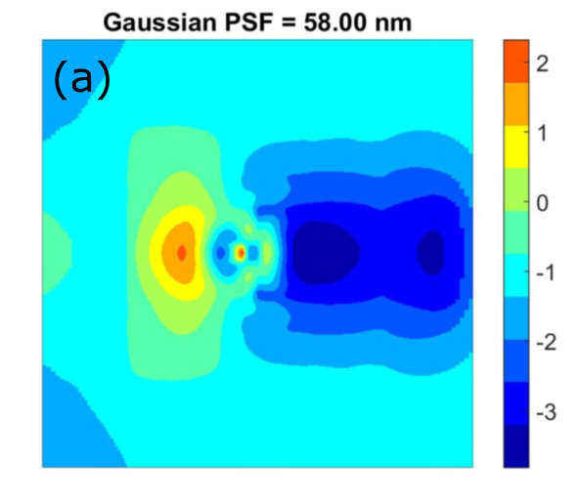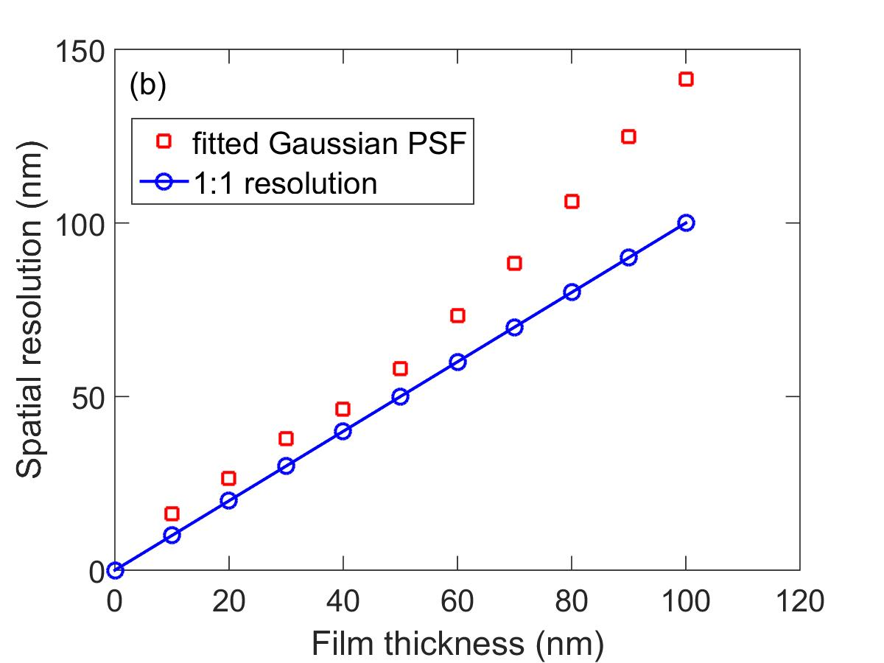

Figure S3. Fitting a Gaussian point spread function (PSF) to relate the polymer temperature, which PITM measures, to device surface temperature, which is our goal. (a) shows the residual map between the simulated polymer temperature, and the simulated device temperature after convolution with a Gaussian PSF with the specified sigma σ. The residual shown here was minimized by varying σ, with the result σ ≈ 58 nm for a 50 nm polymer film. The colorbar shows percent deviation. In (b), the fitted σ are plotted as a function of polymer film thickness (red squares) and compared to a 1:1 ratio (blue connected circles). These calculations ignore blurring contributions from the AFM tip radius.

In short, we can assume with only a few percent error that the polymer temperature represents the Gaussian-blurred surface temperature with spatial resolution scaling nearly 1:1 with the polymer film thickness up to 50 nm, and somewhat faster above 50 nm. We suspect this result is fairly general for temperature-sensitive thin films with low enough thermal conductivity and thickness: regardless of AFM tip sharpness, the spatial resolution of the information we care about, the device surface temperature, will be bounded by the film thickness. Even so, it’s important to blur the simulated polymer temperature by an AFM tip bluntness factor before comparing it to PITM data. Our calculations here neglect that step on the assumption of a sharp AFM tip, but realistically that will not be the case.

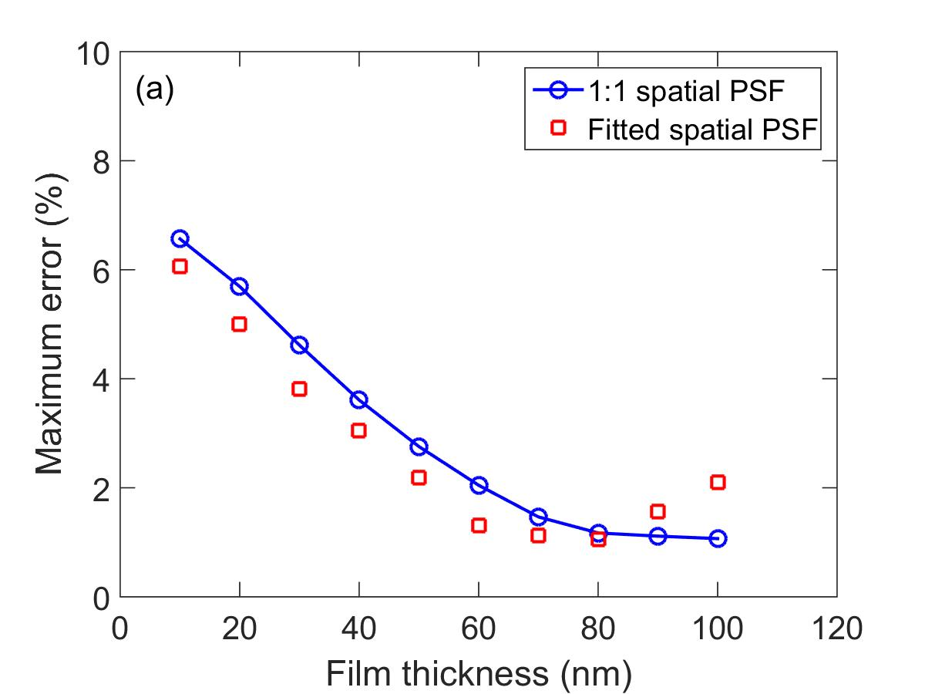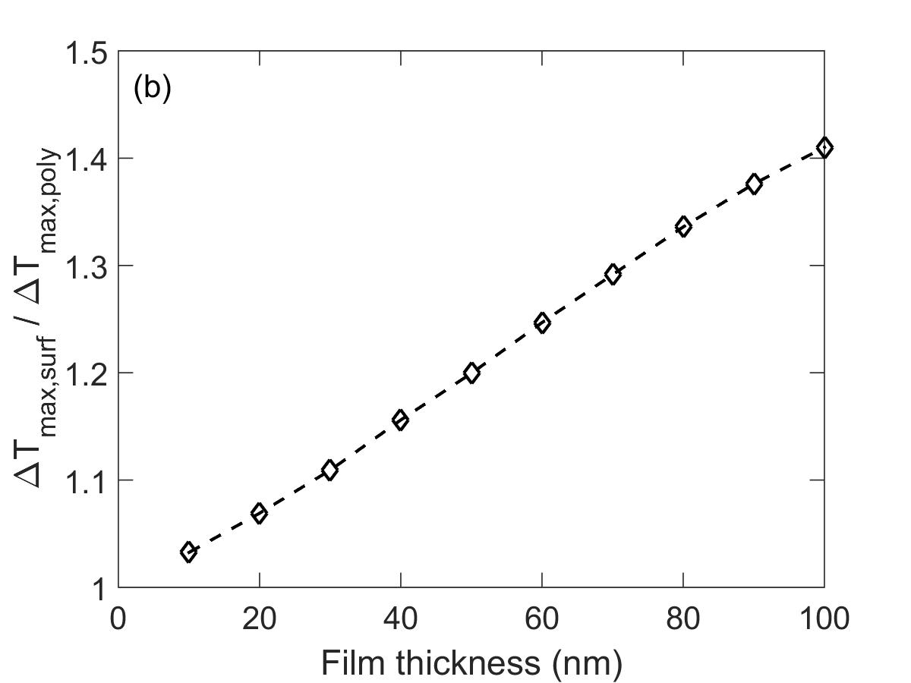

Figure S4. Additional simulation results comparing simulated polymer temperatures to simulated device temperatures. In (a), the maximum error from deviation maps such as Figure S3(a) is selected and plotted versus polymer film thickness, with either a fitted Gaussian PSF or an assumption of σ = h, where h is the film thickness. In (b), we plot the ratio of the peak temperature rises in the polymer versus device surfaces. In reality the simulated polymer surface temperature should be blurred by the AFM tip resolution before this step.

SUPPLEMENTARY REFERENCES

- A.A. Kinkhabwala, M. Staffaroni, O. Suzer, S. Burgos, and B. Stipe, IEEE Trans. Magn. 52, 1–4 (2016).
- M. Guizar-Sicairos, S.T. Thurman, and J.R. Fienup, J. R., Opt. Lett. 33, 156–158 (2008).

