Fluid Lipid Multilayer Stabilization by Tetraethyl Orthosilicate for Underwater AFM Characterization and Cell Culture Applications

Aubrey E. Kusi-Appiah1, Troy W. Lowry1,2, Nicholas Vafai1, David H. Van Winkle2, Steven Lenhert*1,3

1Department of Biological Science, Florida State University, Tallahassee, FL 32306-4370, USA.

2Department of Physics, Florida State University, Tallahassee, FL 32306-4370, USA.

3Integrative NanoScience Institute, Florida State University, Tallahassee, FL 32306, USA

* Corresponding author

**SUPPLEMENTARY INFORMATION**

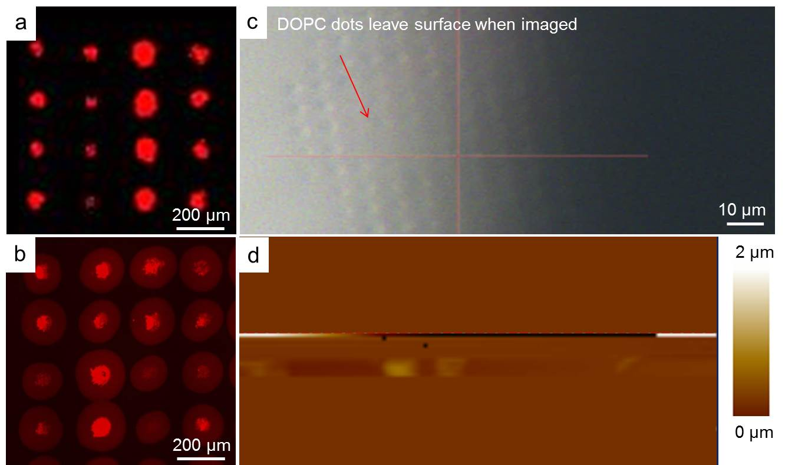

**Supplementary figure 1**. Stability and characterization of immersed, TEOS untreated fluid lipid multilayers. (a) Sample fluorescence image of rhodamine-PE doped DOPC multilayers in air. (b) Sample fluorescence image of rhodamine-PE doped DOPC multilayers immersed in HBSS buffer. (c) Brightfield image of untreated fluid DOPC multilayers showing area of destroyed lipid dots during AFM scanning. (d) AFM image showing failed scan of destroyed DOPC multilayers from attempted scan.