Accelerated Synthesis of Multiantennary Mannosylated Dendrimers Built on Cyclotriphosphazene Core

Lamyaa M. Sallam,1Tze Chieh Shiao,1 Celia Sehad,1 Abdelkrim Azzouz,1 and René Roy1,2,3*

1 Department of Chemistry, Université du Québec à Montréal, P.O. Box 8888, Succ. Centre-Ville, Montréal, Québec H3C 3P8, Canada,

2 INRS-Institut Armand-Frappier, Université du Québec, 531 boul. des Prairies, Laval, Québec, H7V 1B7, Canada

3 Glycovax Pharma Inc., 424 Guy, Suite 202, Montreal, Quebec, Canada, H3J 1S6

**\*** Correspondence: [rroy@glycovax.com](mailto:rroy@glycovax.com) ; Tel.: +1 438-393-5009

**Supplementary materials**



**Figure S1.** 1H-NMR (300 MHz, CDCl3) of compound **6**.



**Figure S2 and S3.** 1H-NMR (300 MHz, CDCl3) and 13C-NMR of compound **8**.



**Figure S4 and S5.** 1H-NMR (300 MHz, CDCl3) and 13C-NMR of compound **10**.



**Figure S6.** 1H-NMR (300 MHz, CDCl3) of compound **12**.



**Figure S7.** 1H-NMR (300 MHz, CDCl3) of compound **11**.



**Figure S8.** 1H-NMR (300 MHz, CDCl3) and 13C-NMR of compound **1**.



**Figure S9 and S10.** 1H-NMR (300 MHz, CDCl3) and 13C-NMR of compound **18**.



**Figure S11 and S12.** 1H-NMR (300 MHz, CDCl3) and 13C-NMR of compound **19**.



**Figure S13 and S14.** 1H-NMR (300 MHz, CDCl3) and 13C-NMR of compound **14**.

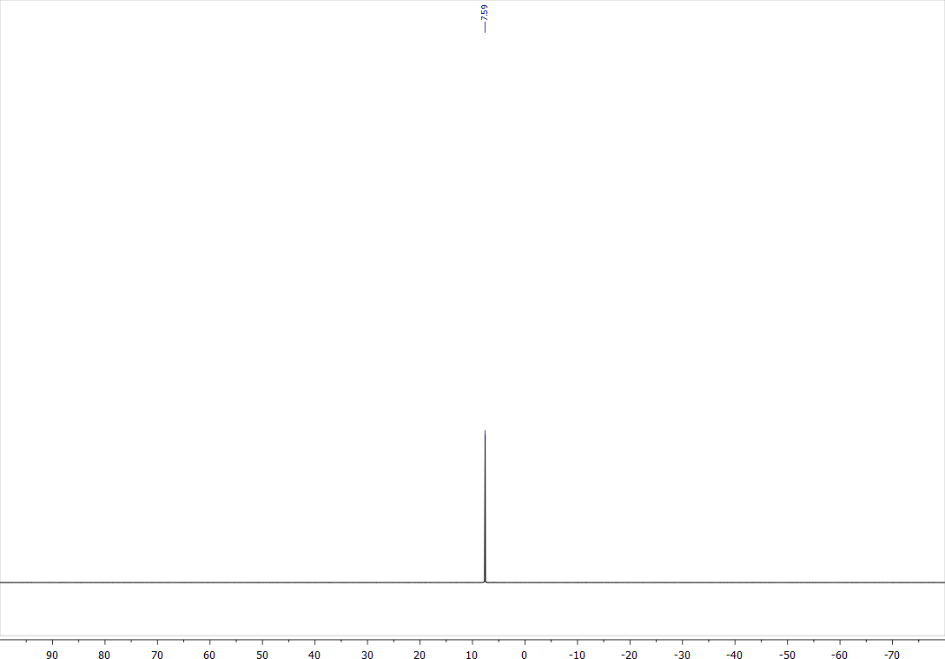

**Figure S15.** 31P-NMR (MHz, CDCl3) of compound **14**.



**Figure S16 and S17.** 1H-NMR (300 MHz, CDCl3) and 13C-NMR of compound **22**.

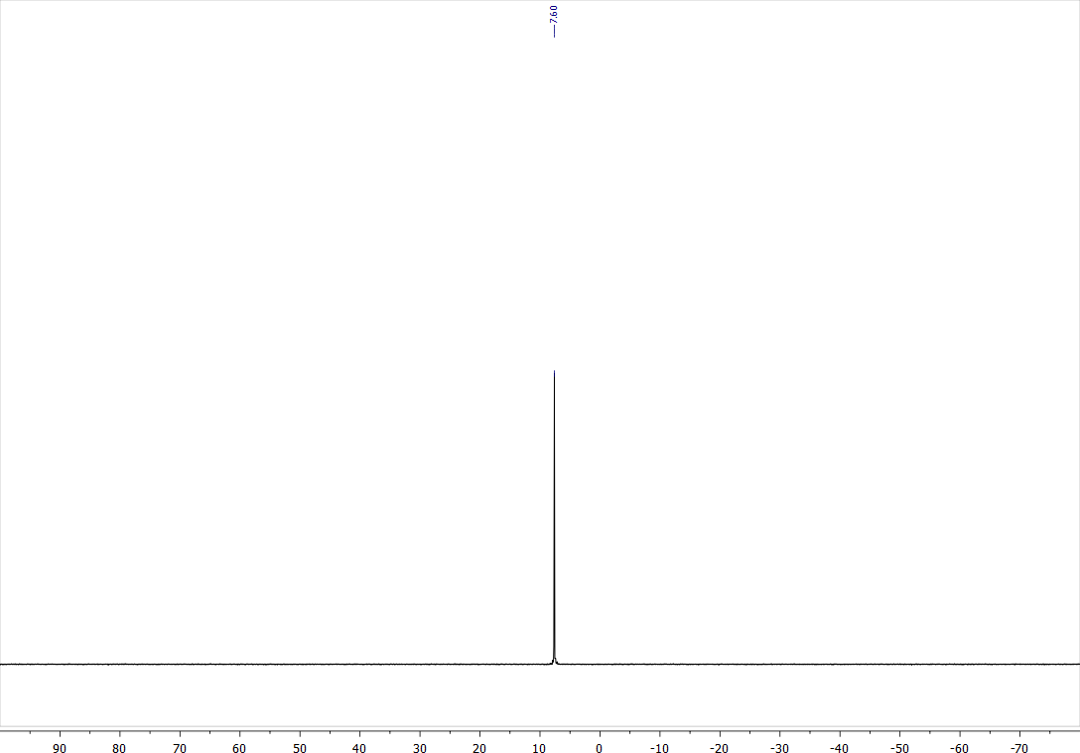

**Figure S18.** 31P-NMR (CDCl3) of compound **22**.



**Figure S19 and S20.** 1H-NMR (300 MHz, CDCl3) and 13C-NMR of compound **23**.

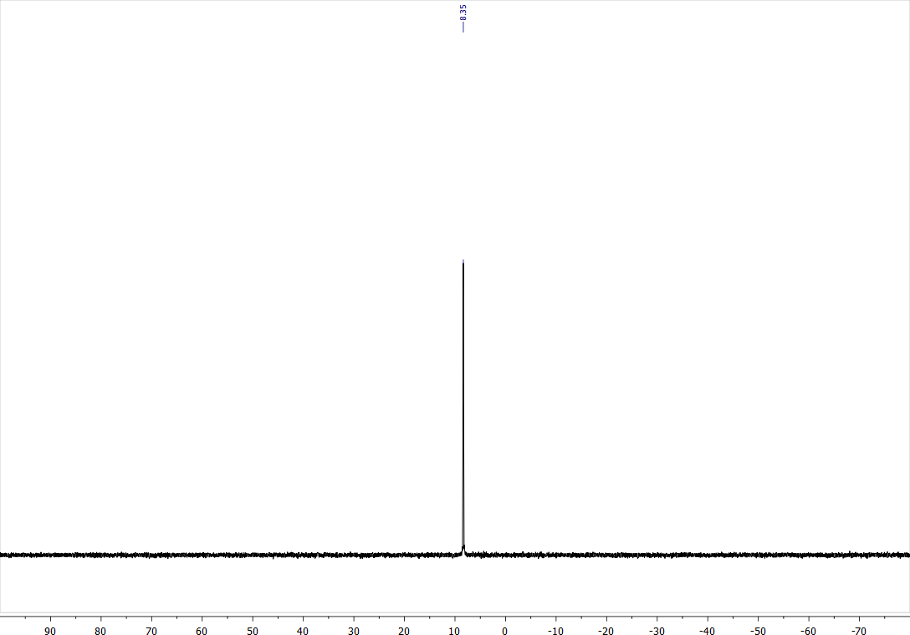

**Figure S21.** 31P-NMR (CDCl3) of compound **23**.