Supplementary Materials: Co doped CeO2

The crystal structure refinement process was carried out using Rietveld method by General Structure Analysis System (GSAS) software package with EXPGUI interface [23]. The peak profile for the analysis was shaped using pseudo - Voigt functions. The background profile was refined by shifting Chebyshev function (1st kind) with 11 points for the entire pattern. In the CeO2 crystal structure, both the Ce and O atoms occupy the special positions. Hence the atomic positions and occupancies were fixed and refined and for the Co doped sample the atomic coordinates and occupancies are constrained and refined together. The temperature factor of the Co and Ce also constrained before the refinement. At the final stage of the refinement, the preferred orientation correction was carried out using a generalized spherical harmonic model.

Figure 1and 2 signify the observed, calculated and difference plots of pure CeO2 and CeO2: 1% Co doped samples FeO3 obtained from Rietveld refinement process. The information about crystallographic parameters, reliability factors (RP & Rwp) and goodness of fit (χ2) obtained from the structure refinement process are given in Table 1. From the Table, it is found that there is a slight deviation in lattice cell parameters and unit cell volume among the prepared compounds, which is attributed due to the difference in ionic radius of the parent and substituent atoms. Further the sample shows severe peak broadening which is related to nano crystalline nature of the samples.

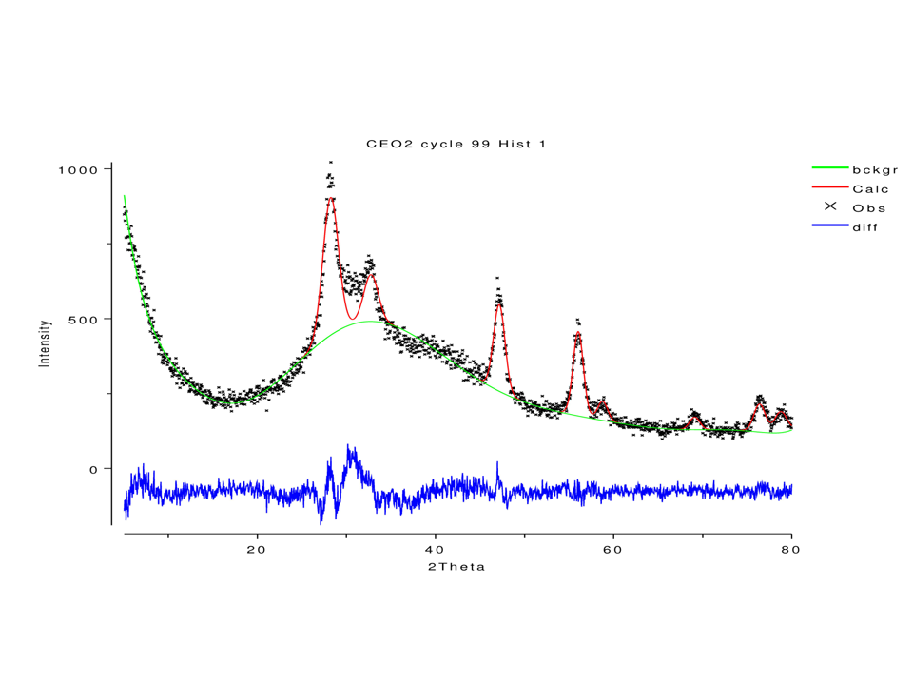Figure 1: Rietveld plot of pure CeO2 nanocrystalline sample 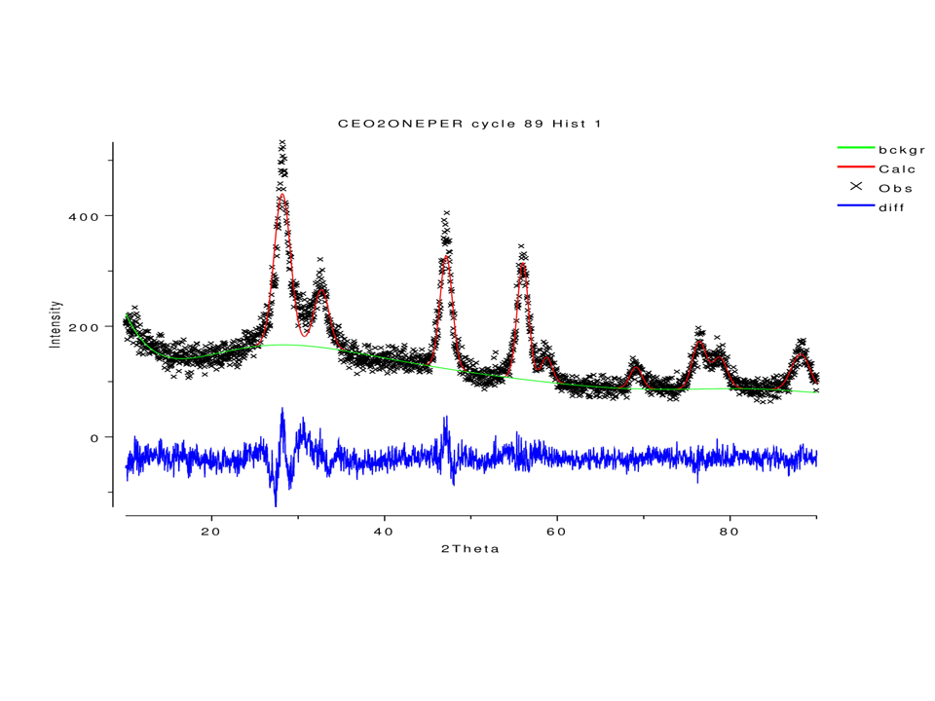

Figure 2: Rietveld plot of 1% Co doped CeO2 nanocrystalline sample

**Table 1 Crystallographic parameters achieved from Rietveld method for the compounds**

|  |  |  |
| --- | --- | --- |
|  | **CeO2** | **CeO2: 1% Co doped** |
| **Space Group** | Fm3m | Fm3m |
| **a** | 5.414 (4) | 5.407 (8) |
| **Volume** | 158.69 (2) | 158.07(7) |
| **Rwp(%)** | 7.9 | 8.9 |
| **Rp(%)** | 6.2 | 7.9 |
| **χ 2** | 2.0 | 1.5 |