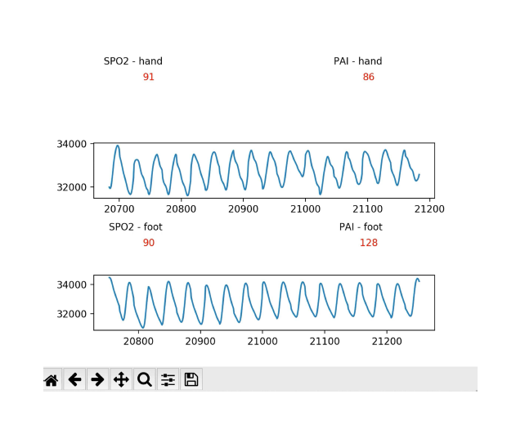

**Supplement Figure. Example of Real-Time Data Visualization During Data Collection.** During data collection, both the right hand and foot photoplethysmography waveforms along with oxygen saturation (SpO2) and perfusion amplitude index (PAI) values are displayed on the Pi-TopTM screen to aid with data quality control.