**Interpretation of the Electric Vehicle Operating Point in Real-time**  
  
 **Srikanth Kolachalama*,Iqbal Surti, Hafiz Malik**

Electrical and Computer Engineering, University of Michigan, Dearborn 48128, USA;  
 General Motors Inc., Warren, Michigan USA; Corresponding author: [skola@umich.edu](mailto:skola@umich.edu)

**Supplementary Material - Figures**

1. **[EVOP] - Speed = 25 MPH, CAT = 77 ℉, EAT = 8.6 ℉, HUM = 39.6 %, IBAQ = 96.3 %, IBAT = 26.6 ℉**

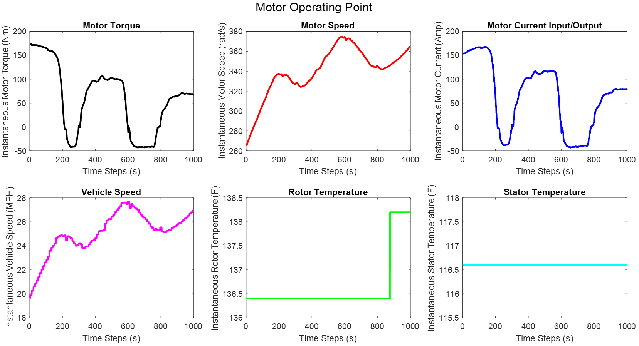**Figure S1**: Motor Operating Point [MOP], Dataset 1   
  
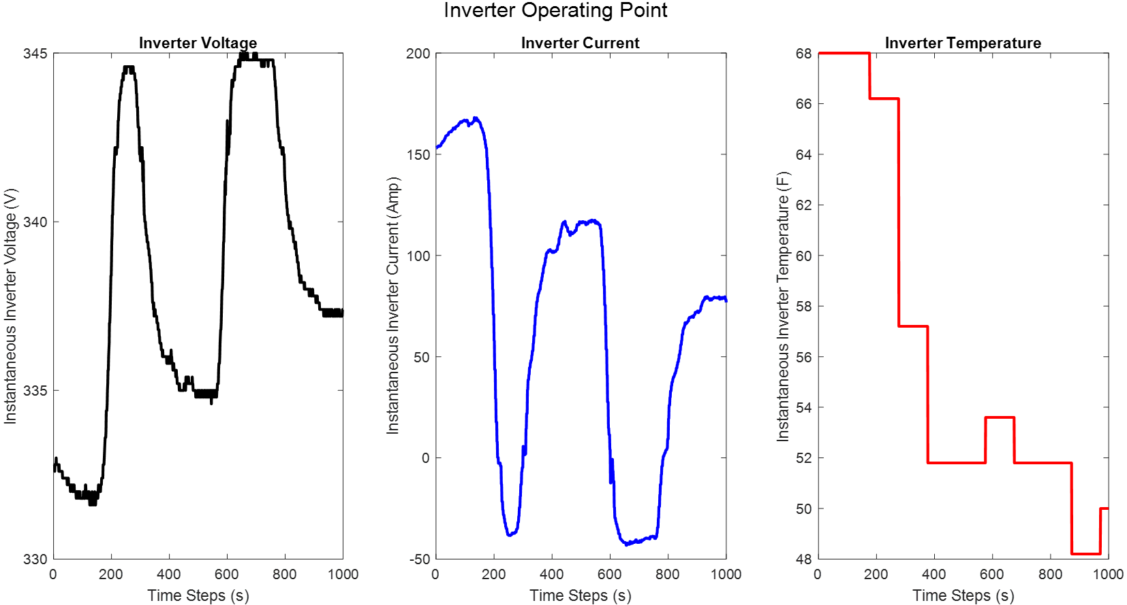  
**Figure S2**: Inverter Operating Point [IOP], Dataset 1

1. **[EVOP] - Speed = 36 MPH, CAT = 77 ℉, EAT = 12.8 ℉, HUM = 36.8 %, IBAQ = 96.3 %, IBAT = 26.6 ℉**

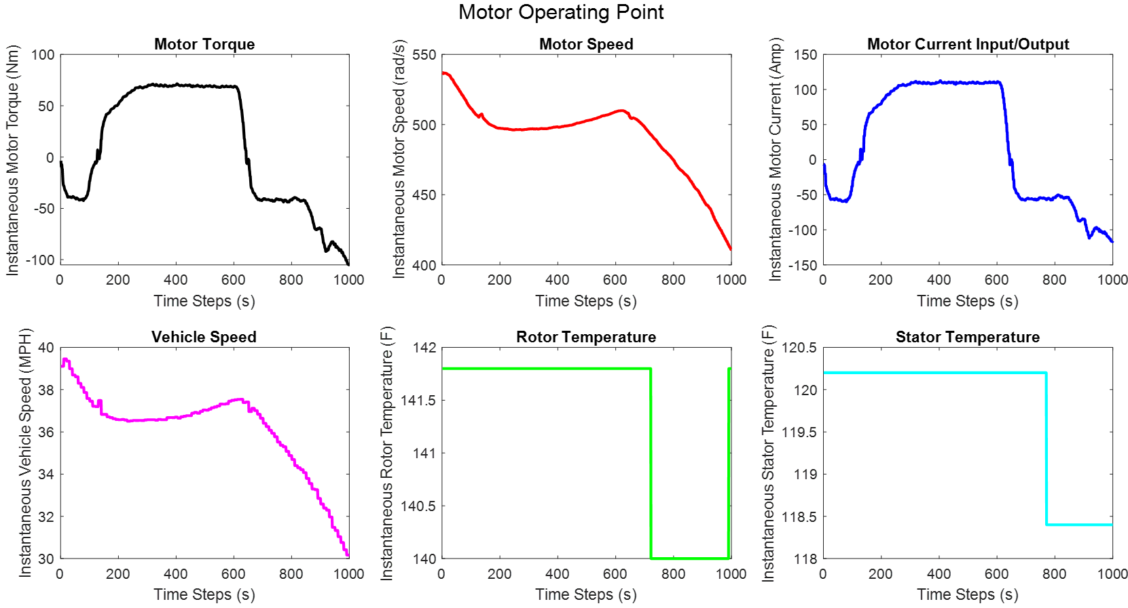**Figure S3**: Motor Operating Point [MOP], Dataset 1 (Vehicle Decelerating)  
  
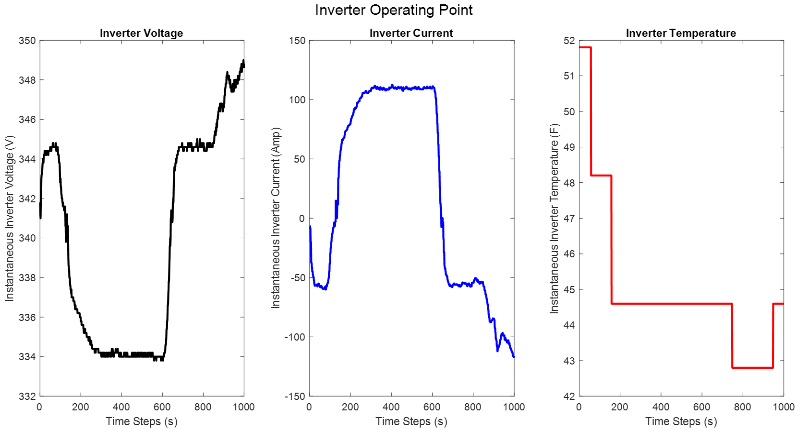  
**Figure S4**: Inverter Operating Point [IOP], Dataset 1 (Vehicle Decelerating)

1. **EVOP - Speed = 36 MPH, CAT = 76 ℉, EAT = 9.45 ℉, HUM = 39.32 %, IBAQ = 96.3 %, IBAT = 26.6 ℉**

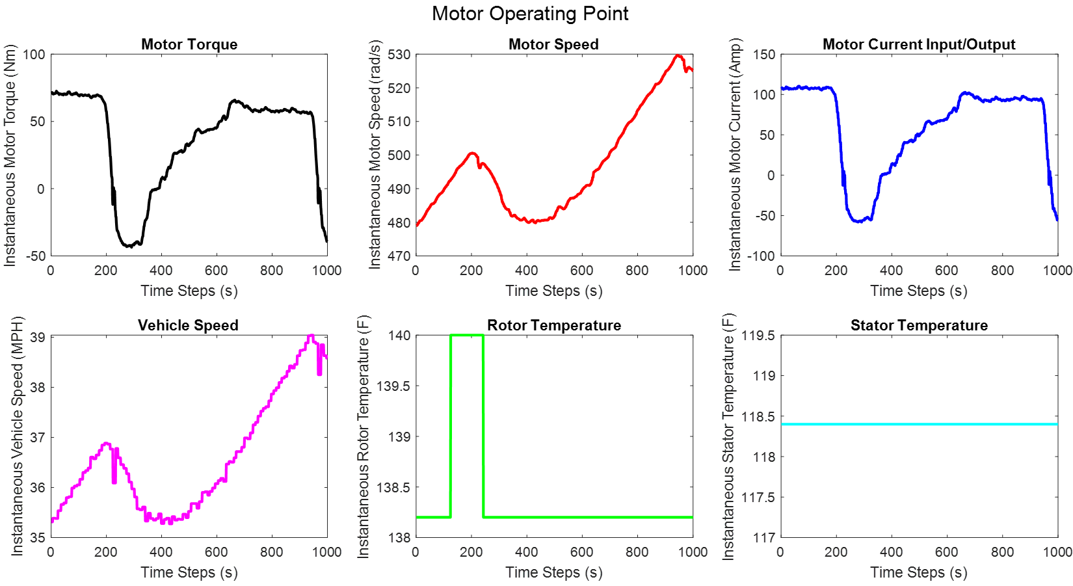**Figure S5**: Motor Operating Point [MOP], Dataset 1 (Vehicle Accelerating)  
  
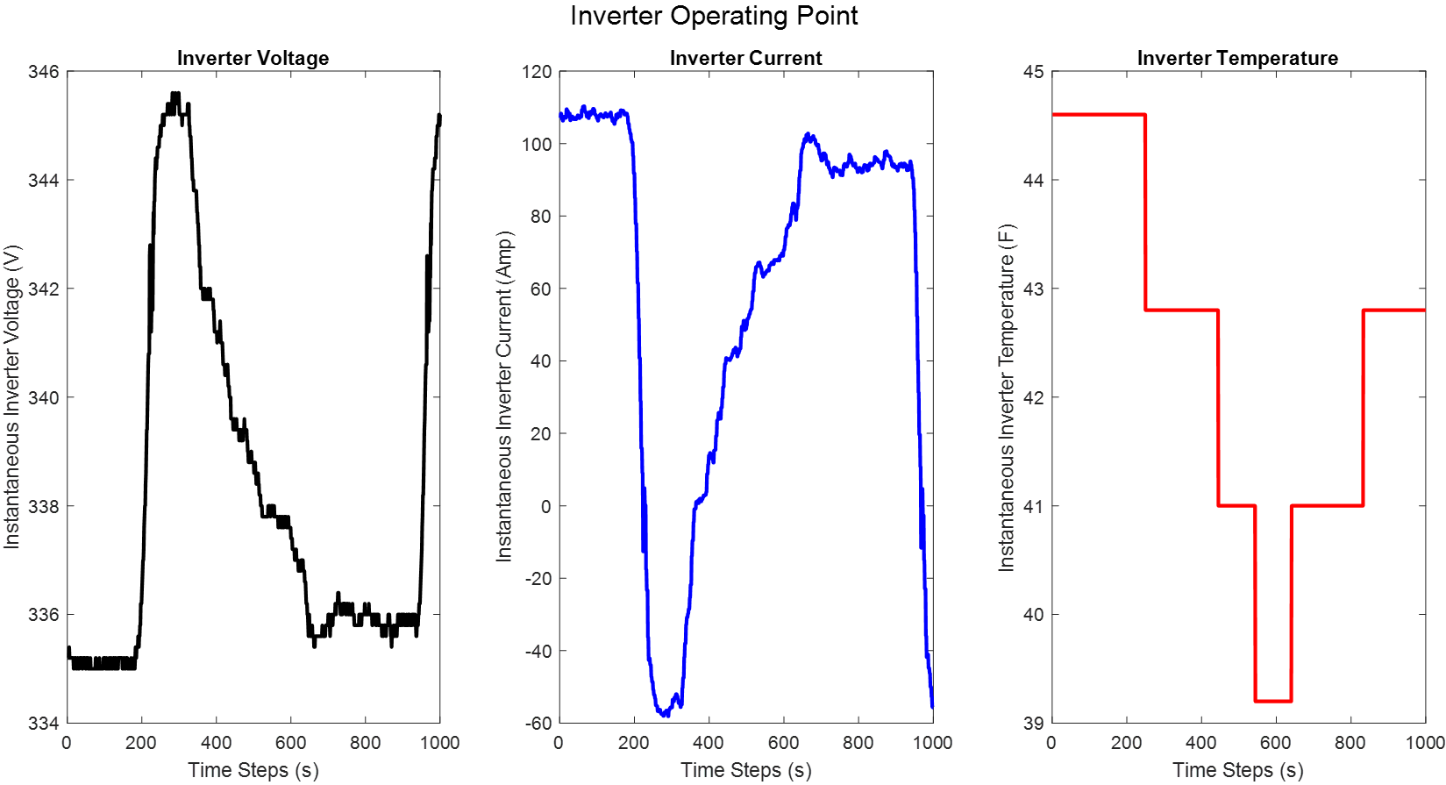  
**Figure S6**: Inverter Operating Point [IOP], Dataset 1 (Vehicle Accelerating)

1. **EVOP - Speed = 0 MPH, CAT = 77 ℉, EAT = 8.6 ℉, HUM = 39.93 %, IBAQ = 96.3 %, IBAT = 26.6 ℉**

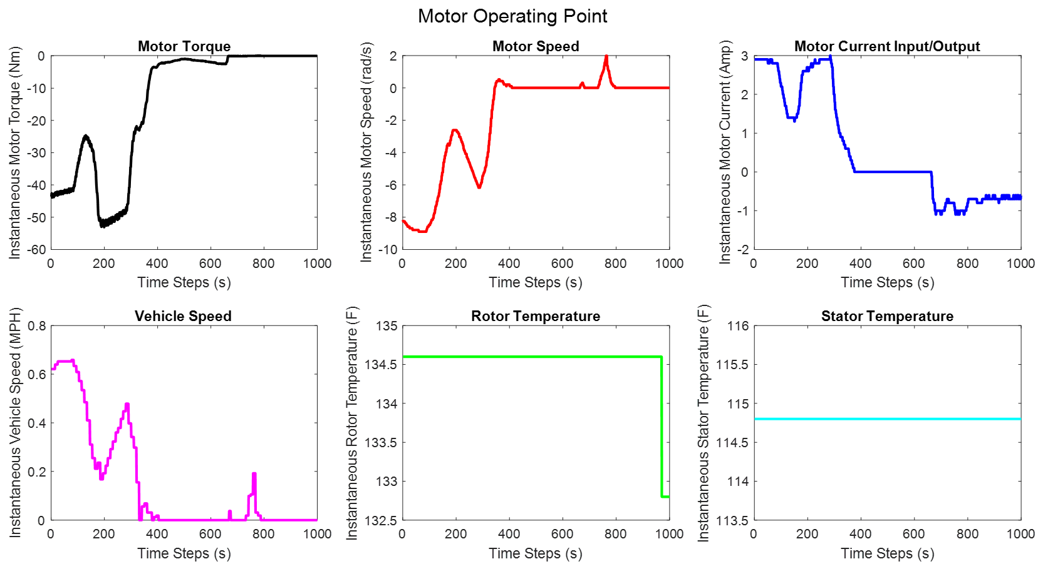**Figure S7**: Motor Operating Point [MOP], Dataset 1 (Vehicle Idling - End of Trip)  
  
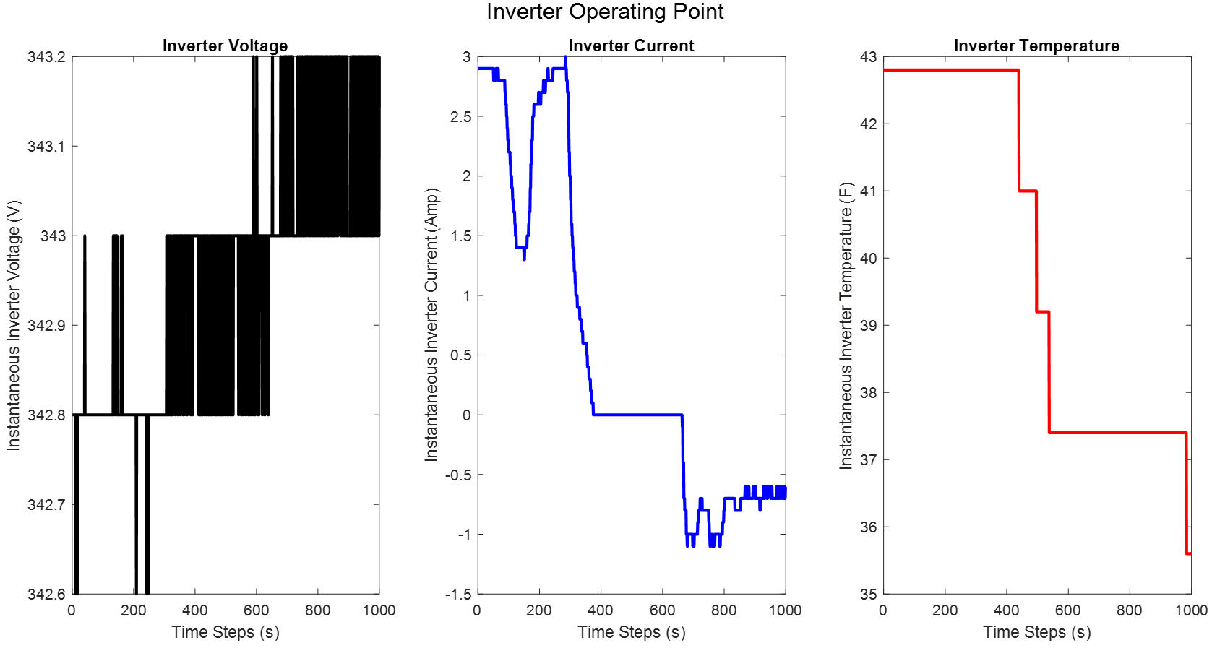  
**Figure S8**: Inverter Operating Point [IOP], Dataset 1 (Vehicle Idling - End of Trip)

1. **EVOP - Speed = 46 MPH, CAT = 72 ℉, EAT = 21.2 ℉, HUM = 44.48 %, IBAQ = 98.7 %, IBAT = 33.8 ℉**

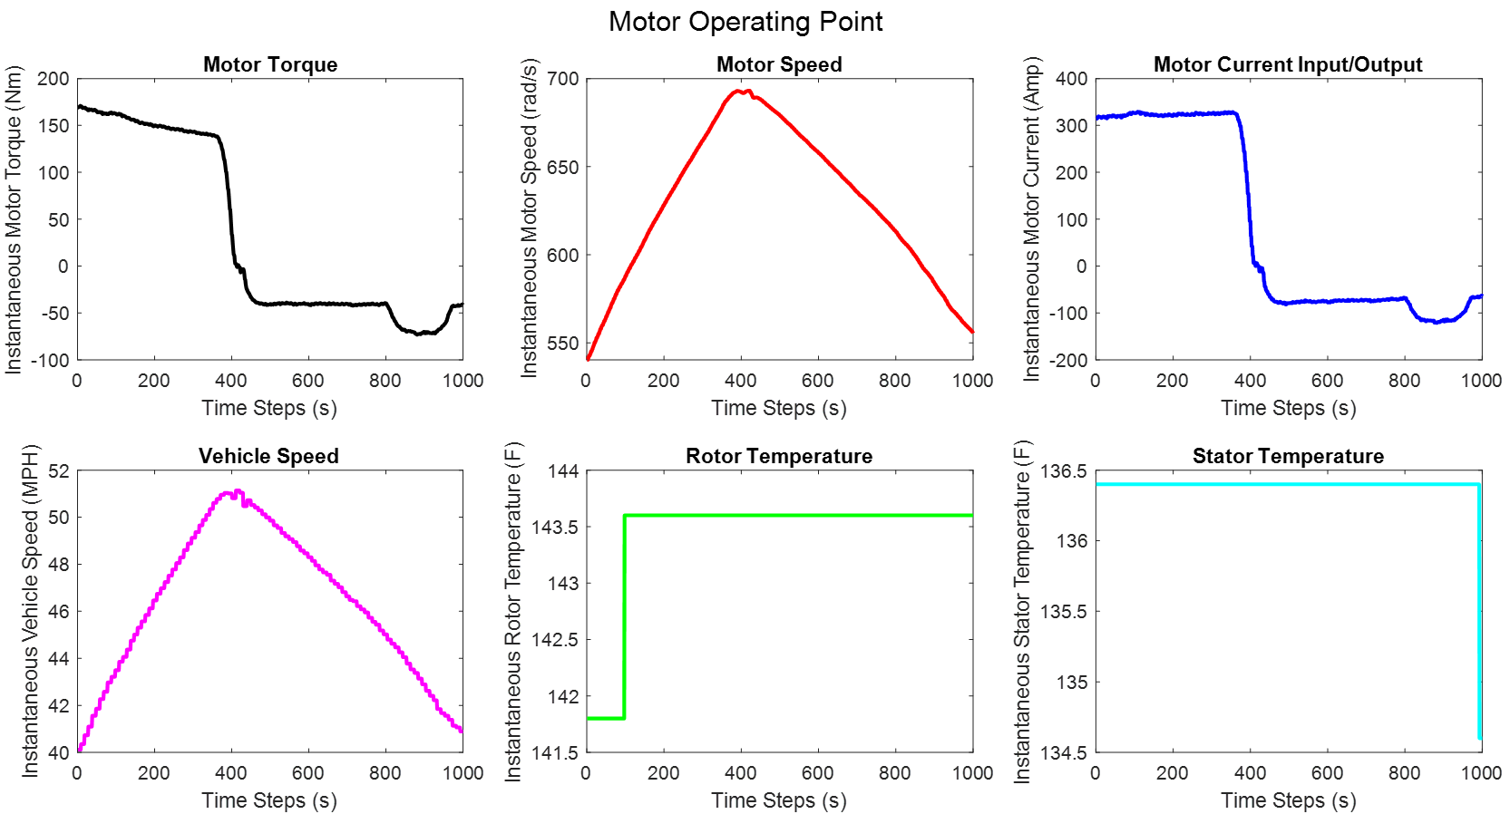**Figure S9**: Motor Operating Point [MOP], Dataset 2  
  
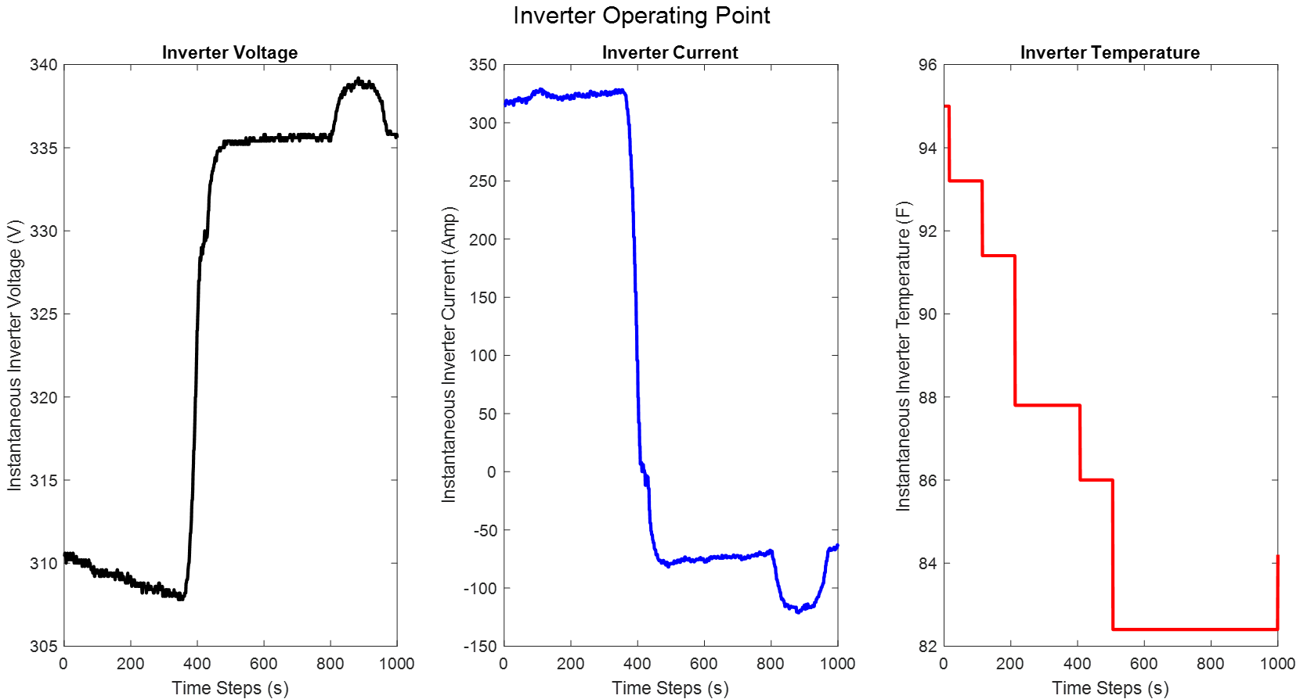  
**Figure S10**: Inverter Operating Point [IOP], Dataset 2

1. **EVOP - Speed = 57 MPH, CAT = 72 ℉, EAT = 20.3 ℉, HUM = 44.22 %, IBAQ = 98.7 %, IBAT = 35.6 ℉**

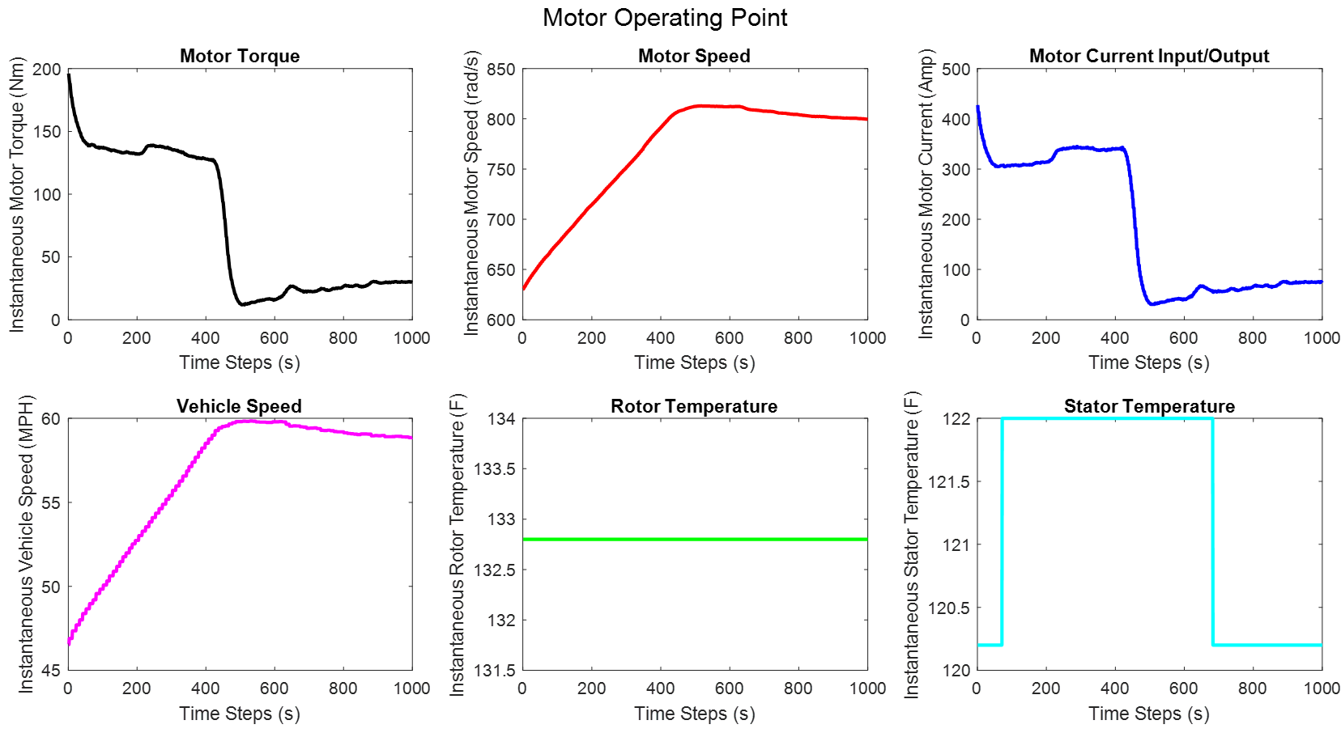**Figure S11**: Motor Operating Point [MOP], Dataset 2  
  
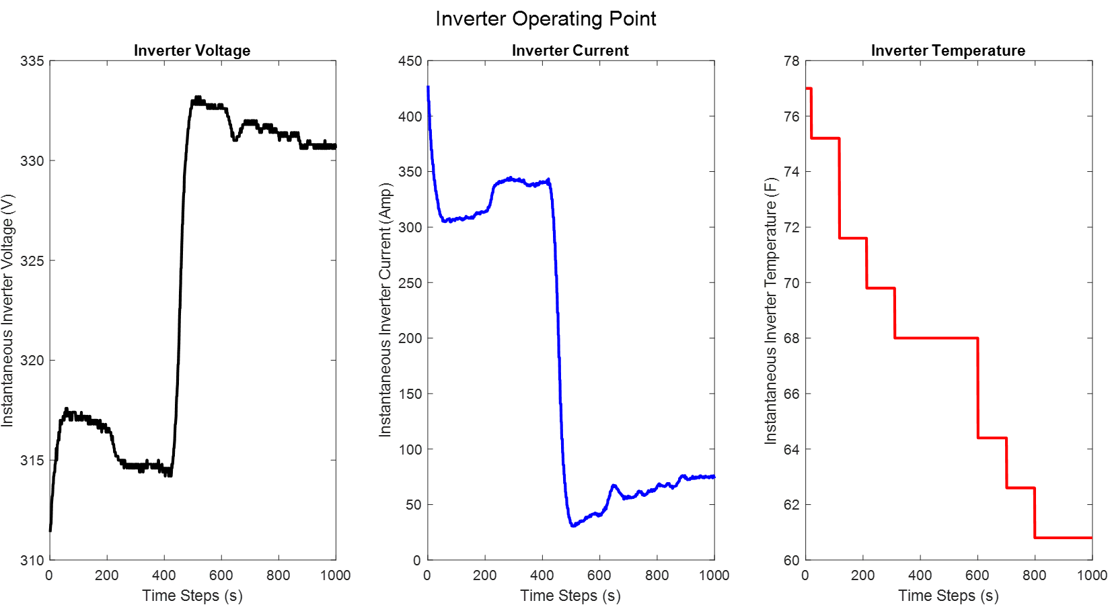  
**Figure S12**: Inverter Operating Point [IOP], Dataset 2

1. **EVOP - Speed = 75 MPH, CAT = 71 ℉, EAT = 21.2 ℉, HUM = 40.80 %, IBAQ = 98.7 %, IBAT = 35.6 ℉**

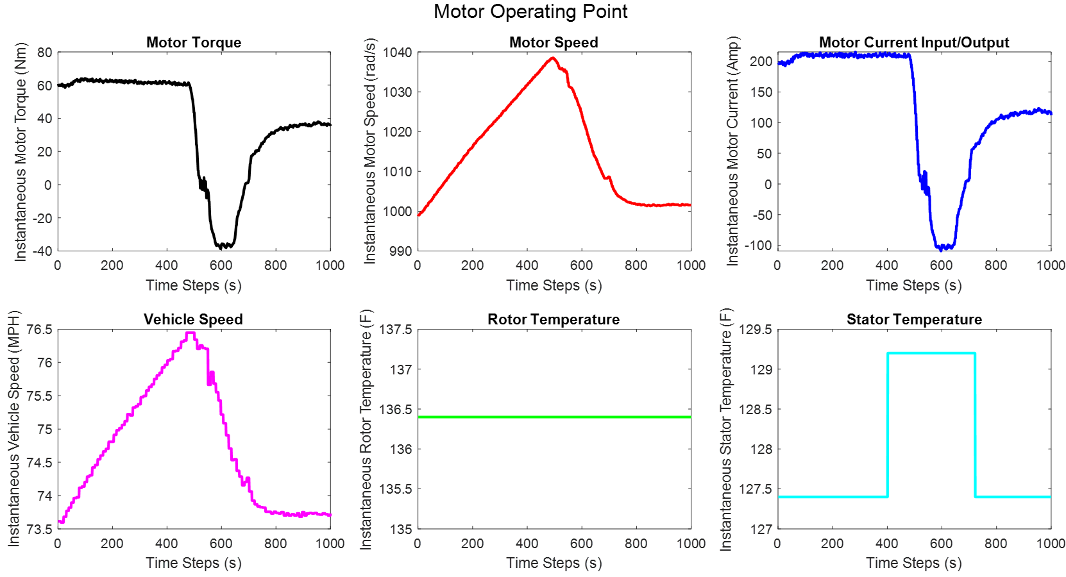**Figure S13**: Motor Operating Point [MOP], Dataset 2  
  
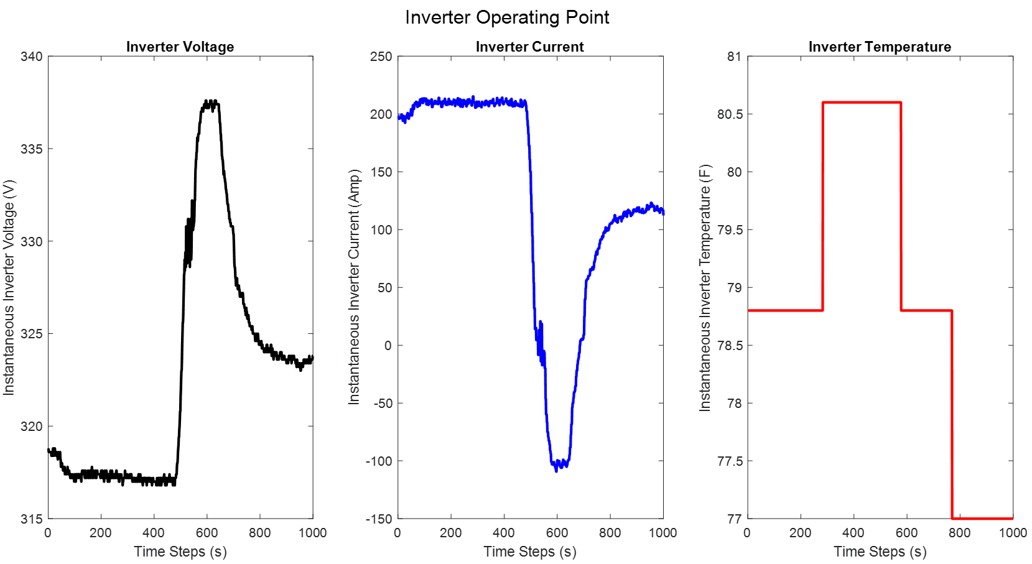  
**Figure S14**: Inverter Operating Point [IOP], Dataset 2