## Appendix A

The aim is to build an equation of motion for the gearbox model considered in Section 4 that takes into account the rotational movements of the two gears. To do that, such an equation needs to include the two main factors that affect the gears’ movements, which are: the input torque that acts on the driving gear and the effects of the interaction between the teeth of the two gears. The area where the interaction between the two gears takes place is called *gear mesh*.



***Figure 29.*** *The backlash between gears.*

**The Gear mesh.** To include the effects of the interaction between the teeth of the two gears we include into the equation of motion we are going to build the backlash, the time-varying mesh stiffness function , the static transmission error , and a linear viscous dumping parameter . The backlash is a clearance or lost motion of the gears caused by gaps between the teeth (Fig. 29). This phenomenon is incorporated in the model via the backlash function  where  is displacement function that will be introduced shortly. The time-varying mesh stiffness function, , describes the varying stiffness of the teeth that are in the gear mesh, and is caused by the transition from single to double and double to single of pairs of teeth in contact. Finally, the static transmission error , is caused by geometrical errors of the teeth profile and represents the difference between the actual position of the driven gear and the position it would occupy if the gears’ edges were manufactured perfectly. The mesh stiffness and static transmission error functions are assumed to be periodic functions of time and, in the theoretical setting we are considering, can be expressed in the following Fourier form:

 (27)

 (28)

where ,  and  are constant Fourier coefficients of the respective signals (Kahraman and Singh, 1991).  is the meshing frequency defined as  where  and  stand for the number of teeth of the first (driving) and second (driven) gears and  is the rotating frequency of the -th gear.

**The torque.** In the scenario we consider, the input torque  that ignites the movement and keeps the gears moving, is not constant, but it rather fluctuates due to the fluctuations of the wind. Thus, the input torque is given by a constant part  and a fluctuating part , i.e., . The output torque  is considered to be constant, i.e., , with  being the mean output torque. In the simulation, the component of the input torque associated with the fluctuations of the wind, , is derived from the torque computed via the FAST (Bir, 2005) design code, i.e., . The torques generated with FAST code, i.e. , that have been used in this work to simulate the effect of the wind turbulence in different wind conditions, are shown in Fig. 30.

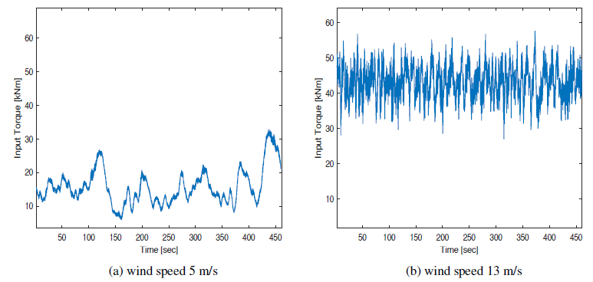

***Figure 30.*** *FAST simulation of the high speed shaft torque for different turbulent wind condition.*

### *A.1* *Equation of motion*

In order to describe the model with a single equation, we consider the following coordinate

 (29)

where  stands for the torsional displacement of the -th gear while  is its radius.

The coordinate  is given by the difference between the dynamic transmission error and the static transmission error. Moreover, through  the model’s equation of motion yields the following formulation (Antoniadou et al., 2015; Kahraman and Singh, 1991)

 (30)

where

 (31)

 (32)

with  mass moment of inertia of the -th gear and . Moreover, concerning the quantities that involve the torque obtained via the FAST code:

 (33)

where  is a normalization constant. The normalization constant is included because the FAST simulations correspond to a different physical system. Thus, it is needed to adapt the magnitude of the fluctuations to our setting.  represents the mean force excitations while  and  pertain to internal excitations related to the static transmission error and external excitations related to wind turbulence, respectively. Lastly, the backlash function  is defined as

 (34)

where  represents the total gear backlash. The backlash function controls the contact between teeth and incorporates in the model the fact that occasionally contact is lost (Fig. 29).

#### A.1.1 Dimensionless equation of motion.

The equation of motion (32) can be written in a dimensionless form (Antoniadou et al., 2015; Kahraman and Singh, 1991) by setting : , , , , ,  and . The meshing frequency can be written in a nondimensional form as well, i.e., . The nondimensional form of the equation of motion (30) is

 (35)

where the dimensionless backlash function is defined in (17).

***Table 3.*** *Simulation parameters*

|  |  |  |  |
| --- | --- | --- | --- |
| Parameter | Value | Parameter | Value |
|  |  |  | 0.1 |
|  |  |  | 0.01 |
|  | 0.0 5(m) |  | 0.004 |
| number of teeth | 16 |  | 0.002 |
|  |  |  | 0.2 |
|  |  |  | 0.1 |
|  | 0.05 |  | 0.05 |
|  | 0.5 |  | 10 |

### *A.2* *Parameter settings*

The parameters for the experiments reported in this paper are given in Table 3. We also performed additional experiments on signal simulated modifying the parameters related to the internal excitations and changing the severity of the damage. Table 4 shows the three different parameter settings we used in our simulation model to generate acceleration signals affected by different gearbox internal excitations. The parameters have been modified in a combined fashion, and their variation affects the simulated signals locally but not their global structure. For what concerns the severity of the damage, in the simulations analyzed and illustrated in this work, the crack of a gear’s tooth is modelled by decreasing the dimensionless mesh stiffness function by 13 % of its nominal stiffness. Over our experiments, we considered two additional severity conditions. Specifically, we reduced the mesh stiffness function by 10 % and 16 %. Thus we considered two additional scenarios where the severity of the damage either increases or decreases. Overall we considered three conditions for the internal excitation parameters, three damage severities and two wind conditions. The combination of these allowed us to simulate eighteen different scenarios on which to test our method

***Table 4.*** *Parameter settings for gearbox internal excitations*

|  |  |  |  |
| --- | --- | --- | --- |
| Parameter | first setting | second setting | third setting |
|  | 0.01 | 0.02 | 0.003 |
|  | 0.004 | 0.001 | 0.002 |
|  | 0.002 | 0.009 | 0.004 |

## Appendix B

***Table 5.*** *Parameter choices for the different operating conditions of the experimental dataset*

|  |  |  |  |
| --- | --- | --- | --- |
| Operating conditions (Angular speed  Load) | Delay "" (Snaphots  Time [s]) | Length acceleration signal (Snaphots  Time [s]) | Decomposition levels |
| Hz  High | 33333  0.5000 s | 48333  0.7250 s | 8 |
| Hz  High | 28572  0.4286 s | 43572  0.6536 s | 8 |
| Hz  Low | 24999  0.3750 s | 39999  0.6000 s | 8 |
| Hz  High | 22221  0.3333 s | 37221  0.5583 s | 8 |
| Hz  Low | 19998  0.3000 s | 34998  0.5250 s | 8 |