SUPPLEMENTARY MATERIAL
SUPPLEMENTARY METHODS
Study Participants
HCP ≥ 18 years of age who were employed at Washington University School of Medicine, Barnes-Jewish Hospital, or St. Louis Children’s Hospital, and who had a positive SARS-CoV-2 PCR test from a nasopharyngeal swab within the previous 28 days were eligible. Participants were identified using records from an Occupational Health COVID-19 Employee Call Center and were contacted within 18 days of the PCR test date. At the time of the study, Occupational Health tested HCP who were symptomatic or a part of contact tracing/exposure investigations.

Specimen Collection and Laboratory Testing
Blood specimens were drawn into a 10mL K₂ EDTA tube and maintained at room temperature for up to 8 hours before refrigeration. Specimens were centrifuged and plasma aliquots stored for up to 4 days at 4°C prior to analysis.
Antibody Testing. Anti-N IgG was detected in plasma samples using the Abbott SARS-CoV-2 IgG assay (Abbott Laboratories, Abbott Park, IL) on the Abbott Architect i2000, with testing performed according to the manufacturer’s instructions. Results were calibrated with a relative light unit calibrator, used to calculate a ratio of specimen absorbance to calibrator absorbance. Samples with an Index Specimen/Calibrator (S/C) value of 1.4 or greater were interpreted as positive.
SARS-CoV-2 RT-PCR. Records from the positive PCR test were obtained, including cycle threshold (C_{T}) values, when available, for participants who received testing BJC/WUSM OH performed at the BJH clinical laboratory. Six HCP received SARS-CoV-2 testing elsewhere. Due to supply chain shortages, the laboratory used a variety of testing platforms during the study period. Seventy-nine percent (58/73) of the NP swabs with C_{T} values available were tested with the Roche cobas® SARS-CoV-2 assay (Roche Diagnostics, Indianapolis, IN), 11% (8/73) with the Quidel Lyra SARS-CoV-2 assay (Quidel, San Diego, CA), and 9.6% (7/73) with the Diasorin Simplexa COVID-19 Direct assay (DiaSorin Molecular, Cypress, CA). To avoid measurement error, only Roche C_{T} values were used in the data analyses.¹ The Roche assay reports two C_{T} values, as it detects two SARS-CoV-2 targets (orf1ab and E). The lowest Roche C_{T} value was used for the purpose of analyses. For the one participant with C_{T} values near the limit of detection (0/37.67), the C_{T} value for the positive target (E gene: 37.67) was used.
Statistical Analyses
Fisher’s exact tests were used to examine associations between N-antibody test results and HCP characteristics, SARS-CoV-2 exposure history, and symptoms. Wilcoxon Rank Sum tests and Wilcoxon Signed Rank tests were used to evaluate differences in median N-antibody signal or C_{T} values among groups. Spearman’s correlation was used to determine the relationship between C_{T} values and N-antibody signal. Statistical analyses were performed in SAS version 9.4 (Cary, NC), with p < 0.05 considered statistically significant.
TABLES AND FIGURES
TABLES
Supplementary Table 1. Cohort Characteristics
Enrollment survey questions | Frequency  N = 79 (%)
Demographics
Age (Median, [IQR]) | 35 (28, 46)
Age, categorical
20-29 years | 23 (29.1)
30-39 years | 24 (30.4)
40-49 years | 17 (21.5)
50-59 years | 11 (13.9)
60 + years | 4 (5.1)
Female | 64 (81.0)
Raceª
Asian | 4 (5.1)
Black | 3 (3.8)
White | 71 (89.9)
Other | 1 (1.3)
Hispanic ethnicity | 3 (3.8)
Employment Information
Department
Medical/Surgical Wards/Specialties | 43 (54.4)
ICU | 7 (8.9)
Emergency Services | 7 (8.9)
Pediatrics | 4 (5.1)
Pathology/Pharmacy/Radiology | 4 (5.1)
Laboratory | 2 (2.5)
Other^{b} | 12 (15.2)
Job role
Direct patient care role^{c} | 41 (51.9)
Other patient care role^{d} | 14 (17.7)
Non-patient care role^{e} | 23 (29.1)
Missing | 1 (1.3)
Commute methodª
Drive a car alone | 73 (92.4)
Drive a car with others | 3 (3.8)
Other^{f} | 2 (2.5)
Missing | 1 (1.3)
Occupational risk factors
Known, specific COVID-19 exposure at work | 13 (16.7)
Contact with known or suspected COVID-19 patients at work
More than half the time | 10 (12.7)
Less than half the time | 41 (51.9)
Never | 25 (31.6)
Missing | 3 (3.8)
Practice social distancing when at work and not involved in immediate patient care
More than half the time | 50 (63.3)
Less than half the time | 27 (34.2)
Never | 1 (1.3)
Missing | 1 (1.3)
Wear a face mask while at work
More than half the time | 78 (98.7)
Missing | 1 (1.3)
Wear a cloth mask at work^{a,g} | 16 (20.3)
Wear a surgical/isolation (disposable) mask at work^{a,g} | 70 (88.6)
Wear a N-95 mask at work^{a,g} | 9 (11.4)
Non-occupational risk factors
Known, specific COVID-19 exposure outside of work | 22 (27.9)
Practice social distancing when in public
More than half the time | 78 (98.7)
Less than half the time | 1 (1.3)
Wear a face mask while in public
More than half the time | 79 (100.0)
Traveled in the past 30 days | 10 (12.7)
Attended a gathering in the past 30 days
Restaurant | 28 (35.4)
Other large gathering^{h} | 28 (35.4)
None | 31 (39.2)
Visited a public location in the past 30 days
Medical office | 22 (27.8)
Store | 75 (94.9)
Other^{i} | 23 (29.1)
None | 3 (3.8)
SARS-CoV-2 PCR Testing
Days from positive SARS-CoV-2 PCR test (Median, [IQR]) 23 (20, 25)
Roche C_{T} value (Median, [IQR])^{j} | 19.5 (17.5, 24.2)
ª Participants could select multiple responses for this question.
^{b}Other departments include: Case management, food and nutrition, operations and facilities management, patient transportation, research.
^{c}Provider with direct patient care roles include: Advanced practice nurse, nurse, nurse practitioner, physician, physician’s assistant.
^{d} Other patient care roles include: Medical student, nurse assistant, paramedic, patient care technician, perfusionist, physical therapist, occupational therapist.
^{e} Non-patient care roles include: Administration, case manager, dietician, dining services personnel, laboratory personnel, pharmacist, research personnel, social worker.
^{f} Other transportation methods include: Bike, train.
^{g} During the study period, PPE recommendations varied by job and location. Cloth masks were recommended for non-clinical staff, surgical masks were recommended in most clinical spaces, and N95s were recommended in COVID ICUs and during aerosol-generating procedures.
^{h}Other large gatherings include: Bar, funeral, gatherings of family or friends, outdoor sporting event, religious service, school, wedding. Large gathering was defined as an event having >10 people outside of their household.
^{i}Other locations include: Bank, DMV, dry cleaner, hair salon, laundromat, library, post office, vet.
^{j}Among 58 HCP with Roche C_{T} values
Supplementary Table 2. Bivariate risk factors for a reactive Anti-N IgG antibody result at follow-up (N=70)
 | Reactive  antibody test result  n=54 (%) | Non-reactive antibody test result  n=16 (%) | p-value
Demographics
Age, 50 years or older | 14 (25.9) | 1 (6.2) | 0.16
White race | 48 (88.9) | 14 (87.5) | 1.00
Hispanic ethnicity | 2 (3.8) | 1 (6.2) | 0.56
Female sex | 45 (83.3) | 12 (75.0) | 0.48
Patient care job role | 36 (66.7) | 8 (50.0) | 0.25
Working on campus | 46 (85.2) | 14 (87.5) | 1.00
Comorbidities
Seasonal allergies | 22 (40.7) | 7 (43.8) | 1.00
Obesity | 11 (20.4) | 3 (18.8) | 1.00
Otherª | 15 (27.8) | 6 (37.5) | 0.54
Symptoms
Ongoing Covid-19 symptoms | 11 (20.4) | 5 (31.2) | 0.50
Duration of COVID-19 symptoms |  |  | 0.046
Less than 7 days | 10 (18.5) | 2 (12.5)
7 – 13 days | 14 (25.9) | 3 (18.8)
14 – 20 days | 8 (14.8) | 2 (12.5)
21 – 27 days | 6 (11.1) | 0 (0.0)
1 – 2 months | 2 (3.7) | 2 (12.5)
More than 2 months | 12 (22.2) | 2 (12.5)
Never had symptoms | 1 (1.8) | 1 (6.3)
Not sure / Missing | 1 (1.8) | 4 (25.0)
Exposures since enrollment survey was completed
COVID-19 exposure at work |  |  | 0.07
Yes | 5 (9.3) | 1 (6.2)
No | 49 (90.7) | 13 (81.2)
Missing | 0 (0.0) | 2 (12.5)
COVID-19 exposure to household member |  |  | 0.05
Yes | 1 (1.8) | 0 (0.0)
No | 53 (98.1) | 14 (87.5)
Missing | 0 (0.0) | 2 (12.5)
COVID-19 exposure outside of work or household |  |  | 0.06
Yes | 3 (5.6) | 0 (0.0)
No | 51 (94.4) | 14 (87.5)
Missing | 0 (0.0) | 2 (12.5)
ª Other comorbidities (reported by <5 participants each) include: Asthma, cerebrovascular disease, eosinophilic esophagitis, epilepsy, Graves’ disease, hearing loss, hypertension, hypothyroidism, liver disease, lung disease, migraine, pregnancy, psoriasis, smoking, use of corticosteroids or other immunosuppressive drugs
Supplementary Table 3. Ongoing Symptoms Reported at Follow-up in 16 HCP
Symptom | Frequency  N=16 (%)
Loss of sense of taste or smell | 10 (63%)
Persistent fatigue | 3 (19%)
Shortness of breath | 2 (13%)
Headaches | 2 (13%)
“Brain fog” | 2 (13%)
Joint pain | 1 (6.3%)
Diarrhea | 1 (6.3%)
Cough | 1 (6.3%)

FIGURE LEGENDS
Supplementary Figure 1. IgG N-antibody signal stratified by reported symptoms. A) Antibody signals were not different between those who reported being symptomatic and those who reported being asymptomatic at enrollment (Wilcoxon Rank Sum Test, p=0.28). Asymptomatic HCP had a median signal of 4.28 (IQR: 2.04-6.87) compared to the median antibody level of symptomatic HCP (5.51, [IQR: 2.8-6.94]). B) Antibody signals were not different between those reported ongoing symptoms at follow-up and those who had no ongoing symptoms (Wilcoxon Rank Sum Test, p=0.15). For those with no ongoing symptoms, the median signal was 3.30 S/C (IQR: 1.58-5.47). For those with ongoing symptoms, the median signal was 2.24 (IQR: 1.25-2.98). The dotted line represents the seropositivity threshold.
Supplementary Figure 2. Roche C_{T} values stratified by symptoms reported in the follow-up survey. Roche RT-PCR C_{T} values were compared among HCP who reported no ongoing symptoms versus those with ongoing symptoms at follow-up. The median C_{T} value for those with no ongoing symptoms was 18.8 (IQR: 17.5-23.5) compared to the median C_{T} value for those with ongoing symptoms, which was 24.8 (IQR: 16.7-27.0), (Wilcoxon Rank Sum Test, p=0.20). The lowest reported Roche C_{T} value was used in the analysis.
Supplementary Figure 3. Relationship between C_{T} values and IgG N-antibody signal. A) Roche RT-PCR C_{T} values do not significantly correlate with IgG N-antibody signal measured at enrollment, 14-28 days after the positive SARS-CoV-2 PCR test. Spearman correlation coefficient = -0.149 (p=0.26). B) Roche RT-PCR C_{T} values significantly correlate with IgG N-antibody signal measured at follow-up, 70-180 days after the positive SARS-CoV-2 PCR test. Spearman correlation coefficient = -0.314 (p=0.022). The lowest reported Roche C_{T} value was used in both analyses. The dotted line depicts the seropositivity threshold.
Supplementary Figure 4. Roche C_{T} values stratified by IgG N-antibody test result. . A) Roche C_{T} values were compared among HCP who had reactive and nonreactive N-antibody results at enrollment. The median C_{T} value for non-reactive HCP was 22.5 (IQR: 18.3-26.3) compared to the median C_{T} value for reactive HCP which was 19.2 (IQR: 17.5-23.9), (Wilcoxon Rank Sum Test, p=0.48). B) Roche C_{T} values were compared among HCP who had reactive and nonreactive N-antibody results at follow-up. The median C_{T} value for non-reactive HCP was 23.5 (IQR: 21.7-26.3) compared to the median C_{T} value for reactive HCP which was 18.8 (IQR: 17.2-23.9), (Wilcoxon Rank Sum Test, p=0.12). The lowest reported Roche C_{T} value was used in both analyses.

FIGURES
Supplementary Figure 1. IgG N-antibody signal stratified by reported symptoms.

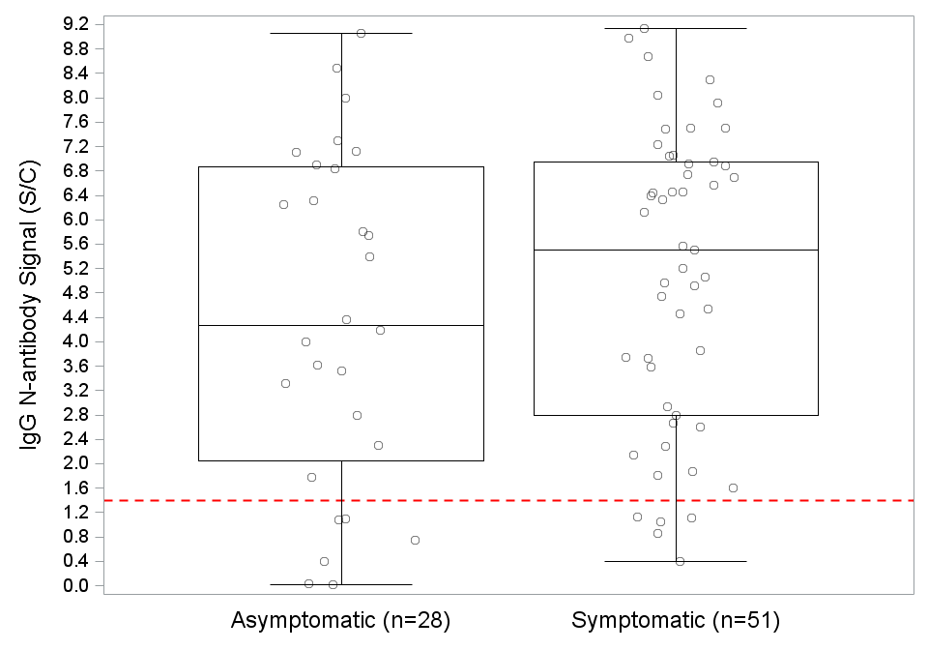

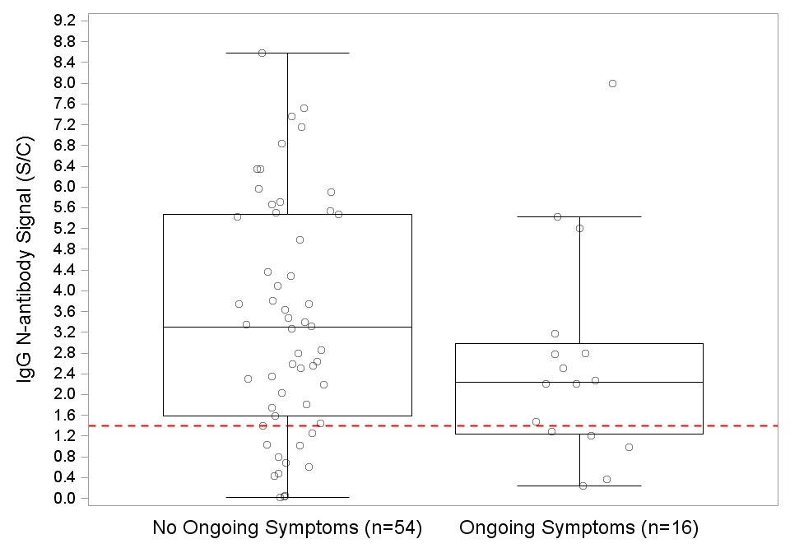
Supplementary Figure 2. Roche C_{T} values stratified by symptoms reported in the follow-up survey.

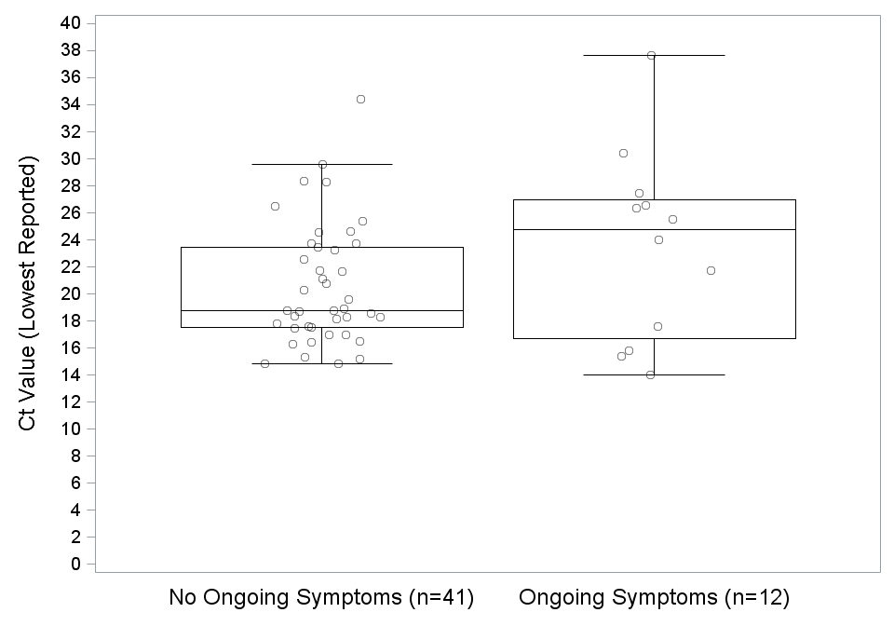
Supplementary Figure 3. Relationship between C_{T} values and IgG N-antibody signal.
A.
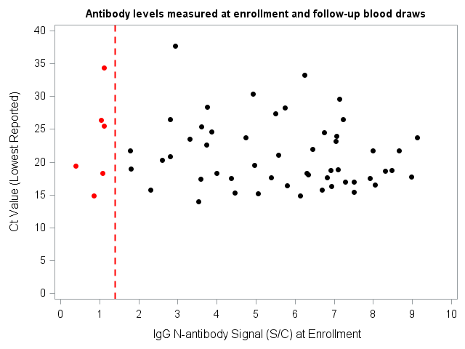
B.
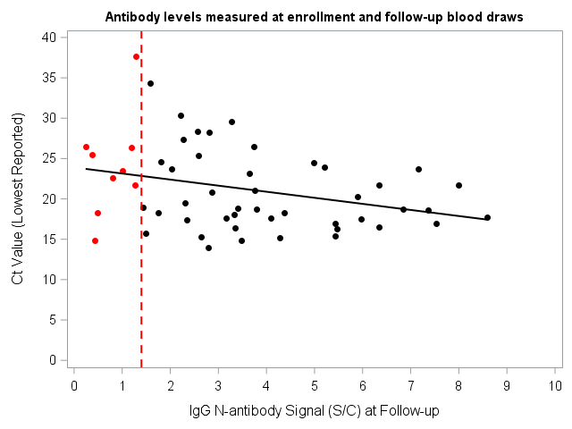

Supplementary Figure 4. Roche C_{T} values stratified by IgG N-antibody test result.
A.
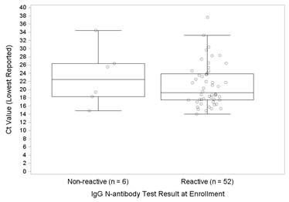

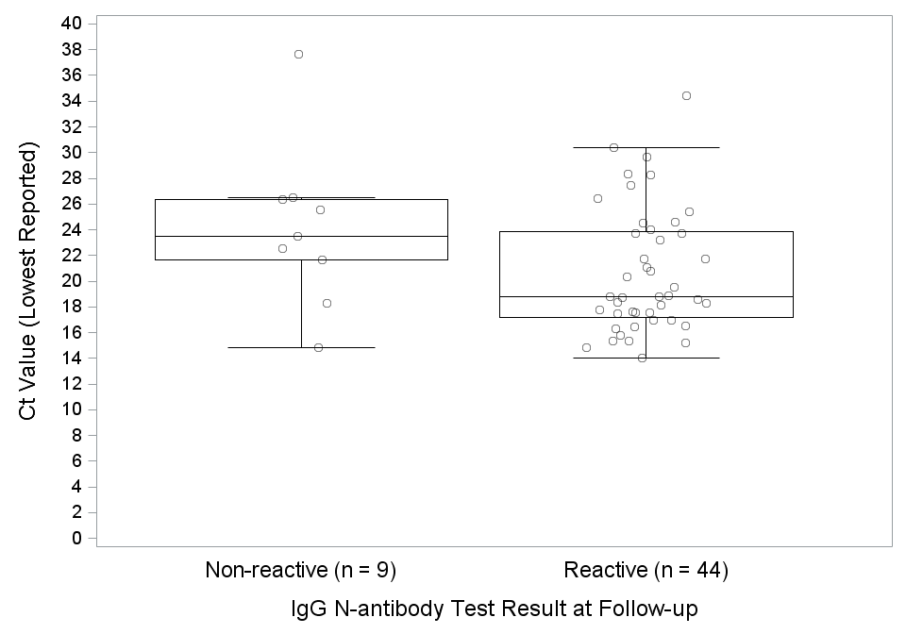
B.

REFERENCES
1. Rhoads D, Peaper DR, She RC, et al. College of American Pathologists (CAP) Microbiology Committee Perspective: Caution Must Be Used in Interpreting the Cycle Threshold (Ct) Value. Clin Infect Dis 2021;72:e685-e686.

